**Title:** **Reproductive modes in populations of** **late-acting self-incompatible and self-compatible polyploid *Ludwigia grandiflora* subsp. *hexapetala* in western Europe**

**Short running title:** Mixed reproductive modes in *Ludwigia*

**Authors:** Solenn Stoeckel1,2, Ronan Becheler1,2, Luis Portillo-Lemus1, Marilyne Harang1, Anne-Laure Besnard1, Gilles Lassalle1, Romain Causse-Védrines3, Sophie Michon-Coudouel3, Daniel J. Park4, Bernard J. Pope4, Eric J. Petit1, Dominique Barloy1

**Affiliations**

1 DECOD (Ecosystem Dynamics and Sustainability), Institut Agro, IFREMER, INRAE, Rennes, France.

2 IGEPP, INRAE, Institut Agro, Université de Rennes, Le Rheu, France.

3 Plateforme EcogenO, UAR3343 OSUR, Université de Rennes, CNRS, Rennes, France.

4 Melbourne Bioinformatics, The University of Melbourne, Parkville, Australia.

**Corresponding author:** solenn.stoeckel@inrae.fr

**Abstract**

Reproductive mode, *i.e.,* the proportion of individuals produced by clonality, selfing and outcrossing in populations, determines how hereditary material is transmitted through generations. It shapes genetic diversity and its structure over time and space, which can be used to infer reproductive modes.

*Ludwigia grandiflora* subsp. *hexapetala* (*Lgh*) is a partially clonal, polyploid, hermaphroditic, and heteromorphic plant that recently colonized multiple countries worldwide. In western Europe, individuals are either self-incompatible caused by a late-acting self-incompatibility (LSI) system developing long-styled flowers, or self-compatible (SC), with short-styled flowers.

In this study, we genotyped 53 long- and short-styled populations newly colonizing France and northern Spain using SNPs to estimate rates of clonality, selfing and outcrossing. We found that populations reproduced mainly clonally but with a high diversity of genotypes along with rates of sexuality ranging from 10% up to 40%. We also found evidence for local admixture between long- and short-styled populations in a background of genetic structure between floral morphs that was twice the level found within morphs. Long- and short-styled populations showed similar rates of clonality but short-styled populations presented significantly higher rates of selfing, as expected considering their breeding system, and despite the small rates of failure of the LSI system. Within the 53 studied populations, the 13 short-styled populations had fewer effective alleles, lower observed heterozygosity, and higher inbreeding coefficients, linkage disequilibrium and estimates of selfing than what was found in long-styled populations. These results emphasize the necessity to consider the variation of reproductive modes when managing invasive plant species. The overall maintenance of higher genetic diversity with the possibility of maintaining populations clonally in the absence of compatible partners may explain why long-styled individuals seem to be more prevalent in all newly expanding populations worldwide. Beyond *Lgh*, our methodological approach may inspire future studies to assess the reproductive modes in other autopolyploid populations.

**Keywords:** Partial clonality, Mating system, Late-acting self-incompatibility system, Selfing, Outcrossing, Autopolyploidy, Water primrose

**Introduction**

Plants reproduce using different mechanisms (i.e., breeding system), including clonality and different types of sexuality (i.e., mating system, including allogamy and selfing; Holsinger 2000). Reproductive mode corresponds to the actual balance between sexual and clonal reproduction, measured by the rate of clonality (De Meeus et al. 2007; Stoeckel et al. 2021a), and, within the proportion of offspring produced by sexuality, the balance between autogamy and geitonogamy (hereafter *selfing*), and allogamy (*outcrossing*), measured by the rate of selfing (Bürkli et al. 2017). Reproductive mode is one of the main drivers of genetic diversity in populations and species (Duminil et al. 2007, Ellegren & Galtier 2016, Glémin et al. 2019). It determines the way hereditary material is transmitted over generations, and thus constrains the range of genetic diversity that can evolve within populations and species (De Meeus et al. 2007, Fehrer 2010, Stoeckel & Masson 2014, Rouger et al. 2016). Its genetic consequences are deep enough to be discernible even in the presence of other affecting factors (Charlesworth 2003). Considering its influence on population genetic diversity and structure, reproductive mode is one of the major biological traits to decipher before interpreting other biological and ecological forces using molecular data (Duminil et al. 2007, Reichel et al. 2016, Bürkli et al. 2017, Orive & Krueger-Hadfield 2021). Given an adequate theoretical framework, population geneticists can use genotypic data to infer reproductive modes in populations (Halkett et al. 2005, Arnaud-Haond et al. 2007, Hardy 2016, Bürkli et al. 2017, Stoeckel et al. 2021a).

Many plant species reproduce using different breeding systems they adapt to different ecological contexts resulting into different reproductive modes (Richards 1997, Charlesworth 2006). Uniparental reproduction, including clonality and selfing, may help plants to spread into new areas (Baker’s conjecture: Barrett et al. l2015). Clonality consists of a parent producing a new descendant that is a genetic copy of itself with the exception of rare somatic mutations and mitotic recombinations (De Meeus et al. 2007). It results into an average excess of heterozygotes compared to Hardy-Weinberg expectations (*i.e.,* negative FIS), large variance of FIS along the genome and a small excess of linkage disequilibrium, increasing with decreasing population size (Navascues et al. 2010, Stoeckel & Masson 2014, Stoeckel et al. 2021a). When parents can yield multiple descendants, it may generate repeated genotypes in populations (Arnaud-Haond et al. These effects vary with the rates of clonality and, which in turn, can be used to infer these rates within populations (De Meeus et al. 2006, Becheler et al. 2020, Arnaud-Haond et al. 2020). Hermaphroditic plants have the possibility to sexually reproduce with themselves (selfing). Selfing decreases effective population sizes and gene diversity resulting into high probability of allele fixing (Wright et al. 2008, Roze 2016, Glémin et al. 2019). Selfing also prohibits genetic mixing between different ancestral lineages, which decreases heterozygosity within individuals (David et al. 2007, Hardy 2016) and strongly increases linkage disequilibrium between genes along genomes (Golding & Strobeck 1980, Norborg 2000, Lucek & Willi 2021). Around half of hermaphrodite plants restrict self-fertilization using a variety of molecular mechanisms grouped under the term “self-incompatibility (SI) systems” which favour outcrossing within populations (De Nettancourt 2001, Castric & Vekemans 2004, Gibbs 2014, Steinecke et al. 2022). Outcrossing is overall expected to increase genetic diversity, to limit allele fixation and to reduce linkage disequilibrium when compared to selfing, but only if linked to the genes involved in self-recognition (Glémin et al. 2001, Stoeckel et al. 2006, Navascues et al. 2010). Within the different identified SI systems (Charlesworth et al. 2005, Franklin-Tong 2008), the late-acting SI system (hereafter LSI) is still poorly studied despite being identified in multiple taxonomic groups in angiosperms (De Nettancourt 1997, Gibbs 2014). In LSI systems, self-pollen tubes grow and are only blocked shortly before penetrating the ovule. Such species may present reduced female fertility due to self-pollen disabling ovules, favouring the clonal regeneration of populations (Vaughton et al. 2010). LSI systems are also characterized by low but recurrent failures of the self-recognition system due to its late mechanism, leading to the production of a low amount of selfed seeds in populations (Seavey & Bawa 1986; Chen et al. 2012, Gibbs 2014). In contrast, gametophytic and sporophytic self-recognition occurring very early in the pistil drastically limit self-pollination and thus selfed seeds (Lawrence 1985, Gibbs 2014). However, we do not yet know if these rare selfed seeds contribute to the dynamics of genetic diversity of LSI populations and species, especially in peripatric conditions or in any situation when compatible partners may lack. Due to these selfed seeds, LSI system may be relatively ineffective at driving genetic diversity within populations, contrary to gametophytic and sporophytic SI systems (Brennan et al. 2002, Stoeckel et al. 2006, Koelling et al. 2011, Busch & Urban 2011). In such situations, the emergence and maintenance of LSI systems appear as new evolutionary puzzles among the reproductive systems.

Water primrose*, Ludwigia grandiflora* subsp. *hexapetala* (Hook. & Arn.) Nesom and Kartesz (2000), hereafter *Lgh*, is an insect pollinated, partially clonal, hermaphroditic and heteromorphic plant. This species is one of the most invasive aquatic plants in the world (Thouvenot et al. 2013). *Lgh* is a decaploid species (2n=10x=80 chromosomes), resulting from hybridization of different ancestral diploid species, some of which are represented more than once in the total genome of *Lgh*, which belongs to the genus *Ludwigia* L. section Jussiaea (Hoch et al. 2015, Barloy et al, 2024). Interestingly, *Lgh* includes an autotetraploid set of chromosomes, shared with *L. peploides* subsp. *montevidensis* (2n=2x=16), hereafter *Lpm*, that is clearly distinct from the other ancestral part of the *Lgh* genome (Barloy et al. 2024). *Lpm* is a self-compatible-only diploid species with only one common floral morphology (Estes & Thorp 1974, Grewel et al. 2016). *Lgh* presents heteromorphic flowers corresponding to two floral morphs: L-morph individuals develop long-styled flowers and S-morph individuals develop short-styled flowers, that cross and result into 100% viable and fertile F1 and F2 descendants (Portillo-Lemus 2021, Portillo-Lemus et al. 2021) while inter-species crosses only result in a low number of chlorotic and unfertile descendants (Barloy et al.

All tested L-morph flowers expressed an active LSI in western European populations (Portillo-Lemus et al. 2022). During the core flowering season (summer), in experimental greenhouse conditions, L-morph individuals show a stable seemingly insignificant rate of autogamy (around 0.2‰ of the available ovules) that increases at the end of the flowering season, during autumn, to 1‰, which is common in LSI systems (Gibbs 2014). Due to the massive blossoming of this species, growing in very dense populations, these selfed seeds would add up yearly in field populations to thousands of seeds per square meter (Portillo-Lemus et al. 2021). This pattern of low rates of autogamy, that increases at the end of the flowering season, may provide the advantage of reproductive assurance (Goodwillie & Weber 2018). In contrast, all tested S-morph individuals were self-compatible (SC) in western European populations but in their pistils, pollen tubes of the L-morph growed significantly faster and were thus advantaged to fertilize ovules when in competition with self-pollen (Portillo-Lemus et al. 2022). In addition, peripatric *Lgh* populations, including European populations, were previously reported as exclusively clonal with few clonal lines (Dandelot 2004, Okada et al. 2009). Recently established populations in France and northern Spain mostly present only one of the two compatibility modes locally, sometimes with a population of the other type a few to tens of kilometers away, which may result in effective allogamy (Portillo-Lemus et al. 2021, 2022). All these different breeding systems make possible very different reproductive modes in populations, comprising all possible quantitative combinations of mainly clonal, autogamous and allogamous modes.

Here, we assessed the reproductive modes of 53 invasive *Lgh* populations across western Europe. Considering the complex case of *Lgh* in western European populations, we hypothesized that L-morph populations supposed to express a LSI should present typical genetic footprints of dominant outcrossing, and perhaps higher rates of clonality due to the local lack of compatible partners and self-pollen interferences, while S-morph populations supposed to be SC should present higher rates of sexuality prevailed by selfing. To understand the genetic impacts of reproductive modes, we also quantified the covariations of genetic indices and their importance to define the genetic diversity within the 53 genotyped populations, and compared these observations to the theoretical expectations obtained from a Wright-Fisher-like model extended to autotetraploids (Stoeckel et al. 2024). Finally, we took advantage from the fact that recent local populations in France and northern Spain still present only one of the two compatibility modes to compare and interpret the genetic differences found within and between L-morph (LSI) and S-morph (SC) populations, with the aim to assess the influence of LSI on genetic diversity, as similarly tackled in sporophytic self-incompatible and SC Brassicaceae species previously (Koelling et al. 2011).

**Materials and methods**

**Sampling strategy and floral morphology** **of populations**

We collected 795 stems of *Lgh* from 53 locations (52 locations in France and one in Catalonia, Spain), corresponding to an area that spans 580 kilometres east-to-west and 1,100 kilometres north-to-south (Figure SI1). At each location, we collected 15 stems (hereafter, ‘individuals’) along a linear transect of 40 meters. Along each transect, we randomly collected three stems at coordinates X1 = 0m; X2 = 10m; X3 = 20m; X4 = 30m and X5 = 40m within a one meter-square quadrat. The young leaves of each sampled individual were stored after lyophilization until DNA extraction.

We visually identified floral morphologies of flowers found along each transect within the sampled *Lgh* populations. In a previous study on seven populations among the 53 studied here (underlined population names in Figure SI1), one hundred and five sampled individuals resulted to identify a binary distribution of floral morphology with formally-identified self-incompatibility types: all L-morph individuals were LSI typed and all S-morph individuals were SC typed (Portillo-Lemus et al 2021) while all these individuals succeeded to cross and give viable and fertile plants. Interestingly, these two types of populations spatially distribute in monomorphic populations along different rivers. We supposed for this study the LSI versus SC status of individuals and populations using their floral morphologies: L-morph individuals were supposed to develop a LSI system and S-morph individuals being SC. To support this conjecture, as done in Portillo-Lemus et al. (2021), we checked the fruitset in each of the 53 sampled and genotyped populations: A low fruitset, or even no fruit at all were found in L-morph individuals and populations, while full fruitsets were found in S-morph individuals and populations, in agreement with our conjecture.

In addition to the crossbreeding results in which all L- and S-morph individuals succeeded to cross, giving full fruit set and 100% viable first- and second-generation descendants (Portillo-Lemus et al. 2021), we here counted the chromosome numbers on karyotypes of S-morph individuals sampled in two fruitful populations and of L-morph individuals sampled in five fruitless populations to validate that L- and S-morph individuals belong to *Lgh*. Between 50 to 150 kilometers separated two consecutive samples (populations underlined Figure SI1). To prepare the karyotypes, we used the method detailed in Barloy et al (2024) that already karyotyped a S-morph individual sampled near the French Atlantic coast. The same method was used in Bou Manobens et al. (2019) to karyotype a L-morph individual sampled in Catalunya.

**Definition of the autotetraploid SNP marker set**

As no molecular markers suitable for clonal discrimination were yet available for *Lgh* and *Lpm*, we generated an original set of SNP markers via RAD-Seq (Baird et al., 2008) using two pools of 15 individuals each, respectively sampled across five *Lgh* and three *Lpm* western European populations. RAD DNA library generation, sequencing and the analysis pipeline to identify *Lgh* SNP markers were carried out as described in Delord et al. (2018). In brief, DNA of *Lgh* and *Lpm* were digested by *Sbfl* restriction enzyme and used to prepare DNA libraries that were then sequenced using an Illumina HiSeq3000 (150bp paired-end reads). A total of 14,233 and 34,287 RAD-Seq-determined SNPs were filtered to yield 340 and 326 SNPs, one per aligned sequence, for *Lpm* and *Lgh*, respectively. Design of primers compatible with Hi-Plex multiplexing was carried out by Melbourne Bioinformatics. Finally, sixty and fifty SNP markers matched the quality criteria to design a Hi-Plex set of SNPs for *Lpm* and *Lgh*, respectively (Hammet et al. 2019). In our study, we only considered polymorphic SNPs that were shared between *Lgh* and *Lpm* to be sure they belong to the tetraploid part of *Lgh* genome derived from *Lpm* (Barloy et al. 2024). We finally kept this set of 36 polymorphic and stable SNP markers to genotype *Lgh* samples and analyze genetic diversity in each sampled population (primer sequences are openly listed in Stoeckel et al. 2023).

To verify that this set of SNPs was really tetraploid, we computed the Akaike’s information criterion from the maximum likelihood of the best genotype considering the distribution of sequenced allele countings among individuals and markers as a function of the ploidy level, using a similar approach to that proposed by Burnham & Anderson (2002).



where ${data}_{i,l}$ is the distribution of sequenced alleles among A, C, G and T within individual $i$ at locus $l$, and K is the number of possible genotypes given the ploidy and the four possible alleles (A, C, G and T). The likelihood of the possible genotypes $L\left({genotype}_{i,l} | ploidy,{data}_{i,l}\right)$ follows a multinomial distribution of the sequenced allele countings distributed between the four different possible nucleobases (A, C, G and T).

**DNA extraction, SNP marker production and genotyping**

To genotype the 795 individually-tagged samples with these 36 SNPs, we extracted DNA from 25 to 30 mg of dried young leaf tissues. The DNA extractions were performed using the NucleoSpin Plant II from MACHEREY-NAGEL kit, following the manufacturer’s recommendations. We used L1 buffer as lysis buffer. All individuals were genotyped from a solution of 20ng/μl of *Lgh* DNA, using a modified version of the Hi-Plex protocol (Hammet et al. 2019; Besnard et al. 2023). Hi-Plex is an amplicon sequencing technique (*sensu* Meek & Larson 2019) in which all SNPs are co-amplified in a multiplex reaction before Illumina or Ion-Torrent sequencing. Here, we used Illumina. Intermediate steps include dual indexing of individual samples used for demultiplexing. Reads were then assigned to loci by aligning them to reference sequences with BWA-MEM 0.7.15-r1140 (Li & Durbin 2010) and alleles were counted with Samtools 1.9 (Danecek et al. 2021).

**Allele dosage**The posterior probabilities of each single SNP genotype within each individual (hereafter *single SNP genotype*) were computed using the likelihood of all possible genotypes considering a multinomial distribution of the number of times each nucleobase was genotyped at one SNP marker within one individual. In order to obtain the most confident dataset possible, we only assigned a genotype when its posterior probability of allele dosage exceeded 70%. When one SNP within one individual presented a posterior probability of allele dosage equal or lower than 70%, we assigned and analysed it afterward as a missing genotype.

**Genotypic and genetic descriptors**

We expected that populations reproducing clonally may yield repeated multi-locus genotypes (MLGs, i.e., the same genotype at all the 36 SNPs found in multiple individuals). By possibly producing these repeated genotypes and by varying the relative distribution of the number of samples of each of these distinct genotypes, rates of clonality impact genotypic richness and evenness in populations (Halkett et al. 2005; Arnaud-Haond et al. 2007).

We measured genotypic richness using the R index (Dorken & Eckert 2001, Arnaud-Haond et al. 2005), which is defined as: $R=\frac{G-1}{N_{g}-1}$

where G is the number of distinct genotypes (genets) and Ng is the number of genotyped individuals. We also measured genotypic evenness as the parameter β of the Pareto distribution, which describes the slope of the power-law inverse cumulative distribution of the size of MLGs (Arnaud-Haond et al. 2007): $N≥X=aX-β$

where N≥X is the number of sampled ramets belonging to genets containing X or more ramets in the sample of the population studied, and the parameters *a* and *β* are fitted by regression analysis. Low β-values indicate the dominance of one or few clonal lineages. Pareto β is less biased by the sampling effort than clonal richness R (Stoeckel et al. 2021a). In our sample of 15 individuals, we expected a population with only one repeated MLG to present a Pareto β value of 0.03 and a value of 3 in samples with no repeated genotypes. β < 2 indicates a population reproducing with high rates of clonality (greater than 0.8 to 0.9). For a sample size of 15 individuals, 2 < β < 3 indicates intermediate to low rates of clonality (0.6 to 0.8). A β at 3, its maximum value, is indicative of a mainly sexual population, with rates of clonality ranging from zero to 0.6, depending on the other genetic indices.Rates of clonality and selfing confer different effects on the range of within-population genetic polymorphism as well as on probabilities of genetic identities within individuals. We thus also estimated expected and observed heterozygosity HE and HO, allelic richness AE, inbreeding coefficient FIS, and linkage disequilibrium within each sampled population.

The inbreeding coefficient FIS (Wright 1931, 1949) accounts for intraindividual genetic variation at one locus as a departure from Hardy-Weinberg assumptions of the genotyped populations. We computed one FIS value per locus per population. We then reported the mean values of FIS (MFIS) and the inter-locus variance of FIS (VarFIS) for each population. Both MFIS and VarFIS are very informative about the underlying reproductive systems (Stoeckel et al. 2006, David et al. 2007). Clonality makes the MFIS values tend toward -1 along with high interlocus variance (Stoeckel & Masson 2014, Stoeckel et al. 2021a). A moderate amount of sexual reproduction results in MFIS values around 0 (Balloux et al. 2003). VarFIS varies with rates of clonality, from very limited variance expected in sexual populations to high variance in very clonal populations (Stoeckel & Masson 2014, Stoeckel et al. 2021a). Positive MFIS values are expected in populations reproducing using consanguinity and selfing (Castric et al. 2002, David et al. 2007). All sexual reproductive modes, allogamous and autogamous, result in low VarFIS within a population as massive recombination tends to homogenize intra-individual genetic identities along the genomes (Stoeckel et al. 2021a).

We measured linkage disequilibrium over all markers using the unbiased multilocus linkage disequilibrium index, ${\overline{r}}_{d}$ (Agapow & Burt 2001). This mean correlation coefficient (*r*) of genetic distances (*d*) between unordered alleles at *n* loci ranges from 0 to 1. This metric has the advantage of limiting the dependency of the correlation coefficient on the number of alleles and loci, and it is well suited to measure linkage disequilibrium in partially clonal populations (De Meeus & Balloux 2004, De Meeus et al. 2006). In general, LD is only slightly affected by clonality, except when clonality is high (c > 0.9) and/or when genetic drift dominates over mutation rate (*e.g.,* when population sizes are small N<50 compared to u=0.001; Navascues et al. 2010, Stoeckel et al. 2021a). In contrast, inbreeding and selfing are efficient processes for quickly generating strong LD, after only few generations. Finally, we measured genetic differentiation between populations of LSI, between populations of SC and between LSI and SC populations using ρST, an index adapted to study autopolyploid populations (Ronfort et al. 1998). All these indices were computed using Genapopop (Stoeckel et al. 2024), a software dedicated to analysing genetic diversity and differentiation in autopolyploid populations genotyped with confident allele dosage and reproducing through all possible rates of clonality and selfing.

We also used Spagedi (v1.5, Hardy & Vekemans 2002) to estimate rates of selfing within autopolyploid populations genotyped with confident allele dosage. This approach infers rate of selfing (Sg) from identity disequilibrium coefficients (g2z estimator), assuming that populations reproduce by self-fertilization and random mating and are at inbreeding equilibrium (David et al. 2007 for diploids, Hardy 2016 for autopolyploids). Identity disequilibrium coefficients are measured as the correlation in heterozygosity of distinct loci within the genome, and present the advantage of being more robust to null alleles and genotyping errors than raw FIS (David et al., 2007). The effect of partial clonality on g2z estimator is not yet defined. We thus considered for this study that clonality would only marginally impact identity disequilibrium coefficients, the possibility to be at the inbreeding equilibrium and the corresponding estimates of selfing. A synthesis of all these hypotheses based on previous knowledge is provided in Table SI1.

**Ranking populations by clonality and selfing**

We proposed and computed a synthesis index ($Σclon$) calculated from Pareto β and VarFIS to rank the studied populations from the less to the more clonal. These two population genetic indices are known to vary with rates of clonality being unbiased in samples (Stoeckel et al. 2021a). To avoid issues of scaling as the range of values of these descriptors are different by several orders of magnitude, $Σclon$ is computed in each population $i$ as the sum of Pareto $β\left(i\right)$ and $VarFIS\left(i\right)$ values that were previously normalized over the whole dataset, respectively $z_{β}\left(i\right)$ and $z_{VarFIS}\left(i\right)$.

$$z_{β}\left(i\right)=1-\frac{β\left(i\right)-min⁡(Β)}{max⁡(Β)-min⁡(Β)}$$

$$z_{VarFIS}\left(i\right)=\frac{VarFIS\left(i\right)-min⁡(VF)}{max⁡(VF)-min⁡(VF)}$$

$$Σclon\left(i\right)=1/2\left[z_{β}\left(i\right)+z_{VarFIS}\left(i\right)\right]$$

where $β\left(i\right)$ and $VarFIS\left(i\right)$ are the measured Pareto β and variance of FIS over loci in the population $i$, and where $Β=\left\{β\left(1\right),β\left(2\right), …,β\left(55\right)\right\}$ and $VF=\left\{VarFIS\left(1\right),VarFIS\left(2\right),…,VarFIS\left(55\right)\right\}$ are the respective sets of Pareto β and VarFIS over loci in the 53 populations used to obtain their minimum ($min$) and maximum ($max$) values.

Using the same approach as for $Σclon$, we computed a synthesis index ($Σself$) calculated from ${\overline{r}}_{d}$, MFIS and Sg to rank the studied populations from the less to the more selfed.

$$Σself\left(i\right)=1/3\left[z_{{\overline{r}}_{d}}\left(i\right)+z_{MFIS}\left(i\right)+z_{Sg}\left(i\right)\right]$$

**Statistical data analysis**

First, to better understand the correlation between population genetic indices and estimates of reproductive modes from a large field dataset and to compare with the theoretical correlations obtained from simulations (Stoeckel et al. 2024), we computed a Principal Component Analysis (PCA) to comprehend the covariations of genetic indices, the correlations and the redundancies between the 17 genetic diversity indices (described above: G, R, D, Pareto $β$, ${\overline{r}}_{d}$, Ae, varAe, He, varHe, Ho, varHo, MFIS, varFIS, PIDsib, PIDu, Sg, SE.Sg) measured among the 53 sampled populations, and their link with reproductive modes including self-compatibility. We reported the amount of variation retained by the first two principal components and the correlation circle on which we plotted predictions of $Σclon$ and $Σself$ as supplementary variables. We also reported the score plot to visualize how L-morph (LSI) and S-morph (SC) populations distribute along the principal components of population genetic diversity. To avoid scaling issues, all descriptors were normalized before analysis.

We then analyzed the relationship between genetic diversity indices and their relationships with $Σclon$ and $Σself$ measured in the 53 sampled populations using Kendal partial rank-order correlation tests. We reported the corresponding matrices of correlation.

To detect differences in distribution of population genetic indices, $Σclon$ and $Σself$, among floral morphs, we computed non-parametric Kruskal-Wallis tests that do not make any assumptions about the type of distribution and about homogeneity of variances between the tested distributions. When needed, we used post-hoc pairwise tests for multiple comparisons of mean rank sums (Nemenyi’s test).

All statistical tests were computed using Python 3.11, Scipy.stats 1.9.3 (Virtanen et al. 2020) and scikit-posthocs (Terpilowski 2019), except the PCA that was performed using R v4.2.2 and the library FactomineR (Lê et al. 2008).

**Results**Among the 53 populations, we found 40 populations with only L-morph individuals and 13 populations with only S-morph individuals (Table SI2, Figure SI1). Karyotypes of L-morph plants from two populations and of S-morph plants from five populations all presented the same number of chromosomes (2n=80, Figure SI2) confirming that L and S-morph individuals in France and L-morph individuals in northern Spain (Bou Manobens et al. 2019) belong to *L. grandiflora* subsp. *hexapetala* (2n=10X=80, Barloy et al. Akaike's information criterion on the distribution of allele counting over all our data supported tetraploidy as the best ploidy level for this set of 36 SNPs (Figure SI3), as expected from Barloy et al (2024).

**Allele dosage and missing genotypes**Within the 795 individuals genotyped at 36 SNPs (resulting in a total of 28,620 single-SNPgenotypes), 99.97% (28,612) of SNPs were genotyped with posterior probability of allele dosage superior to 70% (Table SI3). In total, 785 individuals were genotyped with a full set of 36 SNPs with posterior probabilities of allele dosage higher than 70%. Ten individuals distributed in nine populations showed one of their SNP markers with posterior probabilities of allele dosage equal or lower than 70%, that we assigned therefore as missing genotypes.

**Statistical power of the developed SNP marker set**Over the 36 polymorphic SNPs, we found an effective number of alleles (AE) of 1.36 per SNP over all populations (Table SI2). Among populations, mean AE values over the 36 SNPs were homogenous, ranging from 1.22 to 1.55 (median=1.34). We, however, found large standard deviation of AE between SNPs within populations, ranging from 1.6 to 2.3 (median=2.1). Some SNPs were apparently fixed in some populations while polymorphic at the scale of the whole dataset. When not fixed, gene diversity HE in polymorphic SNPs ranged from 0.14 to 0.33 (median=0.2). These 36 SNPs in the autotetraploid part of *Lgh* would theoretically allow 436=4.7×1021 different possible MLGs considering the four possible nucleobases and 236=6.9×1010 different possible MLGs assuming two possible nucleobases per locus. Considering allele frequencies in the sampled populations, the probabilities of identities under panmixia ranged from 8.5×10-12 to 5.2×10-5 (median=2.1×10-7)and the unbiased probabilities of identity between sibs PID-SIB ranged from 4.2×10-6 to 8.3×10-3 (median=5.6×10-4; Table SI2). We then considered that the SNP set we used to genotype the 795 sampled individuals via Hi-Plex method showed sufficient statistical power to distinguish between true MLGs, and that individuals with identical MLGs were true repeated genotypes (ramets) of a clonal lineage (a genet).**Genetic and genotypic diversity**Across populations, we identified a total of 462 distinct MLGs (genets) within the 795 sampled individuals genotyped. Among them, we found 404 genets (88%) with a single ramet and only 58 genets (12%) with more than two ramets (Table SI4). Forty-eight genets had two to seven ramets distributed over one to six populations (median=2), seven genets with 10 to 33 ramets distributed over two to 17 populations (median=9), and one large genet of 99 ramets distributed over 24 populations (Figure 1).Within populations, we found from three to 15 different genets (median=12) per population among the 15 sampled individuals (Table SI4), implying the clear occurrence of repeated genotypes but also a wide diversity of genets within most populations (Figure 1). Accordingly, genotypic richness (R) ranged from 0.14 to 1 (median=0.79). The genotypic evenness, Pareto β, ranged from 0.056 to 3 (median=1.478, Table SI2).

Observed heterozygosity HO was also high in most populations, slightly above expected heterozygosity, ranging from 0.13 to 0.38 (median=0.26). The mean standard inbreeding coefficients (MFIS) averaged over all genotyped loci within populations were negative in all 53 populations and ranged from -0.33 to -0.126 with a very negative median of -0.274 (Table SI2). Variances of FIS between loci within population were very high, ranging from 1.75 to 36.60 (median=27.57). All these measures argued for reproductive modes implying high rates of clonality. Estimates of selfing (Sg) were overall low with a handful of high values, ranging from 0 to 0.61 (median=0.06). Fifteen populations (28%) were estimated with no selfing. Nineteen populations (36%) showed non-zero estimates under 0.1, 13 populations (25%) between 0.1 and 0.29, and six populations (11%) with estimates between 0.42 and 0.61.

Finally, linkage disequilibria within populations between genotyped SNPs were overall low, with rd values ranging from 0 to 0.51 with a median value of 0.12. Forty-two populations (79%) were under 0.25, and only eight populations (21%) showed linkage disequilibrium between 0.25 and 0.51.

**Analyses of covariations between population genetic indices**The first two components of the principal component analysis on the values of genetic diversity found in the 53 genotyped populations accounted for 78.4% of the total variance between populations (Figure SI4). Non-parametric Kendall partial rank-order correlations between genetic indices (Table SI5) and correlations on the first two principal components from the 17 population genetic indices measured showed three non-collinear groups of associated genetic indices (Figure SI4.A) that are very similar to the theoretical groups of population genetic indices expected to covary with different rates of clonality, selfing and outcrossing in autopolyploids (Stoeckel et al. 2024). A first cluster regrouped G, D*, R, Pareto β and VarFIS, indices that are known to be sensitive to clonality(Stoeckel et al. 2021a) but also VarHe, VarHo, and VarAe. This cluster largely explains the first dimension (50.2% of the total variance) of the PCA and was collinear to ΣCLON (also see Figure SI4.B). As expected under partial clonality, VarFIS was negatively correlated to genotypic diversity indices (R and β; Figure SI5). The second cluster regrouped PID-SIB, PID-u, HE, AE and HO, indices that are linked to the general genetic diversity of populations (Figure SI4.A). The third cluster regrouped Sg, SE.Sg, MFIS and rD, indices that are usually used to identify, rank and estimate rates of selfing versus outcrossing in sexual populations (Castric et al. 2002, Bürkly et al. 2017). The second dimension of the PCA (23.4% of the total variance) was mostly correlated to Ho, Sg, He and rD which was collinear to ΣSELF (Figure SI4.C). The clusters of genetic indices were corroborated by the correlation between ΣCLON and genetic indices (Figure SI5) and ΣSELF and genetic indices (Figure SI6).

The correlation across populations between ΣCLON andΣSELF was negative and highly significant (rs = -0.66; p < 0.001; Figure 2). This correlation within LSI populations was negative and highly significant (rs = -0.65; p < 0.001) while it was no significant in SC populations (rs = -0.32; p =0.289).

**Differences in genetic diversity and structure between L- and S-morph populations**

The number of ramets per genet was similar in L-morph (LSI) and S-morph (SC) populations (H=1.85, p=0.173, Figure 1 & SI7), as were their genotypic richness (R, H=1.23, p=0.267) and evenness (Pareto’s β, H=1.60, p=0.206; Table SI2). The distributions of other population genetic indices related to clonality were also not significantly different between in L-morph (LSI) and S-morph (SC) populations (VarFIS: H=2.94, p=0.086; PID-SIB: H=1.98, p=0.160 and ΣCLON H=2.28, p=0.131; Figure 3).

Mean observed heterozygosity (Ho, H=5.27, p=0.022) and their variances (VarHo, H=13.85, p<0.001), mean effective number of alleles per locus (Ae, H=5.13, p=0.024) and its variance over locus (VarAe, H=9.49, p=0.002), MFIS (H=11.85, p<0.001), linkage disequilibrium (rD, H=5.55, p=0.018), estimate of selfing rates (Sg, H=12.39, p<0.001) and its standard error over loci (SESg, H=9.58, p=0.002) significantly differed between in L-morph (LSI) and S-morph (SC) populations. S-morph (SC) populations, compared to L-morph (LSI), showed lower mean observed heterozygosity (medians, L-morph: 0.262, S-morph: 0.210) and less variance between loci (medians, L-morph: 2.400, S-morph: 1.859), lower effective number of alleles (medians, L-morph: 1.341, S-morph: 1.283) and less variance between loci (medians, L-morph: 4.419, S-morph: 3.580), higher linkage disequilibrium (medians, L-morph: 0.113, S-morph: 0.152), higher estimates of selfing rate (medians, L-morph: 0.045, S-morph: 0.175) even if with higher standard error between loci (medians, L-morph: 0.058, S-morph: 0.156) and higher ΣSELF (medians, L-morph: 0.222, S-morph: 0.495).

Genetic differentiation (ρST) among pairs of S-morph (SC) populations (median value of ρST=0.27) was comparable to the genetic differentiation found among pairs of L-morph (LSI) populations (median value of ρST=0.26; H=319.37, post-hoc p=0.322; Figure 4). The median of ρST between pairs of L-morph (LSI) and S-morph (SC) populations reached 0.65. The distribution of inter-morph ρST values differed both from the distribution of pairs of intra-L-morph (LSI) ρST values (post-hoc p<0.001) and from the distribution of pairs of intra-S-morph (SC) ρST values (post-hoc p<0.001). The minimum spanning tree of genetic distances between individuals computed with *GenAPoPop* showed quite clustered distributions of L-morph (LSI) and S-morph (SC) individuals but also with clear evidence of admixtures between their lineages (Figure 5).

**Discussion**

We used population genetics on autotetraploid SNPs with allele dosage to assess the rate of clonality, of selfing and of outcrossing (i.e., reproductive mode) of 53 populations of *Ludwigia hexapetala* subsp. *grandiflora* (*Lgh*) recently colonizing western European watersheds.

To achieve this goal, we developed reproducible codominant molecular markers (SNPs) that enabled allele dosage-based genotyping of sampled individuals. We then used tailored computational analyses to perform confident population genetic analyses in autopolyploids. These two methodological steps allowed solving the remaining challenges to perform population genetic analyses in autopolyploids (Dufresne et al. 2014), including *Lgh*. The resulting framework can be applied to any autopolyploid species.

*Lgh* develops two floral morphs respectively associated with a Late-acting self-incompatible system (L-morph) and a self-compatible system (S-morph, Portillo-Lemus et al. 2021, 2022). Interestingly, the sampled populations in western Europe showed either L- or S-morph resulting in two groups of sampled populations: one group of 40 L-morph (LSI) populations and one group of 13 S-morph (SC) populations. They live in similar ecological conditions (Portillo-Lemus et al. 2021) which thereby provides a rare opportunity to characterize the genetic consequences of an LSI system compared to a group of SC populations in the same species and ecological context.

**F**ive L-morph and two S-morph water primrose populations separated by 50 to 150 km from one to the other in France we karyotyped, all had 80 chromosomes corresponding to the species *Ludwigia grandiflora* subsp. *hexapetala*. We didn’t find yet individual with 48 chromosomes corresponding to *Ludwigia grandiflora* subsp. *grandiflora*. These results agree with previous observations of Dandelot et al (2005) and Barloy et al. (2024) in France, Bou Manobens et al. (2019) in northern Spain and Armitage et al. (2013) in Great Britain.

**Most of the genetic variance explained by clonality and selfing among *Lgh* populations**

The correlations of population genetics indices on the 53 genotyped *Lgh* populations (Figure SI4) were congruent with previous theoretical predictions on the variations of genetic indices with different rates of clonality and selfing for autopolyploid populations (Stoeckel et al. 2024). Identical covariations were already predicted by Wright-Fisher-like models adapted for diploid (Stoeckel et al. 2021a) and haplodiplontic life-cycles (Stoeckel et al. 2021b), and validated respectively using multiple field populations of marine phanerogams for diploids (Arnaud-Haond et al. 2020) and of brown, green, red algae and mosses for haplodiplontics (Krueger-Hadfield et al. 2021). All these predictions and observations argue for the primary importance of reproductive mode, especially of high clonality, to drive variation in genetic diversity within populations (Duminil et al. 2007). They support the methodological importance of accurate assessment of rates of clonality and of selfing before starting to interpret genetic diversity.

**Dominant clonality within the western European *Lgh* populations**

Previous field and lab observations of peripatric *Lgh* populations reported massive production of dispersing vegetative propagules, rapid expansions of patches, and an important capacity for spontaneous cutting-planting (Dandelot et al. 2005, Thouvenot et al. 2013, Grewell et al. 2016, Skaer-Thomason et al. 2018a,b). Okada et al. (2009) genotyped around 800 individuals sampled in 27 *Lgh* populations in Californian wetlands using a set of eight AFLP markers and reported an extremely reduced clonal diversity: 95% of the samples had the same genotype and 18 populations over 27 (67%) supported a single AFLP-genotype. All over the UK, only two haplotypes on 14 sampled stems were found using chloroplast sequences (Armitage et al. 2013). These haplotypes were even shared with some *Lgh* samples invading California. With no measure of the probability of identity to assess the marker set, these results could be due to the lack of resolution of the markers used resulting in an artificially elevated measure of clonality (Waits et al. 2001, Villate et al. 2010). In any case, all these studies concluded that invasive populations of *Lgh* in Europe and in USA reproduce by exclusive clonality, with a very narrow base of ancestral clones or being monoclonal (Dandelot et al. 2005, Okada et al. 2009, Thouvenot et al. 2013, Grewell et al. 2016).

The 36 SNPs we developed are easily reproducible, accurate enough to distinguish between offspring of sibling mating as evidenced by the probabilities of identity we obtained, and less expensive.

With these SNPs, we found typical genetic signatures of high clonality, including clear occurrence of replicated genotypes and mean negative FIS values with high interlocus variances, in all the 53 western European populations we genotyped.

Globally, gene diversities measured in these invasive *Lgh* populations were in the higher range of values commonly found for SNPs (Fischer et al. 2017, Schmidt et al. 2021). Such levels of gene diversity are in line with strong rates of clonality that buffer the loss of alleles due to genetic drift (Reichel et al. 2016, Stoeckel et al. 2021b). Clonal reproduction by rhizomes at the local scale and by the dispersal of clonal propagules would thus be the main source of population growth and invasive spread of *Lgh* in western Europe.

Our results also report a previously-underestimated genotype diversity in the invasive populations in western Europe. We found 462 distinct MLGs (genets) out of 795 individuals within these populations and the large majority of these MLGs (404, thus 88%) were only sampled once in the 53 populations. Our results are still congruent with Dandelot (2004) unpublished measures obtained in three Mediterranean populations using inter-simple sequence repeats (ISSRs). This data reports

**Between 10 and 40% of sexual reproduction in *Lgh* populations in western Europe**

Beyond the qualitative indication of dominant clonality, we then aimed at estimating the rates of sexuality in each of these 53 populations. All showed small to medium values of linkage disequilibrium between SNPs. Such values are expected in highly but non-exclusive clonal populations with large population sizes (Navascues et al. 2010, Stoeckel et al. 2021a). Thirty-two populations showed Pareto β values of their distributions of clonal sizes under 2, which are only found in theoretical populations with rates of clonality higher than 0.8 (Stoeckel et al. 2024). All 53 populations showed mean negative FIS with high interlocus variance, with values observed in theoretical populations with rates of clonality higher than 0.6 but under 0.9 (Balloux et al. 2024). All these values of population genetic indices were consistent with the interpretation that *Lgh* populations in western Europe must reproduce with effective rates of clonality between 60% and 90%, thus with 10% to 40% sexuality (De Meeus et al. 2006, Arnaud-Haond et al. 2020, Stoeckel et al. 2024). These estimates were also supported by the local evidence of recombination between clonal lineages, and even between L-morph (LSI) and S-morph (SC) lineages at the scale of a watershed (Figure 5). The diversity of genotypes detected in western Europe is thus indicative of rare but significant local sexual events rather than of a large clonal diversity that would have maintain and propagate by exclusive clonality since its introduction. Our results newly advocate that sexual reproduction should not, therefore, be overlooked in these invasive populations, especially in management plans.

**Genetic consequences of LSI compared to self-compatible populations**

The late-acting SI system remains one of the less studied breeding systems among the mechanisms favouring outcrossing in plants (Gibbs 2014). Its efficiency to favour outcrossing and its consequences on genetic diversity within populations, especially considering its low but common failures, were not yet deciphered and not yet compared to SC populations in the same ecological conditions, as already previously explored for gametophytic and sporophyte SI systems (Busch 2005, Koelling et al. 2011).

The maintenance of SI systems is one of the most intriguing evolutionary puzzles (Porcher & Lande 2005). Indeed, SI systems are fated to breakdown because SC individuals present the advantage of reproductive assurance when compatible partners are limited, especially in peripatric conditions (Eckert et al. 2006). This advantage is even absolute when no compatible partners are available within pollination range, as we commonly found in *Lgh* populations in western Europe (Figure SI1). Conversely, outcrossing imposed by SI systems decreases the probability of expressing deleterious mutations in descendants as compared to selfing with the same genetic background (Rice 2004, Navascues et al. 2010).

We found that the 40 populations with L-morph individuals (LSI) had a higher number of effective alleles, higher gene diversity, higher observed heterozygosity and less linkage disequilibrium than the 13 populations with S-morph individuals (SC; Figure 3).

These genetic differences are very unlikely to directly result from the consequences of the LSI system hitchhiked to the whole genome in L-morph individuals and populations. Indeed, it would imply either that all the 36 SNPs would be physically linked to the genes under negative frequency-dependent selection coding for the LSI or that *Lgh* outcrossed for many generations in small population sizes (Glémin et al. 2001, Navascues et al. *Lgh* in western Europe develops including far more than thousands of stems per local population (Portillo-Lemus et al. 2021) and the linkage disequilibrium values also argued for large effective population sizes. We found similar estimated rates of sexuality and of clonality between L-morph and S-morph populations, using ΣCLON and all indices sensible to clonality (R, Pareto β and VarFis; Figure 3). We however found significant difference in estimates of selfing between L-morph (LSI) and S-morph (SC) populations, and in ΣSELF and in all indices sensible to selfing (Ae, linkage disequilibrium, Ho, mean Fis) revealing typical signatures of higher selfing rates in S-morph populations. Hardy (2016) method estimated a median selfing rate (Sg) of 0.18 in S-morph populations versus 0.05 in L-morph populations. Consequently, the genetic differences we found between S-morph and L-morph populations may thus rather be due to the effects of selfing impacting S-morph (SC) populations than due to outcrossing protecting the loss of genetic diversity or rates of clonality in L-morph (LSI) populations.

**Advantages of dominant clonality with preferential allogamy in invasive *Lgh* populations**

Uniparental clonal reproduction (including clonality and selfing) may help the demographical maintenance of plants spreading out of their native range with limited or even without compatible or less related sexual partner at pollination distance (Baker’s conjecture: Barrett et al. 2008, Pannell et al. 2015). If they rather reproduce using selfing, their descendants increase the probability to express inbreeding depression and to lose heterozygosity. Some invasive populations develop with low genetic diversity (He et al. 2024), questioning on the biological and environmental factors that may explain their success (i.e.,But many other plants spread out of their native ranges with substantial genetic diversity and using reproductive modes that favour outcrossing (Roman & Darling 2007, Forsman 2014), like *Lgh* populations in western Europe, mostly when developing in harsh and stressful conditions (Fox & Reed, 2011) or when the costs of inbreeding depression expressed by selfing are superior to the benefits of reproductive assurance (Layman et al. 2017).

Peripatric populations of *Lgh* in western Europe seem to solve all these problems and paradox by mixing clonality with preferential allogamy: clonality allows the local maintenance and spreading of population without losing heterozygosity and genetic diversity, and subtle but significant sexuality with preferential allogamy, favoured by LSI and faster growth of crossed-pollen tubes, enables recombination between lineages favouring the emergence of locally adapted genomes with potential higher vigour and fertility (heterosis: Darwin 1876, Lippman & Zamir 2007, Birchleret al. 2010).

This reproductive mode, i.e. dominant clonality with preferential allogamy, is common in plants (Vallejo-Marin et al. The micro-physiological mechanism(s) slowing down the growth of self-pollen tubes, rather than blocking them, in simultaneous monoecious and hermaphrodite SC species and resulting to favour allogamy when compatible pollen is available may also be common in plant, although potentially overlooked (Glover 2007, Nasrallah 2017). In such peripatric conditions, selfing would thus only present the limited or transient advantage to produce seeds that can maintain in local seed banks and with different dispersal properties compared to clonal propagules. The limited interest of selfing in this species may explain why, based on photos collected on the web, L-morph (LSI) individuals seem more frequent in peripatric than in native populations, and why in western Europe, around 76% of the populations are L-morph (LSI) against 24% of S-morph (SC; Portillo et al. 2021). Our results thus call for measuring the true proportions of LSI and SC in invasive versus native worldwide *Lgh* populations with estimation of their rates of clonality and of selfing.

**Unusual selfing syndrome in *Lgh* populations**

Highly selfed populations of different plant species tend to share similar morphology and functions resulting in a set of traits called *selfing syndrome*, including reduced flower size (Darwin 1876, Tsuchimatsu & Fujii 2022). Selfing syndrome, including reduced flower size, seems to evolve rapidly, as observed for example in five generations in *Mimulus guttatus* (Bodbyl-Roels & Kelly 2011), in four generations in *Silene latifolia* (Delph et al. 2004), in three generations in *Phlox drummondii* (Lendvai & Levin 2003) and after only two generations in *Eichhornia paniculata* (Worley & Barrett 2000).

On the contrary, S-morph (SC) individuals in *Lgh* develop larger flowers than allogamous L-morphs (Portillo-Lemus et al. 2021). However, S-morph (SC) individuals and populations dominantly reproduced using clonality and produced selfed offspring only when lacking crossed pollen. Both clonality and faster growth of crossed-pollen tubes may delay or even compromise the emergence of the first steps of a selfing syndrome. These two traits may call for further studies on the emergence of selfing syndrome in partially clonal and selfed populations.

**Conclusion**

We found that peripatric populations of *Lgh* in western Europe reproduced using dominant clonality with limited but stable significant sexuality with preferential outcrossing, in nearly all populations, within a large clonal diversity. *Lgh* is one of the most invasive aquatic plants in the world, and considerable efforts are made to limit its deleterious effects in the newly colonized ecosystems (Thouvenot et al. 2013, Grewell et al. 2016, Portillo-Lemus et al. 2021). The rare sexual events, allogamous when possible, occurring in invasive peripatric populations of *Lgh* may favour the emergence of new genotypes, more adapted to local conditions. Managers should thus chiefly concentrate their actions on the most sexual populations, and on the contact zones between S- and L-morph populations in France. We also found variations of the rates of clonality and of selfing among *Lgh* populations. Considering the importance of reproductive modes on the dynamics and evolution of populations (Duminil et al. 2007, Ellegren& Galtier 2016, Glémin et al. 2019), our results advocate that management actions should consider the local effective reproductive modes to control *Lgh* population by population. Finally, knowing the reproductive modes of populations, the distribution of clones and the self-compatibility across western European populations now allow deciphering and interpreting their population structure, identifying their origin and routes, and predicting their possible short-term dynamics.

**Data Accessibility Statement**

The data that support the findings of this study are openly available on Zenodo (https://doi.org/10.5281/zenodo.12760022).

**Benefits Generated**

Benefits from this research accrue from the sharing of our data and results on public databases as described above.

**Acknowledgements**

We thank Michel Bozec (UMR DECOD), Diane Corbin (FRAPNA Loire-Ecopôle du Forez), Guillaume Le Roux (Reserve Naturel Val d’Alier Châtel-de-Neuvre), Fabrice Dejoux (Service Agriculture Environnement Roannais Agglomération and Jordi Bou Manobens (University of Girona, Spain) for helping to collect *Lgh* samples. We thank Olivier Coriton and Virginie Huteau for their help acquiring karyotypes.

We warmly thank Ingrid Leveque, Marie-Therese Delaroche, Gervaise Fevrier and Patricia Nadan for their administrative support and facilitation.

**Funding information**

This work was supported by FEDER Région Centre-Val de Loire, by Agence de l’eau Loire-Bretagne (grant Nature 2045, programme 9025, AP 2015 9025) and by the French National Research Agency (project Clonix2D ANR-18-CE32-0001). FEDER funded the doctoral grant of L. Portillo-Lemus and salary of Marilyne Harang. Postdoctoral grant of Ronan Becheler was funded by Clonix2D ANR-18-CE32-0001.

**Conflict of interest**

The authors declare that they have no financial conflicts of interest based on the content of this article.

**Author contributions**

DB and SS laid the foundation of this work, conceived the study and were responsible for funding applications. LPL, MH and DB collected samples and performed field observations. LPL and DB read karyotypes and counted chromosomes. EP and DB conceived and supervised RAD4SNP and Hi-Plex methodology, BJP and DJP contributed to define the SNP set. LPL, MH and ALB performed RAD4SNP approach to develop the SNPs. LPL and MH extracted DNA and genotyped the samples, SMC and RCV sequenced the data. GL performed the bioinformatic analyses and SS computed the Bayesian allele dosages. DB, LPL and SS performed early data explorations at the end of LPL PhD thesis that was supervised by DB and SS. RB and SS performed computations and analyses, tracked and managed the bibliography, produced tables, figures and interpretation. DB, RB and SS wrote the manuscript. All authors read and approved the final manuscript.

**References**

Abdallah, D., Baraket, G., Perez, V., Ben Mustapha, S., Salhi-Hannachi, A., & Hormaza, J. I. (2019). Analysis of self-incompatibility and genetic diversity in diploid and hexaploid plum genotypes. *Frontiers in Plant Science*, *10*. https://www.frontiersin.org/articles/10.3389/fpls.2019.00896

Agapow, P.-M., & Burt, A. (2001). Indices of multilocus linkage disequilibrium. *Molecular Ecology Notes*, *1*(1–2), 101–102. <https://doi.org/10.1046/j.1471-8278.2000.00014.x>

Allendorf, F. W., & Lundquist, L. L. (2003). Introduction: Population Biology, Evolution, and Control of Invasive Species. *Conservation Biology*, 17(1), 24–30. https://doi.org/10.1046/j.1523-1739.2003.02365.x

Armitage, J. D., Könyves, K., Bailey, J. P., David, J. C., & Culham, A. (2013). A molecular, morphological and cytological investigation of the identity of non-native *Ludwigia* (Onagraceae) populations in Britain. *New Journal of Botany*, *3*(2), 88–95. https://doi.org/10.1179/2042349713Y.0000000023

Arnaud-Haond, S., Alberto, F., Teixeira, S., Procaccini, G., Serrão, E. A., & Duarte, C. M. (2005). Assessing genetic diversity in clonal organisms: low diversity or low resolution? combining power and cost efficiency in selecting markers. *Journal of Heredity*, *96*(4), 434–440. https://doi.org/10.1093/jhered/esi043

Arnaud-Haond, S., Duarte, C. M., Alberto, F., & Serrão, E. A. (2007). Standardizing methods to address clonality in population studies. *Molecular Ecology*, *16*(24), 5115–5139. https://doi.org/10.1111/j.1365-294X.2007.03535.x

Arnaud-Haond, S., Stoeckel, S., & Bailleul, D. (2020). New insights into the population genetics of partially clonal organisms: When seagrass data meet theoretical expectations. *Molecular Ecology*, *29*(17), 3248–3260. https://doi.org/10.1111/mec.15532

Baduel, P., Bray, S., Vallejo-Marin, M., Kolář, F., & Yant, L. (2018). The “polyploid hop”: shifting challenges and opportunities over the evolutionary lifespan of genome duplications. *Frontiers in Ecology and Evolution*, *6*. <https://www.frontiersin.org/articles/10.3389/fevo.2018.00117>

Baird, N. A., Etter, P. D., Atwood, T. S., Currey, M. C., Shiver, A. L., Lewis, Z. A., Selker, E. U., Cresko, W. A., & Johnson, E. A. (2008). Rapid SNP Discovery and Genetic Mapping Using Sequenced RAD Markers. *PLOS ONE*, 3(10), e3376. https://doi.org/10.1371/journal.pone.0003376

Balloux, F., Lehmann, L., & de Meeûs, T. (2003). The population genetics of clonal and partially clonal diploids. *Genetics*, *164*(4), 1635–1644. <https://doi.org/10.1093/genetics/164.4.1635>

Barloy, D., Lemus, L. P.-, Krueger-Hadfield, S. A., Huteau, V., & Coriton, O. (2024). Genomic relationships among diploid and polyploid species of the genus Ludwigia L. section Jussiaea using a combination of cytogenetic, morphological, and crossing investigations*.* *Peer Community in Evolutionary Biology*, 4, e8. <https://doi.org/10.24072/pci.evolbiol.100645>.

Barrett, S. C. H., Colautti, R. I., & Eckert, C. G. (2008). Plant reproductive systems and evolution during biological invasion. *Molecular Ecology*, 17(1), 373–383. https://doi.org/10.1111/j.1365-294X.2007.03503.x

Barrett, S. C. H. (2010). Understanding plant reproductive diversity. *Philosophical Transactions of the Royal Society B: Biological Sciences*, *365*(1537), 99–109. https://doi.org/10.1098/rstb.2009.0199

Becheler, R., Guillemin, M.-L., Stoeckel, S., Mauger, S., Saunier, A., Brante, A., Destombe, C., & Valero, M. (2020). After a catastrophe, a little bit of sex is better than nothing: Genetic consequences of a major earthquake on asexual and sexual populations. *Evolutionary Applications*, *13*(8), 2086–2100. <https://doi.org/10.1111/eva.12967>

Becheler, R., Masson, J.-P., Arnaud-Haond, S., Halkett, F., Mariette, S., Guillemin, M.-L., Valero, M., Destombe, C., & Stoeckel, S. (2017). ClonEstiMate, a Bayesian method for quantifying rates of clonality of populations genotyped at two-time steps. *Molecular Ecology Resources*, 17(6), e251–e267. https://doi.org/10.1111/1755-0998.12698

Beck, J. B., Al-Shehbaz, I. A., & Schaal, B. A. (2006). *Leavenworthia* (Brassicaceae) revisited: testing classic systematic and mating system hypotheses. *Systematic Botany*, *31*(1), 151–159. <https://doi.org/10.1600/036364406775971732>

Besnard, A.-L., Park, D. J., Pope, B. J., Hammet, F., Michon-Coudouel, S., Biget, M., Krueger-Hadfield, S. A., Mauger, S., & Petit, E. J. (2023). Workflow for SNP genotyping using the Hi-Plex method. *[Protocols.io](https://www.protocols.io/view/workflow-for-snp-genotyping-using-the-hi-plex-meth-cvmqw45w)*[,](https://www.protocols.io/view/workflow-for-snp-genotyping-using-the-hi-plex-meth-cvmqw45w) <https://doi.org/10.17504/protocols.io.8epv5jnnnl1b/v2>

Birchler, J. A., Yao, H., Chudalayandi, S., Vaiman, D., & Veitia, R. A. (2010). Heterosis. *The Plant Cell*, *22*(7), 2105–2112. https://doi.org/10.1105/tpc.110.076133

Bodbyl Roels, S. A., & Kelly, J. K. (2011). Rapid evolution caused by pollinator loss in *Mimulus guttatus*. *Evolution*, *65*(9), 2541–2552. <https://doi.org/10.1111/j.1558-5646.2011.01326.x>

Booy, G., Hendriks, R.J.J., Smulders, M.J.M., Van Groenendael, J.M. and Vosman, B. (2000). Genetic Diversity and the Survival of Populations. *Plant Biology*, *2,* 379-395. <https://doi.org/10.1055/s-2000-5958>

Bou Manobens, J., Portillo-Lemus, L., & Curcó i Masip, A. (2019). New contributions to allochthonous Ludwigia species (Onagraceae) on Catalonia. Butlletí de La Institució Catalana d’Història Natural, 83, 45–48. <https://doi.org/10.2436/20.1502.01.4>

Brennan, A. C., Harris, S. A., Tabah, D. A., & Hiscock, S. J. (2002). The population genetics of sporophytic self-incompatibility in *Senecio squalidus* L. (Asteraceae) I: S allele diversity in a natural population. *Heredity*, *89*(6), Article 6. https://doi.org/10.1038/sj.hdy.6800159

Bürkli, A., Sieber, N., Seppälä, K., & Jokela, J. (2017). Comparing direct and indirect selfing rate estimates: When are population-structure estimates reliable? *Heredity*, *118*(6), Article 6. https://doi.org/10.1038/hdy.2017.1

Busch, J. W. (2005). Inbreeding depression in self-incompatible and self-compatible populations of *Leavenworthia alabamica*. *Heredity*, *94*(2), Article 2. https://doi.org/10.1038/sj.hdy.6800584

Busch, J. W., & Urban, L. (2011). Insights gained from 50 years of studying the evolution of self-compatibility in *Leavenworthia* (Brassicaceae). *Evolutionary Biology*, *38*(1), 15–27. https://doi.org/10.1007/s11692-010-9104-5

Cabin, R. J., Evans, A. S., Jennings, D. L., Marshall, D. L., Mitchell, R. J., & Sher, A. A. (1996). Using bud pollinations to avoid self-incompatibility: Implications from studies of three mustards. *Canadian Journal of Botany*, 74(2), 285–289. https://doi.org/10.1139/b96-034

Castric, V., Bernatchez, L., Belkhir, K., & Bonhomme, F. (2002). Heterozygote deficiencies in small lacustrine populations of brook charr *Salvelinus fontinalis* Mitchill (Pisces, Salmonidae): A test of alternative hypotheses. *Heredity*, *89*(1), Article 1. https://doi.org/10.1038/sj.hdy.6800089

Castric, V., & Vekemans, X. (2004). Plant self-incompatibility in natural populations: a critical assessment of recent theoretical and empirical advances. *Molecular Ecology*, *13*(10), 2873–2889. <https://doi.org/10.1111/j.1365-294X.2004.02267.x>

Charlesworth, D. (2003). Effects of inbreeding on the genetic diversity of populations. *Philosophical Transactions of the Royal Society of London. Series B: Biological Sciences*, *358*(1434), 1071–1084. <https://doi.org/10.1098/rstb.2003.1296>

Charlesworth, D. (2006). Evolution of Plant Breeding Systems. Current Biology, *16*(17), 726–735. <https://doi.org/10.1016/j.cub.2006.07.068>

Charlesworth, D., Vekemans, X., Castric, V., & Glémin, S. (2005). Plant self-incompatibility systems: A molecular evolutionary perspective. *New Phytologist*, *168*(1), 61–69. https://doi.org/10.1111/j.1469-8137.2005.01443.x

Chen, X., Hao, S., Wang, L., Fang, W., Wang, Y., & Li, X. (2012). Late-acting self-incompatibility in tea plant (*Camellia sinensis*). *Biologia*, *67*(2), 347–351. <https://doi.org/10.2478/s11756-012-0018-9>

Danecek, P., Bonfield, J. K., Liddle, J., Marshall, J., Ohan, V., Pollard, M. O., Whitwham, A., Keane, T., McCarthy, S. A., Davies, R. M., & Li, H. (2021). Twelve years of SAMtools and BCFtools. GigaScience, 10, giab008. https://doi.org/10.1093/gigascience/giab008

Dandelot, S. (2004). *Les Ludwigia spp. Invasives du Sud de la France: Historique, Biosystématique, Biologie et Ecologie* [PhD thesis, Aix-Marseille 3]. <https://www.theses.fr/2004AIX30052>

Dandelot, S., Verlaque, R., Dutartre, A., & Cazaubon, A. (2005). Ecological, Dynamic and Taxonomic Problems Due to Ludwigia (Onagraceae) in France. Hydrobiologia, 551(1), 131–136. <https://doi.org/10.1007/s10750-005-4455-0>

Darwin, C. R. (1876). *The effects of cross and self-fertilization in the vegetable kingdom*. John Murray (London).

David, P., Pujol, B., Viard, F., Castella, V., & Goudet, J. (2007). Reliable selfing rate estimates from imperfect population genetic data. *Molecular Ecology*, *16*(12), 2474–2487. <https://doi.org/10.1111/j.1365-294X.2007.03330.x>

De Meeûs, T., & Balloux, F. (2004). Clonal reproduction and linkage disequilibrium in diploids: A simulation study. *Infection, Genetics and Evolution*, *4*(4), 345–351. https://doi.org/10.1016/j.meegid.2004.05.002

De Meeûs, T., Lehmann, L., & Balloux, F. (2006). Molecular epidemiology of clonal diploids: A quick overview and a short DIY (do it yourself) notice. *Infection, Genetics and Evolution*, *6*(2), 163–170. https://doi.org/10.1016/j.meegid.2005.02.004

De Meeûs, T., Prugnolle, F., & Agnew, P. (2007). Asexual reproduction: Genetics and evolutionary aspects. *Cellular and Molecular Life Sciences*, *64*(11), 1355–1372. https://doi.org/10.1007/s00018-007-6515-2

De Nettancourt, D. (1997). Incompatibility in angiosperms. *Sexual Plant Reproduction*, *10*(4), 185–199. https://doi.org/10.1007/s004970050087

De Nettancourt, D. (2001). *Incompatibility and Incongruity in Wild and Cultivated Plants*. Springer. <https://doi.org/10.1007/978-3-662-04502-2>

Dellaporta, S. L., & Calderon-Urrea, A. (1993). Sex Determination in Flowering Plants. *The Plant Cell*, *5*(10), 1241–1251. https://doi.org/10.2307/3869777

Delord, C., Lassalle, G., Oger, A., Barloy, D., Coutellec, M.-A., Delcamp, A., Evanno, G., Genthon, C., Guichoux, E., Le Bail, P.-Y., Le Quilliec, P., Longin, G., Lorvelec, O., Massot, M., Reveillac, E., Rinaldo, R., Roussel, J.-M., Vigouroux, R., Launey, S., & Petit, E. J. (2018). A cost-and-time effective procedure to develop SNP markers for multiple species: A support for community genetics. *Methods in Ecology and Evolution*, *9*(9), 1959–1974. https://doi.org/10.1111/2041-210X.13034

Delph, L. F., Gehring, J. L., Frey, F. M., Arntz, A. M., & Levri, M. (2004). Genetic constraints on floral evolution in a sexually dimorphic plant revealed by artificial selection. *Evolution*, *58*(9), 1936–1946. <https://doi.org/10.1111/j.0014-3820.2004.tb00481.x>

Dorken, M. E., & Eckert, C. G. (2001). Severely reduced sexual reproduction in northern populations of a clonal plant, *Decodonverticillatus* (Lythraceae). *Journal of Ecology*, *89*(3), 339–350. https://doi.org/10.1046/j.1365-2745.2001.00558.x

Dufresne, F., Stift, M., Vergilino, R., & Mable, B. K. (2014). Recent progress and challenges in population genetics of polyploid organisms: An overview of current state-of-the-art molecular and statistical tools. *Molecular Ecology*, *23*(1), 40–69. https://doi.org/10.1111/mec.12581

Duminil, J., Fineschi, S., Hampe, A., Jordano, P., Salvini, D., Vendramin, G. G., & Petit, R. J. (2007). Can population genetic structure be predicted from life‐history traits? *The American Naturalist*, *169*(5), 662–672. <https://doi.org/10.1086/513490>

Eckert, C., Samis, K. & Dart, S. (2006). Reproductive Assurance and the Evolution of Uniparental Reproduction in Flowering Plants. In Harder & Barrett (Eds), *Ecology and Evolution of Flowers*, pp.183–200. Oxford, UK: Oxford University Press.

Ellegren, H., & Galtier, N. (2016). Determinants of genetic diversity. *Nature Reviews Genetics*, *17*(7), Article 7. <https://doi.org/10.1038/nrg.2016.58>

Estes, J. R., & Thorp, R. W. (1974). Pollination in Ludwigia peploides ssp. Glabrescens (Onagraceae). *Bulletin of the Torrey Botanical Club, 101*(5), 272–276. https://doi.org/10.2307/2484872

Fehrer, J. (2010). Unraveling the mysteries of reproduction. *Heredity*, *104*(5), Article 5. https://doi.org/10.1038/hdy.2010.12

Fischer, M. C., Rellstab, C., Leuzinger, M., Roumet, M., Gugerli, F., Shimizu, K. K., Holderegger, R., & Widmer, A. (2017). Estimating genomic diversity and population differentiation – an empirical comparison of microsatellite and SNP variation in *Arabidopsis halleri*. *BMC Genomics*, *18*(1), 69. https://doi.org/10.1186/s12864-016-3459-7

Flanagan, B. A., Krueger-Hadfield, S. A., Murren, C. J., Nice, C. C., Strand, A. E., & Sotka, E. E. (2021). Founder effects shape linkage disequilibrium and genomic diversity of a partially clonal invader. *Molecular Ecology*, *30*(9), 1962–1978. https://doi.org/10.1111/mec.15854

Forsman, A. (2014). Effects of genotypic and phenotypic variation on establishment are important for conservation, invasion, and infection biology. *Proceedings of the National Academy of Sciences*, 111(1), 302–307. https://doi.org/10.1073/pnas.1317745111

Fox, C. W., & Reed, D. H. (2011). Inbreeding Depression Increases with Environmental Stress: An Experimental Study and Meta-Analysis. *Evolution*, 65(1), 246–258. https://doi.org/10.1111/j.1558-5646.2010.01108.x

Franklin-Tong, V. E. (2008). *Self-Incompatibility in Flowering Plants*. Springer. <https://doi.org/10.1007/978-3-540-68486-2>

Fry, N. K., Savelkoul, P. H., & Visca, P. (2009). Amplified Fragment Length Polymorphism Analysis. In: Caugant, D. (eds) Molecular Epidemiology of Microorganisms. *Methods in Molecular Biology,* vol 551, 89-104. Humana Press, Totowa, NJ. <https://doi.org/10.1007/978-1-60327-999-4_8>

Gibbs, P. E. (2014). Late-acting self-incompatibility – the pariah breeding system in flowering plants. *New Phytologist*, *203*(3), 717–734. <https://doi.org/10.1111/nph.12874>

Glémin, S., Bataillon, T., Ronfort, J., Mignot, A., & Olivieri, I. (2001). inbreeding depression in small populations of self-incompatible plants. *Genetics*, *159*(3), 1217–1229. https://doi.org/10.1093/genetics/159.3.1217

Glémin, S., François, C. M., & Galtier, N. (2019). Genome Evolution in Outcrossing vs. Selfing vs. Asexual Species. In M. Anisimova (Ed.), *Evolutionary Genomics: Statistical and Computational Methods* (pp. 331–369). Springer. https://doi.org/10.1007/978-1-4939-9074-0_11

Glover, B. J. (2007). Preventing Self-fertilization. In B. Glover (Ed.), Understanding Flowers and Flowering: An integrated approach (p. 0). Oxford University Press. https://doi.org/10.1093/acprof:oso/9780198565970.003.0012

Golding, G. B., & Strobeck, C. (1980). Linkage disequilibrium in a finite population that is partially selfing. *Genetics*, *94*(3), 777–789. https://doi.org/10.1093/genetics/94.3.777

Goodwillie, C., & Weber, J. J. (2018). The best of both worlds? A review of delayed selfing in flowering plants. *American Journal of Botany*, *105*(4), 641–655. https://doi.org/10.1002/ajb2.1045

Grewell, B., Netherland, M., & Skaer Thomason, M. (2016). Establishing research and management priorities for invasive water primroses *(Ludwigia spp.)*. <https://doi.org/10.13140/RG.2.1.5020.6482>

Haldane, J. B. S. (1930). Theoretical genetics of autopolyploids. *Journal of Genetics*, 22(3), 359–372. https://doi.org/10.1007/BF02984197

Halkett, F., Simon, J.-C., & Balloux, F. (2005). Tackling the population genetics of clonal and partially clonal organisms. *Trends in Ecology & Evolution*, *20*(4), 194–201. <https://doi.org/10.1016/j.tree.2005.01.001>

Hammet, F., Mahmood, K., Green, T. R., Nguyen-Dumont, T., Southey, M. C., Buchanan, D. D., Lonie, A., Nathanson, K. L., Couch, F. J., Pope, B. J., & Park, D. J. (2019). Hi-Plex2: A simple and robust approach to targeted sequencing-based genetic screening. *BioTechniques*, 67(3), 118–122. https://doi.org/10.2144/btn-2019-0026

Hao, Y.-Q., Zhao, X.-F., She, D.-Y., Xu, B., Zhang, D.-Y., & Liao, W.-J. (2012). The Role of Late-acting self-incompatibility and early-acting inbreeding depression in governing female fertility in monkshood, *Aconitum kusnezoffii*. *PLOS ONE*, *7*(10), e47034. https://doi.org/10.1371/journal.pone.0047034

Harder, L. D., & Barrett, S. C. H. (2006). *Ecology and Evolution of Flowers*. OUP Oxford.

Hardy, O. J. (2016). Population genetics of autopolyploids under a mixed mating model and the estimation of selfing rate. *Molecular Ecology Resources*, *16*(1), 103–117. https://doi.org/10.1111/1755-0998.12431

Hardy, O. J., & Vekemans, X. (2002). spagedi: A versatile computer program to analyze spatial genetic structure at the individual or population levels. *Molecular Ecology Notes*, *2*(4), 618–620. https://doi.org/10.1046/j.1471-8286.2002.00305.x

He, Z.-Z., Stotz, G. C., Liu, X., Liu, J.-J., Wang, Y.-G., Yang, J., Li, L.-F., Zhang, W.-J., Nan, P., & Song, Z.-P. (2024). A global synthesis of the patterns of genetic diversity in endangered and invasive plants. *Biological Conservation*, 291, 110473. https://doi.org/10.1016/j.biocon.2024.110473

Herben, T., Suda, J., & Klimešová, J. (2017). Polyploid species rely on vegetative reproduction more than diploids: A re-examination of the old hypothesis. *Annals of Botany*, *120*(2), 341–349. <https://doi.org/10.1093/aob/mcx009>

Hoban, S., Campbell, C. D., da Silva, J. M., Ekblom, R., Funk, W. C., Garner, B. A., Godoy, J. A., Kershaw, F., MacDonald, A. J., Mergeay, J., Minter, M., O’Brien, D., Vinas, I. P., Pearson, S. K., Pérez-Espona, S., Potter, K. M., Russo, I.-R. M., Segelbacher, G., Vernesi, C., & Hunter, M. E. (2021). Genetic diversity is considered important but interpreted narrowly in country reports to the Convention on Biological Diversity: Current actions and indicators are insufficient. *Biological Conservation*, *261*, 109233. <https://doi.org/10.1016/j.biocon.2021.109233>

Hoch, P. C., Wagner, W. L., & Raven, P. H. (2015). The correct name for a section of Ludwigia L. (Onagraceae). *PhytoKeys*, *50*, 31–34. https://doi.org/10.3897/phytokeys.50.4887

Holsinger, K. E. (2000). Reproductive systems and evolution in vascular plants. *Proceedings of the National Academy of Sciences*, *97*(13), 7037–7042. https://doi.org/10.1073/pnas.97.13.7037

Husband, B. C., Ozimec, B., Martin, S. L., & Pollock, L. (2008). Mating consequences of polyploid evolution in flowering plants: current trends and insights from synthetic polyploids. *International Journal of Plant Sciences*, *169*(1), 195–206. https://doi.org/10.1086/523367

Igic, B., Lande, R., & Kohn, J. R. (2008). Loss of self‐incompatibility and its evolutionary consequences. *International Journal of Plant Sciences*, *169*(1), 93–104. https://doi.org/10.1086/523362

Koelling, V. A., Hamrick, J. L., & Mauricio, R. (2011). Genetic diversity and structure in two species of *Leavenworthia* with self-incompatible and self-compatible populations. *Heredity*, *106*(2), 310-318. https://doi.org/10.1038/hdy.2010.59

Krueger-Hadfield, S. A., Guillemin, M.-L., Destombe, C., Valero, M., & Stoeckel, S. (2021). Exploring the Genetic Consequences of Clonality in Haplodiplontic Taxa. *Journal of Heredity*, 112(1), 92–107. <https://doi.org/10.1093/jhered/esaa063>

Lawrence, M. J., Marshall, D. F., Curtis, V. E., & Fearon, C. H. (1985). Gametophytic self-incompatibility re-examined: A reply. *Heredity*, 54(1), 131–138. <https://doi.org/10.1038/hdy.1985.17>

Layman, N. C., Fernando, M. T. R., Herlihy, C. R., & Busch, J. W. (2017). Costs of selfing prevent the spread of a self-compatibility mutation that causes reproductive assurance. *Evolution*, 71(4), 884–897. https://doi.org/10.1111/evo.13167

Lê, S., Josse, J. & Husson, F. (2008). FactoMineR: An R Package for Multivariate Analysis. *Journal of Statistical Software,* *25*(1), 1-18. <https://doi.org/10.18637/jss.v025.i01>

Lendvai, G., & Levin, D. A. (2003). Rapid response to artificial selection on flower size in *Phlox*. *Heredity*, *90*(4), Article 4. <https://doi.org/10.1038/sj.hdy.6800249>

Li, H., & Durbin, R. (2010). Fast and accurate long-read alignment with Burrows-Wheeler transform. *Bioinformatics*, *26*, 589-595. <https://doi.org/10.1093/bioinformatics/btp698>.

Lippman, Z. B., & Zamir, D. (2007). Heterosis: Revisiting the magic. *Trends in Genetics*, *23*(2), 60–66. https://doi.org/10.1016/j.tig.2006.12.006

Lucek, K., & Willi, Y. (2021). Drivers of linkage disequilibrium across a species’ geographic range. *PLOS Genetics*, *17*(3), e1009477. https://doi.org/10.1371/journal.pgen.1009477

Mable, B. K. (2008). Genetic causes and consequences of the breakdown of self-incompatibility: Case studies in the Brassicaceae. *Genetics Research*, *90*(1), 47–60. <https://doi.org/10.1017/S0016672307008907>

Meek, M. H., & Larson, W. A. (2019). The future is now: Amplicon sequencing and sequence capture usher in the conservation genomics era. Molecular Ecology Resources, 19(4), 795–803. https://doi.org/10.1111/1755-0998.12998

Meirmans, P. G., Liu, S., & van Tienderen, P. H. (2018). The analysis of polyploid genetic data. *Journal of Heredity*, *109*(3), 283–296. <https://doi.org/10.1093/jhered/esy006>

Nasrallah, J. B. (2017). Plant mating systems: Self-incompatibility and evolutionary transitions to self-fertility in the mustard family. Current Opinion in Genetics & Development, 47, 54–60. https://doi.org/10.1016/j.gde.2017.08.005

Navascués, M., Stoeckel, S., & Mariette, S. (2010). Genetic diversity and fitness in small populations of partially asexual, self-incompatible plants. *Heredity*, *104*(5), Article 5. https://doi.org/10.1038/hdy.2009.159

Nesom, G.L. & Kartesz, J.T. (2000). Observations on the *Ludwigia uruguayensis* complex (Onagraceae) in the United States. Castanea 65(2): 123-125. http://www.jstor.org/stable/4034110

Nordborg, M. (2000). Linkage disequilibrium, gene trees and selfing: an ancestral recombination graph with partial self-fertilization. *Genetics*, *154*(2), 923–929. https://doi.org/10.1093/genetics/154.2.923

Okada, M., Grewell, B. J., & Jasieniuk, M. (2009). Clonal spread of invasive *Ludwigia hexapetala* and *L. grandiflora* in freshwater wetlands of California. *Aquatic Botany*, *91*(3), 123–129. https://doi.org/10.1016/j.aquabot.2009.03.006

Orive, M. E., & Krueger-Hadfield, S. A. (2021). Sex and asex: a clonal lexicon. *Journal of Heredity*, *112*(1), 1–8. https://doi.org/10.1093/jhered/esaa058

Pannell, J. R., Auld, J. R., Brandvain, Y., Burd, M., Busch, J. W., Cheptou, P.-O., Conner, J. K., Goldberg, E. E., Grant, A.-G., Grossenbacher, D. L., Hovick, S. M., Igic, B., Kalisz, S., Petanidou, T., Randle, A. M., de Casas, R. R., Pauw, A., Vamosi, J. C., & Winn, A. A. (2015). The scope of Baker’s law. *New Phytologist*, *208*(3), 656–667. https://doi.org/10.1111/nph.13539

Porcher, E., & Lande, R. (2005). The evolution of self-fertilization and inbreeding depression under pollen discounting and pollen limitation. *Journal of Evolutionary Biology*, *18*(3), 497–508. <https://doi.org/10.1111/j.1420-9101.2005.00905.x>

Portillo Lemus, L. O. (2021). Système de reproduction, polyploïdie et diversité génétique des populations invasives de Ludwigia grandiflora subsp hexapetala en France. *PhD Thesis*. http://www.theses.fr/2021NSARA088/document

Portillo Lemus, L. O., Bozec, M., Harang, M., Coudreuse, J., Haury, J., Stoeckel, S., & Barloy, D. (2021). Self-incompatibility limits sexual reproduction rather than environmental conditions in an invasive water primrose. *Plant-Environment Interactions*, *2*(2), 74–86. https://doi.org/10.1002/pei3.10042

Portillo Lemus, L. O., Harang, M., Bozec, M., Haury, J., Stoeckel, S., & Barloy, D. (2022). Late-acting self-incompatible system, preferential allogamy and delayed selfing in the heteromorphic invasive populations of *Ludwigia grandiflora subsp. Hexapetala*. *Peer Community Journal*, *2*. https://doi.org/10.24072/pcjournal.108

Pyšek, P. (1998). Is there a taxonomic pattern to plant invasions? *Oikos*, *82*(2), 282–294. https://doi.org/10.2307/3546968

Reichel, K., Masson, J.-P., Malrieu, F., Arnaud-Haond, S., & Stoeckel, S. (2016). Rare sex or out of reach equilibrium? The dynamics of FISin partially clonal organisms. *BMC Genetics*, *17*(1), 76. https://doi.org/10.1186/s12863-016-0388-z

Rice, S. H. (2004). *Evolutionary theory: Mathematical and conceptual foundations*. Sinauer Associates.

Richards, A. J. (1997). *Plant breeding systems*. Garland Science.

Roman, J., & Darling, J. A. (2007). Paradox lost: Genetic diversity and the success of aquatic invasions. *Trends in Ecology & Evolution*, 22(9), 454–464. https://doi.org/10.1016/j.tree.2007.07.002

Ronfort, J., Jenczewski, E., Bataillon, T., & Rousset, F. (1998). Analysis of population structure in autotetraploid species. *Genetics*, *150*(2), 921–930. https://doi.org/10.1093/genetics/150.2.921

Rouger, R., Reichel, K., Malrieu, F., Masson, J. P., & Stoeckel, S. (2016). Effects of complex life cycles on genetic diversity: Cyclical parthenogenesis. *Heredity*, *117*(5), Article 5. https://doi.org/10.1038/hdy.2016.52

Roze, D. (2016). Background selection in partially selfing populations. *Genetics*, *203*(2), 937–957. https://doi.org/10.1534/genetics.116.187955

Schmidt, T. L., Jasper, M.-E., Weeks, A. R., & Hoffmann, A. A. (2021). Unbiased population heterozygosity estimates from genome-wide sequence data. *Methods in Ecology and Evolution*, *12*(10), 1888–1898. https://doi.org/10.1111/2041-210X.13659

Seavey, S. R., & Bawa, K. S. (1986). Late-acting self-incompatibility in angiosperms. *The Botanical Review*, *52*(2), 195–219. https://doi.org/10.1007/BF02861001

Skaer Thomason, M. J., Grewell, B. J., & Netherland, M. D. (2018a). Dynamics of *Ludwigia hexapetala* invasion at three spatial scales in a regulated river. *Wetlands*, *38*(6), 1285–1298. https://doi.org/10.1007/s13157-018-1053-2

Skaer Thomason, M. J., McCort, C. D., Netherland, M. D., & Grewell, B. J. (2018b). Temporal and nonlinear dispersal patterns of *Ludwigia hexapetala* in a regulated river. *Wetlands Ecology and Management*, *26*(5), 751–762. https://doi.org/10.1007/s11273-018-9605-z

Steinecke, C., Gorman, C. E., Stift, M., & Dorken, M. E. (2022). Outcrossing rates in an experimentally admixed population of self-compatible and self-incompatible Arabidopsis lyrata. *Heredity*, *128*(1), Article 1. https://doi.org/10.1038/s41437-021-00489-8

Stoeckel, S., Arnaud-Haond, S., & Krueger-Hadfield, S. A. (2021b). The combined effect of haplodiplonty and partial clonality on genotypic and genetic diversity in a finite mutating population. *Journal of Heredity*, *112*(1), 78–91. <https://doi.org/10.1093/jhered/esaa062>

Stoeckel, S., Barloy, D., Portillo Lemus, L., & Becheler, R. (2023). Genotyping measures and population genetic indices for assesing reproductive modes of polyploid *Ludwigia grandiflora* subsp. *hexapetala* in western Europe [Data set]. Zenodo. <https://doi.org/10.5281/zenodo.12760022>

Stoeckel, S., Becheler, R., Bocharova, E., & Barloy, D. (2023). GenAPoPop 1.0: A user-friendly software to analyse genetic diversity and structure from partially clonal and selfed autopolyploid organisms. Molecular Ecology Resources, 00, 1–11. <https://doi.org/10.1111/1755-0998.13886>

Stoeckel, S., Grange, J., Fernández-Manjarres, J. F., Bilger, I., Frascaria-Lacoste, N., & Mariette, S. (2006). Heterozygote excess in a self-incompatible and partially clonal forest tree species—Prunus avium L. *Molecular Ecology*, *15*(8), 2109–2118. <https://doi.org/10.1111/j.1365-294X.2006.02926.x>

Stoeckel, S., Castric, V., Mariette, S., & Vekemans, X. (2008). Unequal allelic frequencies at the self-incompatibility locus within local populations of Prunus avium L.: An effect of population structure? Journal of Evolutionary Biology, 21(3), 889–899. https://doi.org/10.1111/j.1420-9101.2008.01504.x

Stoeckel, S., & Masson, J.-P. (2014). The exact distributions of fis under partial asexuality in small finite populations with mutation. *PLOS ONE*, *9*(1), e85228. https://doi.org/10.1371/journal.pone.0085228

Stoeckel, S., Porro, B., & Arnaud-Haond, S. (2021a). The discernible and hidden effects of clonality on the genotypic and genetic states of populations: Improving our estimation of clonal rates. *Molecular Ecology Resources*, *21*(4), 1068–1084. <https://doi.org/10.1111/1755-0998.13316>

Terpilowski, (2019). scikit-posthocs: Pairwise multiple comparison tests in Python. Journal of Open Source Software, 4(36), 1169, https://doi.org/10.21105/joss.01169

Thouvenot, L., Haury, J., & Thiebaut, G. (2013). A success story: Water primroses, aquatic plant pests. *Aquatic Conservation: Marine and Freshwater Ecosystems*, *23*(5), 790–803. <https://doi.org/10.1002/aqc.2387>

Tsuchimatsu, T., & Sota, F. (2022). The selfing syndrome and beyond: diverse evolutionary consequences of mating system transitions in plants. *Philosophical Transactions of the Royal Society B: Biological Sciences*, 377, 20200510. https://doi.org/10.1098/rstb.2020.0510.

Vallejo-Marín, M., Dorken, M. E., & Barrett, S. C. H. (2010). The ecological and evolutionary consequences of clonality for plant mating. *Annual Review of Ecology, Evolution, and Systematics*, *41*(1), 193–213. https://doi.org/10.1146/annurev.ecolsys.110308.120258

Van Drunen, W. E., & Husband, B. C. (2019). Evolutionary associations between polyploidy, clonal reproduction, and perenniality in the angiosperms. *New Phytologist*, *224*(3), 1266–1277. <https://doi.org/10.1111/nph.15999>

Vaughton, G., Ramsey, M., & Johnson, S. D. (2010). Pollination and late-acting self-incompatibility in Cyrtanthus breviflorus (Amaryllidaceae): Implications for seed production. *Annals of Botany*, 106(4), 547–555. <https://doi.org/10.1093/aob/mcq149>

Villate, L., Esmenjaud, D., Van Helden, M., Stoeckel, S., & Plantard, O. (2010). Genetic signature of amphimixis allows for the detection and fine scale localization of sexual reproduction events in a mainly parthenogenetic nematode. *Molecular Ecology*, 19(5), 856–873. https://doi.org/10.1111/j.1365-294X.2009.04511.x

Virtanen, P., Gommers, R., Oliphant, T. E., Haberland, M., Reddy, T., Cournapeau, D., Burovski, E., Peterson, P., Weckesser, W., Bright, J., van der Walt, S. J., Brett, M., Wilson, J., Millman, K. J., Mayorov, N., Nelson, A. R. J., Jones, E., Kern, R., Larson, E., & van Mulbregt, P. (2020). SciPy 1.0: Fundamental algorithms for scientific computing in Python. *Nature Methods*, *17*(3), Article 3. <https://doi.org/10.1038/s41592-019-0686-2>

Waits, L. P., Luikart, G., & Taberlet, P. (2001). Estimating the probability of identity among genotypes in natural populations: Cautions and guidelines. *Molecular Ecology*, 10(1), 249–256. https://doi.org/10.1046/j.1365-294X.2001.01185.x

Wang, Y.-J., Müller-Schärer, H., van Kleunen, M., Cai, A.-M., Zhang, P., Yan, R., Dong, B.-C., & Yu, F.-H. (2017). Invasive alien plants benefit more from clonal integration in heterogeneous environments than natives. *New Phytologist*, *216*(4), 1072–1078. https://doi.org/10.1111/nph.14820

Worley, A. C., & Barrett, S. C. H. (2000). Evolution of floral display in *Eichhornia paniculata* (Pontederiaceae): direct and correlated responses to selection on flower size and number. *Evolution*, *54*(5), 1533–1545. https://doi.org/10.1111/j.0014-3820.2000.tb00699.x

Wright, S. (1931). Evolution in Mendelian Populations. *Genetics*, *16*(2), 97–159.

Wright, S. (1949). The Genetical Structure of Populations. *Annals of Eugenics*, *15*(1), 323–354. https://doi.org/10.1111/j.1469-1809.1949.tb02451.x

Wright, S. I., Ness, R. W., Foxe, J. P., & Barrett, S. C. H. (2008). Genomic consequences of outcrossing and selfing in plants. *International Journal of Plant Sciences*, *169*(1), 105–118. <https://doi.org/10.1086/523366>

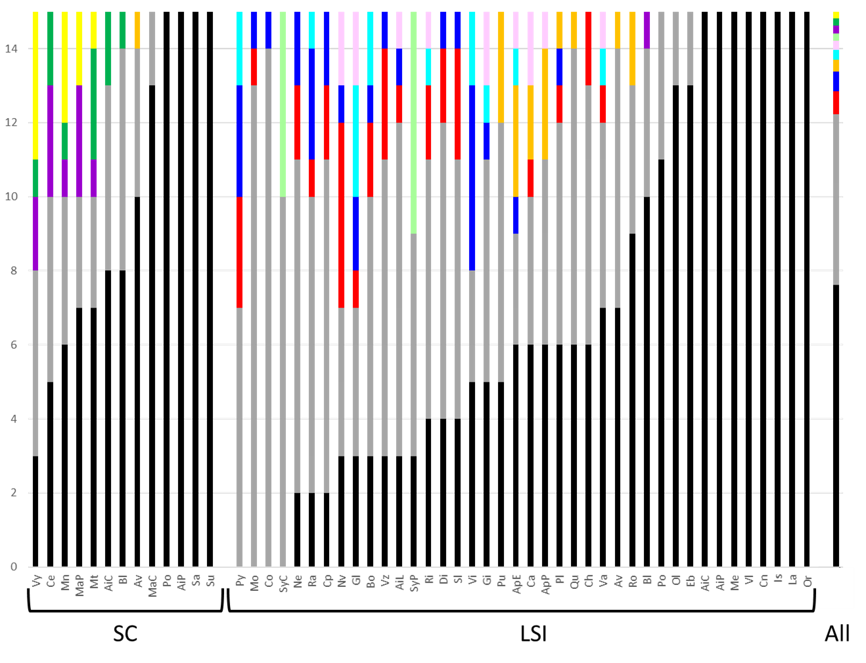

**Figure 1:** Distributions of Multi-Locus Genotypes (MLGs) among LSI and SC *Lgh* populations in western Europe. In black, the number of unique MLGs; In grey, the number of MLGs with less than 7 ramets; In color, MLGs with more than 10 ramets found in multiple populations. Proportions of each MLGs over all the populations are plotted in the last right bar (All). More than half the samples are unique genotypes.

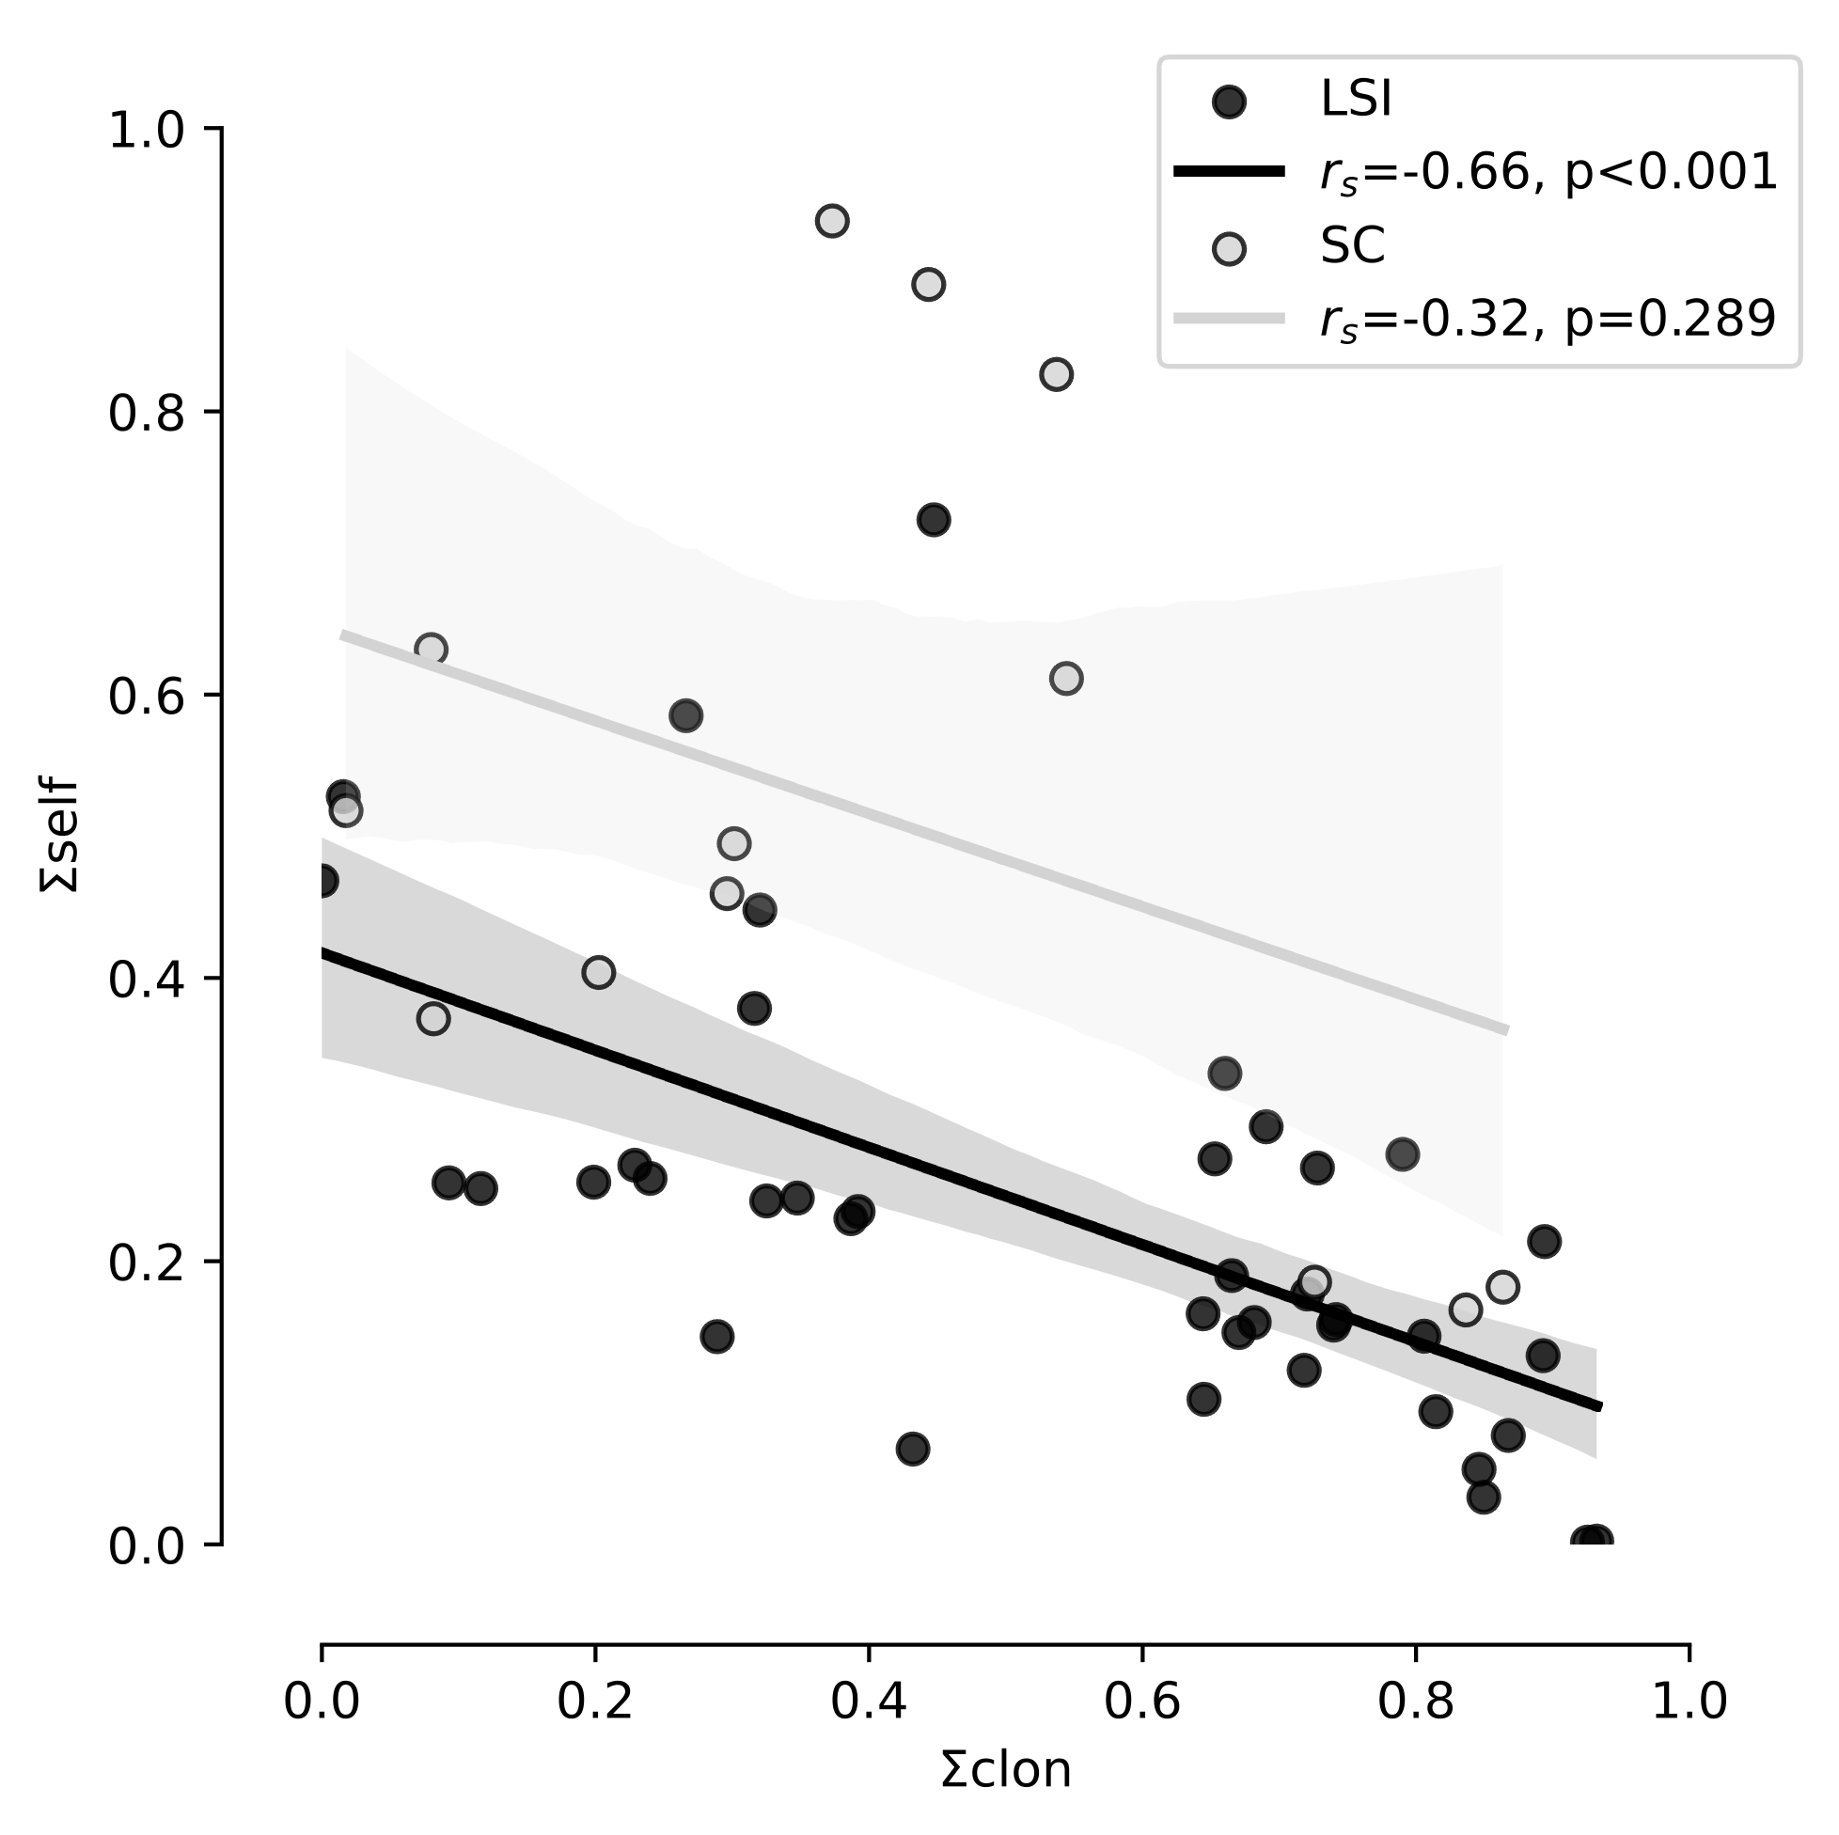

**Figure 2:** Correlations between ΣCLON andΣSELF found in 13 SC populations (light grey points and regression line) and 40 LSI populations (black points and regression line). 95% confidence intervals are given for LSI and SC populations in dark grey and light grey, respectively. Spearman rank-order correlation coefficients (rs) and probabilities that ΣCLON andΣSELF would not be correlated (p) are reported for LSI and SC populations.

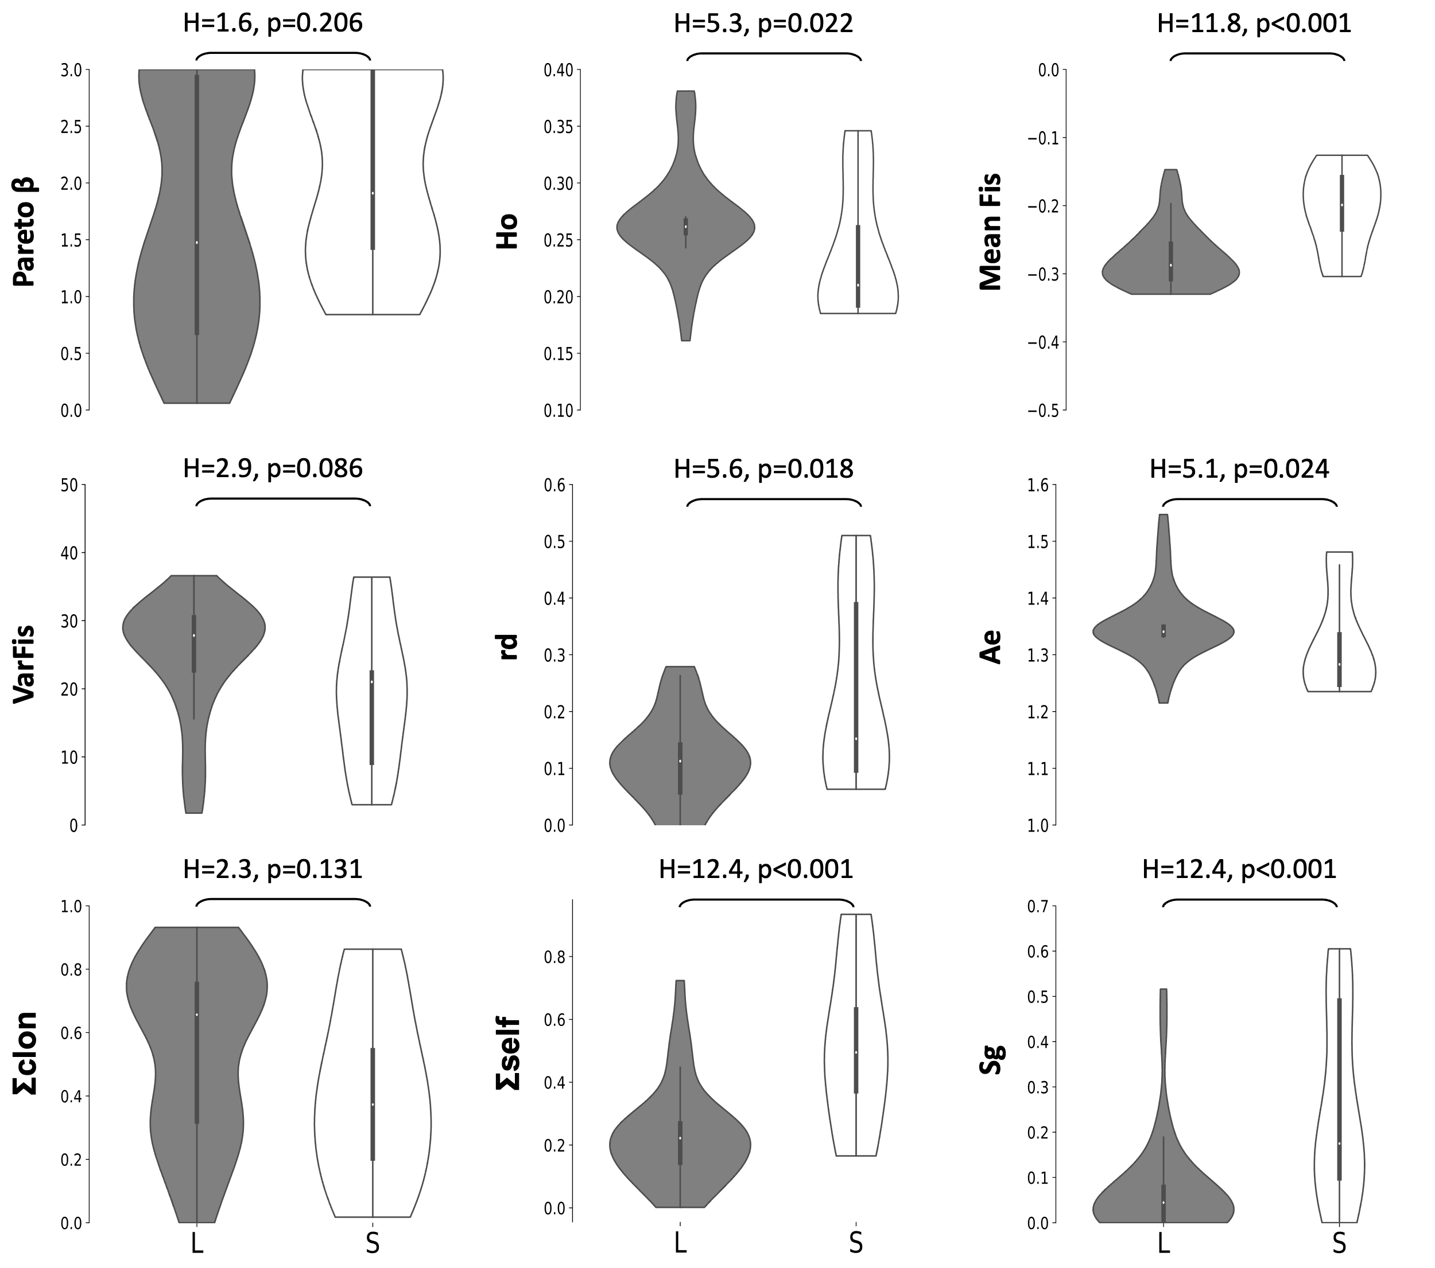 **Figure 3:** Violin plots comparing distributions of genetic indices in LSI (L, grey) versus SC (S, white) populations. Violin plots are cut for their minimum and maximum values. Kruskall-Wallis tests are reported as H-statistics as well as the probability that LSI and SC population would present the same distribution of genetic indices.

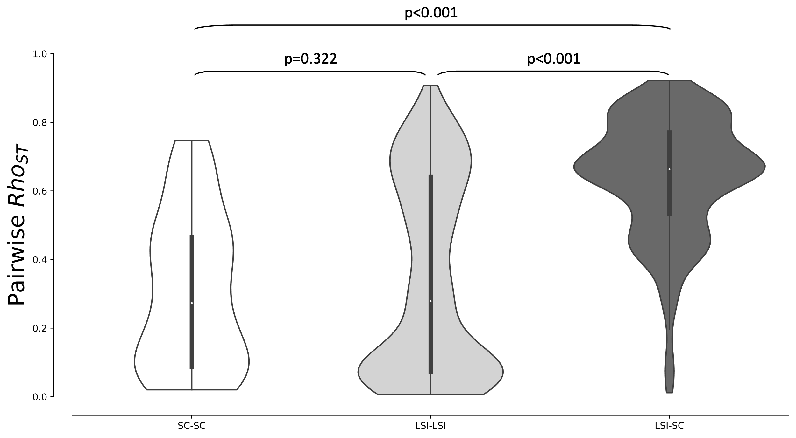 **Figure 4:** Distributions of pairwise rhost within pairs of SC populations (white violin plot), pairs of LSI populations (light grey violin plot) and between pairs of LSI and SC populations (dark grey violin plot). Probabilities that pair of non-parametric distributions are equal are reported.

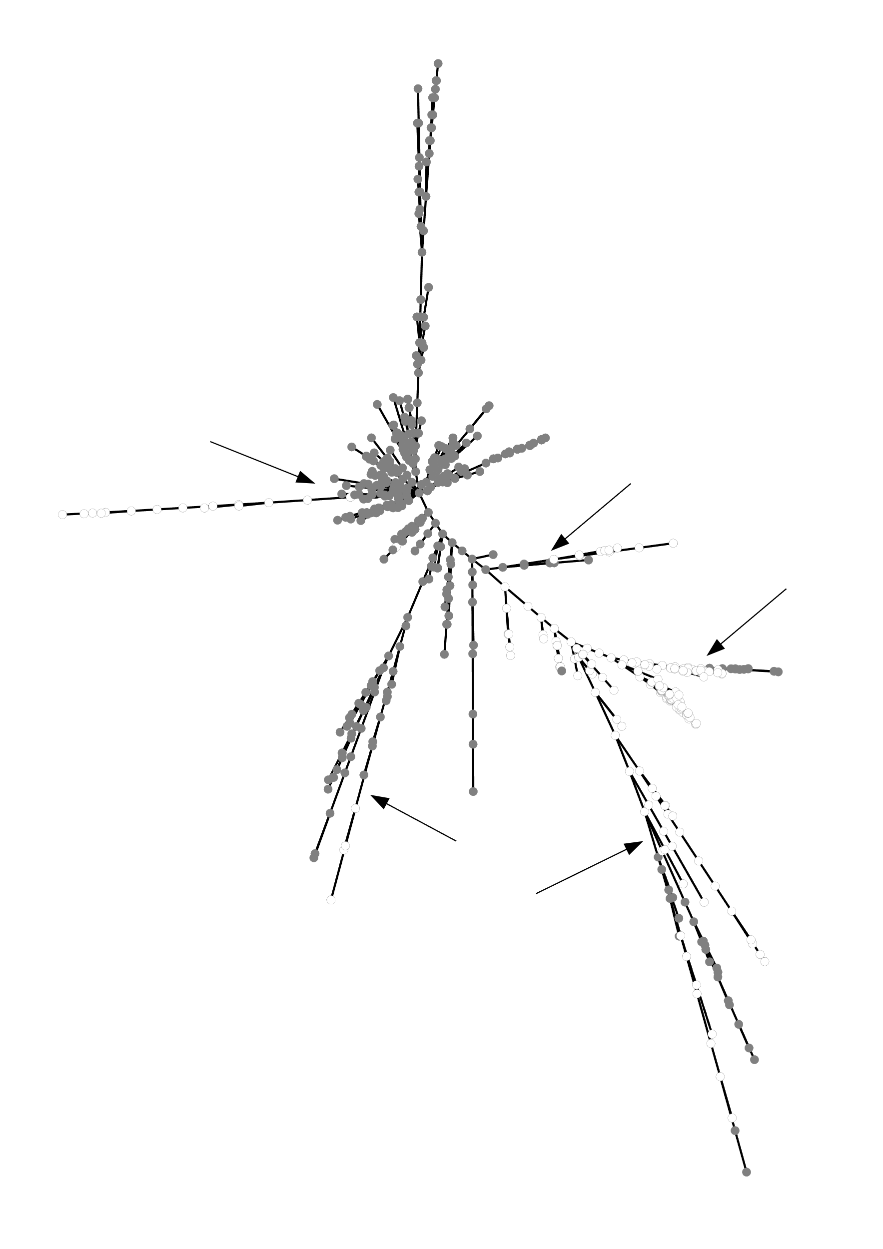**Figure 5:** Minimum spanning tree of the genetic distances (number of different alleles) between LSI (grey points) and SC (white points) individuals. Arrows indicate some of the evidences of admixture between LSI and SC lineages.

**Supplementary Information (SI)**

|  |
| --- |
| **Situation of *Lgh* in USA and Mediterranean populations in previous studies** (Dandelot 2004, Okada et al. 2009, Armitage et al. 2013):  - nearly monoclonal populations arguing for the ecological advantage of clonality (fragmentation and rhizome propagation) in these invasive populations.  But  - using weakly polymorphic markers,  - before the demonstration of the heterostyly and of the Late-acting self-incompatibility system in *Lgh*  **Situation of *Lgh* in western Europe, studied here:**  - Spatial context: The other compatible type populations are away from hundreds of meters to several kilometers (Portillo-Lemus et al. 2021)  - Clonality through fragmentation and rhizomes, as in other populations (Portillo-Lemus 2021).  - Massive blossoming with a lot of pollinators harvesting flowers (Portillo-Lemus 2021).  - Faster pollen tube elongation of pollen from the other compatible type (Portillo-Lemus et al. 2022)  **Our working hypotheses about the main, realized reproductive modes in population:**   * **LSI populations:** A very limited production of seeds (Portillo-Lemus et al. 2021)   Hypothesis 1: **preferential clonality** due to lack of compatible partners to produce seeds 🡪 Baker’s conjecture on reproductive modes (Pannell et al. 2015).  Hypothesis 2: The rare seeds really contribute to the populations 🡪 biological feature of seeds or recombination would have advantage over clones. If so, are they mainly:  **Selfed seeds** 🡪 reproductive assurance and advantage of recombination over clonality in a uniparental context?  **Outcrossed seeds** 🡪 advantage of outcrossed seeds due to heterosis and/or recombination despite the lack of locally-available compatible partners 🡪 selection of long pollination ranges   * **SC populations:** Production of a lot of seeds in natural populations   Hypothesis 1: despite a huge production of seeds, **preferential clonality** due to the physiological and/or ecological advantage of clones over seed germination process?  Hypothesis 2: the mass of seeds does contribute to the populations or some evolutionary advantage of recombination in offspring compared to clonal fragmentation and rhizome propagation to adapt local conditions? If so, are these seeds mainly:  **Selfed seeds** 🡪 within uniparental reproduction, biological feature of seeds or genetic recombination would provide advantage over clones?  **Outcrossed seeds** 🡪 Faster pollen tube elongation of pollen from the other type gives real advantage or advantage to allogamy to adapt new local conditions? |

**Supplementary information1:** Synthesis of the questionings of our study to estimate reproductive mode of 53 populations of invasive Lgh using genetic diversity on the autotetraploid part of its genome.

|  |  |  |  |  |
| --- | --- | --- | --- | --- |
| **Genotypic or genetic index** | **Range of values** | **Main driver** | **Behavior** | **references** |
| β* | ϵ [0; +∞] | Rate of clonality | ↘ when c ↗  β → 0 when c → 1 | Halkett et al. 2005, Arnaud-Haond et al. 2007, 2020, Stoeckel et al. 2021 |
| varFIS | ϵ [0; +∞] | Rate of clonality | ↗ when c ↗  VarFIS → 0 when c → 0 | Stoeckel & Masson 2014, Stoeckel et al. 2021 |
| rd | ϵ [0; 1] | Rate of selfing | slightly ↗ when c ↗  ↗ when s ↗  rd → 1 when s → 1 | Weir and Cockerham 1973, Navascues et al. 2010, Halkett et al. 2005 |
| HO | ϵ [0; 1] | Rate of selfing | ↘ when s ↗  HO → 0 when s → 1 | David et al. 2007, Halkett et al. 2005 |
| FIS | ϵ [-1; 1] | Both rates | ↘ when c ↗  FIS → -1 when c → 1  FIS → +1 when s → 1 | Stoeckel & Masson 2014, Balloux et al. 2003, Stoeckel et al. 2021 |
| HE | ϵ [0; 1] | Rate of selfing | ↘ when s ↗  HE → 0 when s → 1 | Glémin et al. 2001, Ritland & Ganders 1987 |
| PID-SIB | ϵ [0; +∞] | Both rates | ↘ when c ↗  ↘ when s ↗ | Waits et al. 2001 |
| Sg** | ϵ [0; 1] | Rate of selfing | ↗ when s ↗ | David et al. 2007, Hardy et al. 2016 |
| * similar behavior of the clonal richness R  ** inferred values of s, according to the method of Hardy (2016) | | | | |

**Table SI1:** Hypotheses about the influence of clonality and selfing on the expected variations of genetic indices.

**\*see the attached xls file\***

**Table SI2:** All genetic and genotypic indices computed on the 53 sampled populations. Each index was obtained from 15 individuals sampled in each population. (See spreadsheet supplementary material).

|  |  |  |
| --- | --- | --- |
| **Population with missing genotype** | **nb_missing_genotypes** | **nb_individuals_concerned** |
| Bléré_Ls | 1 | 1 |
| Chambéon_écopôle_du_Forez | 2 | 2 |
| Le_Port_Ls | 1 | 1 |
| Plougonver_Léguer | 1 | 1 |
| Quevillon | 1 | 1 |
| Rennes_apigné_prairie | 1 | 1 |
| Roost-Warendin | 1 | 1 |
| Saint_Aignan_Couflons_Ls | 1 | 1 |
| Vichy | 1 | 1 |
|  |  |  |
| **Over single SNP genotypes** | **N** | **%age** |
| single SNP genotype P(cad)>70% | 28610 | 0.99965 |
| single SNP genotype P(cad)≤70% | 10 | 0.00035 |
| total | 28620 | 1 |
|  |  |  |
| **Over individuals** | **N** | **%age** |
| nb_individuals_with_full_genotype | 785 | 0.98742 |
| nb_individuals_with_one_missing_genotype | 10 | 0.01258 |
| total | 795 | 1 |

**Table SI3:** Summary of the allele dosage. First subtable lists populations with individual genotyped with at least one individual with missing genotype at one locus. Second subtable reports the frequency of single SNP genotypes with posterior probability of allele dosage strictly superior to 70%. Third subtable reports the frequency of individuals with their 36 SNP genotypes assigned with posterior probability superior to 70%.

**Table SI4:** Distribution of the different repeated Multi-Locus Genotypes (MLGs) found with 36 SNPs among populations considering their mating system (LSI or SC). Figure 1 presents a summarized plot of this table. (See spreadsheet supplementary material).

|  |  |  |  |  |  |  |  |  |  |  |  |  |  |
| --- | --- | --- | --- | --- | --- | --- | --- | --- | --- | --- | --- | --- | --- |
|  | **G** | **HO** | **HE** | **AE** | **R** | **β** | **FIS** | **VarFIS** | **rd** | **PIDSIB** | **Sg** | **Σclon** | **Σself** |
| **G** | - | 0.438 | **0.013** | **0.009** | **\*\*\*** | **\*\*\*** | **\*\*\*** | **\*\*\*** | 0.057 | **0.008** | **0.008** | **\*\*\*** | **\*\*\*** |
| **HO** | 0.076 | - | **\*\*\*** | **\*\*\*** | 0.397 | 0.462 | 0.122 | **0.025** | 0.653 | **\*\*\*** | **0.032** | 0.065 | 0.142 |
| **HE** | **0.244** | **0.742** | - | **\*\*\*** | **0.01** | **0.014** | 0.212 | **\*\*\*** | **0.026** | **\*\*\*** | 0.844 | **\*\*\*** | 0.372 |
| **AE** | **0.255** | **0.722** | **0.82** | - | **0.008** | **0.013** | 0.353 | **\*\*\*** | 0.094 | **\*\*\*** | 0.347 | **\*\*\*** | 0.845 |
| **R** | **0.991** | 0.083 | **0.251** | **0.258** | - | **\*\*\*** | **\*\*\*** | **\*\*\*** | 0.052 | **0.007** | **0.005** | **\*\*\*** | **\*\*\*** |
| **β** | **0.91** | 0.071 | **0.238** | **0.24** | **0.919** | - | **\*\*\*** | **\*\*\*** | 0.126 | **0.009** | **0.004** | **\*\*\*** | **\*\*\*** |
| **FIS** | **0.602** | -0.144 | 0.116 | 0.086 | **0.603** | **0.557** | - | **\*\*\*** | **\*\*\*** | 0.163 | **\*\*\*** | **\*\*\*** | **\*\*\*** |
| **VarFIS** | **-0.579** | **-0.209** | **-0.435** | **-0.346** | **-0.589** | **-0.551** | **-0.626** | - | **\*\*\*** | **\*\*\*** | **\*\*\*** | **\*\*\*** | **\*\*\*** |
| **rd** | 0.187 | 0.042 | **0.207** | 0.156 | 0.19 | 0.148 | **0.432** | **-0.365** | - | **0.021** | **\*\*\*** | **0.006** | **\*\*\*** |
| **PIDSIB** | **0.259** | **0.729** | **0.981** | **0.833** | **0.265** | **0.251** | 0.13 | **-0.443** | **0.214** | - | 0.936 | **\*\*\*** | 0.286 |
| **Sg** | **0.264** | **-0.202** | -0.019 | -0.089 | **0.277** | **0.28** | **0.542** | **-0.379** | **0.353** | -0.008 | - | **\*\*\*** | **\*\*\*** |
| **Σclon** | **-0.79** | **-0.171** | **-0.376** | **-0.347** | **-0.799** | **-0.809** | **-0.604** | **0.756** | **-0.254** | **-0.387** | **-0.34** | - | **\*\*\*** |
| **Σself** | **0.388** | **-0.136** | 0.083 | 0.018 | **0.399** | **0.361** | **0.723** | **-0.524** | **0.631** | 0.099 | **0.69** | **-0.451** | - |

**Table SI5:** Correlations between genetic indices using non-parametric Kendall partial rank-order correlation. Below the diagonal, the values of the coefficient of correlation τ are consigned. Above, the related p-values are provided. Values inferior to the threshold 0.05, and the related coefficient τ were bold. The parameters ΣCLON and ΣSELF correspond to the sum of normalized indices sensitive to clonality and selfing, respectively.

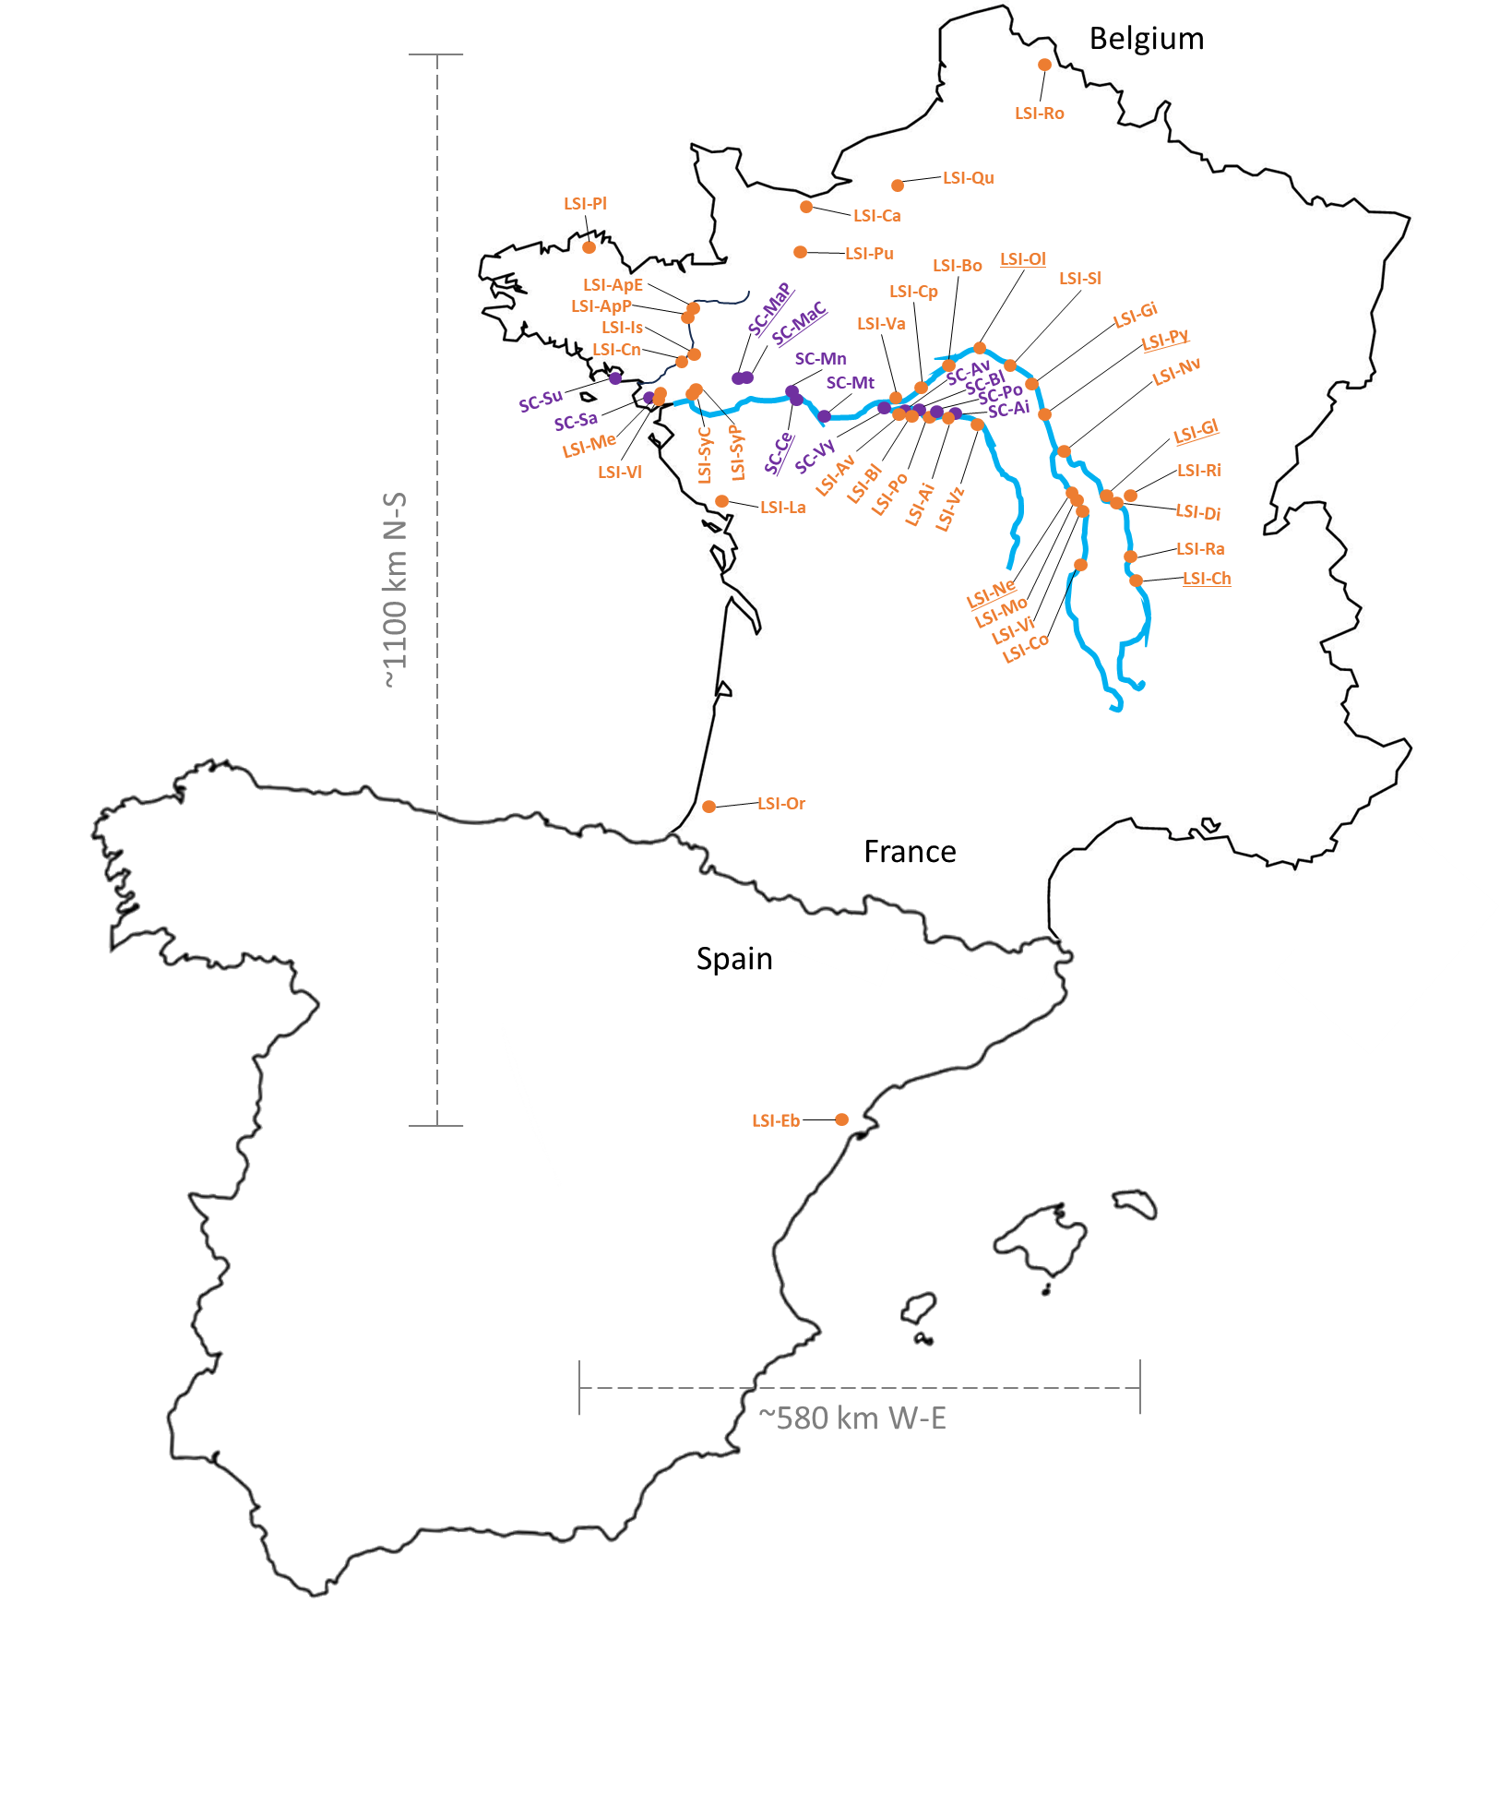

**Figure SI1:** Map of the locations of the 53 sampled populations across France and Spain. In orange, populations with only L-morph individuals, supposed to mate under the control of a late-acting self-incompatible (LSI); In purple, populations with only S-morph individuals, supposed to be self-compatible (SC). In light blue, the Loire river system. In grey, the North-to-South (N-S) and West-to-East (W-E) scale distances of the sampled populations. Underlined, the seven populations in which 15 individuals were tested for the self-incompatibility (Portillo-Lemus et al. 2021) and one individual was karyotyped to count the chromosome numbers.

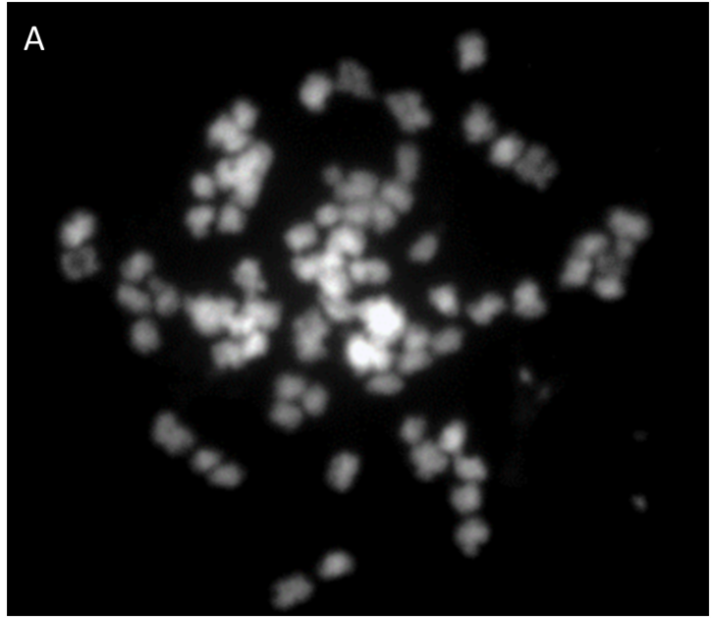

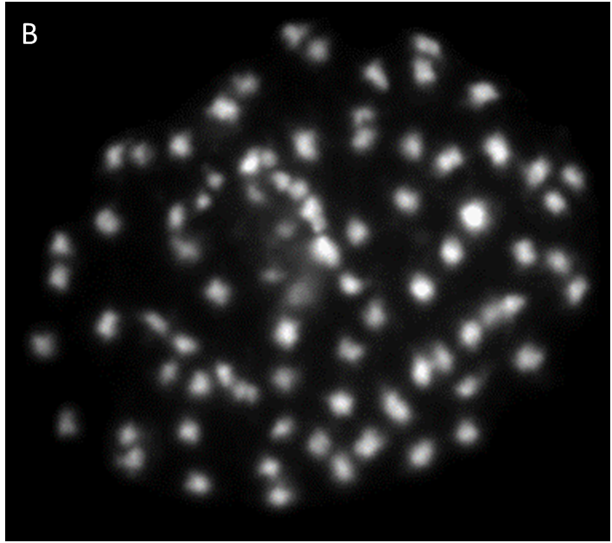

**Figure SI2:** Photos of somatic metaphase chromosomes indicating that L- and S-morph individuals that succeed to mate and to give full fruit set and 100% viable first- and second-generation descendants (Portillo-Lemus et al. 2021) also present the same number of chromosomes (2n=10X=80), belonging to the same taxon *Ludwigia grandiflora* subsp. *hexapetala*. We still didn’t find *Ludwigia grandiflora* subsp. *grandiflora* karyotype in France (2n=6X=48, see Dandelot 2005, Barloy et al. 2024). **A**: somatic metaphase chromosomes from L-morph (2n=10X=80); **B**: somatic metaphase chromosomes from S-morph (2n=10X=80).

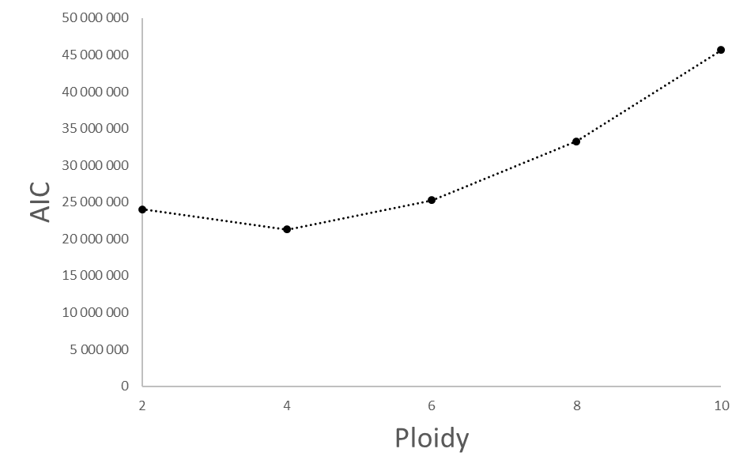

**Figure SI3:** Akaike’s information criterion (AIC) as function of the ploidy level on the likelihoods of the sequenced allele countings over all individuals. Tetraploidy, a ploidy 4x, presents the lowest AIC, and thus the best supported model to explain distribution of sequenced allele countings over all individuals, which confirm our initial SNP development to be sure of their ploidy level.



**Figure SI4.A:** Correlation circles of the principal component analysis on the 17 centered and scaled genetic indices measured in 53 *Lgh* populations in western Europe. The first horizontal dimension accounting for 50.24% of the variance regroups indices related to clonality (number of genotypes *G*, genotypic diversity *R*, clonal heterogeneity *D*, clonal evenness *Beta_Pareto*, variance of Fis *varFis*, variance of expected heterozygosity *varHe*, variance of observed heterozygosity *varHo* and variance of effective number of alleles varAe between loci). The second vertical dimension accounting for 23.39% of the variance with a main contribution of estimate of selfing Sg. Other indices, *i.e.*, mean observed heterozygosity *Ho*, mean expected heterozygosity *He*, effective number of alleles *Ae*, inbreeding coefficient *Mfis*, linkage disequilibrium *rd*, standard error of estimate of selfing *SE.Sg*, unbiased probability of identity under panmixia *PIDu* and between sibs *PIDsib*. In blue and dashed lines, the predictions of Σclon (*Sclon*) and Σself (*Sself*) provided as supplementary variables.

** Figure SI4.B:** Bar plot of the genetic index contributions to the first principal component. The expected average contribution *1/(number of genetic indices)* is plotted as the red dashed line. VarFis and indices of genotypic diversity (Pareto , R, G & D) are the main contributors to the first component.



**Figure SI4.C:** Bar plot of the genetic index contributions to the second principal component. The expected average contribution *1/(number of genetic indices)* is plotted as the red dashed line. Estimates of selfing (Sg), mean observed heterozygosity (HO), mean effective number of alleles (AE) and probabilities of identities (pidu and pidsib) are the main contributors to the second component.



**Figure SI4.D:** Plot of the projection of each population onto the two first principal components. SC populations are plotted as red triangles and LSI populations as black diamonds. Concentration ellipses around LSI and SC populations are plotted in black and red, respectively. Barycenters of the two groups are represented as bigger black diamond and red triangle, respectively.

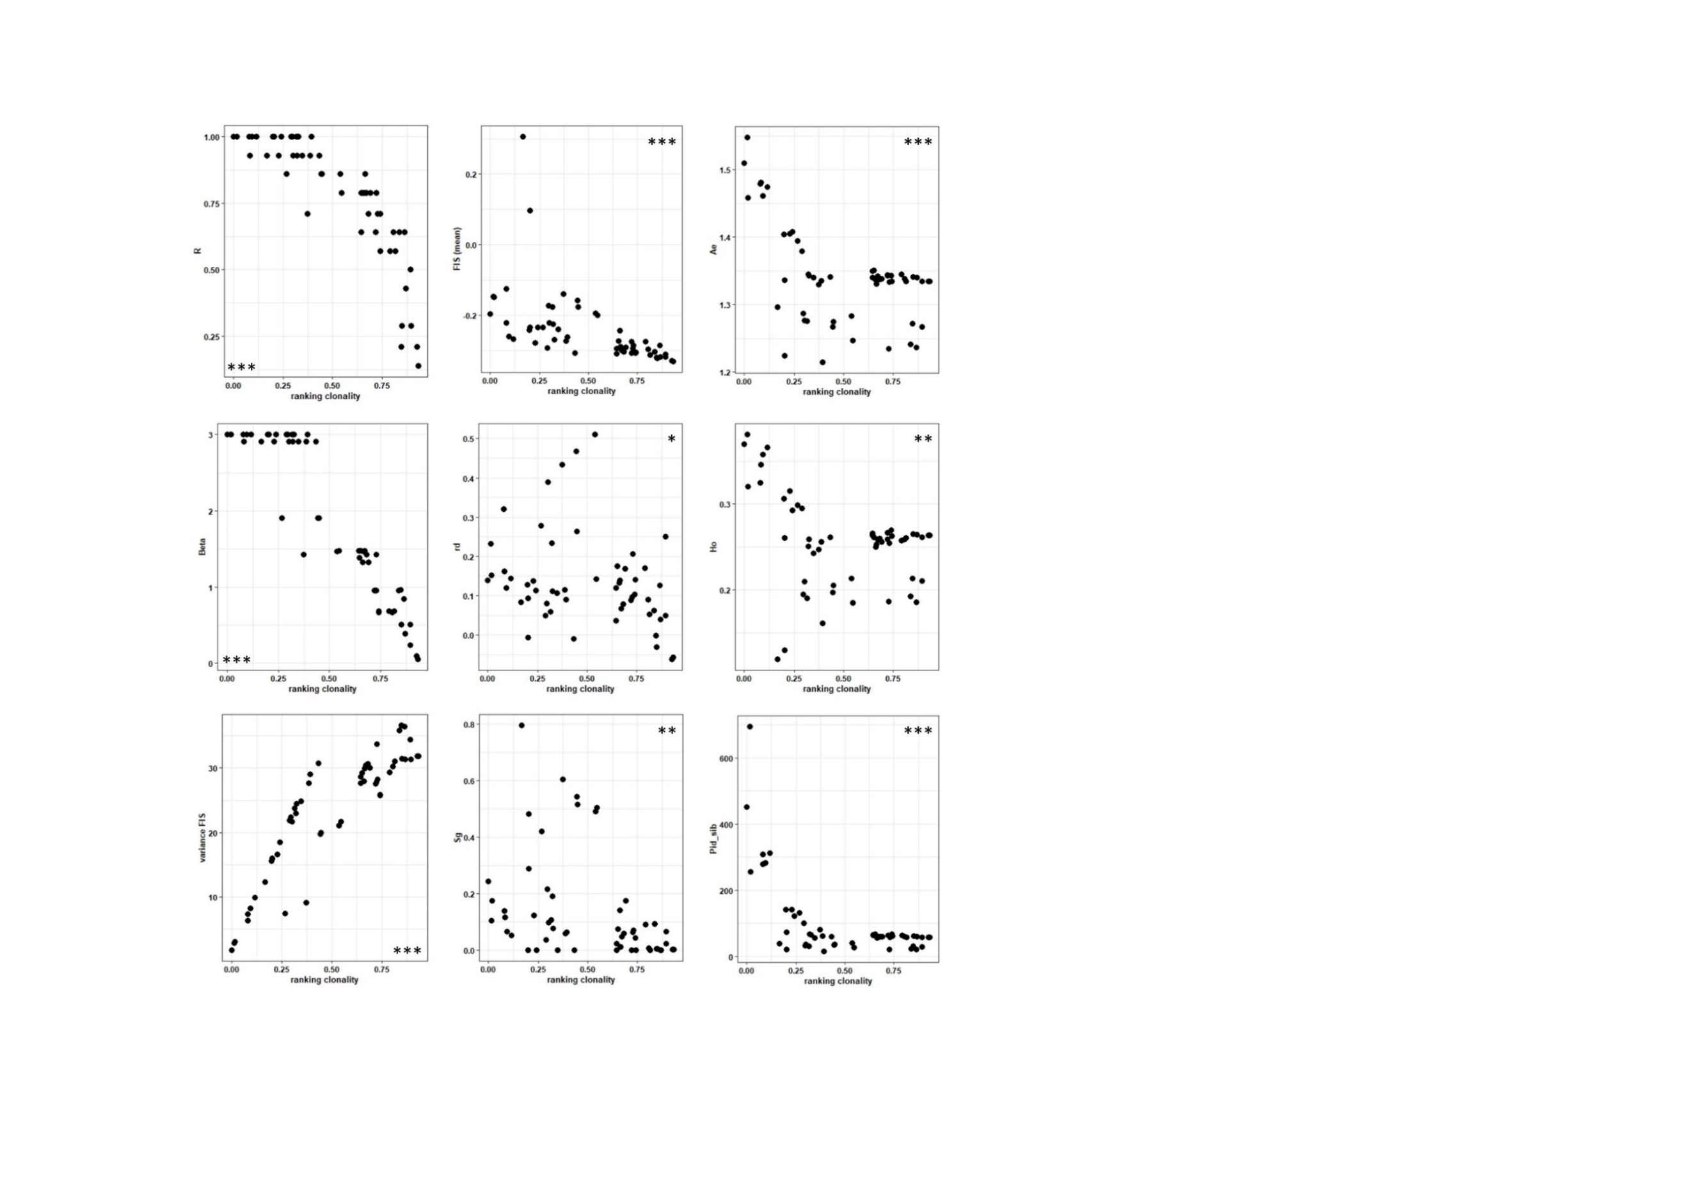**Figure SI5:** Relationship and correlation between ΣCLON and genetic indices (R, Pareto β, MFis, VarFis, Ho, Ae, Sg, pidsib and ${\overline{r}}_{d}$). Per graph, all the 53 populations were plotted as black dots. *: p<0.05, **: p<0.01, ***: p<0.001.

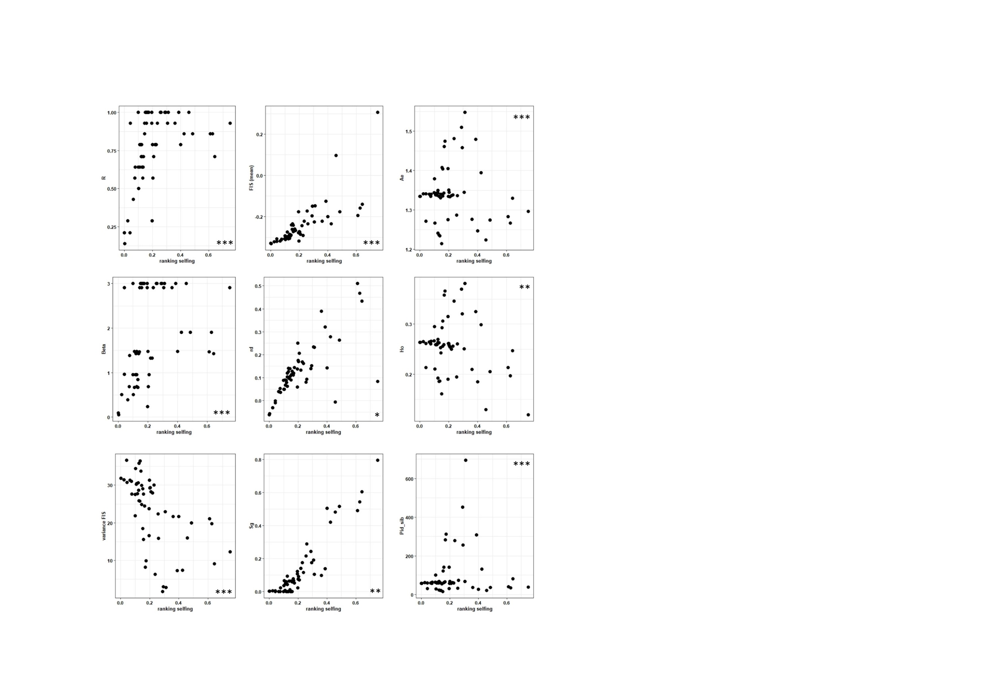

**Figure SI6:** Relationship and correlation between ΣSELF and genetic indices (R, Pareto β, MFis, VarFis, Ho, Ae, Sg, pidsib and ${\overline{r}}_{d}$). Per graph, all the 53 populations were plotted as black dots. *: p<0.05, **: p<0.01, ***: p<0.001.

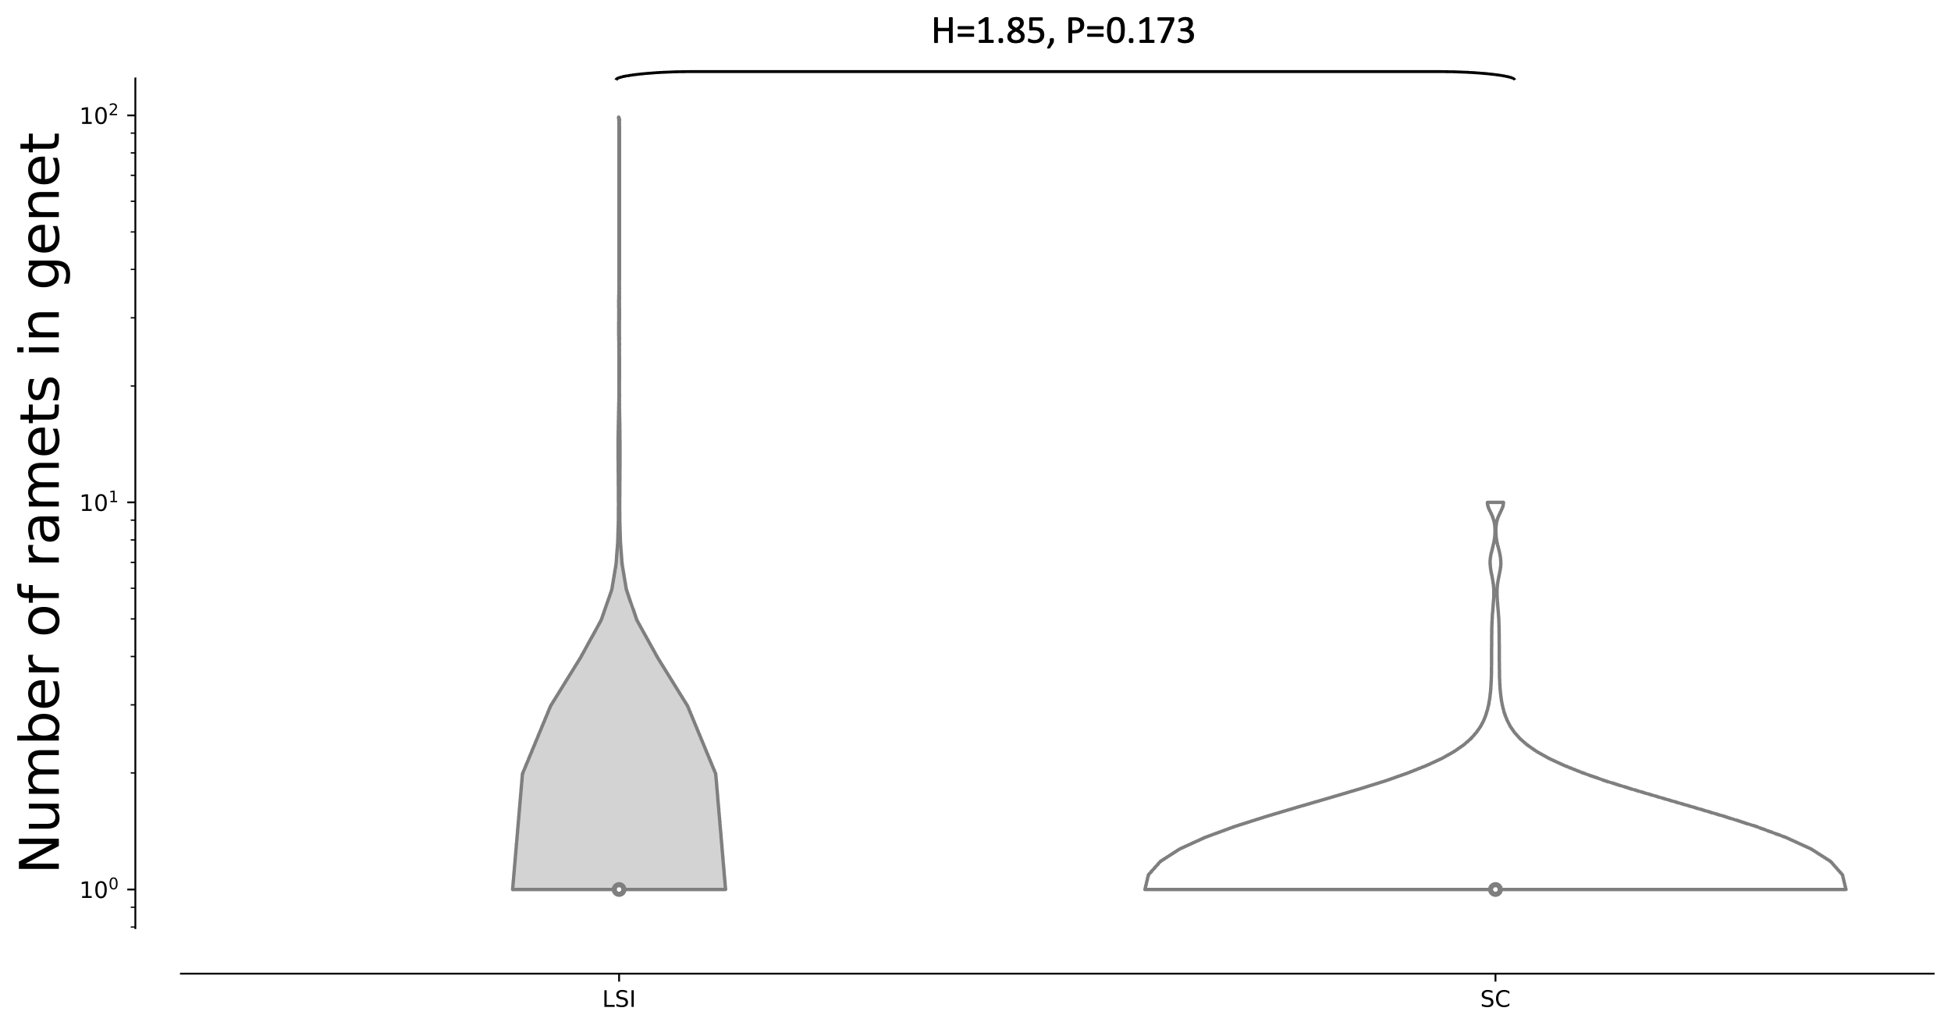

**Figure SI7:** Distributions of the logarithms of the number of ramets per genet in LSI (grey) and SC (white) populations. We report the Kruskal-Wallis probability that the two distributions are identical.

genus

l