Telomere length vary with sex, hatching rank and year of birth in little owls, Athene noctua

François Criscuolo¹, Inès Fache¹, Bertrand Scaar², Sandrine Zahn¹ and Josefa Bleu¹

¹ Université de Strasbourg, CNRS, IPHC UMR 7178, 67000 Strasbourg, France

² Ligue pour la Protection des Oiseaux (LPO) Alsace, 1 rue du Wisch, 67560 Rosenwiller, France

Running title: telomere length in little owl
Key words: telomere, little owl, hatching rank, early-life effects, sex differences
Correspondance: josefa.bleu@iphc.cnrs.fr

Abstract
Telomeres are non-coding DNA sequences located at the end of linear chromosomes, protecting genome integrity. In numerous taxa, telomeres shorten with age and telomere length (TL) is positively correlated with longevity. Moreover, TL is also affected by environmental stressors and/or resource-demanding situations particularly during early-life. Thus, TL has been used as a physiological marker of individual quality and also as an indicator of population trend in conservation physiology. In this study, we investigated the effects of hatching rank, year of birth (2014 to 2017), sex and nest environment on TL of 137 little owls nestlings (Athene noctua). Little owls’ populations in Europe showed a marked declined in the end of the 20th century. Nowadays, in the studied Alsatian population, the population is increasing. In this study, our results indicated that telomeres are longer in females and, independently of sex, in nestlings with the highest body condition. There was also a negative effect of hatching rank but only for last-hatched nestlings in large clutches of 5 nestlings. We did not find any effect of the environmental covariates on nestlings’ TL. Finally, we found that nestlings’ TL were shorter the last year of the study, while nestlings’ body condition stayed unchanged over the same period. This result is intriguing given the local positive population dynamics and is further discussed in the context of physiological conservation. Future studies should investigate the link between reduced TL and survival prospects in this species.

Introduction
Telomeres are non-coding DNA structures, located at the end of the linear chromosomes, serving as a safe-keeper for preservation of coding DNA over cell duplication (Blackburn, 1991). Thanks to the formation of a capped structure with specific shelterin proteins, telomeres help the cell to distinguish real chromosome ends from DNA breaks, thereby avoiding unappropriated cell emergency responses. Still, this telomere status is degrading over time, due to the progressive loss of telomere sequences at each cell division, affecting its functionality and triggering cell senescence (Blackburn, 2000). In addition, telomere sequences are enriched in GC bases, making them highly sensitive to a well-known ageing mechanism, the oxidative stress (von Zglinicki, 2002; Reichert & Stier, 2017; Armstrong & Boonekamp, 2023) (but see Boonekamp et al., 2017). Such a stress-related property triggered the interest of evolutionary biologists to study how telomeres (length or dynamics) may vary with age and thus be used as a proxy to address the question of the existing variance in inter-specific longevity (Haussmann et al., 2003; Dantzer & Fletcher, 2015; Tricola et al., 2018; Criscuolo et al., 2021) or inter-individual differences in lifespan and fitness (Beaulieu et al., 2011; Foote et al., 2011; Boonekamp et al., 2014; Nettle et al., 2017; Bichet et al., 2020; Chatelain et al., 2020; Fitzpatrick et al., 2021; Sheldon et al., 2021; Salmón & Burraco, 2022).
The importance of how early life conditions affect inter-individual telomere length quickly appears as a key question to understand trade-offs between somatic growth and other life history traits (Metcalfe & Monaghan, 2003; Monaghan & Ozanne, 2018). This is based on the observation that growth is a period of high energy metabolism (2-6 times basal metabolic rate, e.g. Kirkwood, 1991) to fuel intense rate of cell division, which is likely to be costly in terms of telomere erosion (Vedder et al., 2017; Spurgin et al., 2018). Studies have shown juveniles exposed to challenging conditions (e.g. stress exposure, competition, food shortage) in early life to have shorter telomeres. This could be due to reduced investment in somatic maintenance (e.g. telomerase activity being considered as the primary mechanism involved or the expression of specific shelterin proteins) as a consequence of low resource availability when conditions are harsh (Herborn et al., 2014; Nettle et al., 2015, 2017; Reichert et al., 2015; Angelier et al., 2017; Quque et al., 2021). Interestingly, telomeres may also be affected during the pre-hatching developmental period. For instance, temperature instability during egg development triggers shorter telomere length at hatching in Japanese quail (Coturnix Japonica, Stier et al., 2020), and decreasing incubation temperature in the common tern (Sterna hirundo) slows down growth rate and preserve telomere length in matched-body sized hatchlings (Vedder et al., 2018). Yet, telomere dynamics are not only affected by stress effects. Producing eggs is costly for the female, and depending on maternal characteristics and environmental conditions, we can expect an adjustment of egg characteristics that will shape consequent embryonic traits (Williams, 1994; Groothuis & Schwabl, 2008). As such, a large diversity of egg components (like yolk and hormones), that may be positively or negatively correlated with each other, may vary and modulate future offspring phenotype (Postma et al., 2014; Williams & Groothuis, 2015). In addition, because an entire clutch is produced over sequential laying of consecutive eggs, intra-clutch variability in egg traits may be part of a mother’s adaptation strategy of the chick’s phenotype, and is then expected to follow the laying order (Groothuis et al., 2005). In particular, according to the brood reduction hypothesis, it is expected that the probability of survival of last hatched nestlings (from last laid eggs) will be smaller than that of first hatched ones in case of harsh conditions (Lack, 1947; Amundsen & Slagsvold, 1996). Thus, we can expect maternal investment to decrease over the laying sequence. Telomere length is not an exception, and progressive shortening has been observed within clutch laying order in captive zebra finches (Taeniopygia guttata, Noguera et al., 2016). In this study, the astonishing result is that the difference in embryonic telomere lengths between the first and the last laid eggs represents 60% of the telomere loss an offspring will show over its first year of life. This source of variation in telomere length may be important to consider since many studies have shown negative consequences of telomere erosion on future individual fitness, e.g. jackdaws (Corvus monedula, Boonekamp et al., 2018), king penguins (Aptenodytes patagonicus, Geiger et al., 2012) or in wild purple-crowned fairy-wrens (Malurus coronatus coronatus, Eastwood et al., 2019), to name a few. Still, we lack data on the effect of laying order in many bird species and on how laying order effect on telomere length may vary in relation to additional stress sources, like environmental conditions in the wild (but see Kärkkäinen et al., 2021).
Our study is based on 4 years of data from a wild population of Little Owl (Athene noctua) reproducing in artificial nestboxes. All nestlings are ringed and measured before fledging. After checking for hatching rank and environmental effects on chick phenotype, we used telomere length measurements made on individual feather sampling to evaluate how nestling telomere length varied with hatching rank and with the local characteristics of nest environment. To do so, we controlled for nestling sex, age, body condition, clutch size and year of birth. To estimate nest environment characteristics, we calculated the proportion of orchards, meadows, crops, buildings, water and forests around each nest box from land use maps. In central Europe, the Little Owl is a bird species associated with traditional farmlands and its optimal habitat should provide cavities, perches for hunting and short herbage with invertebrates and small rodents (herbage size is linked to prey accessibility and availability, van Nieuwenhuyse et al., 2008). In particular, meadows and orchards are supposed to be food-rich habitats (Michel et al., 2017).
We predicted last hatched nestlings to be in worse condition (body mass, telomere length) than first hatched nestlings according to the brood size reduction hypothesis. We also predicted shorter telomeres in broods raised in unfavourable environments, i.e. more proportion of buildings, water and forests around the nest box.

Material and Methods
Model species and data collection
The Little Owl is a small nocturnal raptor living in open or semi-open areas, such as farmland or orchards (van Nieuwenhuyse et al., 2008). The Little Owl is territorial and breeds in cavity, including artificial nestboxes. In Alsace (France), numerous ringers and volunteers from the French league for the protection of birds (LPO) installed and maintained more than 1,500 nest boxes since 2006, thereby monitoring the yearly reproductive success of the local population. Females lay 2-6 eggs in April, hatching occurs ca. 1 month later and nestlings are ringed between 15-35 days of age. At ringing, nestlings’ body mass was measured with an electronic balance to the nearest 0.1 g, as well as tarsus length with a calliper to the nearest 0.1 mm, and the length of the third primary feather with a ruler to the nearest mm. The measure of the feather allows us to approximate the age of the nestling with the formula: age=(length of the feather+36)/3.3, where the age is in days and the length of the feather is in mm (Juillard, 1984; Hameau et al., 2015). This formula is valid between age 15 and 35 when there is a linear growth of the feather. Using the age of each nestling in a nest, the hatching rank was deduced. When two nestling had the same estimated age, we assigned them the same hatching rank. We also collected 3-6 ventral feathers that were stored in ethanol 70% at ambient temperature during fieldwork and then at 4°C in the lab.
For this study, we used data collected on 142 nestlings from 39 broods from 2014 to 2017. All those broods had more than 1 chick (n=3, n=14, n=16, n=6 for broods with respectively 2, 3, 4 and 5 chicks).
Land use around the nestbox
To determine the land use around the nest boxes, we used a land cover database for Alsace (Source: BdOCS CIGAL v2 2011/2012, www.geograndest.fr) which categorizes all the habitats found in our study area. We used the software QGIS version 3.4.14 (QGIS Development Team, 2020) to map the active nest boxes and create a circular buffer zone of a 150 m radius around each one of them. This radius was established thanks to data on home range size (Exo, 1992; Génot, 2005) and the field observations made during the breeding season. Due to the high number of habitats, we made groupings based on the environmental characteristics of each variable to calculate the area (m²) covered by each land type within the buffer zones. Our final nest environment included six categories: (1) buildings, (2) meadows, (3) crops (crop fields, hedges, and vineyard), (4) orchards, (5) forest and (6) water. Because of the rarity of the last two categories, forest and water were pooled together. The surface of habitat of the different categories were correlated with each other and thus we used in the model only the proportion of surface of favorable habitat defined as the proportion of meadows and orchards in the buffer.
Relative telomere length (RTL) measurement and sexing
Genomic DNA was extracted from feathers using an adapted protocol of the NucleoSpin Tissue kit (Macherey Nagel, Düren, Germany). RTL was measured in the 142 nestlings in one 384-wells plate, using the quantitative PCR (qPCR) methodology (see Supplementary Information 1). Intra-plate repeatability of RTL (ICC, see (Eisenberg et al., 2020)) was of 0.769. Molecular sexing of nestlings was determined using the same extracted DNA (following Griffiths et al., 1998). Briefly, the technique is based on the existence of two conserved CHD (chromo-helicase-DNA-binding) genes that are located on the sex chromosomes. The CHD-W gene is located on the W chromosome (only in females) and the CHD-Z gene is located on the Z chromosome (both in males and females). For technical reasons, sex could not be determined in 5 nestlings. All the statistical analyses were performed on the remaining 137 nestlings with known sex.
Statistical analyses
We used R version 4.3.1 (R Core Team, 2023) to compute mixed models (package lme4 version 1.1-33 and lmerTest version 3.1-3). In all statistical models, brood identity was included as a random factor to account for the non-independence of nestlings of the same brood. We checked models’ assumptions (homoscedasticity and normal distribution of residuals) graphically using the package DHARMa (version 0.4.6). We assessed multicollinearity among predictors by calculating variance inflation factor, VIF (package car, version 3.1-2).
Individual phenotypic characteristics
To identify traits shaping inter-individual variation in body condition, we first calculated the Scale Mass Index (SMI) following the formula of Peig & Green (2009): SMI = M_{i} [L₀/L_{i}]^{b} where M_{i} and L_{i} are the body mass and size measurements of individual i, b is the slope of the standardised major axis (SMA) regression of log-transformed M on log-transformed L and L₀ is the arithmetic mean of L for the study population. We then computed a linear mixed model with SMI as a dependent variable and hatching rank, sex, nestling number, nestling age, cohort, the proportion of meadows and orchards, the interaction between hatching rank and sex, and the interaction between hatching rank and the proportion of meadows and orchards as fixed effects. Hatching rank, sex and cohort are categorical covariates. From this global model, we fitted every possible model and then selected a set of top models (AICc threshold of 2). Then, if the null model was not the best model, we averaged the models from these top models set (conditional average, package MuMIn, version 1.47.5).
Inter-individual variation in Relative Telomere Length
RTL were log-transformed before analyses. We computed a linear mixed model with individual covariates (hatching rank, sex, the interaction between hatching rank and sex, nestling number, nestling age, SMI and cohort) and environmental covariates (the proportion of meadows and orchards, the interaction between hatching rank and this proportion) as fixed effects. The model selection procedure was the same as described above.

Results
Individual phenotypic characteristics
Concerning individual covariates, there were no significant variables that explained variation in SMI in our models. The fixed effects retained in the top models set (5 models) were the proportion of meadows and orchards, nestling number and sex (see Table S1) but their effects were not significantly different from 0 (see Figure S1). This is consistent with the fact that the null model was in the top models set (see Table S1).

Figure 1. Forest-plot of estimates for the average model of relative telomere length and individual covariates (see Table S2 and Table 1). Reference level for sex is females, for cohort is 2014 (the first year of the study) and for rank is 5 (last hatched chicks). Significance levels are annotated with asterisks: *** p<00.1,**p<0.01,*p<0.05, . p<0.10
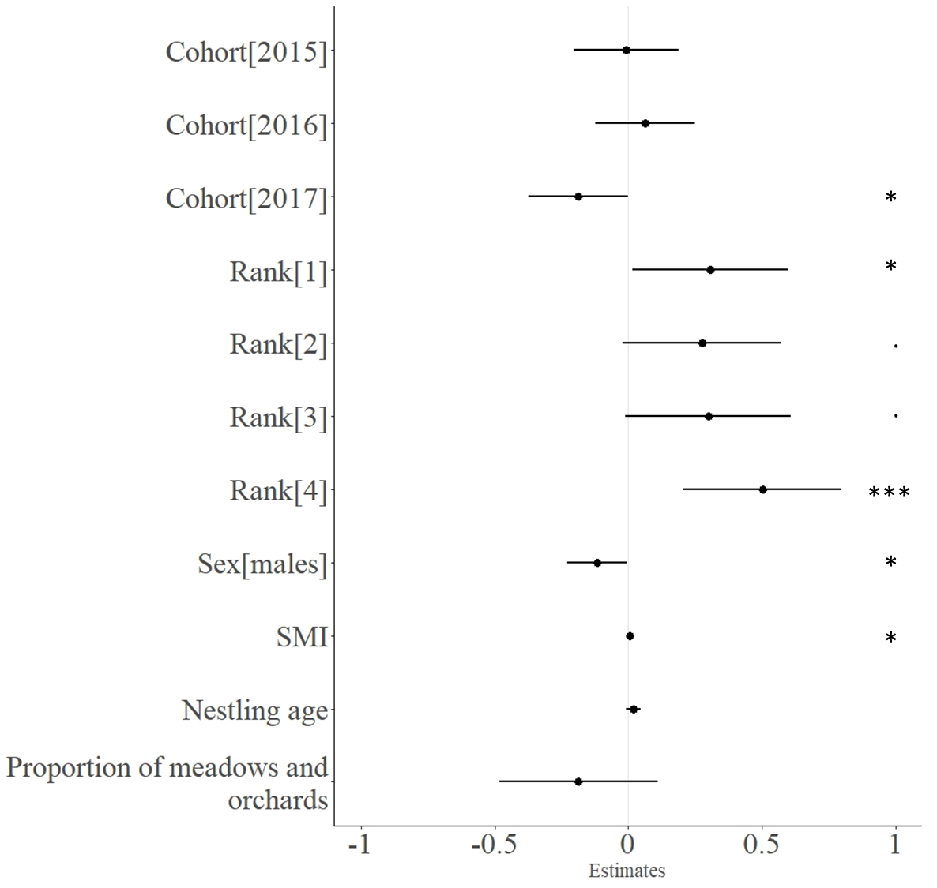

Inter-individual variation in Relative Telomere Length (RTL)
Concerning individual covariates, RTL was not dependent on nestling number and there was no interaction between rank and sex, or between rank and the proportion of meadows and orchards. The variables in the top models set (6 models) were rank, sex, SMI, cohort, nestling age and the proportion of meadows and orchards (Table S2, Figure 1). Males have significantly shorter telomeres than females and there is a small significant positive effect of SMI on RTL (Figure 1, Table 1). In addition, last hatched nestlings have shorter telomeres but only in the largest brood of 5 nestlings (Figures 1 and 2, Table 1). The effect of the year of birth is significant for the last year of study, meaning that individuals born in 2017 have shorter telomeres than individuals born earlier (Figures 1 and 3, Table 1). Concerning environmental covariates, the proportion of meadows and orchards was kept in the best model but has no significant effect on RTL (Figure 1, Table 1).
Table 1. Estimates and confidence interval (CI) for the average model of relative telomere length and individual covariates (see Table S2 and Figure 1). Reference level for sex is females, for cohort is 2014 (the first year of the study) and for rank is 5 (last hatched chicks).
 | Estimate | Lower value (CI 95%) | Upper value (CI 95%)
Cohort[2015] | -0.0088 | -0.20 | 0.19
Cohort[2016] | 0.063 | -0.12 | 0.25
Cohort[2017] | -0.19 | -0.37 | -0.0014
Rank[1] | 0.31 | 0.014 | 0.60
Rank[2] | 0.27 | -0.022 | 0.57
Rank[3] | 0.30 | -0.012 | 0.61
Rank[4] | 0.50 | 0.21 | 0.80
Sex[males] | -0.12 | -0.23 | -0.0038
SMI | 0.0049 | 0.00058 | 0.0093
Nestling age | 0.019 | -0.0087 | 0.047
Proportion of meadows and orchards | -0.19 | -0.48 | 0.11

Figure 2. The effect of hatching rank on the relative telomere length before fledging (unadjusted data). Note that positive estimates correspond to longer telomeres, negative estimates to shorter telomeres.

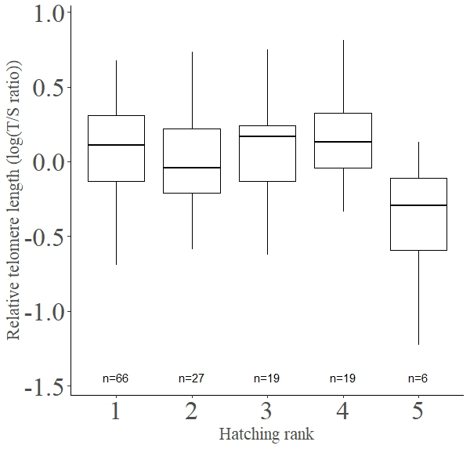

Figure 3. The effect of the cohort on the relative telomere length before fledging (unadjusted data).

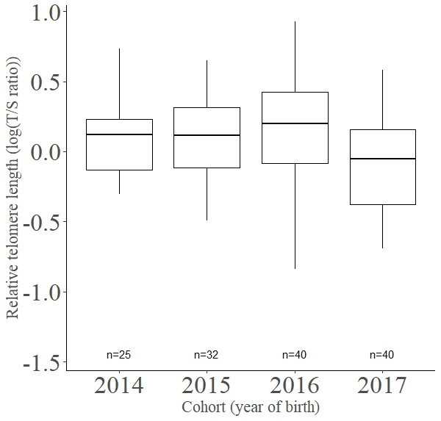
Discussion
Based on the current knowledge on growth and telomeres in bird nestlings, we initially predicted that RTL of little owl nestlings will be: (i) negatively related to the hatching rank and (ii) negatively affected by the unfavourable nature of the nest surroundings. Our results indicated that RTL are longer in females and, independently of sex, in nestlings with the highest body condition. They also supported a mixed negative effect of hatching rank and intra-brood competition on little owl nestlings’ RTL, i.e. detectable only in the largest brood size, suggesting that the effect of hatching rank on telomeres is dependent on a threshold effect in this species. We did not find an effect of the environmental covariates on nestlings’ RTL. Finally, our scan of nestlings’ RTL over years surprisingly underlined a possible progressive shortening, independent of any changes in body condition.
Little owl nestlings’ RTL were shorter in the last year of the study (2017) in comparison to previous years (2014 onwards). Both telomere data and such year effect are of great interest in the context of conservation physiology aiming at developing physiological markers of individual quality to infer consequences at the population level (Beaulieu & Costantini, 2014; Lea et al., 2018). Telomeres are good candidate to be such marker because telomere length at a given age is not reflecting only the negative effects of time on the cells (i.e. chronological age), it also points out the cumulative effects of stressors encountered over time that may accelerate the loss rate of telomere ends over the expected rate at a given age for a given species (Asghar et al., 2015; Louzon et al., 2019; Chatelain et al., 2020; Salmón & Burraco, 2022). Thus, the use of telomere assay is potentially providing data that are useful to establish survival rates at specific age stages, like the nestling period. Since deleterious environmental conditions can affect negatively telomere length, the period of growth is supposed to be the life stage where telomere sequences can be the most impacted (Salomons et al., 2009; Young et al., 2013; Monaghan & Ozanne, 2018). Besides the classical explanation that the growing period is particularly sensitive to environmental stressors because the cell division rate and/or the oxidative metabolism are higher in a growing organism, it is likely that chicks can just hardly escape the trade-off between growth and survival. As such, sustaining a fast (but not too fast, see below) rate of growth to shorten as much as possible the nestling period may be done at a cost for telomere length. Thus, depending on the harshness of early life environment, the erosion of telomeres can be accelerated for a given age (e.g. Boonekamp et al., 2014; Stier et al., 2015), leading the fledglings to be grown physiologically old. In addition, variation in growth rate, due to changes in food availability, may affect telomere length and not body mass or body condition. As an example, growth rate may accelerate after a stunt when optimal feeding conditions are re-established, which are known to trigger transient over-optimal compensatory growth rate and faster telomere erosion (Metcalfe & Monaghan, 2001; Geiger et al., 2012). This has, theoretically, obvious consequences for the individuals in terms of survival prospects and recruitments as adult breeders in the population, as early life telomere length or rate of telomere loss have been shown to predict future individuals’ survival (Boonekamp et al., 2014; Watson et al., 2015; Wood & Young, 2019). Consequently, it also has the potential to affect the population dynamics. First conceptualized few years ago (Stindl, 2004), such a hypothesis was recently supported by studies conducted on ectotherms’ populations (Dupoué et al., 2017, 2022). In the common lizard populations studied, analysis of telomere length in yearlings of populations showing different risks of collapsing due to local global warming, pointed out reduced mean telomere length in the most endangered populations (Dupoué et al., 2017). Thereafter, the same group showed that short telomeres were already inherited in neonates of declining populations, thereby suggesting (epi)genetic roots, i.e. progressive telomere shortening being not only the result of bad early life conditions (Dupoué et al., 2022). We cannot draw the same conclusions in our case, particularly because (i) our data indicate that 2017 was the only year with shorter telomeres and (ii) we lack data on inter-generational variation of telomere length. It can be noted that in vertebrates, heritability estimates are moderate (Chik et al., 2022), but this recent meta-analysis has no data on raptors (Chik et al., 2022). In addition, as low rates of recruitments of juveniles as first-breeders is an important determinant of population decline in the little owl (Le Gouar et al., 2011), the link between reduced telomere length and survival prospects of nestlings needs to be established. Finally, this result is counter-intuitive in our study population of little owl since the population is expanding and not decreasing (Bersuder & Wassmer, 2020), contrary to other populations (Andersen et al., 2017). Whether 2017 is a transient year with unknown bad conditions for chicks or is actually the start of a longer adverse period for our population is currently unknown. Thus, the effects of yearly variations in food availability, intra-nest competition or density on telomere length need to be addressed in future studies.
Little owl female nestlings had longer telomeres than male ones. This has several implications for our understanding of sex-differences in telomere dynamics and of its meaning in terms of sex-biased life history. Differences in telomere length in relation to sex has been previously illustrated in several taxa (reviewed in Barrett & Richardson, 2011), and particularly in birds with sex-biased body size or investment in reproduction, producing no consistent male-female differences (e.g. Caprioli et al., 2013; Remot et al., 2020; Saulnier et al., 2022 for no sex differences) (e.g. Bauch et al., 2020 for sex differences). In our study, sex-differences in RTL were observed at the nestling stage, with longer telomeres in the females. A previous study showed that females were slightly but consistently of bigger size (Tschumi et al., 2019), however it is not the case in our population. Yet, we did not investigate nestlings growth rates, which can be different even if the final size and/or body mass is similar (e.g. Criscuolo et al., 2008). Higher growth rates are usually associated with shorter telomeres (Geiger et al., 2012; Monaghan & Ozanne, 2018) and generally the larger sex is growing at a slower rate in sexually dimorphic bird species (e.g. Teather & Weatherhead, 1994). This may potentially account for our sex-difference in telomere length as females may dilute the growth-body maintenance trade-off over a longer period. However, we also found that, independently of sex, nestlings in better body condition had in general longer telomeres. Thus, it is either unlikely that little owl nestlings had to face such a growth-body maintenance trade-off, or that our result is driven by high quality individuals that can sustain growth without showing any associated cost in terms of telomere loss. Given that body mass is a determinant of survival from hatching to fledging in little owl (Tschumi et al., 2019), nestling telomeres rather acts as a proxy of individual quality (Angelier et al., 2019). In addition, our results do not match with the idea that the heterogametic sex (i.e. females) would be more prone to telomere erosion than the homogametic one (i.e. males) due to the unguarded expression of deleterious alleles of sex chromosomes for telomere maintenance (see Barrett & Richardson, 2011; Remot et al., 2020 for a deep discussion related to telomere dynamics). One alternative explanation lies on optimal parental care towards the offspring sex with the highest chance of survival in a given year (Hasselquist & Kempenaers, 2002). It has been shown previously that females have a higher survival probability from hatching to fledging, independent of any variation in body mass (Tschumi et al., 2019). However, it is not known whether this sex-difference persists in older individuals or is consistent over the years. In that context, the parents would favour female individuals when rearing conditions are unfavourable, meaning that within little owl broods females may, on average, benefit from better access to food resources due to specific parental investment. This may lead to an attenuated body maintenance (i.e. telomere length) and growth rate trade-off over the course of our study. Still, further study in our case is needed to determine whether adaptive brood sex ratio actually occurs, since it may result from non-adaptive additional effects (e.g. sex specific mortality, see Bortolotti, 1986; Hasselquist & Kempenaers, 2002).
The hypothesis that RTL is an indicator of quality is further supported by the fact that, in the largest clutches, the last hatchling of little owl presented the shortest telomeres. Even if our sample size is small (i.e., 6 clutches with 5 nestlings), our data are in accordance with the brood size reduction hypothesis that predicts a lower investment with laying order. Still, our data would restrict such an effect to the last laid egg. We cannot distinguish between effects of the laying order per se on RTL (see introduction) and postnatal effects. Postnatal effects may arise from selective parental care as discussed above. Last-hatched nestling may also suffer from intra-brood competition. Indeed, in a brood, larger nestlings have a competitive advantage compared to smaller nestlings for feeding (“Competitive advantage hypothesis”, Anderson et al., 1993). A previous experiment testing the effect of competitive disadvantage within a brood, based on the size of the nestlings cross-fostered among clutches, highlighted an interesting increased telomere attrition of less competitive nestlings without affecting body mass growth (in European starlings, Nettle et al., 2015).
Finally, our study only suggested non-significant effects of nest surroundings. More precisely, and contrary to our predictions, there was a trend for a negative effect of the proportion of meadows and orchards on telomere length. Thus, this does not support that the proportion of meadows and orchards in a fixed home range size is a good proxy for habitat quality. In other studies, local habitat types around nests and also the heterogeneity of habitats available have been shown to affect reproductive output in little owls (Thorup et al., 2010; Michel et al., 2017). Moreover, it has been shown that the home range size is dependent on the environment around the nest and also is different between males and females (Michel et al., 2017). Thus, it may be important to consider the habitat at a finer scale. Future studies should explore how environmental quality, food resources, parental care, chick growth, intra-brood competition and sex-specific susceptibility to stressors are intertwined factors that determine offspring telomere length and how all these factors affect population dynamics of little owls.

Ethics statement. This work is in accordance with the French legislation concerning the capture and the biological sampling of wildlife. All the ringers of the project had received ringing licenses and authorizations for feather sampling from the CRBPO (National Museum of Natural History, Paris, France) as part of a program led by Bertrand Scaar (PP N°454).
Data, script and code availability. Data and R code used in this study are openly available on zenodo (Criscuolo et al., 2023a, https://doi.org/10.5281/zenodo.7701530).
Authors' contributions. JB and FC conceived the study. BS and volunteers collected the data. SZ developed and performed the sexing and qPCR measurements. IF sorted the samples and calculated the land use around nest boxes. JB and FC ran the statistical analyses and, with SZ for the ESM, wrote the first draft of the manuscript. All authors provided comments on the manuscript and agreed on the final version of the manuscript to be submitted for publication.
Conflict of interest disclosure. The authors declare that they comply with the PCI rule of having no financial conflicts of interest in relation to the content of the article.
Acknowledgements. This study would not have been possible without the continuous investment of local bird watchers and the league for the protection of birds (LPO), heavily concerned by the preservation of the Little Owl in Alsace. We wish to thank warmly all of them, and particularly Aurélie Barboiron, Marc Baumann, Jean Baysang, Dominique Bersuder, Jean-Marc Bronner, Jérôme Isambert, Bernard Meurer, Nicolas Minéry, Anne Reszka, Pierre Robellet and Freddy Sturm from the LPO. We also thank Mégane Jeannelle and Emma Jamann for the help with the laboratory analyses. We are also grateful for all the persons that financially supported our study though their donation to the Foundation of the University of Strasbourg.
Funding statement. This work was supported by the CNRS and the Foundation of the University of Strasbourg (https://fondation.unistra.fr/tag/iphc/).
Supplementary Information. The file available online includes (Criscuolo et al., 2023b, https://doi.org/10.5281/zenodo.8405998):
Supplementary information 1: Amplification of telomere repeats using q-PCR methodology
Table S1. Top models set for models of SMI.
Table S2. Top models set for models of RTL.
Figure S1. Forest-plot of estimates for the average model from Table S1.

References
Amundsen, T. & Slagsvold, T. 1996. Lack’s brood reduction hypothesis and avian hatching asynchrony: what’s next? Oikos 76: 613–620.
Andersen, L.H., Sunde, P., Pellegrino, I., Loeschcke, V. & Pertoldi, C. 2017. Using population viability analysis, genomics, and habitat suitability to forecast future population patterns of Little Owl Athene noctua across Europe. Ecol. Evol. 7: 10987–11001.
Anderson, D.J., Budde, C., Apanius, V., Gomez, J.E.M., Bird, D.M. & Weathers, W.W. 1993. Prey size influences female competitive dominance in nestling american kestrels (Falco sparverius). Ecology 74: 367–376.
Angelier, F., Costantini, D., Blévin, P. & Chastel, O. 2017. Do glucocorticoids mediate the link between environmental conditions and telomere dynamics in wild vertebrates? A review. Gen. Comp. Endocrinol. 256: 99–111.
Angelier, F., Weimerskirch, H., Barbraud, C. & Chastel, O. 2019. Is telomere length a molecular marker of individual quality? Insights from a long-lived bird. Funct. Ecol. 33: 1076–1087.
Armstrong, E. & Boonekamp, J. 2023. Does oxidative stress shorten telomeres in vivo? A meta-analysis. Ageing Res. Rev. 85: 101854.
Asghar, M., Hasselquist, D., Hansson, B., Zehtindjiev, P., Westerdahl, H. & Bensch, S. 2015. Hidden costs of infection: Chronic malaria accelerates telomere degradation and senescence in wild birds. Science 347: 436–438. American Association for the Advancement of Science.
Barrett, E.L.B. & Richardson, D.S. 2011. Sex differences in telomeres and lifespan. Aging Cell 10: 913–921.
Bauch, C., Gatt, M.C., Granadeiro, J.P., Verhulst, S. & Catry, P. 2020. Sex-specific telomere length and dynamics in relation to age and reproductive success in Cory’s shearwaters. Mol. Ecol. 29: 1344–1357.
Beaulieu, M. & Costantini, D. 2014. Biomarkers of oxidative status: missing tools in conservation physiology. Conserv. Physiol. 2: cou014.
Beaulieu, M., Reichert, S., Le Maho, Y., Ancel, A. & Criscuolo, F. 2011. Oxidative status and telomere length in a long-lived bird facing a costly reproductive event. Funct. Ecol. 25: 577–585.
Bersuder, D. & Wassmer, B. 2020. La chevêche d’Athéna Athene noctua dans l’Arrière-Kochersberg (Alsace) : statut, habitat, reproduction et perspectives. Ciconia 44: 89–136.
Bichet, C., Bouwhuis, S., Bauch, C., Verhulst, S., Becker, P.H. & Vedder, O. 2020. Telomere length is repeatable, shortens with age and reproductive success, and predicts remaining lifespan in a long-lived seabird. Mol. Ecol. 29: 429–441.
Blackburn, E.H. 1991. Structure and function of telomeres. Nature 350: 569–573. Nature Publishing Group.
Blackburn, E.H. 2000. Telomere states and cell fates. Nature 408: 53–56. Nature Publishing Group.
Boonekamp, J.J., Bauch, C., Mulder, E. & Verhulst, S. 2017. Does oxidative stress shorten telomeres? Biol. Lett. 13: 20170164.
Boonekamp, J.J., Mulder, E. & Verhulst, S. 2018. Canalisation in the wild: effects of developmental conditions on physiological traits are inversely linked to their association with fitness. Ecol. Lett. 21: 857–864.
Boonekamp, J.J., Mulder, G.A., Salomons, H.M., Dijkstra, C. & Verhulst, S. 2014. Nestling telomere shortening, but not telomere length, reflects developmental stress and predicts survival in wild birds. Proc. R. Soc. Lond. B Biol. Sci. 281: 20133287.
Bortolotti, G.R. 1986. Influence of sibling competition on nestling sex ratios of sexually dimorphic birds. Am. Nat. 127: 495–507. The University of Chicago Press.
Caprioli, M., Romano, M., Romano, A., Rubolini, D., Motta, R., Folini, M., et al. 2013. Nestling telomere length does not predict longevity, but covaries with adult body size in wild barn swallows. Biol. Lett. 9: 20130340. Royal Society.
Chatelain, M., Drobniak, S.M. & Szulkin, M. 2020. The association between stressors and telomeres in non-human vertebrates: a meta-analysis. Ecol. Lett. 23: 381–398.
Chik, H.Y.J., Sparks, A.M., Schroeder, J. & Dugdale, H.L. 2022. A meta-analysis on the heritability of vertebrate telomere length. J. Evol. Biol. 35: 1283–1295.
Criscuolo, F., Dobson, F.S. & Schull, Q. 2021. The influence of phylogeny and life history on telomere lengths and telomere rate of change among bird species: A meta-analysis. Ecol. Evol. 11: 12908–12922.
Criscuolo, F., Fache, I., Scaar, B., Zahn, S. & Bleu, J. 2023a. Code and data for “Telomere length vary with sex, hatching order and year of birth in little owls, Athene noctua.” , doi: 10.5281/zenodo.8316158. Zenodo.
Criscuolo, F., Fache, I., Scaar, B., Zahn, S. & Bleu, J. 2023b. Supplementary Information of the article Telomere length vary with sex, hatching rank and year of birth in little owls, Athene noctua. , doi: 10.5281/zenodo.8405998. Zenodo.
Criscuolo, F., Monaghan, P., Nasir, L. & Metcalfe, N.B. 2008. Early nutrition and phenotypic development: ‘catch-up’ growth leads to elevated metabolic rate in adulthood. Proc. R. Soc. B Biol. Sci. 275: 1565–1570.
Dantzer, B. & Fletcher, Q.E. 2015. Telomeres shorten more slowly in slow-aging wild animals than in fast-aging ones. Exp. Gerontol. 71: 38–47.
Dupoué, A., Blaimont, P., Angelier, F., Ribout, C., Rozen-Rechels, D., Richard, M., et al. 2022. Lizards from warm and declining populations are born with extremely short telomeres. Proc. Natl. Acad. Sci. 119: e2201371119. Proceedings of the National Academy of Sciences.
Dupoué, A., Rutschmann, A., Le Galliard, J.F., Clobert, J., Angelier, F., Marciau, C., et al. 2017. Shorter telomeres precede population extinction in wild lizards. Sci. Rep. 7: 16976. Nature Publishing Group.
Eastwood, J.R., Hall, M.L., Teunissen, N., Kingma, S.A., Hidalgo Aranzamendi, N., Fan, M., et al. 2019. Early-life telomere length predicts lifespan and lifetime reproductive success in a wild bird. Mol. Ecol. 28: 1127–1137.
Eisenberg, D., Nettle, D. & Verhulst, S. 2020. How to calculate the repeatability (ICC) of telomere length measures.
Exo, K.M. 1992. Population ecology of little owls Athene noctua in Central Europe: a review. Ecol. Conserv. Eur. Owls 64–75. Joint Nature Conservation Committee.
Fitzpatrick, L.J., Olsson, M., Pauliny, A., While, G.M. & Wapstra, E. 2021. Individual telomere dynamics and their links to life history in a viviparous lizard. Proc. R. Soc. B Biol. Sci. 288: 20210271. Royal Society.
Foote, C.G., Gault, E.A., Nasir, L. & Monaghan, P. 2011. Telomere dynamics in relation to early growth conditions in the wild in the lesser black-backed gull. J. Zool. 283: 203–209.
Geiger, S., Le Vaillant, M., Lebard, T., Reichert, S., Stier, A., Le Maho, Y., et al. 2012. Catching-up but telomere loss: half-opening the black box of growth and ageing trade-off in wild king penguin chicks. Mol. Ecol. 21: 1500–1510.
Génot, J.-C. 2005. La chevêche d’athéna, Athene noctua, dans la Réserve de la biosphère des Vosges du Nord: de 1984 à 2004.
Griffiths, R., Double, M.C., Orr, K. & Dawson, R.J.G. 1998. A DNA test to sex most birds. Mol. Ecol. 7: 1071–1075.
Groothuis, T.G.G., Müller, W., von Engelhardt, N., Carere, C. & Eising, C. 2005. Maternal hormones as a tool to adjust offspring phenotype in avian species. Neurosci. Biobehav. Rev. 29: 329–352.
Groothuis, Ton.G.G. & Schwabl, H. 2008. Hormone-mediated maternal effects in birds: mechanisms matter but what do we know of them? Philos. Trans. R. Soc. B Biol. Sci. 363: 1647–1661.
Hameau, P.O., Hardouin, L., Lecomte, P., Penpeny-Lecomte, M., Scaar, B., Sève, D., et al. 2015. Protocole minimal commun pour le suivi de la Chevêche d’Athéna (Athene noctua) par capture-recapture en nichoirs dans le cadre d’un programme personnel de baguage en France. Muséum National d’Histoire Naturelle, Paris, France.
Hasselquist, D. & Kempenaers, B. 2002. Parental care and adaptive brood sex ratio manipulation in birds. Philos. Trans. R. Soc. Lond. B. Biol. Sci. 357: 363–372. Royal Society.
Haussmann, M.F., Winkler, D.W., O’Reilly, K.M., Huntington, C.E., Nisbet, I.C.T. & Vleck, C.M. 2003. Telomeres shorten more slowly in long-lived birds and mammals than in short–lived ones. Proc. R. Soc. Lond. B Biol. Sci. 270: 1387–1392.
Herborn, K.A., Heidinger, B.J., Boner, W., Noguera, J.C., Adam, A., Daunt, F., et al. 2014. Stress exposure in early post-natal life reduces telomere length: an experimental demonstration in a long-lived seabird. Proc. R. Soc. B Biol. Sci. 281: 20133151. Royal Society.
Juillard, M. 1984. La chouette chevêche. “Nos oiseaux” Société romande pour l’étude et la protection des oiseaux.
Kärkkäinen, T., Teerikorpi, P., Schuett, W., Stier, A. & Laaksonen, T. 2021. Interplays between pre- and post-natal environments affect early-life mortality, body mass and telomere dynamics in the wild. J. Exp. Biol. 224: jeb231290.
Kirkwood, J.K. 1991. Energy requirements for maintenance and growth of wild mammals, birds and reptiles in captivity. J. Nutr. 121: S29–S34.
Lack, D. 1947. The significance of clutch-size. Ibis 89: 302–352.
Le Gouar, P.J., Schekkerman, H., van der Jeugd, H.P., Boele, A., van Harxen, R., Fuchs, P., et al. 2011. Long-term trends in survival of a declining population: the case of the little owl (Athene noctua) in the Netherlands. Oecologia 166: 369–379.
Lea, J.M.D., Walker, S.L., Kerley, G.I.H., Jackson, J., Matevich, S.C. & Shultz, S. 2018. Non-invasive physiological markers demonstrate link between habitat quality, adult sex ratio and poor population growth rate in a vulnerable species, the Cape mountain zebra. Funct. Ecol. 32: 300–312.
Louzon, M., Coeurdassier, M., Gimbert, F., Pauget, B. & de Vaufleury, A. 2019. Telomere dynamic in humans and animals: Review and perspectives in environmental toxicology. Environ. Int. 131: 105025.
Metcalfe, N.B. & Monaghan, P. 2001. Compensation for a bad start: grow now, pay later? Trends Ecol. Evol. 16: 254–260.
Metcalfe, N.B. & Monaghan, P. 2003. Growth versus lifespan: perspectives from evolutionary ecology. Exp. Gerontol. 38: 935–940.
Michel, V.T., Naef-Daenzer, B., Keil, H. & Grüebler, M.U. 2017. Reproductive consequences of farmland heterogeneity in little owls (Athene noctua). Oecologia 183: 1019–1029.
Monaghan, P. & Ozanne, S.E. 2018. Somatic growth and telomere dynamics in vertebrates: relationships, mechanisms and consequences. Philos. Trans. R. Soc. B Biol. Sci. 373: 20160446. Royal Society.
Nettle, D., Andrews, C., Reichert, S., Bedford, T., Kolenda, C., Parker, C., et al. 2017. Early-life adversity accelerates cellular ageing and affects adult inflammation: Experimental evidence from the European starling. Sci. Rep. 7: 1–10.
Nettle, D., Monaghan, P., Gillespie, R., Brilot, B., Bedford, T. & Bateson, M. 2015. An experimental demonstration that early-life competitive disadvantage accelerates telomere loss. Proc. R. Soc. B Biol. Sci. 282: 20141610. Royal Society.
Noguera, J.C., Metcalfe, N.B., Reichert, S. & Monaghan, P. 2016. Embryonic and postnatal telomere length decrease with ovulation order within clutches. Sci. Rep. 6: 25915. Nature Publishing Group.
Peig, J. & Green, A.J. 2009. New perspectives for estimating body condition from mass/length data: the scaled mass index as an alternative method. Oikos 118: 1883–1891.
Postma, E., Siitari, H., Schwabl, H., Richner, H. & Tschirren, B. 2014. The multivariate egg: quantifying within- and among-clutch correlations between maternally derived yolk immunoglobulins and yolk androgens using multivariate mixed models. Oecologia 174: 631–638.
QGIS Development Team. 2020. QGIS Geographic Information System. QGIS Association.
Quque, M., Paquet, M., Zahn, S., Théron, F., Faivre, B., Sueur, C., et al. 2021. Contrasting associations between nestling telomere length and pre and postnatal helpers’ presence in a cooperatively breeding bird. Oecologia 196: 37–51.
R Core Team. 2023. R: a language and environment for statistical computing.
Reichert, S., Criscuolo, F., Zahn, S., Arrivé, M., Bize, P. & Massemin, S. 2015. Immediate and delayed effects of growth conditions on ageing parameters in nestling zebra finches. J. Exp. Biol. 218: 491–499.
Reichert, S. & Stier, A. 2017. Does oxidative stress shorten telomeres in vivo? A review. Biol. Lett. 13: 20170463.
Remot, F., Ronget, V., Froy, H., Rey, B., Gaillard, J.-M., Nussey, D.H., et al. 2020. No sex differences in adult telomere length across vertebrates: a meta-analysis. R. Soc. Open Sci. 7: 200548. Royal Society.
Salmón, P. & Burraco, P. 2022. Telomeres and anthropogenic disturbances in wildlife: A systematic review and meta-analysis. Mol. Ecol. in press.
Salomons, H.M., Mulder, G.A., Zande, L. van de, Haussmann, M.F., Linskens, M.H.K. & Verhulst, S. 2009. Telomere shortening and survival in free-living corvids. Proc. R. Soc. Lond. B Biol. Sci. 276: 3157–3165.
Saulnier, A., Bleu, J., Lemonnier, G., Uhlrich, P., Zahn, S. & Massemin, S. 2022. Does the urban environment act as a filter on the individual quality of birds? Birds 3: 84–98. Multidisciplinary Digital Publishing Institute.
Sheldon, E.L., Eastwood, J.R., Teunissen, N., Roast, M.J., Aranzamendi, N.H., Fan, M., et al. 2021. Telomere dynamics in the first year of life, but not later in life, predict lifespan in a wild bird. Mol. Ecol. in press.
Spurgin, L.G., Bebbington, K., Fairfield, E.A., Hammers, M., Komdeur, J., Burke, T., et al. 2018. Spatio-temporal variation in lifelong telomere dynamics in a long-term ecological study. J. Anim. Ecol. 87: 187–198.
Stier, A., Massemin, S., Zahn, S., Tissier, M.L. & Criscuolo, F. 2015. Starting with a handicap: effects of asynchronous hatching on growth rate, oxidative stress and telomere dynamics in free-living great tits. Oecologia 179: 999–1010.
Stier, A., Metcalfe, N.B. & Monaghan, P. 2020. Pace and stability of embryonic development affect telomere dynamics: an experimental study in a precocial bird model. Proc. R. Soc. B Biol. Sci. 287: 20201378. Royal Society.
Stindl, R. 2004. Is telomere erosion a mechanism of species extinction? J. Exp. Zool. 302B: 111–120.
Teather, K.L. & Weatherhead, P.J. 1994. Allometry, Adaptation, and the Growth and Development of Sexually Dimorphic Birds. Oikos 71: 515–525. [Nordic Society Oikos, Wiley].
Thorup, K., Sunde, P., Jacobsen, L.B. & Rahbek, C. 2010. Breeding season food limitation drives population decline of the Little Owl Athene noctua in Denmark. Ibis 152: 803–814.
Tricola, G.M., Simons, M.J.P., Atema, E., Boughton, R.K., Brown, J.L., Dearborn, D.C., et al. 2018. The rate of telomere loss is related to maximum lifespan in birds. Phil Trans R Soc B 373: 20160445.
Tschumi, M., Humbel, J., Erbes, J., Fattebert, J., Fischer, J., Fritz, G., et al. 2019. Parental sex allocation and sex-specific survival drive offspring sex ratio bias in little owls. Behav. Ecol. Sociobiol. 73: 85.
van Nieuwenhuyse, D.V., Génot, J.-C. & Johnson, D.H. 2008. The Little Owl: Conservation, Ecology and Behavior of Athene Noctua. Cambridge University Press.
Vedder, O., Verhulst, S., Bauch, C. & Bouwhuis, S. 2017. Telomere attrition and growth: a life-history framework and case study in common terns. J. Evol. Biol. 30: 1409–1419.
Vedder, O., Verhulst, S., Zuidersma, E. & Bouwhuis, S. 2018. Embryonic growth rate affects telomere attrition: an experiment in a wild bird. J. Exp. Biol. 221: jeb181586.
von Zglinicki, T. 2002. Oxidative stress shortens telomeres. Trends Biochem. Sci. 27: 339–344.
Watson, H., Bolton, M. & Monaghan, P. 2015. Variation in early-life telomere dynamics in a long-lived bird: links to environmental conditions and survival. J. Exp. Biol. 218: 668–674.
Williams, T.D. 1994. Intraspecific variation in egg size and egg composition in birds: effects on offspring fitness. Biol. Rev. 69: 35–59.
Williams, T.D. & Groothuis, T.G.G. 2015. Egg quality, embryonic development, and post-hatching phenotype: an integrated perspective. In: Nests, eggs, and incubation: new ideas about avian reproduction, pp. 113–126. Oxford University Press Oxford.
Wood, E.M. & Young, A.J. 2019. Telomere attrition predicts reduced survival in a wild social bird, but short telomeres do not. Mol. Ecol. 28: 3669–3680.
Young, R.C., Kitaysky, A.S., Haussmann, M.F., Descamps, S., Orben, R.A., Elliott, K.H., et al. 2013. Age, Sex, and Telomere Dynamics in a Long-Lived Seabird with Male-Biased Parental Care. PLOS ONE 8: e74931. Public Library of Science.

