How ancient forest fragmentation and riparian connectivity generate high levels of genetic diversity in a micro-endemic Malagasy tree

Jordi Salmona^{1*}, Axel Dresen¹, Anicet E. Ranaivoson^{1,2}, Sophie Manzi¹, Barbara Le Pors³, Cynthia Hong-Wa⁴, Jacqueline Razanatsoa⁵, Nicole V. Andriaholinirina², Solofonirina Rasoloharijaona², Marie-Elodie Vavitsara², Guillaume Besnard^{1*}

¹ CNRS-UPS-IRD, UMR5174, Laboratoire Évolution & Diversité Biologique, Université Paul Sabatier, 118 route de Narbonne, 31062 Toulouse, France
² Faculté des Sciences, Université de Mahajanga, BP 652 401, Mahajanga, Madagascar
³ Instituto Gulbenkian de Ciênca, Rua da Quinta Grande, 6, P-2780-156 Oeiras, Portugal
⁴ Claude E. Phillips Herbarium, Delaware State University, 1200 N. Dupont Hwy, Dover, DE 19901-2277, USA
⁵ Herbier, Département Flore, Parc Botanique et Zoologique de Tsimbazaza, BP 4096, Antananarivo - 101, Madagascar

*Corresponding authors:
Jordi Salmona: jordi.salmona@gmail.com
Guillaume Besnard: guillaume.besnard@univ-tlse3.fr

Number of figures: 4, all figures should be published in color.
Number of tables: 2
The Supporting Information comprises 10 method and 3 result supporting paragraphs, 10 tables, 25 figures and associated references.

Abstract

- Understanding landscape changes is central to predicting evolutionary trajectories and defining conservation practices. While human-driven deforestation is intense throughout Madagascar, exception in areas like the Loky-Manambato region (North) raises questions. This region also harbors a rich and endemic flora, whose evolutionary origin remains poorly understood.
- We assessed the genetic diversity of an endangered micro-endemic Malagasy olive species (Noronhia spinifolia) to better understand the vegetation dynamic in the Loky-Manambato region and its influence on past evolutionary processes. We characterized 72 individuals sampled across eight forests through nuclear and mitochondrial restriction associated sequencing data (RADseq) and chloroplast microsatellites (cpSSR).
- Extremely high genetic diversity was revealed in two genomic compartments (chloroplast h = 0.99, and mitochondrial h = 0.85). Combined population and landscape genetics analyses indicate that N. spinifolia diversity is best explained by the current forest cover (R² = 0.90), highlighting a long-standing habitat mosaic in the region. Our results further suggest a predominant role of forest-dwelling organisms in mediating pollen and seed dispersals.
- This sustains a major and long-term role of riparian corridors in maintaining connectivity across those antique mosaic-habitats, calling for the study of organismal interactions that promote gene flow.

Key words: Habitat loss and fragmentation, habitat mosaic, Landscape genetics, Malagasy olive, Mitochondrial DNA, gene flow, connectivity, cpSSR, RADseq, Madagascar.

Introduction
Offsetting rapid anthropogenic habitat destruction and fragmentation, the primary causes of declines in global biodiversity (Fahrig, 2003; Lindenmayer & Fischer, 2013; Goudie, 2018), requires, among others, to urgently preserving connectivity (Haddad et al., 2015). Although defining appropriate conservation programs largely depends on knowledge of species dispersal strategies (Sutherland et al., 2004; Lebuhn et al., 2015; Gardner et al., 2018), these remain poorly understood, in particular in tropical biodiversity hotspots. This typically requires understanding species diversity, their dynamic, behavior and interactions across rapidly changing landscapes (Pressey et al., 2007), which can be efficiently inferred from genetic data (Frankham, 2010; Salmona et al., 2017a).
Madagascar’s unique biodiversity (Goodman & Benstead, 2003; Myers et al., 2000), constitutes an ideal model to study evolutionary processes of diversification (Vences, 2005; Wilmé et al., 2006; Vences et al., 2009). Drivers of evolution, such as riverine barriers (Craul et al., 2008), refugia interconnection (Wilmé et al., 2006), and habitat loss and fragmentation (Yoder et al., 2016; Salmona et al., 2017b), have been identified from taxonomic diversity and the genetic makeup of the Malagasy biota. However, assessing the relative and confounding effects of complex landscape dynamics (forest loss, fragmentation, barriers emergence, etc.) on population dynamics, is notoriously challenging (Nater et al., 2015; Salmona et al., 2017a,b; Beichman et al., 2018).
Deforestation is among the greatest drivers of biodiversity and habitat loss, and fragmentation in Madagascar [~40-50% area since the 1950’s (Harper et al., 2007; Vieilledent et al., 2018)]. However, the recent documentation of the Miocene origin of the Malagasy grassland endemics (Bond et al., 2008; Vorontsova et al., 2016; Hackel et al., 2018; Solofondranohatra et al., 2018; Salmona et al., 2020) sparked a hot debate on the antiquity of open-canopy environments (Godfrey & Crowley, 2016; Joseph & Seymour, 2020, 2021). Since the genetic diversity of an organism, and its conservation implications, are the combined results of its distribution structure and history, it is crucial to assess the antiquity of landscapes, which can be questioned from genetic data [e.g. (Quéméré et al., 2010; Yoder et al., 2016; Salmona et al., 2017b, 2020)].
The Loky-Manambato (LM) region in northern Madagascar rose as a small-scale model-region to assess landscape antiquity and to study habitat loss and fragmentation, and forest mosaic, thanks to its perplexingly mild deforestation (Quéméré et al., 2012; Salmona et al., 2017b), its well-characterized matrix of forests and open-habitats, the diversity of its putative barriers to gene flow, as well as its high levels of endemicity across living kingdoms (Goodman & Wilmé, 2006; Goodman et al., 2018). For instance, the forest-matrix was identified as the landscape feature shaping genetic diversity across all species studied in the LM region, while the Manankolana River, showed a strong effect on Propithecus tattersalli, not consistently recovered in other species (Quéméré et al., 2010; Rakotoarisoa et al., 2013a; Sgarlata et al., 2018; Aleixo-Pais et al., 2019; Tang et al., 2020). Although multiple studies on mammals attempted to describe and understand the processes that shaped its landscape and generated its diversity (Quéméré et al., 2012; Rakotoarisoa et al., 2013b; Salmona et al., 2017b; Sgarlata et al., 2018, 2019), contributions on other taxa, such as plants, are crucial to draw taxonomically-broad generalities regarding the antiquity of its landscape, its connectivity and conservation.
Despite their long generation time, native tree species are putatively good models for landscape genetics studies in fragmented habitats, being the primary and immediate target of deforestation and landscape changes. However, only a few studies have used the genetic diversity of Malagasy plant populations (Andrianoelina et al., 2009; Gardiner et al., 2017; Salmona et al., 2020; Helmstetter et al., 2021) to infer landscape dynamics and inform conservation. The Malagasy olives (genus Noronhia), with a high number of taxa and a high micro-endemism rate, are among the major components of Madagascar forests and of the LM region in particular (Hong-Wa & Besnard, 2014; Hong-Wa, 2016). Among them, the Malagasy spiny olive (Noronhia spinifolia Hong-Wa) is mostly endemic to the dry to sub-humid forests of the LM region; and although it is relatively frequent there, it is of high conservation concern due to its narrow range. With such a distribution, N. spinifolia's genetic diversity holds the potential to have retained information about the macro- and micro-evolutionary processes that have shaped the genus and species-level diversity in the region. Furthermore, being narrowly distributed, it may hold relatively low genetic diversity (Kimura, 1983) and suffer from inbreeding depression due to recent population collapse. Although its pollen and seed dispersal have yet to be studied, N. spinifolia’s flower and fruit morphology suggests insect pollination and animal-mediated dispersal of fruits (see below). Noronhia spinifolia therefore represents an excellent model to better understand Malagasy olives’ ecology and offers a case study to define appropriate action for dry-forests plant conservation in northern Madagascar.
In such sexually-reproducing plants, dispersal occurs by two means: via haploid male gametes in pollen, and via diploid embryos in seeds. Without field data, population and landscape genetics offer an alternative way to estimate effective dispersal (Holderegger et al., 2010; Balkenhol et al., 2016). In particular, the combined use of complementary maternally and biparentally inherited genetic data [respectively from chloroplast or mitochondrial genomes (cpDNA or mtDNA) and the nuclear genome (nDNA)] allows disentangling, to a certain level, the relative contribution of seed and pollen dispersals in gene flow. For instance, the congeneric N. lowryi exhibited contrasting strong chloroplast and near-panmixia nuclear genetic structure suggesting a long and short distance dispersal of pollen and seed, respectively (Salmona et al., 2020). While progresses in sequencing technologies facilitated the generation of such genetic data for non-model organisms (Allendorf et al., 2010), recent advances in spatially explicit analyses also unlocked our ability to estimate the effect of numerous collinear landscape features on genetic diversity (Balkenhol et al., 2016; Prunier et al., 2017). Furthermore, although the limited number of tested alternative landscape hypotheses long relied on prior knowledge or expert opinions, recent approaches iterating around a large panel of resistance values (Graves et al., 2013) or searching for Bayesian optima (Peterman, 2018), widened the potential to identifying relevant landscape components while optimizing their cost values from the genetic data itself.
Here, we used genomic data from recently collected specimens of N. spinifolia across most of its range, the LM region. We first tested whether its restricted geographic distribution resulted in a low genetic diversity, as expected under a neutral model (Kimura, 1983), or remained relatively high as for co-distributed primates [P. tattersalli and Microcebus tavaratra (Quéméré et al., 2010; Aleixo-Pais et al., 2019)]. We then measured the effect of landscape components on maternally and biparentally inherited genetic diversity, to investigate patterns of seed and pollen dispersals, and assessed their congruence with those of a congeneric species from the High Plateau [N. lowryi (Salmona et al., 2020)], and of co-distributed mammal taxa (abovementioned). From the latter, we expect open-canopy habitats and rivers to cause resistance to N. spinifolia’s gene-flow. In contrast, congruence with its congener from the High Plateau would imply near-panmixia on pollen-dispersed genes, but very short seed dispersal. The little knowledge about its pollen and seed dispersal agents does not allow making strong predictions, except that dispersal will depend on the vectors and on their use of the landscape. We also examined whether the relative stability of the forest cover in the past 70 years (Quéméré et al., 2012; Salmona et al., 2017b) is reflected in N. spinifolia genetic makeup, comparing the effect of recent and historical forest covers on gene flow, as a proxy for the temporality of its habitat loss and fragmentation. Finally, we present the application of our work to the conservation of the LM region forest network.

Material and methods

Study region
The Loky-Manambato (LM) region (Daraina; Fig. 1) is a biogeographical transition zone between dry deciduous and humid forests (Goodman & Wilmé, 2006), which is delimited by the Loky and Manambato Rivers. This region is crossed by the relatively shallow Manankolana River, bordered by riparian forests along most of its course, and by a national dirt road (Fig. 1). It consists of an area of ~2,500 km² covered by ~360 km² of forests (Goodman et al., 2018), which consist in a dozen major forest patches surrounded by human-altered grasslands, dry scrub and agricultural lands. Most forests are situated at low- to mid-elevations and mostly consist of dry deciduous vegetation. In contrast, some mountain forests (Binara and Antsahabe, plus Bobankora to a lower extent) are covered by a gradient of dry deciduous, transition, humid and ericoid vegetation (Gautier et al., 2006). Despite sustained grassland fires, slash-and-burn agriculture and charcoal production, as well as exploitation of wood, gold and sapphires (Fanamby, 2010; Goodman et al., 2018), deforestation rate in the LM region is still relatively low (Quéméré et al., 2012) compared with those of eastern and southwestern Madagascar (Vieilledent et al., 2018), likely stemming from its remoteness, difficult accessibility and climate. However, to mitigate the threats, the LM region progressively became managed as a protected area by the Malagasy NGO "Fanamby” since 2005 (Fanamby, 2010; Goodman et al., 2018).

Study species
Noronhia spinifolia (Oleaceae), small-sized, understory tree that is easily distinguishable from other Noronhia species by its narrow linear leaves with a spiny tip. The plant has cream-white, urceolate, small (< 7 mm long), and hermaphroditic flowers, as well as small (< 10 mm long) and drupaceous fruits that have a thin mesocarp and a rather crustaceous endocarp. Flowering and fruiting typically occur from October to May, during the rainy season. Flower and fruit characteristics, along with observational accounts, suggest insect pollination (e.g. bees) and animal dispersal (e.g. birds, lemurs, rodents) (Hong-Wa, 2016). It is micro-endemic to northern Madagascar, mainly found in the LM region except for one record from further north in Montagne des Français, and is reported mainly in semi-deciduous forests of low altitude, mostly on alkaline substrate (e.g. limestone, calc-alkaline rocks). Noronhia spinifolia has been assigned a preliminary conservation status of "Endangered" due to threats to its habitat (Hong-Wa, 2016).

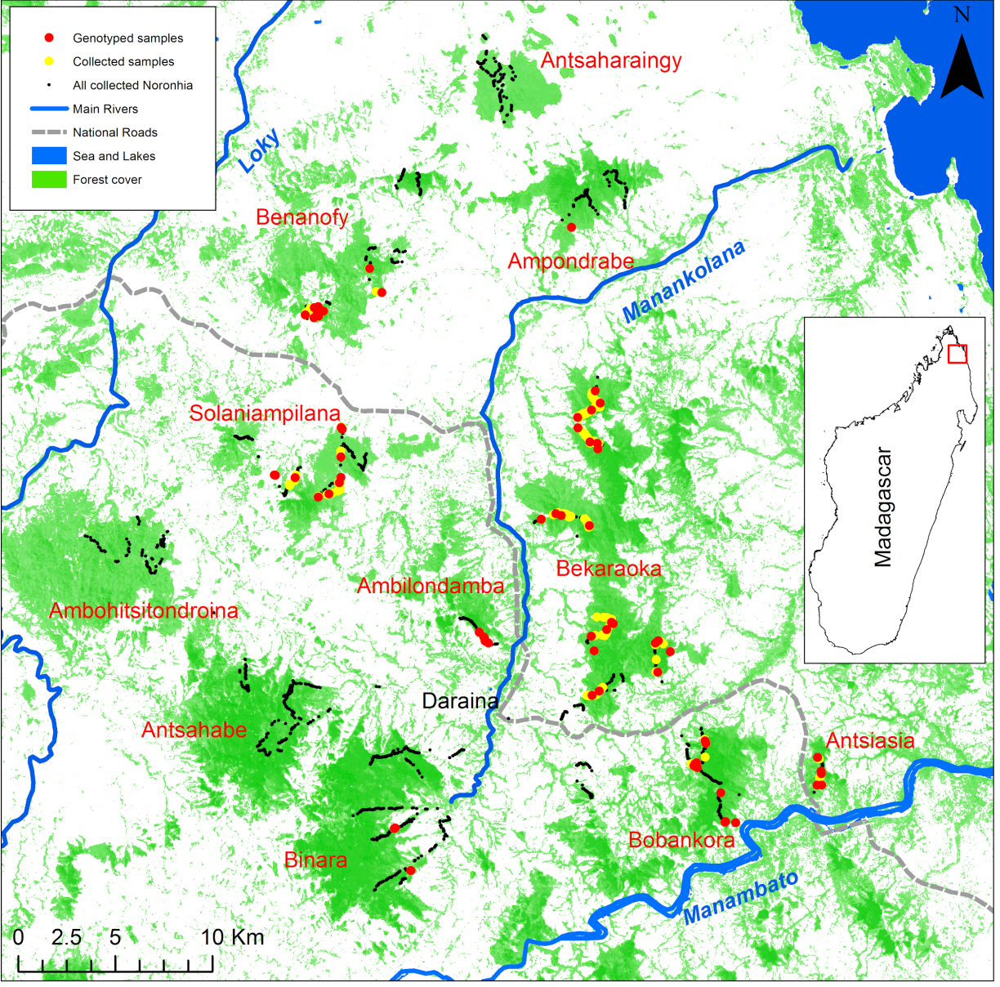

Figure 1: Map of Noronhia spinifolia sampling in the Loky-Manambato (LM) region.
The small black points represent samples collected for all Noronhia species (ca. 30 distinct taxa) and illustrate the survey effort conducted in the region. The yellow and red dots represent N. spinifolia samples, with the red dots corresponding to samples included in our genomic analyses. The forest cover is adapted from Hansen et al. (2013). Pixels with less than 30% tree cover are represented in white. The remaining tree cover percentage values are represented from light green (30%) to dark green (100%). This forest cover representation also illustrates the presence of riparian forests along streams of the LM region.

Plant sampling
To sample N. spinifolia populations, we surveyed all major forests of the LM region (Fig. 1) in 2017 and 2018, during the dry season (July-September), and used topography (altitude and shape) as a sampling guide to maximize the representation of all landscape features. Most surveys started from the forest edge at low altitude towards the forest core at higher elevation. We identified Noronhia species based on tree characteristics, leaf morphology and tissue structure, and collected leaf samples of 220 N. spinifolia trees, preserved in silica gel for DNA conservation. We prioritized fully-grown mature tree sampling because much of the density-dependent mortality takes place before maturity in trees, and their effective population size contributing to the genetic diversity is thus closer to the actual adult census size than to the size of the entire population including young trees and seedlings (Dodd et al., 1999; Petit & Hampe, 2006). Therefore, the regional patterns of diversity are expected to be better represented by adult samples. For each tree, we systematically recorded its height, diameter and reproductive state, as well as its geographical coordinates (GPS) and elevation. For all forests, at least one specimen voucher was prepared and deposited at the herbarium of the Parc Botanique et Zoologique de Tsimbazaza (TAN).

Laboratory procedures

DNA extraction, organellar and nuclear genotyping
We extracted DNA from 137 samples of N. spinifolia using a commercial protocol adapted to plants, followed by quality control procedures ensuring high quality genomic DNA. We subsequently genotyped 72 high DNA quality samples (Fig. 1, Methods S1); a cost-effective subsampling that nonetheless maximizes geographic and altitudinal representation, and also prioritizes reproductively mature and fully-grown trees with a targeted sequencing depth >15×. Using a two-pronged approach, we genotyped 15 chloroplast microsatellites (cpSSR) and one mitochondrial microsatellite (mtSSR), originally developed on Olea europaea (Table S1, Methods S2, S3; Besnard et al., 2011), and also used restriction associated DNA sequencing (RADseq; generating data from the biparentally inherited nuclear genome and the mitogenome; Methods S4). RADseq consists in sequencing regions neighboring restriction sites, to obtain homologous sequences across individuals, spread across the genome, at a decent coverage and a reasonable cost (Baird et al., 2008; Andrews et al., 2016).

Data processing

Organellar RADseq loci, de-novo assembly of the nuclear loci catalog and ploidy
After ad-hoc demultiplexing and cleaning of reads (Methods S4), we screened the organellar genomes using bwa-mem sequence alignment (Li, 2013) to the N. clarinerva mitogenome and N. spinifolia plastome (MW202230 and MT081057, respectively; Methods S5). We identified ten mitochondrial SbfI RAD loci in silico, from which haplotypes were called using ANGSD v0.92 (Nielsen et al., 2012; Korneliussen et al., 2014), based on their highest effective base depth (Wang et al., 2013). Conversely, no cpDNA RAD locus was recovered, confirming in silico analyses (Methods S5).
A catalog of nuclear tags (loci) was de-novo optimized (Methods S6) by iterating around the core parameters of Stacks (Rochette et al., 2019) to maximize the amount of available biological information (Paris et al., 2017). The final catalog was further cleaned (Methods S6) for exogenous contaminants using DeconSeq (Schmieder & Edwards, 2011) and endogenous orthologs using MUMmer (Kurtz et al., 2004). Ploidy was first inspected using minor allele frequency plots and further statistically confirmed using nQuire (Weiß et al., 2018).

RADseq genotyping
We used two fundamentally distinct genotyping approaches to ensure the robustness of our results: single nucleotide polymorphism (SNPs) called in Stacks, and genotype likelihoods (GLs) estimated with ANGSD (Methods S7). GLs retain information about uncertainty in base calls, which alleviates some issues associated with RADseq data such as unevenness in sequencing depth and allele drop-outs (Pedersen et al., 2018; Warmuth & Ellegren, 2019; Heller et al., 2021).

Landscape genetics
We conducted complementary analyses to assess the effect of landscape components on the genetic diversity of N. spinifolia. We first investigated the raw patterns of genetic diversity and structure without priors to describe the major trends and build hypotheses. Then, using univariate approaches under an isolation-by-resistance model (IBR; McRae, 2006), we assessed the effect of each landscape component, iterating through their cost and resolution. Finally, using a multivariate model considering spatial autocorrelation and multicollinearity, we assessed the contribution of selected landscape components.

Genetic diversity
We assessed the forest and individual based expected heterozygosity (H_{E}) according to (Fumagalli, 2013) and the proportion of heterozygous genotypes (H_{O}), from nuclear genotype likelihoods (GL), based on unfolded site frequency spectra estimated in ANGSD. We further estimated organellar diversity (h), the probability that two haplotypes are different (Nei, 1987).

Population structure
We assessed the level of genetic differentiation among localities with Reynolds’ weighted F_{ST} (Reynolds et al., 1983) from GL inferred in ANGSD. We explored the genetic structure of our study system through naive clustering analyses (Methods S8), based on ANGSD GLs using NgsAdmix v32 (Skotte et al., 2013) and on Stacks called genotypes using ADMIXTURE v1.3.0 (Alexander et al., 2009), and with a principal component analysis (PCA) from GLs with PCAngsd. We estimated the level of organellar genetic differentiation among forests with Nei’s weighted F_{ST} (Nei, 1973) using the R package hierfstat. We also investigated the phylogenetic structure of organellar DNA data using minimum spanning networks of genetic distances (see below) constructed with the R package poppr (Kamvar et al., 2015).

Genetic distances
We assessed the power of several individual pairwise estimates of genetic relationships (distances or relatedness) from chloroplast, mitochondrial and nuclear data. For cpSSR data, we used the Bruvo’s and Prevosti’s genetic distances (Prevosti et al., 1975; Bruvo et al., 2004). From mtRAD SNPs, we inferred Euclidian and Manhattan distances. We estimated an overall genetic distance for organellar genomes by combining weighted Manhattan mtDNA and Bruvo’s cpDNA distances (Methods S3).
We estimated the covariance of nuclear RADseq GLs (Meisner & Albrechtsen, 2018), as well as Hall’s and Vieira’s metrics (Hall et al., 2012; Vieira et al., 2013) in PCAnsgd. Using nuclear SNP data, we also computed Nei's genetic distance (Nei, 1972) and Yang’s relatedness (Yang et al., 2010) in the StAMPP R package (Pembleton et al., 2013).

Isolation by distance
We investigated patterns of isolation by distance (IBD) to assess how the geographic distance alone explains the genetic diversity (Wright, 1943; Slatkin, 1993). We used Mantel tests (Mantel, 1967) between individual geographic and genetic distances (Methods S9). Since IBD may be limited to a certain scale (e.g. Keller & Holderegger, 2013; Van Strien et al., 2015; Cayuela et al., 2019), we compared subsets of pairwise data defined by a maximum geographic distance (S) between samples (Methods S9).

Isolation by resistance
Landscapes are rarely homogeneous, and gene flow may be limited or facilitated by its components. We used an IBR approach (McRae, 2006) to assess the cost associated with effective dispersal through each landscape feature.

Landscape variables, cost and resolution
As N. spinifolia was recently described and occurs in a remote area (Hong-Wa, 2016), we had little prior knowledge on the landscape variables that may affect pollen and seed dispersal. We therefore assessed the effect of most available landscape variables (Table 1; Methods S10). To test if the genetic diversity of old trees may be better explained by past forest cover, we used forest cover data from 1953, 1973, and 2000s (Hansen et al., 2013; Vieilledent et al., 2018).
Although strong priors associating a landscape component to a particular cost may be available for well-studied species (e.g. Dellicour et al., 2019; Quéméré et al., 2010), landscape variables and their associated cost are often chosen almost arbitrarily when little or no data are available (Beier et al., 2008, 2011). To identify the variable-cost associations that matter for our study system, we iteratively tested 14 conductance-resistance values (Methods S10). Similarly, organisms do not necessarily perceive each environmental component at the same resolution (or granularity: Baguette & Van Dyck, 2007; Everson & Boucher, 1998; Laurance et al., 2007; Murcia, 1995). To identify the variable-cost-granularity relevant for N. spinifolia, we tested four pixel resolutions (Methods S10).

Table 1: Landscape variables.
Variable | Abbreviation | Type | Univariate effect | Unique contribution
Geographic distance | IBD | Continuous | RES | NS*
Rivers | Rivers | Discrete | NA | NS*
Streams | Streams | Discrete | NA | NS
Roads | Roads | Discrete | NA | NS
Trails | Trails | Discrete | NA | NS
Slope | Slope | Continuous | NA | NS*
Wind | Wind_November | Continuous | NA | NS
% tree cover | %_tree_cov | Continuous | CON | CON*
% tree cover discrete | %_tree_cov_dis | Discrete | CON | CON
Forest cover ~2000 | Veg_2000 | Continuous | CON | CON
Forest cover ~1973 | Veg_1973 | Continuous | CON | CON
Forest cover ~1953 | Veg_1953 | Continuous | NA | NS

RES = variable exhibiting resistance; CON = variable exhibiting conductance; NA = no major effect detected; NS = non-significant unique contribution; * variable included in the final model presented in the main manuscript.

Movement models
To determine which dispersal model best applies to N. spinifolia, we used both the Least Cost Path (LCP) and the Circuit Theory (CT). These two approaches, respectively, consider the least cost trajectory and the cost of all possible trajectories (McRae & Beier, 2007). We computed landscape distances using the R package gdistance (Van Etten, 2012).

Statistical procedures
We used a two-step procedure to first select landscape components, as well as their best fitting cost, resolution, and movement model, and then, to assess their unique and common contributions to the spatial structure of N. spinifolia’s genetic diversity.
We estimated the correlation between geographic or landscape distance and genetic matrices (i.e. Landscape variables and Genetic distances as described above) using Mantel tests (Mantel, 1967) in the R Package vegan (Dixon, 2003). We retained variables showing a better fit (R²) than IBD, exhibiting sensitivity to cost values (i.e. variables with a fixed fit across all cost values were discarded), and selected their best fitting cost, movement model, and resolution. We modeled the contribution of the retained landscape variables using logistic regressions on distance matrices [LRDM] (Smouse et al., 1986; Prunier et al., 2015), a statistical procedure that is similar to classical multiple ordinary least-square regressions, except that the significance of model fit (multiple R²) is assessed through permutations of the dependent matrix (Legendre et al., 1994). We finally disentangled multicollinearity among variables and decomposed their unique and common contributions using commonality analyses (CA; Prunier et al., 2015).

Results

Species occurrence
We sampled N. spinifolia in eight of the 11 surveyed major forests of the LM region (Fig. 1). The species occurs from low to medium elevation, between 87 and 505 m, but with strong discrepancies among forests (Fig. S1). While it was mainly recorded in dry forests, it was surprisingly found in dry to wet transition forests at medium elevation (451-505 m) in Binara. Furthermore, the species was not found in three major forest patches of the LM region - namely Antsahabe, Ambohitsitondroina and Antsaharaingy - despite (i) large prospection efforts in these forests, and (ii) apparently similar habitat as the neighboring forests harboring the species (Fig. 1).

Organellar genotyping, ploidy and nuclear catalog construction
Of the 15 chloroplast microsatellites, 14 showed polymorphism (Table S2), and allowed distinguishing 55 chlorotype profiles among 72 trees (Results S1). The ten mitochondrial RAD loci (mtRAD) allowed identifying 11 SNPs (Results S1; Table S3). The combination of mtRADs and the mtSSR locus permits the identification of 15 mitotypes among 72 trees (Table 2). The cpSSR markers showed low to moderate linkage disequilibrium (LD; Fig. S2), a likely consequence of microsatellite-repeat-length homoplasy. Meanwhile, the mtDNA markers showed either high (among seven loci) or no LD (Fig. S3). Because SNPs are expected to be more stable (unlikely homoplasy) than SSRs, no LD between SNP loci was not expected, and could indicate recombination in the mitogenome. Finally, the overall LD among mtDNA and cpDNA markers (Fig. S4) suggests that they are both maternally inherited, although paternal leaks may occur occasionally.
Individuals-based minor allele frequency profiles displayed unimodal diploid patterns, confirmed by nQuire analyses, and echoing the low frequency of polyploid in the genus Noronhia (Gorrilliot et al., 2021). The nuclear catalog parameter space exploration iterating around the core parameters for Stacks [i.e. m – the minimum number of reads required to build a stack, M – the maximum number of differences between stacks of an individual allowed when building a locus; and N – the maximum number of differences between loci of multiple individuals allowed when building a loci] allowed selecting values (m = 4, M = 5, N = 8) that offer a trade-off between the coverage, loci number, and SNP number, while limiting the number of paralogs and the presence of contaminants (Figs S5-S7; Results S2). The SNP-calling procedure showing low ability to recover the genetic makeup of N. spinifolia (when compared to the GL-based procedure; Figs S8-S13), we therefore limited its use to preliminary analyses (ADMIXTURE & genetic distances) and proceeded with the GL-based procedure for downstream analyses.

Genetic diversity
Chloroplast microsatellites revealed a relatively high genetic diversity with only two chlorotypes shared by individuals from more than one forest, resulting in a high probability that two randomly sampled haplotypes are different (h = 0.99) and a mean allelic richness (A_{r}; estimated for five individuals) of 2.41 (Table 2). Consequently, most forests showed an extremely high cpSSR genetic diversity (h > 0.92) with the exception of Binara that appeared slightly less diverse (h = 0.73; Table 2). A relatively high mitotype diversity was also revealed [h = 0.85 (ranging from 0.66 to 0.97 per forest), A_{r} = 2.12]. Contrastingly, most forest patches exhibit moderately high levels of nuclear diversity with H_{E} values ranging from 4.53 to 6.52 x 10⁻³, with discrepancies within and among forests (Tables 2 and S1; Fig. S14). This diversity is not homogeneously distributed in space, and higher levels of genetic diversity seemingly occurring in certain areas such as Solaniampilana (Fig. S15). Furthermore, genetic diversity does not seem influenced by altitude (Fig. S16).

Table 2: Chloroplast, mitochondrial and nuclear summary statistics.
 | cpSSR |  |  |  |  | mtRAD |  |  |  |  | nRAD
Forests | N | n_{h} | H | A_{r} |  | N | n_{h} | H | A_{r} |  | N | H_{E}
Ambilondamba | 6 | 5 | 0.98 | 2.22 |  | 5 | 4 | 0.97 | 2.16 |  | 5 | 0.00510
Ampondrabe | 1 | 1 | - | - |  | 1 | 1 | - | - |  | 1 | -
Antsiasia | 6 | 4 | 0.92 | 2.67 |  | 6 | 3 | 0.81 | 2.14 |  | 6 | 0.00563
Bekaraoka | 25 | 19 | 0.99 | 2.38 |  | 23 | 5 | 0.66 | 2.04 |  | 23 | 0.00652
Benanofy | 11 | 8 | 0.94 | 2.39 |  | 11 | 4 | 0.78 | 2.26 |  | 11 | 0.00559
Binara | 5 | 2 | 0.73 | 2.36 |  | 5 | 2 | 0.73 | 2.05 |  | 5 | 0.00453
Bobankora | 11 | 10 | 0.99 | 2.45 |  | 11 | 3 | 0.73 | 2.04 |  | 11 | 0.00624
Solaniampilana | 10 | 8 | 0.97 | 2.37 |  | 10 | 5 | 0.87 | 2.17 |  | 10 | 0.00624
Total / Mean | 75 | 55 | 0.99 | 2.41 |  | 72 | 15 | 0.85 | 2.12 |  | 72 | 0.00676
N = number of analyzed individuals; n_{h} = number of haplotypes; h = haplotype diversity; A_{r}: allelic richness (estimated for five individuals), H_{E} = expected heterozygosity.

Population structure
The chloroplast and mitochondrial data both revealed substantial differentiation among forests (F_{ST} estimates ranging from 0.040 to 0.393 for cpSSRs; and 0.005 to 0.661 for mtRADs). As expected, a strong differentiation was also observed when combining cpDNA and mtDNA data (F_{ST} estimates ranging from 0.101 to 0.401; Table S4). The Solaniampilana-Benanofy forest cluster was clearly distinguished from other forests for both mtDNA and cpDNA (Figs S17-S18), while Bekaraoka and Bobankora showed limited divergence with their neighboring forests. Haplotype networks based on cpSSR and/or mtRAD data also revealed that one maternal lineage is unique to Solaniampilana and Benanofy (Fig. 2). Furthermore, the geographic Euclidean distances showed low, but highly significant, power at explaining genetic distances among individuals (R² [cpSSR]: 11.7%; R² [mtRAD]: 20.7%; and R² [cpSSR + mtRAD]: 21.3%; Figs S13, S19; Results S3).

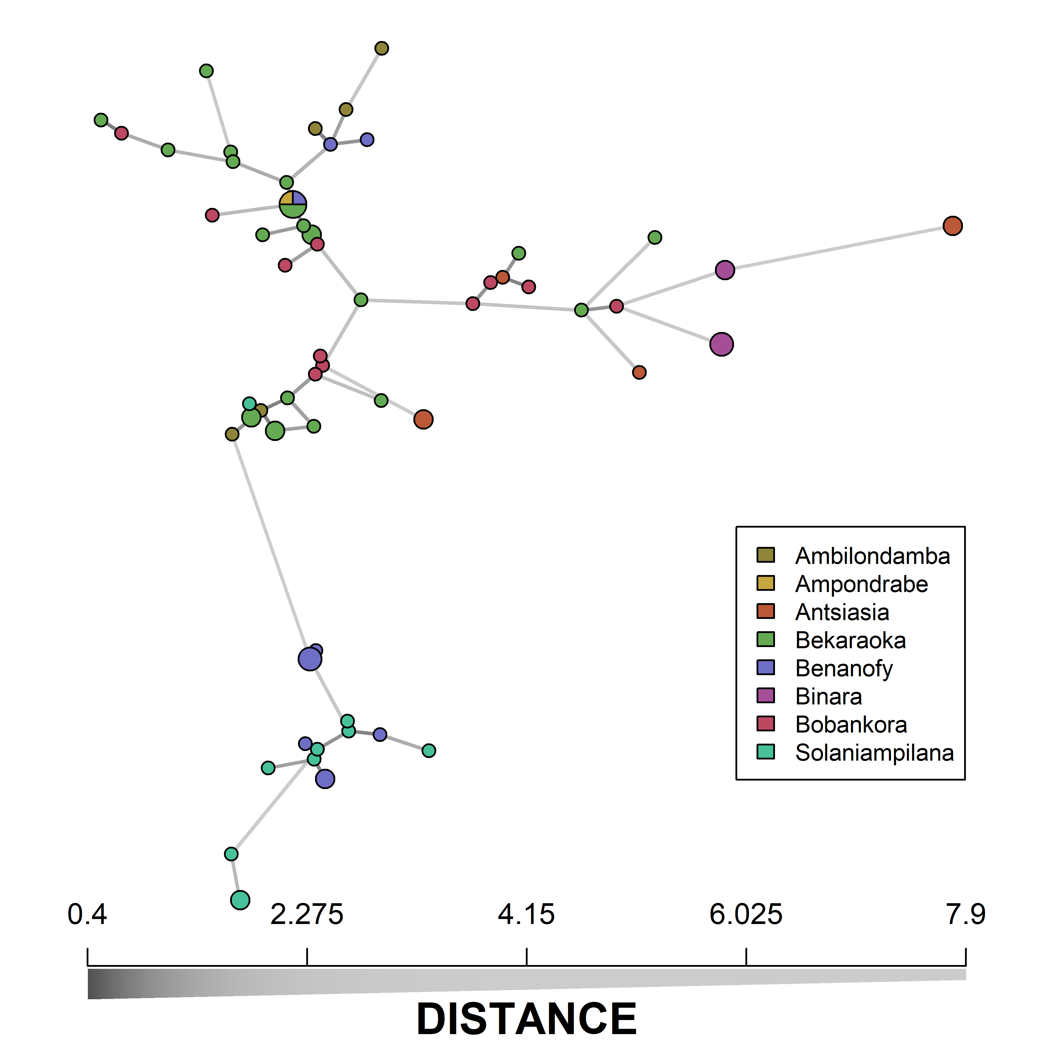

Figure 2: Organellar DNA haplotype network of Noronhia spinifolia.
Line length and gray scale are proportional to the Bruvo’s cpDNA + Manhattan mtDNA combined genetic distances between distinct organellar haplotypes. Pie chart size is proportional to the occurrence number of a given haplotype. All edges of equal weight are represented. Distances among haplotypes are represented both through longer edges and the gray scale. The network highlights the huge organellar DNA diversity in N. spinifolia, with only one haplotype shared by individuals from at least two forests. It further shows a limited spatial structure, with, for instance, haplotypes from Solaniampilana and Benanofy grouping together at the bottom of the network.

F_{ST} estimates based on nuclear markers (Table S5) ranged from 0.089 to 0.210, indicating that most forests are differentiated from each other. However, we found no strong structure in sub-populations, with no particular support for number of clusters >1, both for GL- and SNP-based analyses (Figs S8, S9). Instead, we found a clear northwest-southeast signal of continuous genetic differentiation across space, through GL-based PCA (First axis, ~15% of the variance explained; Fig. S20), clustering (Figs 3, S10, S11), and IBD analyses (Figs S13, S19). The observed continuous structure is well illustrated by the clustering structure for K = 3 that shows admixed patterns at sampling sites (Fig. 3). We found a clear IBD signal explaining up to 56.6% of the among-individuals nuclear GL covariance (Fig. S19).

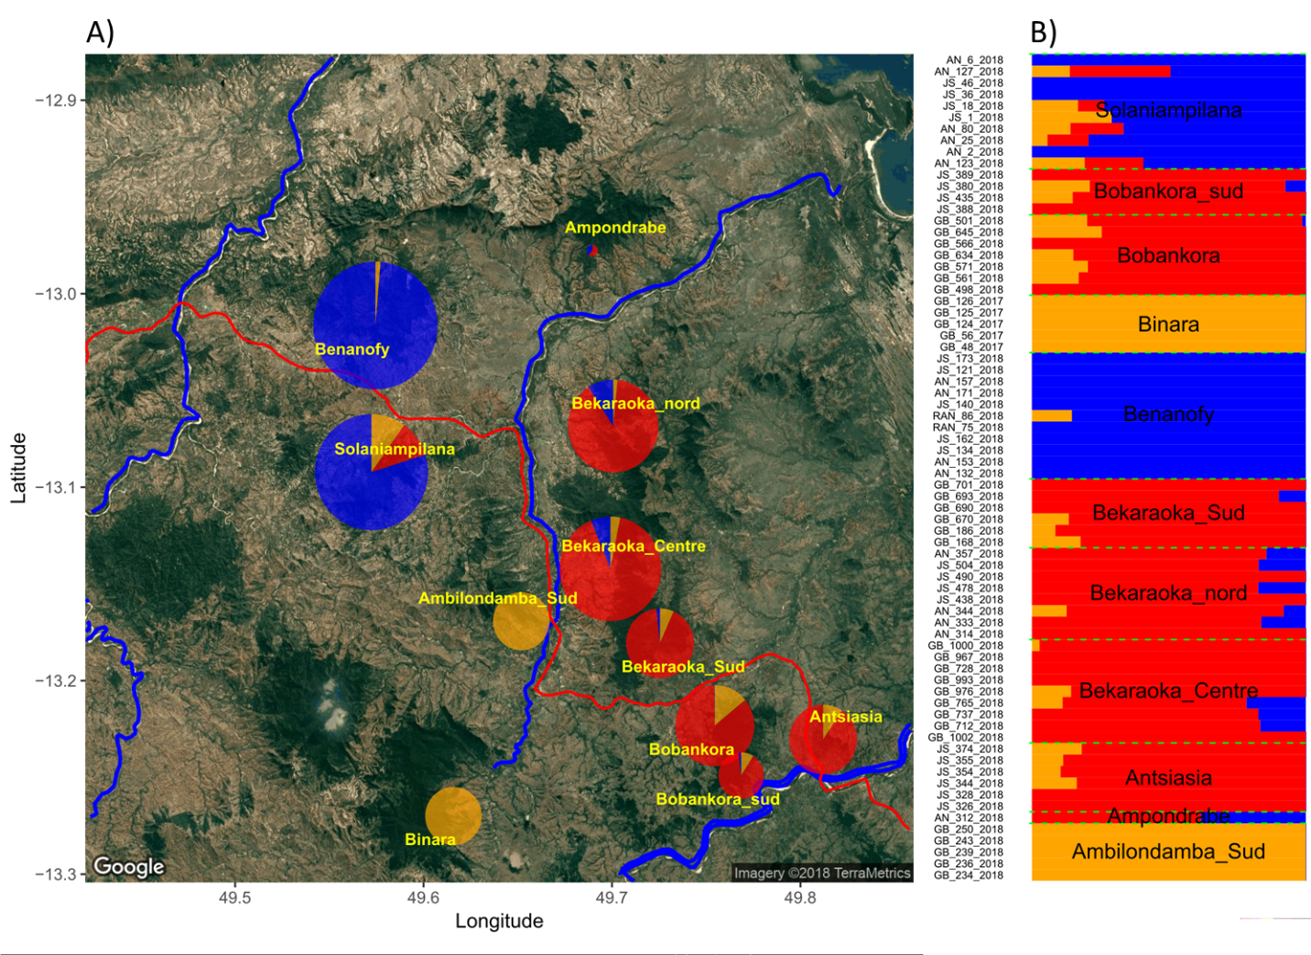

Figure 3: Spatial genetic structure of Noronhia spinifolia in the Loky-Manambato region.
NgsAdmix ancestry proportions (for K = 3 genetic clusters) represented either (A) spatially by sampling site, or (B) per individual. Size of pie charts (in A) is proportional to the number of samples per site. Pie shares represent the sums of individual ancestry proportions that are shown in B. Results are arbitrarily represented for K = 3, according to the likelihood and deltaK results in Fig. S8, because this K value best illustrates the continuous pattern of structure inferred using ngsAdmix and other approaches.

Landscape genetics
The optimization of resistance surfaces through univariate comparison of genetic and landscape distances (IBR) showed lower fit for cpDNA (R² max ~0.14) than for mtDNA (R² max ~0.38) and nDNA (R² max ~0.90). Among the four vegetation layers, the continuous and discrete percent tree cover layer always exhibited the highest fit for conductance values at high resolution with cpDNA, mtDNA and nDNA (R² = 0.14; 0.38 and 0.90, respectively; Figs S21-S24). In other words, the percent tree cover data alone shows a strong conducting effect on gene flow and explains a very large portion of the genetic variation (R² = 0.90). Altogether the parameter space exploration reveals a strong effect of all forest cover layers, whereas some other variables (i.e., rivers, roads and slope) may have subtle lower effects too. To build multivariate models, we retained in priority landscape variables showing a better fit (R²) than the null model considering IBD alone, and exhibiting sensitivity to cost values (e.g. % forest cover). Our results combining LRDM and CA confirmed that forest cover was the best landscape predictor of genetic differentiation, releasing other landscape components and IBD to account mostly for collinearity with the forest cover (Fig. 4; Table S6). This pattern was consistent across organellar and nuclear DNA (Table S6), and the high quality percent tree cover from Hansen et al. (2013) was always the best forest cover predictor (Table S6). The 2000’s forest covers all better fit genetic distances than the 1953 and 1973 forest covers, meaning we did not recover particular effect of the documented forest-cover changes on the genetic diversity of N. spinifolia.
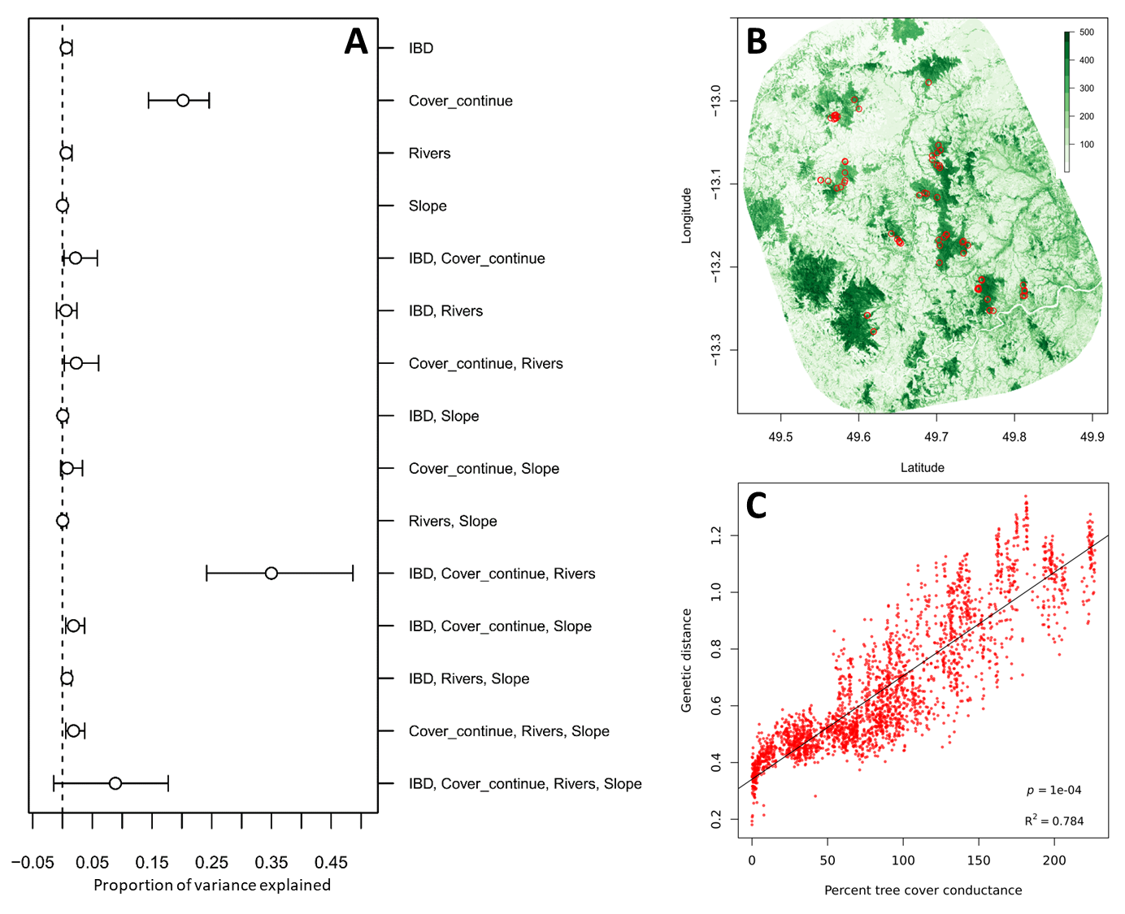

Figure 4: Landscape contribution to nuclear gene flow in Noronhia spinifolia.
A) Unique and common contributions of four selected landscape variables to nuclear gene flow, estimated using commonality analysis. B) Geographic representation of the percent tree cover conductance (inverse of cost), which illustrates the landscape conductance. C) Graphic representation of the relationship between percent tree cover conductance and genetic distances (isolation by resistance). This figure illustrates a strong conducting effect of forest cover (percent tree cover) on the connectivity of N. spinifolia, and it further shows that Euclidean geographic distance (IBD), the Manankolana River (Rivers) and the topology (Slope) have very low unique contribution, if any, to N. spinifolia nuclear gene flow. Cover_continue: Percent tree cover, conductance = 5; IBD: Isolation by distance, resistance = 1; Rivers: resistance = 5; Slope: conductance = 5.

Discussion
From a comprehensive and extensive sampling of Noronhia spinifolia in its core distribution area, and leveraging the rare combination of nuclear and mitochondrial RADseq data with cpDNA microsatellites, this study allowed us to reveal a strong effect of forest cover on gene flow in a patchy habitat in northern Madagascar. We not only report a surprisingly high organellar genetic diversity unevenly distributed in space, but also found that GL-based approaches were able to recover much more information than SNP-calling approaches in our model species. Moreover, the iterative optimization of resistance surface allowed identifying outstanding landscape variables with a strong effect on the connectivity of N. spinifolia. Finally, we show that recent forest cover better explains the genetic structure of N. spinifolia than more ancient ones.

Noronhia spinifolia, a highly diverse Malagasy micro-endemic
Our analyses exhibit unexpectedly high chloroplast (h = 0.99; 55 chlorotypes for 72 individuals), and mitochondrial (h = 0.85; 15 mitotypes) genetic diversity in a micro-endemic Malagasy tree species.
Firstly, the cpDNA diversity is tremendously higher than that of another micro-endemic congener of the High Plateau (N. lowryi) when using the same 15 cpSSR loci [6 haplotypes in 77 individuals; h_{cp} = 0.58 (Salmona et al., 2020)]. More surprisingly, more cpDNA haplotypes and diversity were revealed in 72 N. spinifolia individuals than in 1263 wild olive trees from the whole Mediterranean basin [47 chlorotypes; h_{cp} = 0.35 (Besnard et al., 2013)] and thus across very different geographic scales (LM region = 900 km² vs Mediterranean basin = ~2.5 Million km²) and despite the use of more polymorphic cpSSRs (n = 35) in olive. Similarly, the N. spinifolia mtDNA diversity is also higher than in the Mediterranean olive [4 mitotypes; h_{mt} = 0.58; (Besnard et al., 2002)], although comparable diversity levels have been revealed in other plant groups exhibiting large mitogenomes with high mutation rates as Silene vulgaris in Central Europe [30 mitotypes; h_{mt} = 0.94; (Štorchová & Olson, 2004)]. Finally, the nuclear genomic diversity is within the range of that estimated in poplar, pedunculate oak and Norway spruce populations across distribution ranges several order of magnitude larger (Ma et al., 2018; Plomion et al., 2018; Chen et al., 2019). This high genetic diversity is particularly unexpected for a narrowly distributed micro-endemic, and thus threatened, species.
Although high standing genetic diversity is common in forest trees, the relative importance of the multiple mechanisms generating and maintaining this diversity are still debated (Petit & Hampe, 2006; Scotti et al., 2016; Isabel et al., 2020). In N. spinifolia, several non-exclusive evolutionary mechanisms may explain such an exceptionally high intraspecific genetic diversity. Firstly, it suggests that a long-term maintenance of a large effective population size precluded significant genetic drift. Persistent connectivity between forest patches may have been key in this process, particularly during climatic fluctuations of the Late Quaternary that may have contributed to fragmenting habitat, as suggested for other species of the LM region (Quéméré et al., 2012; Salmona et al., 2017b). Secondly, the genus Noronhia has extremely diversified in northern Madagascar (Hong-Wa, 2016), and about 30 taxa have been recently recorded and sampled in the LM region (JS & GB, unpublished data). What caused such diversification remains unknown. But the co-occurrence of closely related taxa may offer some opportunities for hybridization events, which could have contributed to the increased genetic diversity in N. spinifolia. However, the cpSSR characterization of four sympatric/parapatric LM Noronhia (i.e. N. candicans, N. clarinerva, N. crassinodis and N. intermedia; > 200 individuals), closely related to N. spinifolia (according to cpDNA and nDNA data; Salmona et al., 2020), shows that these species have no shared chlorotype with our study model (GB, unpubl. data), thus suggesting that maternal introgression events to N. spinifolia, if any, may not be recent. Lastly, high mutation rate may also contribute to the high genetic diversity in N. spinifolia. An obvious acceleration of the mitogenome evolutionary rate has been recently documented in the closely related species N. candicans, N. clarinerva, N. intermedia and N. spinifolia, with a high number of di- or tri-nucleotide mutations possibly reflecting frequent mtDNA recombination in this clade (Van de Paer, 2017), as also suggested by a lack of LD between some SNPs. While accelerated mutation rate was missing on the plastome (Salmona et al., 2020), we are still lacking any evidence for the nuclear genome. Such accelerated evolutionary rate could result from relatively frequent and recurrent hybridization events in this group, promoting genomic instability (Fontdevila, 2005; Payseur & Rieseberg, 2016). Moreover, the strong linear relationship between geographic and genetic distance could preclude cryptic radiation (Pillon et al., 2014) and microgeographic adaptation (Scotti et al., 2016) as major drivers of the observed diversity. In conclusion, the surprisingly high genetic diversity calls for the identification of the evolutionary, ecological and/or molecular mechanisms underlying this peculiar pattern.

Landscape effects on the genetic diversity of Noronhia spinifolia

A strong continuous spatial structure
Beyond revealing surprisingly high levels of diversity, our results also show complementary signals of a strong continuous structure in space (PCA, clustering and IBD), from both organelles and the nucleus, in contrast to generally expected incongruent patterns among genomes (Olofsson et al., 2019; Bianconi et al., 2020). While the northwest-southeast differentiation cline represented as much as ~15% of the variance of the PCA, the geographic Euclidean distance alone explained up to ~55% of the nuclear genetic variance using IBD tests. This strong pattern of nuclear genetic structure sharply contrasts with the absence of nuclear spatial structure in the savanna olive tree, N. lowryi (Salmona et al., 2020). However, reported IBD patterns in trees show a wide range from low values in Dalbergia monticola across eastern Madagascar humid forests [R² = 0.18; (Andrianoelina et al., 2009)], or Coffea mauritiana in the Reunion Island [R² = 0.21; (Garot et al., 2019)], to high values in Swietenia macrophylla in Central America [R² = 0.62; (McRae & Beier, 2007)]. Unexpectedly, this genetic structure was here extremely well explained by the vegetation cover (percent tree cover; mtDNA R² = 0.38; nDNA R² = 0.90), releasing IBD to account mostly for collinearity with the forest cover. Although strong landscape effects were also found in S. macrophylla (McRae & Beier, 2007), we report a unique evidence of a strong habitat effect explained mostly by one landscape variable.

On seed-mediated gene flow: the organellar DNA testimony
Although organellar IBR patterns (Figs S19, S21-S24) suggest that seed-mediated gene flow is driven by forest cover, the recovered pattern was of lower intensity than for pollen-mediated gene flow (nDNA). Despite slope and watershed networks being candidates for barochory and hydrochory, we could not recover any landscape variable (other than forest cover) with noticeable effect on seed dispersal. Similarly, the overall structures of organellar haplotype networks (Figs 2, S17-S18) are coherent with the geographic repartition of forests, and in line with the effect of the forest cover. These prevailing effects of forest cover suggest that seed dispersal may be primarily performed by forest-dwelling animals (zoochory), especially those with limited and/or rare across-forest movements, such as lemurs, rodents and territorial birds (Quéméré et al., 2010; Rakotoarisoa et al., 2013a; Sgarlata et al., 2018; Aleixo-Pais et al., 2019). However, the networks also show multiple potential fluxes among forests, hence supporting the network complementarity to the IBR approach. Several non-exclusive interpretations can be invoked for explaining these patterns: (i) relevant landscape variables are not included or of low resolution (e.g. forest type and climatic variables); (ii) the cpDNA and mtDNA diversities are confounded by homoplasy, recombination, strong drift, long-term phylogenetic or demographic history; and (iii) seed dispersal also results from infrequent seed ingestion by wide-ranging birds (or other vertebrates).

A deep forest cover effect on gene flow
Unlike organellar DNAs, nDNA diversity is deeply explained by the LM region forest cover (Fig. 4). While this partially confirms the effect of forest cover on seed dispersal since nDNA diversity is influenced by both seed and pollen movement, wind-mediated pollen dispersal favored in open-canopy environments is not supported here. It thus further sustains that pollen dispersal is mediated by forest-dwelling organisms with movements limited by open-canopy environments. Insect-mediated pollen dispersal in N. spinifolia is also strongly suggested by its flower morphology and color (Hong-Wa, 2016). However, the currently limited knowledge of the Malagasy entomofauna and plant-pollinator networks prevents us from clearly identifying this species' forest-dwelling pollinators.
The antiquity of habitat mosaic in northern Madagascar
Our results further support a long-standing habitat mosaic in the LM region. First, the better fit of all recent forest cover (2000's), compared to older vegetation cover (1953, 1973), suggests that the small forest changes that have occurred through this period (Quéméré et al., 2012) are unable to explain the genetic diversity of N. spinifolia. These mild landscape changes in the LM region contrast with the high deforestation rates observed throughout Madagascar since the fifties (Hansen et al., 2013; Vieilledent et al., 2018). Under such high recent deforestation rates, a better fit of the recent forest cover layer would be very unlikely, even considering that its better resolution could positively bias its fit. Second, because we mostly genotyped fully-grown mature trees, and since the generation time of Noronhia is potentially long [>20-50 years; (Salmona et al., 2020)], the genetic diversity is expected to reflect ancient forest cover. The time lag for a particular landscape feature to imprint its effects in the genetic diversity of a species, has been little studied (Landguth et al., 2010; Mona et al., 2014). However, in N. spinifolia, based on the strength of the signal, the high level of diversity and of gene-flow, the re-shuffling of allele frequencies after fragmentation can be relatively long (tens to hundreds of generations), before harboring the signature of the new geographical pattern. The period with data on forest cover (1953-present) represents less than five generations, a too short period to erase the signal of previous population structure (or lack thereof). This suggests that the landscape changes leading to the current forest cover long pre-dates the most ancient available layer (1953). The strong genetic correlation with the recent forest cover is, therefore, sound evidence that the landscape of the LM region was relatively stable at least for the last century (i.e. when most of Madagascar’s deforestation occurred), and possibly the last millennium. This result concurs with those of recent studies (Quéméré et al., 2012; Salmona et al., 2020) supporting a relative antiquity of habitat mosaic in northern Madagascar. Furthermore, both the high diversity of Noronhia spinifolia, and its predominant distribution in low-elevation dry forest suggests that this habitat type may have been spatially, topographically, and temporally extensive in northern Madagascar, albeit frequently fragmented, as seemingly evidenced by a rare and likely relictual occurrence of the species in contemporary high-elevation humid forest (e.g. Binara) and similarly peculiar presence further north (e.g. Montagne des Français). To assess forest-cover changes over a larger timeframe (e.g. the last ten or so millennia), inferences of N. spinifolia’s demography over time would be relevant (Salmona et al., 2017a; Beichman et al., 2018). Coupling these inferences, with that of short-generation grassland organisms, would also help clarifying the dynamics of fire-prone open-canopy environments, through the succession of environmental changes that occurred during last millennia, namely the last-glacial-maximum, early human’s colonization, the mid-Holocene transition, and the 1-Kya expansion of agro-pastoralism.
Further prospects and conservation implications
The power of coupling genomic data to landscape genetics allowed not only identifying major landscape components influencing effective dispersal, but also their respective effects on seed and pollen dispersal. This surprising result warrants further investigation using higher resolution landscape and environmental layers, not used, or not available to our study. In particular, it would benefit from the use of forest type, soil type, land use, and climate data of better resolution. In addition, the wind effect has been tested without considering its directionality. Recent analytical advances allowing wind directionality integration within a landscape genetics framework (Fernández-López & Schliep, 2018) may allow to formally test its effect on pollen dispersal. Furthermore, while our study clearly identifies that seed and pollen are dispersed by forest-dwelling organisms, it neither identifies these organisms nor does it clearly show that seed and pollen do still effectively disperse among forests. These questions could be tackled (i) by inferring pedigree data from high density population sampling, coupled with sampling of young trees and seedlings, (ii) using field survey of potential dispersers during flowering and fructification (e.g. camera tracking), and/or (iii) using metabarcoding approaches to assess the interaction network within the LM forests.
While our study confirms the biological importance of the LM region, which is known for its species richness and endemism across taxa (Goodman & Wilmé, 2006; Rakotondravony, 2006, 2009; Sgarlata et al., 2019), and more specifically for the genus Noronhia (Hong-Wa, 2016), our results also have several implications for biodiversity conservation in the region:
- First, they underscore the conservation value of the often-overlooked intraspecific genetic diversity, which is unexpectedly high in N. spinifolia.
- Second, this study highlights the importance of riparian forests of the LM region for their major role both as corridors connecting forest patches, which is supported by the fact that genetic diversity in N. spinifolia is explained by forest cover rather than geographical distance, and as vectors promoting the roles of vertebrates and insects on seed and pollen dispersal. Therefore, actively maintaining, protecting, and reforesting riparian and corridor forests, which are likely pivotal for the functional connectivity of N. spinifolia but also most native and endemic species of the LM region (Quéméré et al., 2010; Rakotoarisoa et al., 2013a; Sgarlata et al., 2018; Aleixo-Pais et al., 2019), remain critical conservation actions.
- Third, our study identifies the Binara forest as unique among the major forests of the LM region and in urgent need of deeper conservation focus. Indeed, our extensive forest survey allowed us to find and collect just a few samples in this forest, where they were found only at unexpectedly higher altitude and wetter habitat (Fig. S1). Similarly, several other Malagasy olive species that are mostly distributed in dry forests (e.g. N. ankaranensis, N. candicans, N. christenseniana and N. oblanceolata; GB and JS unpublished data), were also found to occur only at higher altitude in the mountain evergreen forests of this region (e.g. Binara and Antsahabe). Altogether, this pattern, though unclear, echoes the peculiarities of these forests, that likely acted as refugia for numerous taxa during drier periods (Raxworthy & Nussbaum, 1995; Goodman & Wilmé, 2006; Rakotoarisoa et al., 2013b; Sgarlata et al., 2019).

Data availability
Raw RADseq data and RADseq mtDNA alignments have been deposited to the Short Read Archive (SRA) NCBI database under the reference PRJNA632767. Organellar microsatellite genotypes and mtRAD variants are available in Tables S7 and S8, respectively. All additional data, scripts and materials are available to readers at 10.5281/zenodo.5595978.

Conflict of interest disclosure
The authors of this article declare that they have no financial conflict of interest with the content of this article.

Acknowledgments

We thank the Direction Générale du Ministère de l’Environnement et des Forêts de Madagascar, Madagascar’s Ad Hoc Committee for Fauna and Flora, and Organizational Committee for Environmental Research (CAFF/CORE) for permission to perform this study (permits number: [49/17] & [127/18]/MEEF/SG/DGF/DSAP/SCB.Re) and for their support. We thank the local communities of Daraina and of the LM region for their warm reception and support. We thank E. Rasolondraibe and the many local guides and cooks for sharing their incomparable expertise and help in the field, misaotra anareo jiaby. We thank U. Suescun, C. Verbeke and M.A. Naranjo Arcos for lab assistance, L. Chikhi for comments on an earlier version of the draft and P. Raimondeau for sharing a complete, annotated mitogenome sequence of N. clarinerva. This work was mostly funded through an ERA-NET BiodivERsA project: INFRAGECO (Inference, Fragmentation, Genomics, and Conservation, ANR-16-EBI3-0014). We also thank the LABEX TULIP (ANR-10-LABX-0041) and CEBA (ANR-10-LABX-25-01), and the LIA BEEG-B (Laboratoire International Associé – Bioinformatics, Ecology, Evolution, Genomics and Behaviour, CNRS). We are grateful to the Get-Plage sequencing and Genotoul bioinformatics (Bioinfo Genotoul) platforms for sequencing services and providing computing resources.

Author Contribution

JS and GB designed the experiment. JS, AER, BLP, JR, CHW and GB were pivotal to field material collection and herbarium composition. JS, SM, and GB generated the genetic data. JS conducted bioinformatics and population genetic analyses. JS and AD conducted IBR analyses. JS and GB drafted a first version of the manuscript with a significant input from CHW. All co-authors agreed with the last version of the manuscript.

Supporting Information

Supporting methods 3
Method S1: DNA extraction 3
Method S2: Chloroplast microsatellites 3
Method S3: Organellar markers processing 3
Method S4: RAD sequencing 3
Method S5: Screening the organellar genomes for RADseq loci 4
Method S6: De-novo assembly of the nuclear loci catalog 4
Method S7: SNP calling & Genotype likelihood 4
Method S8: Clustering analyses 5
Method S9: Isolation by distance 5
Method S10: Landscape variables, cost and resolution 5
Supporting results 7
Result S1: Organellar DNA genotyping 7
Result S2: Catalog construction and genotypes data 7
Result S3: Isolation by distance 7
Supporting tables 8
Table S1: Samples and genetic data used in this study 8
Table S2: Characteristics of the organellar DNA microsatellites 8
Table S3: Characteristics of the mtDNA variants obtained from RADseq data (mtRAD) 9
Table S4: Organellar DNA differentiation among Noronhia spinifolia sampling sites 10
Table S5: Nuclear genetic differentiation among Noronhia spinifolia sampling sites 11
Table S6: Commonality summary results for all multi-variable models 12
Table S7: Organellar microsatellite genotypes 12
Table S8: Mitochondrial RADseq genotypes 12
Supporting figures 13
Figure S1: Altitudinal distribution range of Noronhia spinifolia in the Loky-Manambato region 13
Figure S2: Linkage disequilibrium in chloroplast microsatellites data 14
Figure S3: Linkage disequilibrium in mitochondrial data 15
Figure S4: Linkage disequilibrium in organellar DNA data 16
Figure S5: Selecting ustacks parameters for Noronhia spinifolia 17
Figure S6: Selecting cstacks parameters for Noronhia spinifolia 18
Figure S7: Assessing Noronhia spinifolia RAD catalog contaminations 19
Figure S8: Number of nuclear genetic clusters best explaining the data when using NgsAdmix 20
Figure S9: Number of nuclear genetic clusters best explaining the data when using Admixture 21
Figure S10: Genetic structure in Noronhia spinifolia 22
Figure S11: ngsAdmix ancestry proportion estimates for K = 2 to 10 23
Figure S12: Admixture ancestry proportion estimates for K = 2 to 10 24
Figure S13: Geographic scale influence on isolation by distance (IBD) 25
Figure S14: Noronhia spinifolia’s genetic diversity 26
Figure S15: Spatial distribution of nuclear genetic diversity in Noronhia spinifolia 27
Figure S16: Altitude effect on Noronhia spinifolia’s genetic diversity 28
Figure S17: Noronhia spinifolia mtDNA haplotype network 29
Figure S18: Noronhia spinifolia chlorotype network 30
Figure S19: Isolation by distance in Noronhia spinifolia 31
Figure S20: Principal component analysis of nuclear genomic data of Noronhia spinifolia 32
Figure S21: Univariate variable selection for chloroplast data 33
Figure S22: Univariate variable selection for mitochondrial data 34
Figure S23: Univariate variable selection for organellar data 35
Figure S24: Univariate variable selection for nuclear data 36
Figure S25: Effect of weight of combined organellar data on isolation by distance (IBD) 37
References 38

References
Aleixo-Pais I, Salmona J, Sgarlata GM, Rakotonanahary A, Sousa AP, Parreira B, Kun-Rodrigues C, Ralantoharijaona T, Jan F, Rasolondraibe E, et al. 2019. The genetic structure of a mouse lemur living in a fragmented habitat in northern Madagascar. Conservation Genetics 20: 229–243.
Alexander DH, Novembre J, Lange K. 2009. Fast model-based estimation of ancestry in unrelated individuals. Genome Research 19: 1655–1664.
Allendorf FW, Hohenlohe PA, Luikart G. 2010. Genomics and the future of conservation genetics. Nature Reviews Genetics 11: 697–709.
Andrews KR, Good JM, Miller MR, Luikart G, Hohenlohe PA. 2016. Harnessing the power of RADseq for ecological and evolutionary genomics. Nature Reviews Genetics 17: 81–92.
Andrianoelina O, Favreau B, Ramamonjisoa L, Bouvet J-M. 2009. Small effect of fragmentation on the genetic diversity of Dalbergia monticola, an endangered tree species of the eastern forest of Madagascar, detected by chloroplast and nuclear microsatellites. Annals of Botany 104: 1231–1242.
Baguette M, Van Dyck H. 2007. Landscape connectivity and animal behavior: functional grain as a key determinant for dispersal. Landscape Ecology 22: 1117–1129.
Baird NA, Etter PD, Atwood TS, Currey MC, Shiver AL, Lewis ZA, Selker EU, Cresko WA, Johnson EA. 2008. Rapid SNP discovery and genetic mapping using sequenced RAD markers. PLoS One 3: e3376.
Balkenhol N, Cushman S, Storfer A, Waits L (Eds.). 2016. Landscape genetics: concepts, methods, applications. Oxford: John Wiley & Sons.
Beichman AC, Huerta-Sanchez E, Lohmueller KE. 2018. Using genomic data to infer historic population dynamics of nonmodel organisms. Annual Review of Ecology, Evolution, and Systematics 49: 433–456.
Beier P, Majka DR, Spencer WD. 2008. Forks in the road: choices in procedures for designing wildland linkages. Conservation Biology 22: 836–851.
Beier P, Spencer W, Baldwin RF, McRae BH. 2011. Toward best practices for developing regional connectivity maps. Conservation Biology 25: 879–892.
Besnard G, Hernández P, Khadari B, Dorado G, Savolainen V. 2011. Genomic profiling of plastid DNA variation in the Mediterranean olive tree. BMC Plant Biology 11: 80.
Besnard G, Khadari B, Baradat P, Bervillé A. 2002. Combination of chloroplast and mitochondrial DNA polymorphisms to study cytoplasm genetic differentiation in the olive complex (Olea europaea L.). Theoretical and Applied Genetics 105: 139–144.
Besnard G, Khadari B, Navascués M, Fernández-Mazuecos M, El Bakkali A, Arrigo N, Baali-Cherif D, Brunini-Bronzini de Caraffa V, Santoni S, Vargas P, et al. 2013. The complex history of the olive tree: from Late Quaternary diversification of Mediterranean lineages to primary domestication in the northern Levant. Proceedings of the Royal Society B: Biological Sciences 280: 20122833.
Bianconi ME, Dunning LT, Curran EV, Hidalgo O, Powell RF, Mian S, Leitch IJ, Lundgren MR, Manzi S, Vorontsova MS, et al. 2020. Contrasted histories of organelle and nuclear genomes underlying physiological diversification in a grass species. Proceedings of the Royal Society B: Biological Sciences 287: 20201960.
Bond WJ, Silander Jr JA, Ranaivonasy J, Ratsirarson J. 2008. The antiquity of Madagascar’s grasslands and the rise of C₄ grassy biomes. Journal of Biogeography 35: 1743–1758.
Bruvo R, Michiels NK, D’Souza TG, Schulenburg H. 2004. A simple method for the calculation of microsatellite genotype distances irrespective of ploidy level. Molecular Ecology 13: 2101–2106.
Cayuela H, Boualit L, Laporte M, Prunier JG, Preiss F, Laurent A, Foletti F, Clobert J, Jacob G. 2019. Kin-dependent dispersal influences relatedness and genetic structuring in a lek system. Oecologia 191: 97–112.
Chen J, Li L, Milesi P, Jansson G, Berlin M, Karlsson B, Aleksic J, Vendramin GG, Lascoux M. 2019. Genomic data provide new insights on the demographic history and the extent of recent material transfers in Norway spruce. Evolutionary Applications 12: 1539–1551.
Craul M, Radespiel U, Rasolofoson DW, Rakotondratsimba G, Rakotonirainy O, Rasoloharijaona S, Randrianambinina B, Ratsimbazafy J, Ratelolahy F, Randrianamboavaonjy T. 2008. Large rivers do not always act as species barriers for Lepilemur sp. Primates 49: 211–218.
Dellicour S, Prunier JG, Piry S, Eloy M-C, Bertouille S, Licoppe A, Frantz AC, Flamand M-C. 2019. Landscape genetic analyses of Cervus elaphus and Sus scrofa: comparative study and analytical developments. Heredity 123: 228–241.
Dixon P. 2003. VEGAN, a package of R functions for community ecology. Journal of Vegetation Science 14: 927–930.
Dodd ME, Silvertown J, Chase MW. 1999. Phylogenetic analysis of trait evolution and species diversity variation among angiosperm families. Evolution 53: 732–744.
Everson DA, Boucher DH. 1998. Tree species-richness and topographic complexity along the riparian edge of the Potomac River. Forest Ecology and Management 109: 305–314.
Fahrig L. 2003. Effects of habitat fragmentation on biodiversity. Annual Review of Ecology, Evolution, and Systematics 34: 487–515.
Fanamby. 2010. Plan de gestion environnementale et de sauvegarde sociale (PGESS). Etude d’impact environnemental et social (EIES) de la Nouvelle Aire Protégée Loky-Manambato.
Fernández-López J, Schliep K. 2018. rWind: download, edit and include wind data in ecological and evolutionary analysis. Ecography 42: 804–810.
Fontdevila A. 2005. Hybrid genome evolution by transposition. Cytogenetic and Genome Research 110: 49–55.
Frankham R. 2010. Challenges and opportunities of genetic approaches to biological conservation. Biological Conservation 143: 1919–1927.
Fumagalli M. 2013. Assessing the effect of sequencing depth and sample size in population genetics inferences. PLoS One 8: e79667.
Gardiner LM, Rakotoarinivo M, Rajaovelona LR, Clubbe C. 2017. Population genetics data help to guide the conservation of palm species with small population sizes and fragmented habitats in Madagascar. PeerJ 5: e3248.
Gardner CJ, Waeber PO, Razafindratsima OH, Wilmé L. 2018. Decision complacency and conservation planning. Conservation Biology 32: 1469–1472.
Garot E, Joët T, Combes M-C, Lashermes P. 2019. Genetic diversity and population divergences of an indigenous tree (Coffea mauritiana) in Reunion Island: role of climatic and geographical factors. Heredity 122: 833–847.
Gautier L, Ranirison P, Nusbaumer L, Wohlhauser S. 2006. Aperçu des massifs forestiers de la région Loky-Manambato. Inventaires de la faune et de la flore du nord de Madagascar dans la région Loky-Manambato, Analamerana et Andavakoera. Série Sciences Biologiques 23: 81–99.
Godfrey LR, Crowley BE. 2016. Madagascar’s ephemeral palaeo-grazer guild: who ate the ancient C₄ grasses? Proceedings of the Royal Society B: Biological Sciences 283: 20160360.
Goodman SM, Benstead JP. 2003. Natural history of Madagascar. Chicago and London: University Chicago Press.
Goodman SM, Raherilalao MJ, Wohlhauser S. 2018. The terrestrial protected areas of Madagascar: their history, description, and biota. Chicago: University of Chicago Press.
Goodman SM, Wilmé L. 2006. Inventaires de la faune et de la flore du nord de Madagascar dans la région Loky-Manambato, Analamerana et Andavakoera. Recherche pour le Dévelopement 23: 1–238.
Gorrilliot O, Hong-Wa C, Rakotonasolo F, Besnard G. 2021. Microsatellite-assisted identification and comparative population genetics of Malagasy olive species (Noronhia spp., Oleaceae). Botany Letters 168: 1–13.
Goudie AS. 2018. Human impact on the natural environment: Past, present and future. Hoboken, NJ: Wiley-Blackwell.
Graves TA, Beier P, Royle JA. 2013. Current approaches using genetic distances produce poor estimates of landscape resistance to interindividual dispersal. Molecular Ecology 22: 3888–3903.
Hackel J, Vorontsova MS, Nanjarisoa OP, Hall RC, Razanatsoa J, Malakasi P, Besnard G. 2018. Grass diversification in Madagascar: in situ radiation of two large C₃ shade clades and support for a Miocene to Pliocene origin of C₄ grassy biomes. Journal of Biogeography 45: 750–761.
Haddad NM, Brudvig LA, Clobert J, Davies KF, Gonzalez A, Holt RD, Lovejoy TE, Sexton JO, Austin MP, Collins CD. 2015. Habitat fragmentation and its lasting impact on Earth’s ecosystems. Science Advances 1: e1500052.
Hall N, Mercer L, Phillips D, Shaw J, Anderson AD. 2012. Maximum likelihood estimation of individual inbreeding coefficients and null allele frequencies. Genetics Research 94: 151–161.
Hansen MC, Potapov PV, Moore R, Hancher M, Turubanova SA, Tyukavina A, Thau D, Stehman SV, Goetz SJ, Loveland TR. 2013. High-resolution global maps of 21st-century forest cover change. Science 342: 850–853.
Harper GJ, Steininger MK, Tucker CJ, Juhn D, Hawkins F. 2007. Fifty years of deforestation and forest fragmentation in Madagascar. Environmental Conservation 34: 325–333.
Heller R, Nursyifa C, Garcia Erill G, Salmona J, Chikhi L, Meisner J, Korneliussen TS, Albrechtsen A. 2021. A reference-free approach to analyze non-model RADseq data using standard Next Generation Sequencing toolkits. Molecular Ecology Resources 21: 1085–1097.
Helmstetter AJ, Cable S, Rakotonasolo F, Rabarijaona R, Rakotoarinivo M, Eiserhardt WL, Baker WJ, Papadopulos AST. 2021. The demographic history of Madagascan micro-endemics: have rare species always been rare? Proceedings of the Royal Society B: Biological Sciences 288: 20210957.
Holderegger R, Buehler D, Gugerli F, Manel S. 2010. Landscape genetics of plants. Trends in Plant Science 15: 675–683.
Hong-Wa C. 2016. A taxonomic revision of the genus Noronhia Stadtm. ex Thouars (Oleaceae) in Madagascar and the Comoro Islands. Boissiera 70: 1–291.
Hong-Wa C, Besnard G. 2014. Species limits and diversification in the Madagascar olive (Noronhia, Oleaceae). Botanical Journal of the Linnean Society 174: 141–161.
Isabel N, Holliday JA, Aitken SN. 2020. Forest genomics: Advancing climate adaptation, forest health, productivity, and conservation. Evolutionary Applications 13: 3–10.
Joseph GS, Seymour CL. 2020. Madagascan highlands: originally woodland and forest containing endemic grasses, not grazing-adapted grassland. Proceedings of the Royal Society B: Biological Sciences 287: 20201956.
Joseph GS, Seymour CL. 2021. The unlikely ‘antiquity of Madagascar’s grasslands’: Disproportionately forest‐limited endemic fauna support anthropogenic transformation from woodland. Journal of Biogeography 48: 2111–2115.
Kamvar ZN, Brooks JC, Grünwald NJ. 2015. Novel R tools for analysis of genome-wide population genetic data with emphasis on clonality. Frontiers in Genetics 6: 208.
Keller D, Holderegger R. 2013. Damselflies use different movement strategies for short-and long-distance dispersal. Insect Conservation and Diversity 6: 590–597.
Kimura M. 1983. The neutral theory of molecular evolution. Cambridge University Press.
Korneliussen TS, Albrechtsen A, Nielsen R. 2014. ANGSD: analysis of next generation sequencing data. BMC Bioinformatics 15: 356.
Kurtz S, Phillippy A, Delcher AL, Smoot M, Shumway M, Antonescu C, Salzberg SL. 2004. Versatile and open software for comparing large genomes. Genome Biology 5: R12.
Landguth EL, Cushman SA, Schwartz MK, McKelvey KS, Murphy M, Luikart G. 2010. Quantifying the lag time to detect barriers in landscape genetics. Molecular Ecology 19: 4179–4191.
Laurance WF, Nascimento HE, Laurance SG, Andrade A, Ewers RM, Harms KE, Luizao RC, Ribeiro JE. 2007. Habitat fragmentation, variable edge effects, and the landscape-divergence hypothesis. PLoS One 2: e1017.
Lebuhn G, Droege S, Connor EF, Gemmill-Herren B, Potts SG, Minckley RL, Jean RP, Kula E, Roubik DW, Wright KW. 2015. Evidence-based conservation: reply to Tepedino et al. Conservation Biology 29: 283–285.
Legendre P, Lapointe F-J, Casgrain P. 1994. Modeling brain evolution from behavior: a permutational regression approach. Evolution 48: 1487–1499.
Li H. 2013. Aligning sequence reads, clone sequences and assembly contigs with BWA-MEM. arXiv preprint arXiv:1303.3997.
Lindenmayer DB, Fischer J. 2013. Habitat fragmentation and landscape change: an ecological and conservation synthesis. Washington, DC: Island Press.
Ma T, Wang K, Hu Q, Xi Z, Wan D, Wang Q, Feng J, Jiang D, Ahani H, Abbott RJ. 2018. Ancient polymorphisms and divergence hitchhiking contribute to genomic islands of divergence within a poplar species complex. Proceedings of the National Academy of Sciences of the United States of America 115: E236–E243.
Mantel N. 1967. The detection of disease clustering and a generalized regression approach. Cancer Research 27: 209.
McRae BH. 2006. Isolation by resistance. Evolution 60: 1551–1561.
McRae BH, Beier P. 2007. Circuit theory predicts gene flow in plant and animal populations. Proceedings of the National Academy of Sciences of the United States of America 104: 19885–19890.
Meisner J, Albrechtsen A. 2018. Inferring population structure and admixture proportions in low-depth NGS data. Genetics 210: 719–731.
Mona S, Ray N, Arenas M, Excoffier L. 2014. Genetic consequences of habitat fragmentation during a range expansion. Heredity 112: 291–299.
Murcia C. 1995. Edge effects in fragmented forests: implications for conservation. Trends in Ecology & Evolution 10: 58–62.
Myers N, Mittermeier RA, Mittermeier CG, Da Fonseca GA, Kent J. 2000. Biodiversity hotspots for conservation priorities. Nature 403: 853–858.
Nater A, Greminger MP, Arora N, Schaik CP, Goossens B, Singleton I, Verschoor EJ, Warren KS, Krützen M. 2015. Reconstructing the demographic history of orang-utans using Approximate Bayesian Computation. Molecular Ecology 24: 310–327.
Nei M. 1972. Genetic distance between populations. The American Naturalist 106: 283–292.
Nei M. 1973. Analysis of gene diversity in subdivided populations. Proceedings of the National Academy of Sciences of the United States of America 70: 3321–3323.
Nei M. 1987. Molecular evolutionary genetics. Columbia University Press.
Nielsen R, Korneliussen T, Albrechtsen A, Li Y, Wang J. 2012. SNP calling, genotype calling, and sample allele frequency estimation from new-generation sequencing data. PLoS One 7: e37558.
Olofsson JK, Dunning LT, Lundgren MR, Barton HJ, Thompson J, Cuff N, Ariyarathne M, Yakandawala D, Sotelo G, Zeng K. 2019. Population-specific selection on standing variation generated by lateral gene transfers in a grass. Current Biology 29: 3921–3927.
Paris JR, Stevens JR, Catchen JM. 2017. Lost in parameter space: a road map for stacks. Methods in Ecology and Evolution 8: 1360–1373.
Payseur BA, Rieseberg LH. 2016. A genomic perspective on hybridization and speciation. Molecular Ecology 25: 2337–2360.
Pedersen C-ET, Albrechtsen A, Etter PD, Johnson EA, Orlando L, Chikhi L, Siegismund HR, Heller R. 2018. A southern African origin and cryptic structure in the highly mobile plains zebra. Nature Ecology & Evolution 1: 491–498.
Pembleton LW, Cogan NO, Forster JW. 2013. St AMPP: An R package for calculation of genetic differentiation and structure of mixed-ploidy level populations. Molecular Ecology Resources 13: 946–952.
Peterman WE. 2018. ResistanceGA: An R package for the optimization of resistance surfaces using genetic algorithms. Methods in Ecology and Evolution 9: 1638–1647.
Petit RJ, Hampe A. 2006. Some evolutionary consequences of being a tree. Annual Review of Ecology, Evolution, and Systematics 37: 187–214.
Pillon Y, Hopkins HC, Rigault F, Jaffré T, Stacy EA. 2014. Cryptic adaptive radiation in tropical forest trees in New Caledonia. New Phytologist 202: 521–530.
Plomion C, Aury J-M, Amselem J, Leroy T, Murat F, Duplessis S, Faye S, Francillonne N, Labadie K, Le Provost G. 2018. Oak genome reveals facets of long lifespan. Nature Plants 4: 440–452.
Pressey RL, Cabeza M, Watts ME, Cowling RM, Wilson KA. 2007. Conservation planning in a changing world. Trends in Ecology & Evolution 22: 583–592.
Prevosti A, Ocana J, Alonso G. 1975. Distances between populations of Drosophila subobscura, based on chromosome arrangement frequencies. Theoretical and Applied Genetics 45: 231–241.
Prunier JG, Colyn M, Legendre X, Flamand M-C. 2017. Regression commonality analyses on hierarchical genetic distances. Ecography 40: 1412–1425.
Prunier JG, Colyn M, Legendre X, Nimon KF, Flamand M-C. 2015. Multicollinearity in spatial genetics: separating the wheat from the chaff using commonality analyses. Molecular Ecology 24: 263–283.
Quéméré E, Amelot X, Pierson J, Crouau-Roy B, Chikhi L. 2012. Genetic data suggest a natural prehuman origin of open habitats in northern Madagascar and question the deforestation narrative in this region. Proceedings of the National Academy of Sciences of the United States of America 109: 13028–13033.
Quéméré E, Crouau-Roy B, Rabarivola C, Louis EE, Chikhi L. 2010. Landscape genetics of an endangered lemur (Propithecus tattersalli) within its entire fragmented range. Molecular Ecology 19: 1606–1621.
Rakotoarisoa J-E, Raheriarisena M, Goodman SM. 2013a. A phylogeographic study of the endemic rodent Eliurus carletoni (Rodentia: Nesomyinae) in an ecological transition zone of northern Madagascar. Journal of Heredity 104: 23–35.
Rakotoarisoa J-E, Raheriarisena M, Goodman SM. 2013b. Late Quaternary climatic vegetational shifts in an ecological transition zone of northern Madagascar: insights from genetic analyses of two endemic rodent species. Journal of Evolutionary Biology 26: 1019–1034.
Rakotondravony HA. 2006. Patterns de la diversité des reptiles et amphibiens de la région de Loky-Manambato. Inventaires de la faune et de la flore du nord de Madagascar dans la région Loky-Manambato, Analamerana et Andavakoera. Série Sciences Biologiques 23: 101–148.
Rakotondravony HA. 2009. Aspects de la conservation des reptiles et des amphibiens dans la région de Daraina. Madagascar Conservation & Development 1: 15–18.
Raxworthy CJ, Nussbaum RA. 1995. Systematics, speciation and biogeography of the dwarf chameleons (Brookesia; Reptilia, Squamata, Chamaeleontidae) of northern Madagascar. Journal of Zoology 235: 525–558.
Reynolds J, Weir BS, Cockerham CC. 1983. Estimation of the coancestry coefficient: basis for a short-term genetic distance. Genetics 105: 767–779.
Rochette NC, Rivera-Colón AG, Catchen JM. 2019. Stacks 2: Analytical methods for paired-end sequencing improve RADseq-based population genomics. Molecular Ecology 28: 4737–4754.
Salmona J, Heller R, Lascoux M, Shafer A. 2017a. Inferring demographic history using genomic data. In: Rajora O, ed. Population Genomics. Cham: Springer, 511–537.
Salmona J, Heller R, Quéméré E, Chikhi L. 2017b. Climate change and human colonization triggered habitat loss and fragmentation in Madagascar. Molecular Ecology 26: 5203–5222.
Salmona J, Olofsson JK, Hong-Wa C, Razanatsoa J, Rakotonasolo F, Ralimanana H, Randriamboavonjy T, Suescun U, Vorontsova MS, Besnard G. 2020. Late Miocene origin and recent population collapse of the Malagasy savanna olive tree (Noronhia lowryi). Biological Journal of the Linnean Society 129: 227–243.
Schmieder R, Edwards R. 2011. Fast identification and removal of sequence contamination from genomic and metagenomic datasets. PLoS One 6: e17288.
Scotti I, González-Martínez SC, Budde KB, Lalagüe H. 2016. Fifty years of genetic studies: what to make of the large amounts of variation found within populations? Annals of Forest Science 73: 69–75.
Sgarlata GM, Salmona J, Aleixo-Pais I, Rakotonanahary A, Sousa AP, Kun-Rodrigues C, Ralantoharijaona T, Jan F, Zaranaina R, Rasolondraibe E, et al. 2018. Genetic differentiation and demographic history of the northern rufous mouse Lemur (Microcebus tavaratra) across a fragmented landscape in northern Madagascar. International Journal of Primatology 39: 65–89.
Sgarlata GM, Salmona J, Le Pors B, Rasolondraibe E, Jan F, Ralantoharijaona T, Rakotonanahary A, Randriamaroson J, Marques AJ, Aleixo-Pais I, et al. 2019. Genetic and morphological diversity of mouse lemurs (Microcebus spp.) in northern Madagascar: The discovery of a putative new species? American Journal of Primatology 81: e23070.
Skotte L, Korneliussen TS, Albrechtsen A. 2013. Estimating individual admixture proportions from next generation sequencing data. Genetics 195: 693–702.
Slatkin M. 1993. Isolation by distance in equilibrium and non-equilibrium populations. Evolution 47: 264–279.
Smouse PE, Long JC, Sokal RR. 1986. Multiple regression and correlation extensions of the Mantel test of matrix correspondence. Systematic Zoology 35: 627–632.
Solofondranohatra CL, Vorontsova MS, Hackel J, Besnard G, Cable S, Williams J, Jeannoda V, Lehmann CE. 2018. Grass functional traits differentiate forest and savanna in the Madagascar central highlands. Frontiers in Ecology and Evolution 6: 184.
Štorchová H, Olson MS. 2004. Comparison between mitochondrial and chloroplast DNA variation in the native range of Silene vulgaris. Molecular Ecology 13: 2909–2919.
Sutherland WJ, Pullin AS, Dolman PM, Knight TM. 2004. The need for evidence-based conservation. Trends in Ecology & Evolution 19: 305–308.
Tang Q, Fung T, Rheindt FE. 2020. ResDisMapper: An r package for fine-scale mapping of resistance to dispersal. Molecular Ecology Resources 20: 819–831.
Van de Paer C. 2017. Structural diversity and contrasted evolution of cytoplasmic genomes in flowering plants: a phylogenomic approach in Oleaceae. PhD thesis, University of Toulouse III-Paul Sabatier.
Van Etten J. 2012. R package gdistance: distances and routes on geographical grids (version 1.1-4). Journal of Statistical Software 76: 13.
Van Strien MJ, Holderegger R, Van Heck HJ. 2015. Isolation-by-distance in landscapes: considerations for landscape genetics. Heredity 114: 27–37.
Vences M. 2005. Madagascar as a model region for the study of tempo and pattern in adaptive radiations. In: Huber BA, Sinclair BJ, Lampe KH, eds. Molecules, Organisms, Ecosystems. African Biodiversity. Boston, MA: Springer, 69–84.
Vences M, Wollenberg KC, Vieites DR, Lees DC. 2009. Madagascar as a model region of species diversification. Trends in Ecology & Evolution 24: 456–465.
Vieilledent G, Grinand C, Rakotomalala FA, Ranaivosoa R, Rakotoarijaona J-R, Allnutt TF, Achard F. 2018. Combining global tree cover loss data with historical national forest cover maps to look at six decades of deforestation and forest fragmentation in Madagascar. Biological Conservation 222: 189–197.
Vieira FG, Fumagalli M, Albrechtsen A, Nielsen R. 2013. Estimating inbreeding coefficients from NGS data: impact on genotype calling and allele frequency estimation. Genome Research 23: 1852–1861.
Vorontsova MS, Besnard G, Forest F, Malakasi P, Moat J, Clayton WD, Ficinski P, Savva GM, Nanjarisoa OP, Razanatsoa J. 2016. Madagascar’s grasses and grasslands: anthropogenic or natural? Proceedings of the Royal Society B: Biological Sciences 283: 20152262.
Wang Y, Lu J, Yu J, Gibbs RA, Yu F. 2013. An integrative variant analysis pipeline for accurate genotype/haplotype inference in population NGS data. Genome Research 23: 833–842.
Warmuth VM, Ellegren H. 2019. Genotype-free estimation of allele frequencies reduces bias and improves demographic inference from RADSeq data. Molecular Ecology Resources 19: 586–596.
Weiß CL, Pais M, Cano LM, Kamoun S, Burbano HA. 2018. nQuire: a statistical framework for ploidy estimation using next generation sequencing. BMC Bioinformatics 19: 1–8.
Wilmé L, Goodman SM, Ganzhorn JU. 2006. Biogeographic evolution of Madagascar’s microendemic biota. Science 312: 1063–1065.
Wright S. 1943. Isolation by distance. Genetics 28: 114–138.
Yang J, Benyamin B, McEvoy BP, Gordon S, Henders AK, Nyholt DR, Madden PA, Heath AC, Martin NG, Montgomery GW. 2010. Common SNPs explain a large proportion of the heritability for human height. Nature Genetics 42: 565.
Yoder AD, Campbell CR, Blanco MB, Dos Reis M, Ganzhorn JU, Goodman SM, Hunnicutt KE, Larsen PA, Kappeler PM, Rasoloarison RM. 2016. Geogenetic patterns in mouse lemurs (genus Microcebus) reveal the ghosts of Madagascar’s forests past. Proceedings of the National Academy of Sciences of the United States of America 113: 8049–8056.

