**Potential adaptive divergence between subspecies and populations of snapdragon plants inferred from QST – FST comparisons**

Sara Marin1,2§, Anaïs Gibert1§, Juliette Archambeau3, Vincent Bonhomme4, Mylène Lascoste2 and Benoit Pujol1,2\*

1 PSL Université Paris: EPHE-UPVD-CNRS, USR 3278 CRIOBE, Université de Perpignan, 52 Avenue Paul Alduy, 66860, 66360 Perpignan Cedex, France.

2 Laboratoire Évolution & Diversité Biologique (EDB UMR 5174), Université Fédérale de Toulouse Midi-Pyrénées, CNRS, IRD, UPS, Toulouse, France

3 BIOGECO, INRA, University of Bordeaux, Pessac, France

4 Institut des Sciences de l’Évolution (ISEM), équipe "Dynamique de la biodiversité, anthropo-écologie", UMR 5554, Université de Montpellier, CNRS, IRD, EPHE, Place Eugène Bataillon, Cc 065, 34095 Montpellier cedex 05, France

§ Both authors share first authorship of this work

\* Author for correspondence: [benoit.pujol@univ-perp.fr](mailto:benoit.pujol@univ-perp.fr)

**ABSTRACT**

Phenotypic divergence among natural populations can be explained by natural selection or by neutral processes such as drift. Many examples in the literature compare putatively neutral (*F*ST) and quantitative genetic (*Q*ST) differentiation in multiple populations to assess their evolutionary signature and identify candidate traits involved with local adaptation. Investigating these signatures in closely related or recently diversified species has the potential to shed light on the divergence processes acting at the interspecific level. Here, we conducted this comparison in two subspecies of snapdragon plants (eight populations of *Antirrhinum majus pseudomajus* and five populations of *A. m. striatum*) in a common garden experiment. We also tested whether altitude was involved with population phenotypic divergence. Our results identified candidate phenological and morphological traits involved with local adaptation. Most of these traits were identified in one subspecies but not the other. Phenotypic divergence increased with altitude for a few biomass-related traits, but only in *A. m. striatum*. These traits therefore potentially reflect *A. m. striatum* adaptation to altitude. Our findings imply that adaptive processes potentially differ at the scale of *A. majus* subspecies.

**KEYWORDS**

Local adaptation, altitudinal gradient, quantitative genetics, subspecies divergence, *Antirrhinum majus*

**INTRODUCTION**

Local adaptation - the evolutionary response to selection that makes populations fitter in their own local habitat than in other populations’ local habitats - is widespread in both plant and animal species (Kawecki and Ebert, 2004; Leinonen *et al*, 2013; Halbritter *et al*, 2018). There is evidence for its role in the adaptive divergence of plant species (Leimu and Fischer, 2008; Hereford, 2009; Halbritter *et al*, 2018). For example, empirical studies have demonstrated differential adaptation in plant sister or hybridizing species, for instance between pairs of *Silene* (Favre *et al*, 2017), *Senecio* (Abbott and Brennan, 2014), and *Mimulus* (Angert and Schemske, 2005) species. These studies compared local adaptation for sister species confronted to different ecological requirements; moister and rich vs drier and disturbed sites for *Silene* species (Favre *et al*, 2017), at high vs low altitude for *Senecio* species (Abbott and Brennan, 2014) and *Mimulus* species (Angert and Schemske, 2005). Different species may also respond similarly to a same type of environmental gradient. Recently, Halbritter *et al* (2018) combined the information from studies of multiple plant species along elevation gradients. They found significant evidence for adaptation to different elevations in terms of survival and biomass, with a lower survival at foreign elevations, and a clear trend towards smaller plants at higher elevation. Their results also showed variation across- and within-species in plant responses to elevation. For example, in *Capsella bursa-pastoris*, native plants from higher elevation flowered at different times, both earlier and later, than plants from lower elevation (Neuffer and Hurka, 1986). The study of local adaptation in populations of closely related taxa exposed to environmental gradients, e.g. altitude, is an opportunity to investigate the conditions promoting or impeding the consistency of adaptive responses.

An indirect approach to investigate whether local adaptation might potentially be involved in the phenotypic divergence of populations is the *Q*ST-*F*ST comparison (Spitze, 1993; Merilä and Crnokrak, 2001; McKay and Latta, 2002). The comparison of population genetic differentiation estimated for putatively neutral molecular markers with the population quantitative genetic differentiation estimated for phenotypic traits can be used to identify candidate traits playing a role in local adaptation (Whitlock, 2008). This is done by estimating whether trait quantitative genetic differentiation among populations is more likely the result of divergent selection (*Q*ST>*F*ST), stabilizing selection(*Q*ST<*F*ST), or neutral evolutionary divergence (*Q*ST=*F*ST, e.g., as a result of drift). Some debate around the accuracy of *Q*ST-*F*ST comparisons resulted in a variety of methodological adjustments (Whitlock, 2008; Edelaar *et al*, 2011; Ovaskainen *et al*, 2011; Whitlock and Gilbert, 2012). In plants, reciprocal transplants directly comparing fitness between the native habitat and the foreign habitats are often preferred to *Q*ST-*F*ST approaches conducted in common gardens because they allow to evaluate the effect of environmental conditions (Etterson, 2004; Angert and Schemske, 2005; Kim and Donohue, 2013). When the conditions for the reciprocal transplant cannot be easily met, *Q*ST-*F*ST comparisons represent an opportunity for exploring local adaptation hypotheses.

In our study, we investigated patterns of local adaptation in two closely related plant subspecies by using *Q*ST-*F*ST comparisons estimated in a common garden experiment, and evaluated whether altitudinal gradients might play a role in the potential adaptive divergence of populations. This evaluation was conducted in snapdragon plants (*Antirrhinum majus* L., Plantaginaceae). We studied eight populations of magenta-flowered *A. m. pseudomajus* and five populations of yellow-flowered *A. m. striatum* sampled along altitudinal gradients. These two subspecies are interfertile (Andalo *et al*, 2010). They are distributed parapatrically, with the geographic range of *A. m. striatum* surrounded by the range of *A. m. pseudomajus*, and come frequently into contact at the margins of their ranges where there is evidence for gene exchanges (Khimoun *et al*, 2011; Ringbauer *et al*, 2018). Their geographic separation is not explained by actual climatic differences, as illustrated by the substantial overlap of environmental conditions between the two subspecies (Khimoun *et al*, 2013). This system is therefore promising to explore potential differential adaptive responses between closely related subspecies, in particular regarding the role played by altitude in their adaptive divergence.

There is poor support in the literature for adaptive changes in reproductive traits along altitudinal gradients (Halbritter *et al*, 2018). In contrast, adaptive differentiation along altitudinal gradients is expected for biomass-related traits and height, with a trend toward smaller plants for populations from high altitude compared to plants from lowland sites (Halbritter *et al*, 2018). We tested this hypothesis for five morphological traits (the basal stem diameter, the number of branches on the plant, the number of vegetative nodes on the main stem, and the total height of the plant). We also studied three additional traits: a phenological trait (the germination date), a developmental trait (the average internode length) and a functional trait (the specific leaf area, SLA). We expected populations from higher altitudes to germinate later, over a shorter period (Gimenez-Benavides *et al*, 2006; Donohue *et al*, 2010). This is because germinating later over shorter periods allows plants to track the late arrival and the shorter-term availability of suitable climatic conditions for growth at higher altitudes (Körner, 1999). Because the internode length is a trait related to both plant height and growth rates, we had no clear expectations. Finally, SLA refers to leaf construction cost and captures information about leaf economic strategies (Wright *et al*, 2004); low SLA suggests high leaf construction cost and high stress tolerance. Selective pressures associated with lower temperatures at higher elevations are expected to promote leaf trait syndromes associated with superior stress tolerance but inferior competitiveness (Read *et al*, 2014). These relationships are generally stronger among species than among populations of the same species (Read *et al*, 2014). Therefore, we expected no correlation or a negative correlation between SLA and elevation among populations.

In this study, we estimated neutral genetic differentiation (*F*ST), quantitative genetic differentiation (*Q*ST) based on the partition of trait genetic variance and trait heritability (*h*²) in *A. majus*. Previous studies of genetic differentiation between populations and subspecies at putatively neutral microsatellite markers brought evidence that gene flow was limited between populations (Debout *et al*, 2012; Pujol *et al*, 2017), which sets the stage for local adaptation. We then tested for the hypothesis that traits were potentially involved with local adaptation by comparing *Q*ST and *F*ST. Finally, we investigated whether quantitative genetic differentiation increased with altitudinal difference, with the hypothesis that environmental changes associated with altitude, which include a suite of climatic variables, drove adaptive responses. Other environmental variables (e.g., atmospheric pressure) can also change with altitude. Our study also ultimately contributes to evaluating whether *Q*ST-*F*ST comparisons can be used as a tool to identify candidate traits involved with the potential adaptation of populations to altitudinal gradients, and thereby climate differences.

**MATERIAL AND METHODS**

**Study system**

*Antirrhinum majus* L. (Plantaginaceae) is a hermaphroditic, self-incompatible, short-lived perennial species, characterized by a patchy distribution in southern Europe centred over the Pyrenees Mountains (Khimoun *et al*, 2011). This species occurs from sea level to an altitude of 1900 m (Andalo *et al*, 2010), on limestone or siliceous substrates and in habitats with contrasted moisture regimes (rainfall 500-1000 mm per year), where it forms restricted patches mostly in rocky outcrops and screes. *A. majus* thrives in disturbed habitats, and is especially common along roadside and railway embankments (Khimoun *et al*, 2011).

**The subspecies level**

*A. majus* produces annual inflorescences with zygomorphic flowers. The colour of flowers is either magenta or yellow and distinguishes two interfertile subspecies *A. m. pseudomajus* and *A. m. striatum* respectively (Andalo et al.*et al*, 2010). At the genetic level, ~c. 1% genetic differentiation (estimated via *F*ST) was found between *A. m. pseudomajus* and *A. m.* *striatum* on the basis of putatively neutral microsatellite loci, which was one order of magnitude lower than the c. 10% differentiation found among these populations (Pujol *et al*, 2017). There is evidence for gene exchange between subspecies in multiple populations across contact zones (Khimoun *et al*, 2011). Genome scans across a particular contact zone in the Pyrenees also revealed little to negligible differentiation between the two subspecies, with the exception of loci underlying flower colour differences between the two subspecies that were characterized by high differentiation (Whibley, 2006; Tavares *et al*, 2018). Frequency dependent selection exerted by pollinators on the basis of flower colour is acknowledged to maintain the two subspecies separate (Tastard *et al*, 2012). At the environmental level, the separation between the geographic distribution of *A. m. pseudomajus* and *A. m. striatum* is not explained by habitat differences, as illustrated by the substantial overlap of environmental conditions between the two species (Khimoun *et al*, 2013).

**Collection sites and plant material**

Thirteen wild populations of *A. majus* were sampled in 2011 across the geographic range (between north-eastern Spain and south-western France) to represent the overall diversity of the species, with eight populations of *A. m. pseudomajus* and five populations of *A. m. striatum* (Figure 1, Table S1). For each subspecies, we sampled populations from low and high altitude habitats in different parts of the species geographic range. The variance in altitude was not significantly different between subspecies (see Supporting Information) and should not drive potential differences between taxa. Populations sampled along elevation gradients are likely to be confronted to contrasted environmental conditions. Fifty-year averages (1950-2000) of mean annual temperature and annual average rainfall were extracted from the WorldClim database (resolution 1km², [www.worldclim.org](http://www.worldclim.org), Hijmans *et al*, 2005). They ranged from 14.8°C and 52 mm (BAN, 61 m above sea level) to 6.1°C and 94 mm (MON, 1564 m above sea level) (Figure S1). The sampling of populations in different valleys or on different summits limits spatial autocorrelation in the data and shared phylogeographic history between populations from similar altitudes. As a result, populations with similar elevation are not geographically closer.

In each wild population, seeds were randomly collected in October 2011. These seeds sampled in the wild were used to grow plants in 2012, in a greenhouse at the CNRS Experimental Ecology Station in Moulis, France. Seeds were sown in spring in individual pots (9 × 9 × 10 cm) filled with universal compost. Plants germinated and grew with no nutrient addition under an average temperature from 15 to 28°C and weekly watering. Mature plants were hand-pollinated during the summer 2012. These plants were not measured. Crosses were conducted within populations where mates from different families were assigned randomly. The seed collection of full sib families produced by these plants was stored at room temperature, in the dark, under dry conditions until they were used to produce the plants measured in our experiment. This intermediate generation of plants grown in controlled conditions allowed us to reduce potential maternal environmental effects that could have otherwise affected plants grown from seeds sampled in the wild.

**Common garden experiment**

Nine to 42 seed families from each of the 13 study populations were grown outdoor in spring 2014 in a common garden at ENSFEA (Toulouse, France). Two plants per family were grown. Some plants died before measurements were done, which resulted in some families being represented by only one plant (Table S1). Plants were grown in individual pots (9 × 9 × 10 cm) filled with universal compost, with no nutrient addition, under outdoor climatic conditions (average month temperatures ranging from 20.6 to 21.5°C and cumulative monthly rainfall ranging from 28.3 to 73.4mm). Plants were arranged in a randomized block design (40 plastic containers, 600 × 400 × 120 mm) with each containing 24 randomly chosen plants. The bottom of each container was covered with an irrigation sheet (400 g.m-²) that allowed to regulate the moisture of the compost. Plants were supplied with water in case of prolonged drought. Damage caused by herbivorous insects were contained by using a wintering veil. This veil also limited pollination.

**Phenotypic data**

We measured several vegetative traits on each individual. First, we measured the germination date, a phenological trait corresponding to the number of days between sowing and germination. At the time of first flowering, we measured multiple morphological traits including the basal stem diameter, the number of branches on the plant, the number of vegetative nodes on the main stem, and the total height of the plant. We also measured a developmental trait: the average internode length. At the end of the experiment, we measured a functional trait: the specific leaf area (SLA). The SLA refers to leaf construction cost and captures information about species leaf economic strategies (Wright *et al*, 2004). It was calculated as the ratio between the cumulated area of five mature but non-senescent fresh leaves and their oven-dried mass (Pujol *et al*, 2008; Pérez-Harguindeguy *et al*, 2016). Leaf area was measured by using the R package Momocs v. 1.2.9 (Bonhomme *et al*, 2014). Flower-related traits were measured but they were not included in this study. This is because not enough statistical power was available to analyse them within subspecies, as less data was available for these traits (not all plants that grew flowered).

**Molecular analyses**

To infer genetic diversity estimates in each population and to compute *F*ST, we genotyped the 637 plants that germinated. DNA was extracted from silica gel dried leaf samples using the Biosprint 15 DNA Plant kit (Qiagen, Hilden, Germany) following the manufacturer's instructions. Individuals were genotyped for 23 putatively neutral microsatellite markers that were developed for population genetic studies (Debout *et al*, 2012; Pujol *et al*, 2017). To compute *F*ST, we used populationpairwise *F*ST estimates and the overall *F*ST estimate amongst populations from the study by Pujol *et al* (2017). We used the GenoDive 3.0 software (Meirmans and Van Tienderen, 2004) to compute the complementary parameters required for this study, e.g., the genetic diversity at each locus.

**Statistical analysis**

All statistical analyses were performed using the R.3.5.0 software (R Core Team, 2018).

*Phenotypic traits*

First, to test for phenotypic differences between subspecies, hierarchical generalized linear models were conducted with population nested in subspecies. Second, for each subspecies, linear mixed models were conducted to test for phenotypic differences among populations, with population as a fixed effect and the plastic container (“block”) as a random effect. Estimates of marginal means for each trait in each population were extracted using the emmeans package (Lenth *et al*, 2019). These linear mixed-effects models were implemented in R via the lme4 package (Bates *et al*, 2015). Trait changes with altitude were analysed by using a linear regression of the marginal means by altitude. Finally, mean phenotypic traits were also generated, and provided in the Supplementary materials (Fig S1).

*Calculation of h² and phenotypic differentiation indices (Q*ST*)*

For each subspecies, narrow-sense heritabilities (*h*²) were estimated for each phenotypic trait across all populations using a model with population, family and plastic containers as random factors as *h²*=*2 V*w/(*V*w + *V*res), where *V*wis the family variance component and *V*res is the residual variance component corresponding to the within-population variance component. We multiplied *V*W by two in the calculation of *h*² because we used a full-sib crossing design (Roff, 1997). Caution must be taken when using this type of *h²* estimates. Estimates based on full-sib designs can be less precise than estimates calculated on the basis of a full pedigree. We maximised the precision of our *h*² estimates by calculating *h*² based on all the families, without considering the differences of *h*² between different populations. We also calculated confidence intervals of *h*² by using a parametric bootstrap method adapted from O’Hara and Merilä (2005).

For each trait and each subspecies, quantitative trait divergence indices (*Q*ST) were generated among populations (overall *Q*ST) and for each population pair (population pairwise *Q*ST) based on mixed model analyses. In these models, population, family and plastic containers were random factors. Variance components were extracted from these analyses for each trait and used for estimating *Q*ST using the following formula (Spitze, 1993): *Q*ST *=* *V*b */ (V*b *+*2 *h2 (V*w *+ V*res*))* with *Vb* being the trait genetic variance among populations. *h*² was calculated based on all the families and populations by subspecies. Here, no environmental sources of phenotypic variance due to the ecological conditions of the location of origin of populations could in theory bias *Q*ST estimates because data was obtained from a common garden experiment (Pujol *et al*, 2008). When a variance component was non-significant, it was considered as null in further calculations. When necessary (as for population pairwise *Q*ST calculation), data was normalized by using a square root transformation. All variance components were estimated by using the linear mixed model approach implemented in the R package lme4 v. 1.1.17 (Bates *et al*, 2015). Confidence intervals of *Q*ST values were calculated following a parametric bootstrap method adapted from O’Hara and Merilä (2005).

*Overall Q*ST-*F*ST *comparisons*

We compared overall *Q*ST and *F*ST for each trait to investigate if divergence was compatible with a scenario of genetic drift (overall *Q*ST = *F*ST), or whether it was more likely explained by directional selection (overall *Q*ST > *F*ST) or by stabilizing selection (overall *Q*ST < *F*ST). Comparisons between overall *Q*ST and*F*ST values were performed for each trait based on two methods: i) a comparison of confidence intervals, the *Q*ST is considered non significantly different from neutral differentiation when the confidence interval of the overall *Q*ST for a trait overlaps the mean *F*ST value, ii) a bootstrapping method developed by Whitlock and Guillaume (2009). This latter approach aims at comparing the observed difference between the overall *Q*ST and the *F*ST with the expected simulated distribution of this difference under a scenario of neutral evolution. We generated 100 000 bootstrap replicates of the expected *Q*ST-*F*ST difference under the neutrality hypothesis for each trait, and built the corresponding distribution. In this approach, *P* values were estimated by assessing whether the observed value of the *Q*ST -*F*ST difference overlapped its expected distribution under neutrality. We used the modification by Lind *et al* (2011) of the approach of Whitlock and Guillaume (2009) to estimate the variance components of the simulated values of the *Q*ST-*F*ST difference.

*Mantel tests*

Mantel tests (Mantel, 1967) were used to analyse correlations between geographic distances, environmental distances (altitudinal), neutral genetic differentiation (population pairwise *F*ST), and quantitative genetic differentiation (population pairwise *Q*ST). They were run separately for each subspecies. First, a correlation test between population pairwise *F*ST and population pairwise geographic distance matrices was performed to test for an isolation by distance relationship. Second, a correlation test between population pairwise *F*ST and population pairwise *Q*ST was performed for each trait to test if neutral genetic differentiation explained divergence in quantitative traits. Third, a correlation test between population pairwise *Q*ST and population pairwise altitudinal differences was performed for each trait to test whether divergence in quantitative traits was related to altitudinal differences. Finally, we conducted partial mantel tests to test for the association between population pairwise *Q*ST and population pairwise altitude differences while controlling for neutral genetic differentiation (*F*ST). All mantel and partial mantel tests were performed in R, with a significance threshold α=0.05, using the vegan package (Oksanen *et al*, 2009).

**RESULTS**

**Phenotypic differentiation between subspecies and populations**

The two subspecies - *A. m. pseudomajus* and *A. m. striatum* - showed significant differences on several phenotypic traits (Table 1 a, Figure S2). When grown in a common garden, plants of *A. m. pseudomajus* were on average taller, with more branches and nodes than plants from *A. m striatum*. However, these subspecies germinated on average at the same time, and showed similar internode length and SLA. Phenotypic differentiation between subspecies (c. 1.9 %) was lower than among populations (c. 13.7 %, see mean R² in Table 1 a). For each subspecies, most of the traits showed a phenotypic divergence among populations (see LRT in Table 1 b). Germination date was the only trait that showed no significant difference among populations of *A. m. pseudomajus* (see LRT in Table 1 b).

**Neutral genetic differentiation**

Population neutral genetic differentiation was low but significant. Overall *F*ST among populations of *A. m. pseudomajus* was 0.109 (P < 0.001), and ranged from 0.06 to 0.159 across population pairs (see Table S2, and see Pujol *et al*, 2017 for more details on population pairwise neutral genetic differentiation). *F*ST among populations of *A. m. striatum* was 0.097 (P < 0.001), and ranged from 0.055 to 0.131 (Table S2). There was no significant relationship between population pairwise *F*ST and population pairwise geographic distance, or between population pairwise *F*ST / (1 - *F*ST) and the log of population pairwise geographic distance for both subspecies (Figure 2 a and b, *F*ST vs distance: *A. m. pseudomajus* Mantel r = 0.018, P = 0.457, *A. m. striatum* Mantel r = -0.15, P = 0.625, *F*ST / (1 - *F*ST) vs log distance: *A. m. pseudomajus* Mantel r = 0.04, P = 0.405, *A. m. striatum* Mantel r = -0.18, P = 0.595). Similarly, there was no significant relationship between population pairwise *F*ST and population pairwise altitude difference for both subspecies (Figure 2 c), although the Mantel tests showed a relationship close to significance levels in *A. m. pseudomajus* (*A. m. pseudomajus* Mantel r = 0.23, P = 0.052, *A. m. striatum* Mantel r = -0.3, P = 0.943).

**Changes in phenotypic traits with altitude**

We found significant correlations between trait values (i.e., population estimates of marginal means) and altitude for two traits across *A. m. striatum* populations. Plants from populations at low altitude had more nodes and branches than plants from populations at high altitude for *A. m. striatum* (Figure 3, see population arithmetic means in Figure S2 and population estimates of marginal means for other traits in Figure S3). No phenotypic changes associated with altitude were found significant in *A. m. pseudomajus*.

**Inheritance of quantitative traits**

Heritability estimates were comprised between 0.11 and 0.83 for *A. m. pseudomajus*, and 0.01 and 0.89 for *A. m. striatum* (Table S3). The highest heritability estimates were found for the internode length in *A. m. pseudomajus* (0.83) and SLA in *A. m. striatum* (0.89). Several traits had similar heritabilities between subspecies (stem diameter, number of nodes, internode length), as illustrated by their overlapping confidence intervals. However, other traits appeared to be different, with no CI overlap (germination date, number of branches, plant height, SLA, Table S3).

***Q*ST-*F*ST comparisons.**

Overall *Q*ST was not different from mean *F*ST for *A. m. pseudomajus* traits (Figure 4 a). In contrast, overall *Q*ST was higher than mean *F*ST for three traits in *A. m. striatum* as illustrated by their non-overlapping confidence intervals (number of branches, plant height and internode length, Figure 4 b). Overall *Q*ST was lower than mean *F*ST for the germination date in *A. m. pseudomajus* (Figure 4 a). These results were fully consistent with the results obtained via the bootstrapping method developed by Whitlock and Guillaume (2009). For one trait in *A. m. pseudomajus* (germination date), and for three traits in *A.m. striatum* (number of branches, plant height and internode length), observed values of overall *Q*ST-*F*ST differences were either in the tail of the expected probability distribution under the hypothesis of neutrality, or did not overlap with this distribution (Figure S4 and S5).

In our study, the average difference between overall *Q*ST-*F*ST estimates was around 0.15, which is consistent with values found in the literature (around 0.12, see meta-analysis from Leinonen et al 2008). Yet, this difference reached 0.7 for the traits that we considered significant (traits with non-overlapping *Q*ST and *F*ST confidence intervals). This result suggests that only traits with very high *Q*ST values could be tested significant for the *Q*ST-*F*ST difference in our study because the confident intervals were very large for most overall *Q*ST estimates (Figure 4). This might be caused by lack of statistical power. This lack of statistical power might induce conservative results, with possible false negative overall *Q*ST-*F*ST differences.

Mantel tests showed no relationship between population pairwise *Q*ST and *F*ST for most traits (Table 2). Only population pairwise *Q*ST for the germination date in *A. m. striatum* was significantly correlated with population pairwise *F*ST.

**Increased quantitative genetic differentiation with altitude difference**

Mantel tests showed a significant correlation between population pairwise *Q*ST and population pairwise altitudinal difference for two traits in *A. m. striatum*: the number of nodes and the number of branches (Table 2, Figure 5). For both traits, the increase in pairwise population differentiation associated with an increase in altitudinal difference was higher for the *Q*ST than for the *F*ST (Figures 5 c and e). Partial mantel tests showed that population pairwise *Q*ST was significantly correlated with differences in altitude for the number of nodes (and marginally significant for the number of branches, see *Q*ST vs Alt. diff. / *F*ST in Table 2) while controlling for neutral genetic differentiation (*F*ST). This result is expected under the hypothesis that the divergence among populations of *A. m. striatum* in the number of nodes is a result of altitude-mediated divergent selection. In contrast, none of the seven traits showed a significant correlation between population pairwise *Q*ST and population pairwise altitude difference in *A. m. pseudomajus*.

**DISCUSSION**

Our results support the hypothesis of differential adaptation between *A. m. pseudomajus* and *A. m. striatum* subspecies. We detected phenotypic differentiation in a common garden among the populations of *A. m pseudomajus*, among the populations of *A. m striatum*, and among subspecies. For both subspecies, local adaptation and neutral evolution explained the extent to which populations diverged over their geographic range, with slight differences between subspecies. Signatures of potential selection were found for only few traits. Potential divergence along altitude was also detected, but only for one subspecies: *A. m. striatum*.

Our findings support the idea that *Q*ST-*F*STcomparisons are a good first step for exploring the potential roles of divergent natural selection and neutral evolutionary processes in phenotypic divergence (Whitlock, 2008; Edelaar *et al*, 2011; Ovaskainen *et al*, 2011; Whitlock and Gilbert, 2012). They highlighted how traits can be used to identify the potential ecological pressures underlying natural selection, with some traits potentially involved with *A. majus* adaptation to the conditions of populations’ local sites of origin, and a subsample of these traits potentially playing a role in *A. m. striatum* adaptation to altitude.

**Adaptive evolution of *A. m.* *striatum* populations along the altitudinal gradient**

Our results imply that the quantitative genetic basis of two of the seven traits under study (number of nodes, and marginally significant for the number of branches) was shaped by divergent selection between populations from different altitudes in *A. m. striatum* but not in *A. m. pseudomajus*. Most studies on plant adaptation to altitude report the selection of smaller plants at higher altitudes (Körner, 1999; Halbritter *et al*, 2018). In agreement with this expectation, we found that *A. m. striatum* plants at higher altitudes had fewer branches and fewer nodes. It is important to note that branches can only grow from axillary buds located between leaf and stem at the level of nodes. These two developmentally correlated traits can reflect the same growth measurement. Their lack of independence is therefore not surprising. Although evidence for changes in leaf traits with elevation can be found in the literature (Read *et al*, 2014; Halbritter *et al*, 2018), our results did not support a potential scenario of selection based on SLA at play in *A. m. striatum*.

**Support for different subspecies scenarios of adaptation to local sites of origin**

Our results showed that quantitative genetic differentiation was higher than what could be explained by neutral evolutionary divergence among *A. m.* *striatum* populations for three of the seven traits (number of branches, plant height and internode length). They imply that adaptation to local sites of origin potentially shaped the phenotypic diversity of populations for *A. m.* *striatum* across their geographic range. We used classical overall *Q*ST-*F*ST comparisons to detect potential adaptation to local sites conditions (reviewed in Leinonen *et al*, 2013) and also more recent methods to insure that our findings were robust against a range of neutral evolution scenarios for these traits (Whitlock, 2008). Furthermore, our approach minimized the possibility that phenotypic differences between populations were generated by environmental effects by using a common garden experiment, and including trait heritability estimates in *Q*ST calculations (Spitze, 1993; Pujol *et al*, 2008). In contrast, four of the seven studied traits (germination date, diameter, number of nodes and SLA) did not show departure from plausible baseline scenarios of neutral evolutionary divergence when using overall *Q*ST-*F*ST comparisons. One particular trait (germination date) was in fact more similar among populations than expected under neutrality in *A. m. pseudomajus*. A scenario of stabilizing selection is classically extrapolated in the case of similar results (Lamy *et al*, 2012) but another plausible explanation is that population similarity might have been caused by convergent phenotypic responses to the common garden environmental similarity. Here we found different patterns between subspecies, which supports the hypothesis of their potential adaptive divergence. Caution must nevertheless be taken when interpreting different *Q*ST-*F*ST patterns between subspecies as the signature of different adaptive processes. Our results cannot be interpreted as direct proof but only as evidence that this hypothesis has some potential.

**The ecological significance of adaptation to local sites of origin in *A. majus***

In the absence of environmental measures included in the overall *Q*ST-*F*ST analysis, it is impossible to identify the potential environmental agents of local selection that shape the quantitative genetic variation of traits. The functions behind the traits that have diverged can nevertheless be used to discuss plausible evolutionary scenarios of natural selection. Our results imply that adaptation to local sites of origin has potentially shaped the vegetative architecture of plants that is specific to each *A. majus* population. The quantitative genetic variation of several phenotypic traits characterising the vegetative growth and development of plants (plant height, internode length, number of branches) has likely diverged among populations as a result of adaptation to local sites of origin. Divergence in the genetic variation underlying the shape and size of plants was already found at the level of *Antirrhinum* species but its adaptive significance was not tested for (Langlade *et al*, 2005). In southern France and northern Spain, under the Mediterranean climate, dryer locations are expected to select for plants with a bushier vegetative architecture, i.e., plants with smaller leaves and more branches that have a better water use efficiency and resilience to drought stress (Langlade *et al*, 2005). It is difficult to identify exactly which environmental pressures underlay selection at local sites because several combinations of environmental parameters (vegetation cover, wind, disturbance, temperature, water availability, etc.) can interact to affect phenotypic traits.

**Gene flow, ecological and reproductive isolation**

Our findings imply that the most likely evolutionary scenario applying to *A. majus* requires invoking a history of adaptation to local sites in a complex background of gene flow, ecological heterogeneity and reproductive isolation. Pyrenees mountains are widely acknowledged to constitute a heterogeneous landscape promoting complex patterns of population connectivity and prone to generate local adaptation (Alberto *et al*, 2010). *Q*ST-*F*ST comparisons reflected a potential scenario of population divergent adaptation to contrasting environmental conditions between their local sites of origins. Our findings also suggested that evolutionary signatures of local adaptation differed between *A. m. pseudomajus* and *A. m striatum*, which includes the potential adaptation to altitude of *A.m. striatum* populations. One might speculate that this divergence might be related to the distribution of *A. m. striatum* populations across a narrower range of climatic conditions, even if both subspecies share to a large extent the same ecological niche (Khimoun *et al*, 2013). However, caution must be taken with this explanation because the state of the environment in the past, when divergence might have occurred, is unknown and might have differed. Contrasting hypotheses might be interesting to consider, e.g., different evolutionary potentials in the presence of similar environmental pressures. These scenarios are not exclusive and can reinforce each other through a feedback loop between reproductive isolation, neutral divergence and selection.

Restricted gene flow or strong selection pressures are required for evolutionary divergence. Genetic drift, or foundation events by different gene pools, might have shaped differentially the genetic background of *A. majus* populations and to some extent subspecies at the scale of their global geographic range. There is evidence for the genetic signature of restricted gene exchanges in *A. majus* (Pujol *et al*, 2017). No genetic isolation by distance was found but ecological barriers characterizing the mountain landscape of the Pyrenees likely participate to isolate populations (Pujol *et al*, 2017). At first sight, *A. majus* subspecies divergence might not be expected because both subspecies are interfertile (Andalo *et al*, 2010), and no genome wide barrier to gene flow was found between them at the scale of a hybrid zone across c. 2 km in the Pyrenees (Ringbauer *et al*, 2018). There is also evidence for gene exchanges between the two subspecies in several contact zone locations at the periphery of their geographic ranges (Khimoun *et al*, 2011). Yet, subspecies flower colour differences attest that flower colour genes are under frequency dependent selection and generate reproductive isolation between subspecies (Tastard *et al*, 2012; Ringbauer *et al*, 2018). This reproductive isolation might participate to the subspecies phenotypic divergence of other traits that we detected here.

**CONCLUSION**

Our findings corroborate the utility of *Q*ST-*F*ST approaches conducted in common garden experiments to explore potential adaptive evolutionary divergence among populations and between subspecies in plants. They also illustrate the limit of this approach that identifies traits that might be involved with local adaptation but does not bring direct evidence for their response to selection. Here, our common garden results for *A. m. pseudomajus* and *A.* *m. striatum* populations identified vegetative traits that might play a role in the local adaptation and the differential adaptation of *A. m. pseudomajus* and *A.* *m. striatum* along altitudinal gradients. They suggest that the adaptation to climate variables of otherwise interfertile subspecies might differ as a result of reproductive isolation.

**ACKNOWLEDGMENTS**

We thank Jessica Côte for helpful discussions on the methods and David Field for helpful comments on the manuscript. This project has received funding from the European Research Council (ERC) under the European Union’s horizon 2020 research and innovation program (grant agreement No ERC-CoG-2015-681484-ANGI) awarded to BP. This work was supported by funding from the French “Agence Nationale de la Recherche” (ANR-13-JSV7-0002 “CAPA”) to BP. This project was also supported by the ANR funded French Laboratory of Excellence projects “LABEX TULIP” and “LABEX CEBA” (ANR-10-LABX-41, ANR-10-LABX-25-01). Version 3 of this preprint has been peer-reviewed and recommended by Peer Community In Evolutionary Biology (<https://doi.org/10.24072/pci.evolbiol.100097)>". We thank the PCI recommender Emmanuelle Porcher, and three reviewers: Santiago C. Gonzalez-Martinez, Sophie Karrenberg, and an anonymous reviewer for helpful comments.

Conflict of interest disclosure

The authors of this preprint declare that they have no financial conflict of interest with the content of this article. BP is one of the *PCI Evol Biol* recommenders

**TABLE 1. Effects of subspecies and populations on phenotypic traits.**

a) R² and P-value from hierarchical generalized linear models (GLM) with subspecies alone and populations nested in subspecies. b) Likelihood Ratio Tests (LRT) comparing the maximum-likelihood fit between a model where populations were pooled and a model estimating the effect of the population of origin. A significant P- value means the model including populations effect fitted the data better than the null model. Significant results (P-value < 0.05) are in bold.

|  |  |  |  |  |  |  |
| --- | --- | --- | --- | --- | --- | --- |
| a) |  | Subspecies | |  | Populations in subspecies | |
|  |  | R2 | P-value |  | R2 | P-value |
| Germination date |  | 0.0005 | 0.968 |  | 0.02 | 0.260 |
| Diameter |  | 0.003 | 0.1719 |  | **0.05** | **0.00068** |
| Nodes |  | **0.045** | **<0.0001** |  | **0.19** | **<0.0001** |
| Branches |  | **0.032** | **<0.0001** |  | **0.10** | **0.00001** |
| Plant height |  | **0.041** | **<0.0001** |  | **0.26** | **<0.0001** |
| Internode length |  | 0.003 | 0.285 |  | **0.20** | **0** |
| SLA |  | 0.010 | 0.052 |  | **0.137** | **0.0003** |
| Mean |  | 0.019 |  |  | **0.137** |  |
|  |  |  |  |  |  |  |
| b) |  | *A. m. pseudmomajus* | |  | *A. m. striatum* | |
|  |  | LRT | P-value |  | LRT | P-value |
| Germination date |  | 6 | 0.570 |  | 12 | **0.021** |
| Diameter |  | 17 | **0.001** |  | 23 | **<0.0001** |
| Nodes |  | 73 | **<0.0001** |  | 27 | **<0.0001** |
| Branches |  | 30 | **<0.0001** |  | 19 | **<0.0001** |
| Plant height |  | 32 | **<0.0001** |  | 81 | **<0.0001** |
| Internode length |  | 61 | **<0.0001** |  | 24 | **<0.0001** |
| SLA |  | 29 | **0.004** |  | 28 | **0.004** |

**TABLE 2. Mantel tests**

Mantel tests and partial Mantel tests on pairwise *Q*ST vs *F*ST and *Q*ST vs difference in altitude of origin (Alt. diff.), as well as partial Mantel tests on *Q*ST vs Alt. diff. controlled for *F*ST, for phenology traits in a) eight populations of *A. m. pseudomajus* and b) five populations of *A. m. striatum*, that were grown in a common garden. Significant values are indicated in bold.

|  |  |  |  |  |  |  |  |  |  |
| --- | --- | --- | --- | --- | --- | --- | --- | --- | --- |
| a) |  | *A majus pseudomajus* | | | | | | | |
| Traits |  | QST vs FST | |  | QST vs Alt. diff. | |  | QST vs Alt. diff. / FST | |
|  |  | Mantel r | P-value |  | Mantel r | P-value |  | Mantel r | P-value |
| Germination date |  | -0.37 | 0.937 |  | -0.13 | 0.745 |  | -0.06 | 0.602 |
| Diameter |  | -0.07 | 0.618 |  | -0.19 | 0.933 |  | -0.18 | 0.780 |
| Nodes |  | 0.07 | 0.464 |  | -0.14 | 0.795 |  | -0.16 | 0.888 |
| Branches |  | 0.11 | 0.279 |  | -0.13 | 0.713 |  | -0.16 | 0.820 |
| Height |  | 0.24 | 0.187 |  | -0.15 | 0.831 |  | -0.21 | 0.911 |
| Internode length |  | 0.20 | 0.250 |  | 0.05 | 0.311 |  | -0.01 | 0.442 |
| SLA |  | 0.20 | 0.246 |  | 0.02 | 0.379 |  | -0.04 | 0.529 |
|  |  |  |  |  |  |  |  |  |  |
| b) |  | *A majus striatum* | | | | | | | |
|  |  | QST vs FST | |  | QST vs Alt. diff. | |  | QST vs Alt. diff. / FST | |
|  |  | Mantel r | P-value |  | Mantel r | P-value |  | Mantel r | P-value |
| Germination date |  | **0.54** | **0.042** |  | 0.05 | 0.333 |  | 0.27 | 0.233 |
| Diameter |  | 0.08 | 0.366 |  | -0.09 | 0.583 |  | -0.07 | 0.566 |
| Nodes |  | -0.3 | 0.825 |  | **0.93** | **0.016** |  | **0.92** | **0.025** |
| Branches |  | -0.23 | 0.758 |  | **0.91** | **0.025** |  | 0.91 | 0.058 |
| Height |  | -0.61 | 0.891 |  | 0.09 | 0.317 |  | -0.13 | 0.6 |
| Internode length |  | 0.36 | 0.241 |  | -0.14 | 0.667 |  | -0.04 | 0.258 |
| SLA |  | -0.74 | 0.950 |  | 0.12 | 0.300 |  | -0.17 | 0.858 |

**FIGURE**

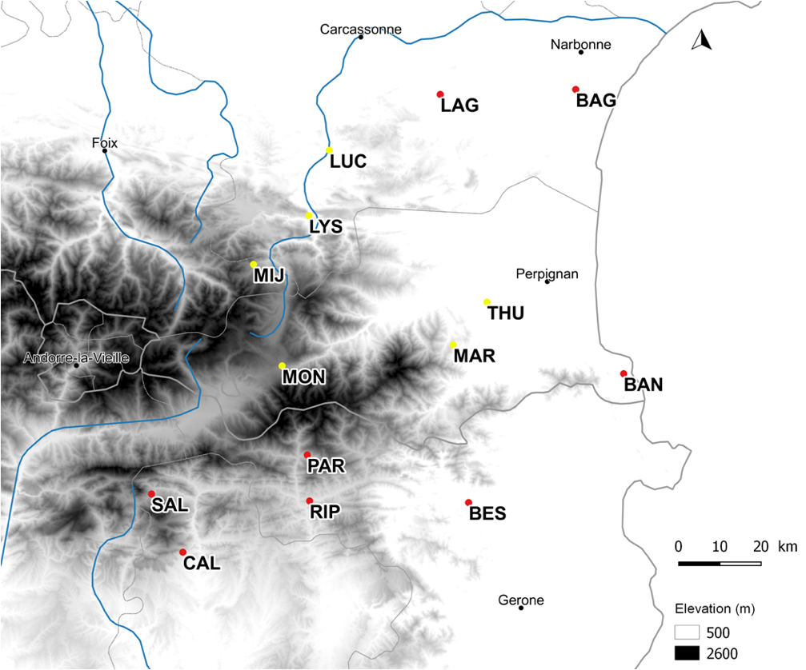

**FIGURE 1. Map of *Antirrhinum majus* populations**

*A. majus* populations were sampled across the geographic range of the species in Southern France. Red dots represent *A. m. pseudomajus* populations, yellow dots represent *A. m striatum* populations. Population names and description can be found in Table S1.

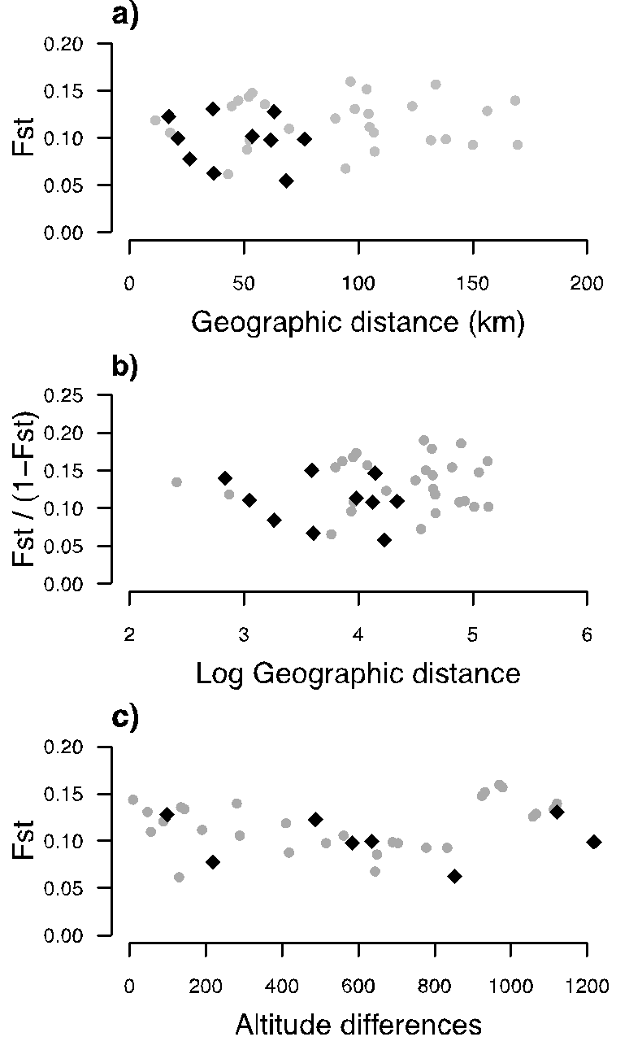

**FIGURE 2. Pairwise neutral genetic differentiation *F*ST plotted against pairwise geographic distances or altitudinal differences.**

Pairwise FST was estimatedamong eight *Antirrhinum majus pseudomajus* populations pairs (grey dots), and five *A. m. striatum* populations pairs (black diamonds). There were non-significant relationship between a) *F*ST and geographic distance in *A. m. pseudomajus* (Mantel r = 0.018, P = 0.46 ns) and in *A. m striatum* (Mantel r = -0.15, P = 0.63 ns), b) *F*ST / (1- *F*ST) and the log of geographic distance in *A. m. pseudomajus* (Mantel r = 0.04, P = 0.41 ns) and in *A. m striatum* (Mantel r = -0.18, P = 0.6 ns), c) *F*ST and altitude differences in *A. m. pseudomajus* (Mantel r = 0.23, P = 0.05 ns) and in *A. m striatum* (Mantel r = -0.3, P = 0.94 ns).

**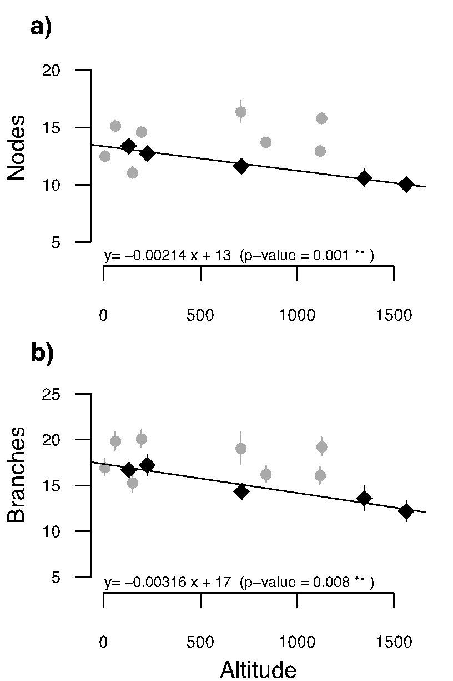**

**FIGURE 3. Trait changes with altitude.**

Population estimates of marginal means with standard errors of two phenotypic traits (a. number of nodes, b. number of branches) in populations of two subspecies of *Antirrhinum majus* grown in a common garden. Means are plotted against altitude of origin. Lines refer to the linear regression between trait mean estimates and altitude. Grey dots represent *A. m. pseudomajus* populations, black diamonds represent *A. m. striatum* populations. Equation of non-significant linear regressions were a) y= 0.00125 x +12 (P = 0.43 ns) and b), y= -0.00048 x +18 (P = 0.78 ns) for *A. m. pseudomajus*.



**FIGURE 4. Overall *Q*ST estimates with their 95% CI**

Overall *Q*ST estimates with their 95% CI are represented for seven phenotypic traits in eight *Antirrhinum majus pseudomajus* populations (grey dots) and five *A. m. striatum* populations (black diamonds) that were grown in a common garden.Average population *F*ST is represented by the dashed grey line for *A. m. pseudomajus*, and the dashed black line for *A. m. striatum*. Germ.date = germination date, Diameter= stem diameter, Nodes = number of nodes, Branches = number of branches, Height= plant height, Inter. Length= internodes length, SLA= specific leaf area.

figures/fig5.pdf

**FIGURE 5. Illustration of the relationship between population pairwise *Q*ST, *F*ST and altitudinal differences**

Population pairwise quantitative trait differentiation (*Q*ST) for the germination date, the number of branches and the number of nodes in *Antirrhinum majus striatum* (a, c and e, black diamonds) and *A. m. pseudomajus* (b, d and f, black dots). Black lines are only indicative. They represent the informal linear relationship of population pairwise QST on population pairwise altitudinal differences (m), thereby illustrating the statistical dependency formally tested by Mantel test approaches. Grey dots and dashed line refer to population neutral genetic differentiation (*F*ST).

**Reference List**

Abbott, R. J., and A. C. Brennan. 2014. Altitudinal gradients, plant hybrid zones and evolutionary novelty. *Philosophical Transactions of the Royal Society B: Biological Sciences* 369: 20130346.

Alberto, F., J. Niort, J. Derory, O. Lepais, R. Vitalis, D. Galop, and A. Kremer. 2010. Population differentiation of sessile oak at the altitudinal front of migration in the French Pyrenees: genetic diversity of oaks in the Pyrenees. *Molecular Ecology* 19: 2626–2639.

Andalo, C., M. B. Cruzan, C. Cazettes, B. Pujol, M. Burrus, and C. Thébaud. 2010. Post-pollination barriers do not explain the persistence of two distinct *Antirrhinum* subspecies with parapatric distribution. *Plant Systematics and Evolution* 286: 223–234.

Angert, A. L., and D. W. Schemske. 2005. The evolution of species’ distributions: reciprocal transplants across the elevation ranges of *Mimulus cardinalis* and *M. lewisii*. *Evolution* 59: 1671–1684.

Bates, D., M. Mächler, B. Bolker, and S. Walker. 2015. Fitting linear mixed-effects models using **lme4**. *Journal of Statistical Software* 67.

Bonhomme, V., S. Picq, C. Gaucherel, and J. Claude. 2014. **Momocs**: outline analysis using *R*. *Journal of Statistical Software* 56.

Debout, G. D. G., E. Lhuillier, P.-J. G. Malé, B. Pujol, and C. Thébaud. 2012. Development and characterization of 24 polymorphic microsatellite loci in two *Antirrhinum majus* subspecies (Plantaginaceae) using pyrosequencing technology. *Conservation Genetics Resources* 4: 75–79.

Donohue, K., R. Rubio de Casas, L. Burghardt, K. Kovach, and C. G. Willis. 2010. Germination, postgermination adaptation, and species ecological ranges. *Annual Review of Ecology, Evolution, and Systematics* 41: 293–319.

Edelaar, P., P. Burraco, and I. Gomez-Mestre. 2011. Comparisons between *Q*ST and *F*ST-how wrong have we been? *Molecular Ecology* 20: 4830–4839.

Etterson, J. R. 2004. Evolutionary potential of *Chamaecrista fasciculata* in relation to climate change. II. Genetic architecture of three populations reciprocally planted along an environmental gradient in the great plains. *Evolution* 58: 1459–1471.

Gimenez-Benavides, L., A. Escudero, and J. M. Iriondo. 2006. Local adaptation enhances seedling recruitment along an altitudinal gradient in a high mountain mediterranean plant. *Annals of Botany* 99: 723–734.

Halbritter, A. H., S. Fior, I. Keller, R. Billeter, P. J. Edwards, R. Holderegger, S. Karrenberg, *et al* 2018. Trait differentiation and adaptation of plants along elevation gradients. *Journal of Evolutionary Biology* 31: 784–800.

Hereford, J. 2009. A quantitative survey of local adaptation and fitness trade‐offs. *The American Naturalist* 173: 579–588.

Kawecki, T. J., and D. Ebert. 2004. Conceptual issues in local adaptation. *Ecology Letters* 7: 1225–1241.

Khimoun, A., M. Burrus, C. Andalo, Z.-L. Liu, C. Vicédo-Cazettes, C. Thébaud, and B. Pujol. 2011. Locally asymmetric introgressions between subspecies suggest circular range expansion at the *Antirrhinum majus* global scale. *Journal of Evolutionary Biology* 24: 1433–1441.

Khimoun, A., J. Cornuault, M. Burrus, B. Pujol, C. Thebaud, and C. Andalo. 2013. Ecology predicts parapatric distributions in two closely related *Antirrhinum majus* subspecies. *Evolutionary Ecology* 27: 51–64.

Kim, E., and K. Donohue. 2013. Local adaptation and plasticity of *Erysimum capitatum* to altitude: its implications for responses to climate change. *Journal of Ecology* 101: 796–805.

Körner, C. 1999. Alpine plant life. Springer Berlin Heidelberg, Berlin, Heidelberg.

Lamy, J.-B., C. Plomion, A. Kremer, and S. Delzon. 2012. *Q*ST < *F*ST as a signature of canalization. *Molecular Ecology* 21: 5646–5655.

Langlade, N. B., X. Feng, T. Dransfield, L. Copsey, A. I. Hanna, C. Thebaud, A. Bangham, *et al* 2005. Evolution through genetically controlled allometry space. *Proceedings of the National Academy of Sciences* 102: 10221–10226.

Leimu, R., and M. Fischer. 2008. A meta-analysis of local adaptation in plants. *PLoS ONE* 3: e4010.

Leinonen, T., R. J. S. McCairns, R. B. O’Hara, and J. Merilä. 2013. *Q*ST - *F*ST comparisons: evolutionary and ecological insights from genomic heterogeneity. *Nature Reviews Genetics* 14: 179–190.

Leinonen, T., R. B. O’Hara, J. M. Cano, and J. Merilä. 2008. Comparative studies of quantitative trait and neutral marker divergence: a meta-analysis: *Q*ST - *F*ST meta-analysis. *Journal of Evolutionary Biology* 21: 1–17.

Lenth, R., H. Singmann, J. Love, P. Buerkner, and M. Herve. 2019. Package ‘emmeans’: Estimated marginal means, aka least-squares means. Version 1.4.3.01. *CRAN*.

Lind, M. I., P. K. Ingvarsson, H. Johansson, D. Hall, and F. Johansson. 2011. Gene flow and selection on phenotypic plasticity in an island system of *Rana temporaria*. *Evolution* 65: 684–697.

Mantel, N. 1967. The detection of disease clustering and a generalized regression approach. *Cancer Research* 27: 209–220.

McKay, J. K., and R. G. Latta. 2002. Adaptive population divergence: markers, QTL and traits. *Trends in Ecology & Evolution* 17: 285–291.

Meirmans, P.G., and P.H. Van Tienderen. 2004. GENOTYPE and GENODIVE: two programs for the analysis of genetic diversity of asexual organisms, *Molecular Ecology Notes* 4: 792-794.

Merilä, J., and P. Crnokrak. 2001. Comparison of genetic differentiation at marker loci and quantitative traits: Natural selection and genetic differentiation. *Journal of Evolutionary Biology* 14: 892–903.

Neuffer, B. and H. Hurka. 1986. Variation of development time until flowering in natural-populations of *Capsella bursa-pastoris* (Cruciferae). *Plant Systematics and Evolution* 152: 277-296.

O’Hara, R. B., and J. Merilä. 2005. Bias and precision in *Q*ST estimates: problems and some solutions. *Genetics* 171: 1331–1339.

Oksanen, J., R. Kindt, P. Legendre, B. O’Hara, G. Simpson, P. Solymos, M. Stevens, and H. Wagner. 2009. The VEGAN Package: community ecology package.

Ovaskainen, O., M. Karhunen, C. Zheng, J. M. C. Arias, and J. Merilä. 2011. A new method to uncover signatures of divergent and stabilizing selection in quantitative traits. *Genetics* 189: 621–632.

Pérez-Harguindeguy, N., S. Díaz, E. Garnier, S. Lavorel, H. Poorter, P. Jaureguiberry, M. S. Bret-Harte, *et al* 2016. Corrigendum to: New handbook for standardised measurement of plant functional traits worldwide. *Australian Journal of Botany* 64: 715.

Pujol, B., J. Archambeau, A. Bontemps, M. Lascoste, S. Marin, and A. Meunier. 2017. Mountain landscape connectivity and subspecies appurtenance shape genetic differentiation in natural plant populations of the snapdragon (*Antirrhinum majus* L.). *Botany Letters* 164: 111–119.

Pujol, B., J.-L. Salager, M. Beltran, S. Bousquet, and D. McKey. 2008. Photosynthesis and leaf structure in domesticated Cassava (Euphorbiaceae) and a close wild relative: have leaf photosynthetic parameters evolved under domestication? *Biotropica* 40: 305–312.

Pujol, B., A. J. Wilson, R. I. C. Ross, and J. R. Pannell. 2008. Are *Q* ST - *F* ST comparisons for natural populations meaningful? *Molecular Ecology* 17: 4782–4785.

R Core Team. 2018. R: a language and environment for statistical computing. R Foundation for Statistical Computing, Vienna, Austria.

Read, Q. D., L. C. Moorhead, N. G. Swenson, J. K. Bailey, and N. J. Sanders. 2014. Convergent effects of elevation on functional leaf traits within and among species. *Functional Ecology* 28: 37–45.

Ringbauer, H., A. Kolesnikov, D. L. Field, and N. H. Barton. 2018. Estimating barriers to gene flow from distorted isolation-by-distance patterns. *Genetics* 208: 1231–1245.

Roff, D. A. 1997. Evolutionary Quantitative Genetics. Springer US, Boston, MA.

Spitze, K. 1993. Population structure in *Daphnia obtusa*: quantitative genetic and allozymic variation. *Genetics* 135: 367–374.

Tastard, E., J.-B. Ferdy, M. Burrus, C. Thébaud, and C. Andalo. 2012. Patterns of floral colour neighbourhood and their effects on female reproductive success in an *Antirrhinum* hybrid zone: flower colour and selection in a hybrid zone. *Journal of Evolutionary Biology* 25: 388–399.

Tavares, H., A. Whibley, D. L. Field, D. Bradley, M. Couchman, L. Copsey, J. Elleouet, *et al* 2018. Selection and gene flow shape genomic islands that control floral guides. *Proceedings of the National Academy of Sciences* 115: 11006–11011.

Whibley, A. C. 2006. Evolutionary paths underlying flower color variation in Antirrhinum. *Science* 313: 963–966.

Whitlock, M. C. 2008. Evolutionary inference from *Q*ST. *Molecular Ecology* 17: 1885–1896.

Whitlock, M. C., and K. J. Gilbert. 2012. *Q*ST in a hierarchically structured population. *Molecular Ecology Resources* 12: 481–483.

Whitlock, M. C., and F. Guillaume. 2009. Testing for spatially divergent selection: comparing *Q*ST to *F*ST. *Genetics* 183: 1055–1063.

Wright, I. J., P. B. Reich, M. Westoby, D. D. Ackerly, Z. Baruch, F. Bongers, J. Cavender-Bares, *et al* 2004. The worldwide leaf economics spectrum. *Nature* 428: 821–827.

**Supplementary material**

**Supplementary information**

The variance in altitude was not significantly different between subspecies, and should not drive difference between taxa. Indeed, we performed an ANOVA testing the difference of variance in altitude between subspecies and we found no significant differences (P-value = 0.4, F-value = 0.765, df =1, Sum Sq =225889, Mean Sq= 225889, df Residuals = 11, Sum Sq residuals= 3247238, Mean Sq Residuals= 295203).

**TABLES**

TABLE S1 Description of *Anthirinum majus* populations grown in the common garden experiment. *Nfam*= number of families, *N*= number of plants

|  |  |  |  |  |  |  |  |  |
| --- | --- | --- | --- | --- | --- | --- | --- | --- |
| **Acronym** | **Latitude** | **Longitude** | **Location** | **Elevation (m)** | **Subspecies** | **Description** | ***Nfam*** | ***N*** |
| BAG | 43.10 | 2.98 | Bages | 6 | *pseudomajus* | Dunes on seaside (rocky / herbaceous) | 40 | 67 |
| BAN | 42.49 | 3.12 | Banyuls-sur-Mer | 61 | *pseudomajus* | Rockside bank (rocky) | 32 | 54 |
| THU | 42.64 | 2.72 | Thuir | 130 | *striatum* | Roadside bank (herbaceous) | 34 | 60 |
| LAG | 43.09 | 2.58 | Lagrasse | 149 | *pseudomajus* | Roadside bank (rocky / herbaceous) | 32 | 55 |
| BES | 42.21 | 2.67 | Besalú | 195 | *pseudomajus* | Stone walls in village | 39 | 69 |
| LUC | 42.97 | 2.26 | Luc-sur-Aude | 227 | *striatum* | Roadside bank and river-side bank (rocky) | 19 | 29 |
| RIP | 42.21 | 2.20 | Ripoll | 709 | *pseudomajus* | Roadside bank (herbaceous) | 9 | 16 |
| LYS | 42.83 | 2.20 | ‘Pierre-Lys’ gorge | 713 | *striatum* | Roadside bank (rocky / herbaceous) | 32 | 53 |
| CAL | 42.10 | 1.83 | Berga | 838 | *pseudomajus* | Roadside bank (herbaceous) | 42 | 69 |
| PAR | 42.31 | 2.20 | Pardines | 1118 | *pseudomajus* | Roadside bank (herbaceous) | 32 | 58 |
| SAL | 42.23 | 1.74 | Saldes | 1126 | *pseudomajus* | Banks in pasture (herbaceous) | 30 | 55 |
| MIJ | 42.73 | 2.04 | Mijanès | 1347 | *striatum* | Roadside bank (herbaceous) | 10 | 18 |
| MON | 42.51 | 2.12 | Mont-Louis citadelle | 1564 | *striatum* | Stone walls on fortifications | 21 | 34 |
|  |  |  |  |  |  | *All populations* | *372* | *637* |

TABLE S2

Population pairwise *F*ST for a) *Anthirinum majus pseudomajus* and b) *A. m. striatum.*

|  |  |  |  |  |  |  |  |  |  |
| --- | --- | --- | --- | --- | --- | --- | --- | --- | --- |
| a) *Anthirinum majus pseudomajus* | | | | |  |  |  |  |  |
| Obs. | BAG | | BAN | BES | CAL | LAG | PAR | RIP | SAL |
| BAG | 0.000000 | | 0.109661 | 0.111560 | 0.093282 | 0.134302 | 0.134404 | 0.097873 | 0.140489 |
| BAN | 0.109661 | | 0.000000 | 0.136375 | 0.093343 | 0.120889 | 0.125510 | 0.086353 | 0.128994 |
| BES | 0.111560 | | 0.136375 | 0.000000 | 0.068186 | 0.131472 | 0.147507 | 0.098488 | 0.152424 |
| CAL | 0.093282 | | 0.093343 | 0.068186 | 0.000000 | 0.099317 | 0.139897 | 0.062174 | 0.106419 |
| LAG | 0.134302 | | 0.120889 | 0.131472 | 0.099317 | 0.000000 | 0.159517 | 0.106148 | 0.156761 |
| PAR | 0.134404 | | 0.125510 | 0.147507 | 0.139897 | 0.159517 | 0.000000 | 0.119122 | 0.144271 |
| RIP | 0.097873 | | 0.086353 | 0.098488 | 0.062174 | 0.106148 | 0.119122 | 0.000000 | 0.088219 |
| SAL | 0.140489 | | 0.128994 | 0.152424 | 0.106419 | 0.156761 | 0.144271 | 0.088219 | 0.000000 |
|  |  | |  |  |  |  |  |  |  |
| b) *Anthirinum majus striatum* | | | | |  |  |  |  |  |
| Obs | | LUC | LYS | MIJ | MON | THU |  |  |  |
| LUC | | 0.000 | 0.123 | 0.131 | 0.102 | 0.128 |  |  |  |
| LYS | | 0.123 | 0.000 | 0.100 | 0.063 | 0.098 |  |  |  |
| MIJ | | 0.131 | 0.100 | 0.000 | 0.078 | 0.099 |  |  |  |
| MON | | 0.102 | 0.063 | 0.078 | 0.000 | 0.055 |  |  |  |
| THU | | 0.128 | 0.098 | 0.099 | 0.055 | 0.000 |  |  |  |

TABLE S3

Quantitative genetics parameters for phenotypic traits among eight populations of *Anthirinum majus pseudomajus* and five populations of *Anthirinum majus striatum* grown in a common garden. Values for trait heritability (*h*²), family variance (*V*w), among-population variance (*V*b), residual variance corresponding to the within-population variance (*V*res) and quantitative trait divergence (*Q*ST). The degrees of freedom used in the bootstrapping procedures are seven for the among-population component (*V*b) for *A.m. pseudomajus* and four for *A. m. striatum*. Degrees of freedom are given in this table for the within-population component (df*V*w).

|  |  |  |  |  |  |  |  |  |  |  |
| --- | --- | --- | --- | --- | --- | --- | --- | --- | --- | --- |
|  | Traits | *h*² |  | *h*².CI | *V*w | *V*b | *V*res | df*V*w | *Q*ST | *Q*ST |
|  |  |  |  |  |  |  |  |  |  |  |
| a) *A. m. pseudomajus* | |  |  |  |  |  |  |  |  |  |  |
|  | Germination date | 0.35 |  | 0.3; 0.43 | 14.05 | 0 | 65.13 | 184 | 0 | 0 |
|  | Diameter | 0.19 |  | 0.16; 0.23 | 0.07 | 0.02 | 0.68 | 184 | 0.06 | 0.06 |
|  | Nodes | 0.45 |  | 0.38; 0.53 | 2.97. | 2.69 | 10.27 | 184 | 0.19 | 0.19 |
|  | Branches | 0.11 |  | 0.09; 0.14 | 2.46 | 2.80 | 41.25 | 184 | 0.22 | 0.22 |
|  | Plant height | 0.32 |  | 0.27; 0.38 | 19.72 | 16.1 | 105.45 | 184 | 0.17 | 0.17 |
|  | Internode length | 0.83 |  | 0.73; 0.94 | 0.10 | 0.06 | 0.14 | 184 | 0.14 | 0.14 |
|  | SLA | 0.25 |  | 0.21; 0.30 | 172 | 141.7 | 1216 | 184 | 0.17 | 0.17 |
|  |  |  |  |  |  |  |  |  |  |  |
| b) *A. m. striatum* | |  |  |  |  |  |  |  |  |  |  |
|  | Germination date | 0.12 |  | 0.09; 0.16 | 4.37 | 4.49 | 71.98 | 82 | 0.20 | 0.20 |
|  | Diameter | 0.17 |  | 0.12; 0.23 | 0.05 | 0.07 | 0.55 | 82 | 0.27 | 0.27 |
|  | Nodes | 0.56 |  | 0.44; 0.70 | 2.90 | 1.64 | 7.57 | 82 | 0.12 | 0.12 |
|  | Branches | 0.01 |  | 0.01; 0.01 | 0.12 | 3.52 | 26.31 | 82 | 0.88 | 0.88 |
|  | Plant height | 0.06 |  | 0.04; 0.08 | 2.47 | 92.95 | 84 | 82 | 0.90 | 0.90 |
|  | Internode length | 0.81 |  | 0.66; 0.98 | 0.08 | 0.04 | 0.11 | 82 | 0.12 | 0.12 |
|  | SLA | 0.89 |  | 0.73; 1 | 541 | 400 | 689 | 82 | 0.16 | 0.16 |

**Figures**

**R/Fichier/2018-2019/LocalAdapt_Sara/manuscript/figures/figS1.pdf**

FIGURE S1.

Annual average temperatures and rainfall of eight *Antirrhinum majus pseudomajus* populations (grey dots) and five *A. m. striatum* populations (black diamonds) from the Southern France. Population average temperature (a) and average rainfall (b) as a function of altitude. Bioclimatic data was extracted from the *WorldClim* database *(*www.worldclim.org).

**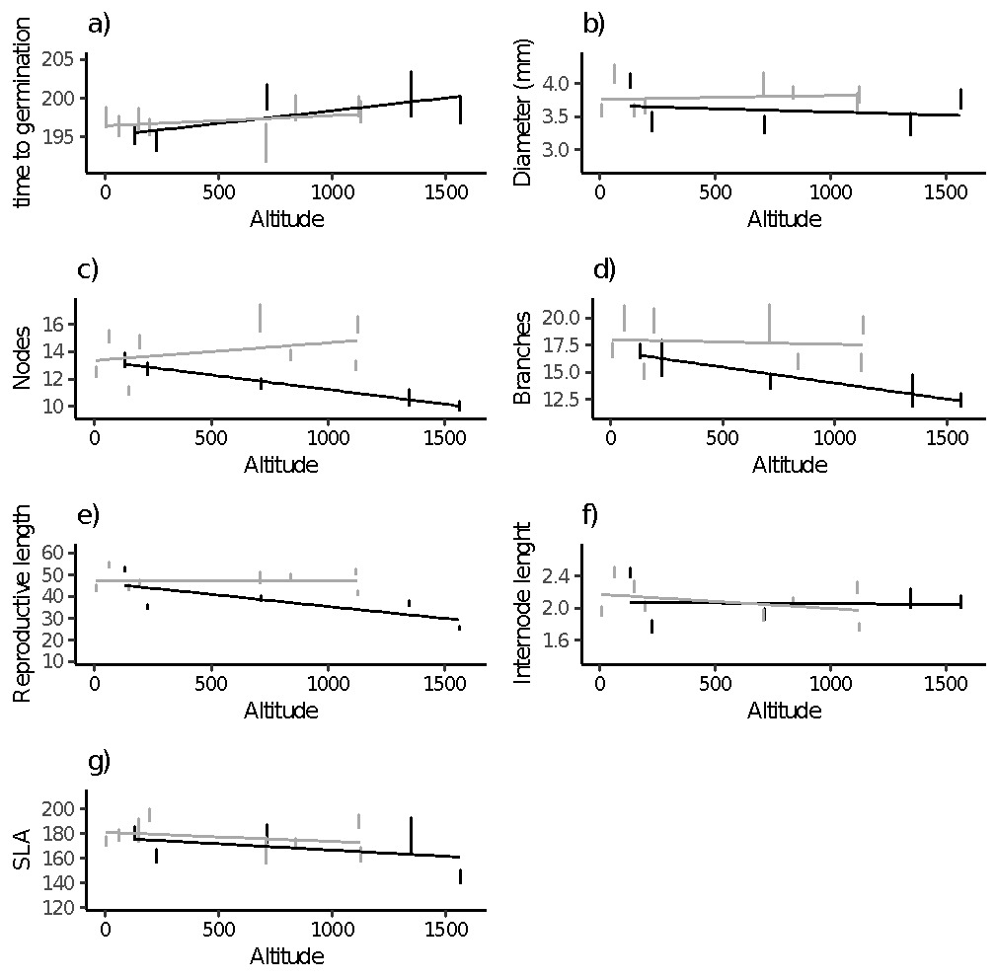**

FIGURE S2.

Population arithmetic means with standard errors of seven phenotypic traits in populations of two subspecies of *Antirrhinum majus* grown in a common garden. Means are plotted against altitude of origin. Grey dots represent *A. m.* ssp. *pseudomajus* populations, black diamonds represent *A. m.* ssp. *striatum* populations.

**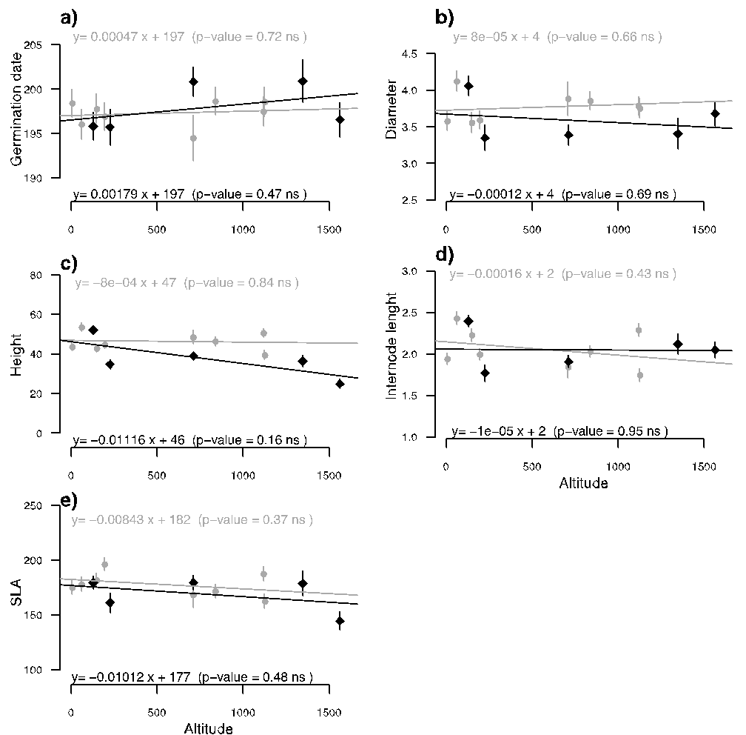**

FIGURE S3. Population estimates of marginal means with standard errors of five phenotypic traits in populations of two subspecies of *Antirrhinum majus* grown in a common garden. Means are plotted against altitude of origin. Lines refer to the linear regression between traits means estimates and altitude. Grey dots and lines represent *A. m. pseudomajus* populations, black diamonds and lines represent *A. m.* ssp. *striatum* populations.

figures/figS2.pdf

FIGURE S4.  The simulated distribution of *Q*ST - *F*ST for a neutral trait, and the observed point estimates of *Q*ST - *F*ST differences in seven phenotypic traits measured for the eight *Antirrhinum majus* *pseudomajus* populations from the Southern France. The distribution of *Q*ST - *F*ST differences for a neutrally evolving trait was simulated following Whitlock and Guillaume (2009) based upon the observed population differentiation in neutral markers (*F*ST) and the within-population variance in each trait. The arrow indicates the observed *Q*ST - *F*ST.

figures/figS3.pdf

FIGURE S5.  The simulated distribution of *Q*ST - *F*ST for a neutral trait, and the observed point estimates of *Q*ST - *F*ST differences in seven phenotypic traits measured for the five *Antirrhinum majus* *striatum* populations from the Southern France. The distribution of *Q*ST - *F*ST differences for a neutrally evolving trait was simulated following Whitlock and Guillaume (2009) based upon the observed population differentiation in neutral markers (*F*ST) and the within-population variance in each trait. The arrow indicates the observed *Q*ST - *F*ST.