Primate sympatry shapes the evolution of their brain architecture
Benjamin Robira^{1,2,✉}, and Benoît Perez-Lamarque^{3,4}
¹ CEFE, Univ Montpellier, CNRS, EPHE, IRD, Montpellier, France.
² Eco-anthropologie (EA), Muséum National d’Histoire Naturelle, CNRS, Université de Paris, Musée de l’Homme, Paris, France.
³ Institut de Biologie de l’École Normale Supérieure (IBENS), École Normale Supérieure, CNRS, INSERM, Université PSL, Paris, France.
⁴ Institut de Systématique, Évolution, Biodiversité (ISYEB), Muséum National d’Histoire Naturelle, CNRS, Sorbonne Université, EPHE, Université des Antilles, Paris, France.
✉ Correspondence: Benjamin Robira <benjamin.robira@normalesup.org>

Abstract | The main hypotheses on the evolution of animal cognition emphasise the role of conspecifics in affecting the socio-ecological environment shaping cognition. Yet, space is often simultaneously occupied by multiple species from the same ecological guild. These sympatric species can compete for food, which may thereby stimulate or hamper cognition. Considering brain size as a proxy for cognition, we tested whether species sympatry impacted the evolution of cognition in frugivorous primates. We first retraced the evolutionary history of sympatry between frugivorous primate lineages. We then fitted phylogenetic models of the evolution of the size of several brain areas in frugivorous primates, considering or not species sympatry. We found that the whole brain or brain areas used in immediate information processing were best fitted by models not considering sympatry. By contrast, models considering species sympatry best predicted the evolution of brain areas related to a long-term memory of interactions with the social or ecological environment, with a decrease of their size the higher the sympatry. We speculate that species sympatry, by generating intense food depletion, leads to an over-complexification of resource spatio-temporality that may counteract the benefits of high cognitive abilities, drives niche partitioning and specialisation, and thereby induces lower brain area sizes. In addition, we reported that primate species in sympatry diversify more slowly. This comparative study suggests that species sympatry significantly contributes to shaping primate cognition and diversification.
Short title: Sympatry shapes primates’ brain architecture
Keywords: Brain size - Cognition - Diversification - Frugivory - Primates - Sympatry

Introduction
Cognition evolution is shaped by the balance between socio-ecological drivers promoting cognitive abilities (González-Forero and Gardner 2018) and physiological and energetic constraints limiting them (Navarrete, Schaik, and Isler 2011). Primates are pivotal species for cognitive studies (Byrne 2000) because their cognition is thought to be promoted by interactions of individuals with conspecifics within the social unit (Byrne 2018; Dunbar and Shultz 2017), among generations (Wilson 1991; Whiten and Schaik 2007; Reader and Laland 2002; Herrmann et al. 2007; Tomasello 2019; Schaik and Burkart 2011), between social units (Ashton, Kennedy, and Radford 2020), or with the rest of their environment (Clutton‐Brock and Harvey 1980; Milton 1981; Rosati 2017). However, space is often occupied by many primate species, including species sharing the same diet. Because of direct and indirect interactions linked to resource availability, the presence of heterospecifics is also likely to shape the evolution of species cognition.
Retracing the evolutionary history of cognitive abilities proves to be challenging because there is still no consensual measurement for cognition applicable across all species. Up to now, a raw approximation consists in considering the (relative) brain size as a proxy for cognitive abilities, with larger sizes considered equivalent to more advanced cognitive abilities (mammalian carnivores: Benson-Amram et al. 2016; primates: MacLean et al. 2014). Although the relevance of this assumption is heavily limited within species, in part because of plasticity (Gonda, Herczeg, and Merilä 2013), this holds true when comparing different species (e.g. in primates, Reader and Laland 2002). In addition, instead of considering the brain as a whole, the multifaceted aspect of animal cognition is then more precisely depicted by appreciating the mosaic nature of the brain (Barton and Harvey 2000). For instance, variations in the size of some specific brain areas have been robustly associated with variations in cognition related to the functions of these areas (Healy and Rowe 2007). The brain is therefore a patchwork of areas cognitively specialised that may follow different evolutionary trajectories.
Because the coexistence of primate species in the same biogeographic area (henceforth referred to as sympatry) can affect multiple aspects of their social-ecological environment, brain areas may be affected differently by sympatry. Considering a simplistic functional picture of the primate brain, one can hypothesise how sympatry might, through direct or indirect competition or cooperation, influence the relative benefits of cognition (i.e. the balance between its benefits and its costs).
First, sympatric primate species may have dietary overlaps and compete for the same food resources (Kamilar and Ledogar 2011). Broad dietary guilds (frugivores, folivores, nectarivores, granivores, insectivores, etc.) are generally considered based on the main type of food they consume. Having several sympatric species competing for the same food resource often leads to an increase in food depletion of the shared resource compared with an environment with only one foraging species (Minot 1981). Such depletion may therefore complexify the pattern of resource distribution and availability in space and time. This complexification may in turn affect the selective pressures upon brain areas involved in the storing of spatio-temporal information, such as the hippocampus (Burgess, Maguire, and O’Keefe 2002, Hypothesis 1: the long term memory is affected by sympatry). This complexification may also occur when the dietary overlap is inexistent, as foragers may rely on phenological cross-correlations between plant species (e.g. if plant species A produces fruits earlier in the season than plant species B, thus the availability of B fruits can be predicted based on the availability of A fruits, even though A is not consumed by the forager, Robira et al. 2021). Food depletion may thus weaken these cross-correlations and make food availability predictions less reliable.
Second, sympatric species may enrich the landscape of visual, olfactory or acoustic cues usable to locate available food (e.g. Avarguès-Weber, Dawson, and Chittka 2013; Kashetsky, Avgar, and Dukas 2021). Consequently, it may impact the selective pressures upon brain areas involved in processing more immediate sensory information, such as the Main Olfactory Bulb (MOB), the cerebellum (Koziol et al. 2014; Sokolov, Miall, and Ivry 2017), and the neocortex (Wiltgen et al. 2004) (Hypothesis 2: cue processing is affected by sympatry).
Third, besides indirect interactions through foraging, cognition can also be triggered by direct “social” interactions with other individuals (Byrne 2018; Dunbar and Shultz 2017). The striatum, a brain area stimulated during social interactions (Báez-Mendoza and Schultz 2013), or to a lesser extent, the hippocampus (Todorov et al. 2019), may therefore be affected by the increase of direct social interactions between heterospecifics (Hypothesis 3: sociality is affected by sympatry).
Under these (non-exclusive) hypotheses, sympatry could stimulate or hamper cognition evolution by affecting the relative benefits that cognition provides. Indeed, memory stands as a valuable tool to infer food availability and location when food is rare and ephemeral but predictable (Milton 1981; Rosati 2017), but is energetically costly. On the one hand, having a better memory should be advantageous under reasonable food depletion. In addition, competition for the shared resource between species should promote anticipatory behaviour, hence high cognition, as expected for within-species competition (Ashton, Kennedy, and Radford 2020). In this case, the size of the hippocampus (reflecting long-term memory abilities) should be larger the higher the sympatry intensity (Prediction 1.1). On the other hand, intense depletion also increases environmental unpredictability. In the case of a frugivore searching for fruit, for instance, the perceived synchrony in fruit production between trees of the same or different species, used to infer food availability (Janmaat et al. 2012), can be lowered by depletion, therefore limiting the benefits of memory (Robira et al. 2021). Due to the energy constraints of maintaining a large brain, the hippocampus size could thus be smaller in species experiencing high levels of sympatry (Prediction 1.2). Furthermore, the competition between sympatric species from a given dietary guild may be lowered by specialising in different food resources, i.e. niche partitioning. While a species might specialise in food that is difficult to access and requires high cognition (e.g. through the use of tools), specialisation is generally associated with reduced flexibility and thus lower cognitive abilities (Henke-von der Malsburg, Kappeler, and Fichtel 2020). A strong association between niche partitioning and cognitive specialisation has been previously raised in primates (Aristide et al. 2016). From this perspective, a high level of sympatry could be enabled by high cognitive specialisation toward specific food types, requiring less long-term memory abilities, and could also result in smaller hippocampus sizes in highly (specialised) sympatric species.
Meanwhile, cues left out by heterospecifics and usable to locate available food might also add to environmental ones already available. Hence, sympatry could be associated with larger sizes of the MOB, the cerebellum, or the neocortex (Prediction 2).
Finally, an increase in direct interactions between species, such as with the formation of mixed-group species (Goodale et al. 2010), should imply an upsurge of social stimuli leading to a larger size of the striatum or hippocampus in sympatry (Prediction 3).
In any case, the evolution of brain size in primates likely impacted their dynamic of species diversification. Larger brain sizes are indeed found to be associated with higher diversification rates in birds (Sayol et al. 2019) and similar patterns have been suggested in primates (Melchionna et al. 2020). However, it remains unclear how brain size and diversification are interlinked in the context of sympatry.
Here, we investigated whether species sympatry affected the evolution of cognition using frugivorous primates as a study example. Frugivorous primates are an interesting group for such a question because fruit is the archetype of a hard-to-find resource yet predictable (Janmaat et al. 2016), for which cognition considerably shapes the foraging strategy (Trapanese et al. 2019). To infer the effect of species sympatry on cognition in frugivorous primates, we evaluated the support for phylogenetic models of brain size evolution accounting or not for species sympatry, and investigated the directionality of the selection induced by sympatry on brain size evolution. Finally, we tested for correlative patterns between brain size or current sympatry and species diversification in all primates, to better understand the impact of cognition and interactions between primates on their evolutionary success.

Methods
Data processing, analyses, and plots were computed with R software (v.4.1.2, R Core Team 2020).

Data Collection

Phylogeny
We used chronogram trees of the primate taxon of the 10kTrees project (downloaded on May 2021, version 3), as well as a consensus tree of 1000 trees for the subsequent phylogenetic analyses. The trees contain 301 primate species (Figure 2). Note that in all these analyses, we discarded Homo sapiens and Macaca sylvanus. The latter was discarded because of its complete geographic isolation and repeated intervention of humans in population maintenance (Modolo, Salzburger, and Martin 2005). A summary of available data per species is presented in Supplementary Figure S4.

Trait data
Data were pooled from previous literature surveys (see Supplementary Material “Data availability”). Brain data were obtained from DeCasien and Higham (2019) for the whole brain and all other areas mentioned (cerebellum, hippocampus, Main Olfactory Bulb (MOB), neocortex, striatum) from Powell, Isler, and Barton (2017) and from Powell, Barton, and Street (2019) for the whole brain, cerebellum and neocortex size, from Todorov et al. (2019) for hippocampus, and neocortex size, from Grueter (2015) for the whole brain size, and from Navarrete et al. (2018) for the whole brain, cerebellum, hippocampus, and striatum size. They were freely available in the main manuscript or supplementary material. For each primate species, the percentage of frugivory and/or folivory was obtained based on a freely available dataset from DeCasien, Williams, and Higham (2017), from Powell, Isler, and Barton (2017), and from Willems, Hellriegel, and Schaik (2013). The availability of trait and distribution range for the 301 primate species is depicted in Supplementary Figure S4. From the global endocranial brain volume, we obtained the Encephalization Quotient (EQ, N$​_{EQ,max}$ = 182) as follows (DeCasien, Williams, and Higham 2017)
$$EQ=1.036×Brain volume/\left(0.085×{Body mass}^{0.775}\right)$$
with the brain volume in cm$​^{3}$, 1.036 g/cm$​^{3}$ being the assumed homogeneous brain density, and the body mass in g. EQ indicates whether the brain size ranges above (> 1) or below (< 1) what is expected given the body mass. Body mass was obtained from DeCasien, Williams, and Higham (2017), from Powell, Isler, and Barton (2017), from Grueter (2015), and from Pearce et al. (2013). The sub-parts of the brain were chosen because they were involved in immediate sensory information processing (MOB, N$​_{MOB,max}$ = 39), in movement and/or general information processing and retention (neocortex, N$​_{Neocortex,max}$ = 69, Wiltgen et al. 2004; cerebellum, N$​_{Cerebellum,max}$ = 70, Koziol et al. 2014; Sokolov, Miall, and Ivry 2017), or short-term working memory and long-term spatio-temporal memory (hippocampus, N$​_{Hippocampus,max}$ = 63, Burgess, Maguire, and O’Keefe 2002). The striatum (N$​_{Striatum,max}$ = 63) supports information processing during social interaction, reward assessment, planning or goal-oriented behaviours (Báez-Mendoza and Schultz 2013; Johnson, Meer, and Redish 2007). To investigate their evolutionary history, we first used the ratio between their volume and body mass to maximize comparability. As such, the use of specific area sizes relative to the body mass and not raw sizes depicts the evolution of cognitive abilities in terms of allocation rather than abilities per se (but see discussion in Deaner, Nunn, and Schaik 2000). Second, we repeated the analyses considering the ratio between the brain area volume and the whole brain volume, as this might reflect within brain energy reallocation (i.e. mosaic evolution of the brain).

Ranging Data
The current biogeographic range of each primate species was assessed using ranging maps provided by the IUCN red list (IUCN 2021). Ranging data were available for 249 species among the 301 represented in the 10kTrees primate phylogeny.

Retracing past sympatry between primate species
Based on the biogeographic distribution of each extant primate species, we first reconstructed the history of past sympatry between primate lineages. To do so, we followed Drury et al. (2018) and first reconstructed the biogeographic history of each primate lineage to then retrace which pairs of primate lineages were likely to be simultaneously present at the same place. Leaning on Kamilar (2009), we considered that the biogeography of primates can be described by 12 discrete biogeographic areas with highly similar community structures shaped by both the environment geography and climatic correlates. These geographic areas, mapped using Google earth professional (v7.3.3), are represented in Figure 1. One to multiple biogeographic areas were assigned to each species as soon as 10% of their current distribution range overlapped on the surface with a given biogeographic area. We also replicated these biogeographic assignations by using instead a larger threshold of 30%. This upper threshold was chosen because, as such, a species could initially occupy a maximum of three areas, thus at best would occupy one continent at present (Figure 1). Overlaps of primate current ranges with biogeographic areas were calculated with the “gIntersection” function from the rgeos package (Bivand and Rundel 2021) applied to Mercator-projected data to get the overlapping contour, and the “area” function from the geosphere package (Hijmans 2021), applied directly on unprojected longitudinal-latitudinal data for area size calculation.
Given these 12 biogeographic areas, we retraced the biogeographic history of primates with the BioGeoBEARS package (Matzke 2013), using the biogeographic stochastic mapping algorithm (Matzke 2016). We fitted non-time-stratified dispersal-extinction-cladogenesis (DEC) models specifically suiting analyses of range data since it accounts for spatially explicit processes of cladogenetic and anagenetic events (see Matzke (2013) for further details on these events). We fixed to three biogeographic areas the maximum number of areas that a lineage can simultaneously occupy since it offers the possibility to occupy a complete mainland continent while keeping computational time reasonable. DEC models were independently fitted when considering either a 10% or a 30% threshold of range overlaps. Finally, to account for the uncertainty in biogeographic reconstructions, we sampled 10 histories of primate biogeographic ranges. We assumed that two primate lineages were in sympatry at a given time whenever two lineages simultaneously occupied the same biogeographic area.

Inferring past diets of primate lineages
Next, we retraced the evolutionary history of frugivorous lineages in primates. We first classified extant species as either “frugivorous” or “folivorous” based on the availability of percentage of frugivory and folivory, prioritizing frugivory over folivory. A species was classified as frugivorous if the percentage of frugivory was at least above 20%. If this was not the case, or if the percentage of frugivory was unavailable, a species could be classified as folivorous if the percentage of folivory was at least above 40%. Otherwise, DeCasien, Williams, and Higham (2017) gave a binary classification of diet, species being categorised as frugivorous or folivorous, partly based on anatomical criteria. Whenever the percentages were not available, we referred to this classification. In any other cases (e.g. species feeding on invertebrates or tree exudates), the species were discarded. We also replicated these diet assignments by considering a threshold of 40% for frugivory and 60% for folivory.
Second, considering diet as a binary variable (frugivory versus folivory), we retraced the evolutionary history of such discrete traits based on a continuous Markovian process (extended Mk models) using Bayesian inference (Bollback 2006), with the “simmap” function of the phytools package (Revell 2012) and internally setting up the prior probability of trait, but with no prior on the transition matrix. Ancestral diet reconstructions were performed using both combinations of dietary thresholds (20/40% and 40/60% for frugivory and folivory, respectively). To account for the uncertainty in the reconstructions, we sampled 10 stochastic mapping of ancestral diet reconstructions. These ancestral reconstructions were used in combination with the histories of primate biogeographic ranges to assess whether a pair of frugivorous species were in sympatry or not (i.e. we obtained reconstructions of the evolutionary history of sympatry between frugivorous primate lineages).

Phylogenetic models
We assessed the effect of sympatry on primate brain evolution using two approaches. First, we used phylogenetic models of trait evolution to assess the role of sympatry in the evolution of brain size. Second, we investigated how sympatry has influenced brain size evolution (i.e. selection towards smaller or larger brain sizes) by evaluating correlations between current levels of sympatry and brain sizes, using linear models independently for each brain area. Although it does not explicitly consider the potential independence between brain areas, we modelled independently each brain area to preserve the maximum power (i.e. the largest sample size) in each analysis. Finally, we also checked for correlative patterns between primate diversification rate and brain size or levels of sympatry to better understand the impact of cognition and interactions between primates on their evolutionary success.

Phylogenetic models of trait evolution: does species sympatry shape brain size evolution?
- Fitting models of trait evolution
We restricted the analyses to frugivorous species to test whether species sympatry has impacted the evolution of cognition, depicted either by the whole brain (using the Encephalization Quotient, EQ), or the size of the aforementioned specific brain areas relative (i) to the whole body mass (Figure 3) or (ii) to the whole brain size. Models of trait evolution testing the effect of species sympatry on one brain area relative to the whole body mass (models (i)) test whether the total allocation towards specific brain area is affected by species sympatry. In contrast, models of trait evolution testing the effect of species sympatry on one brain area relative to the whole brain size (models (ii)) test whether the within-brain energy reallocation (i.e. mosaic evolution) is affected by species sympatry.
Considering the size of the different brain areas, we independently fitted phylogenetic models of trait evolution (Drury et al. 2016). For models accounting for species sympatry, following Drury et al. (2016), we used our ancestral reconstructions of sympatry between frugivorous lineages. In practice, we obtained a series of interaction matrices (i.e. lines and columns correspond to frugivorous species, and each cell indicates whether a given species pair is in sympatry (value of 1) or not (value of 0)), along the phylogenetic tree of frugivorous primates (see Drury et al. 2016). We fitted three models of brain size evolution accounting for species sympatry: the matching competition (MC) model (Nuismer and Harmon 2015) and density-dependent models (DD$​_{lin}$ and DD$​_{exp}$, Drury et al. 2016). Specifically, these models expand classical Brownian motion (BM) models of stochastic evolution, by including an additional variable related to the current brain size of sympatric species (MC), or by considering density-dependent evolutionary rate (DD models). The MC model considers the repulsion of traits of sympatric lineages from the same dietary guild due to competition (character displacement), that is $z_{i}\left(t+dt\right)=z_{i}\left(t\right)+S\left(μ\left(t\right)-z_{i}\left(t\right)\right)dt+σdB_{i}$ where $z$ is the brain size of a species $i$ at time $t$, $μ$ is the mean value of the trait of sympatric species, $S$ reflects the strength of the effect of species sympatry and $σdB_{i}$ is the drift with a constant evolutionary rate $σ$ (Drury et al. 2016). Here, $S$ is constrained to be negative, which means that sympatric species would tend to divergently evolve either lower, or higher, EQ or relative brain size. Linear (DD$​_{lin}$) or exponential (DD$​_{exp}$) density-dependence (Drury et al. 2016; Weir and Mursleen 2013) assumes that the evolutionary rate, $σ$, of trait change, varies either positively or negatively as a function $f$ of the number of frugivorous sympatric lineages, such as
$$σ_{l}=f_{lin}\left(l\right)=σ_{0}+rl$$
$$σ_{l}=f_{exp}\left(l\right)=σ_{0}\text{exp}\left(rl\right)$$
where $σ_{0}$ corresponds to the value of the initial ancestor, $l$ indicates the number of lineages at a given time, $r$ allows for modelling the speed and direction of the dependency to lineage number ($r>0$ leads to an increase of trait changes, while $r<0$ leads to a decline of the trait changes). In particular, DD models have been extensively used for testing hypotheses linked with adaptive radiations ($r<0$), yet, by their mathematic constructions, they can accomodate much broader scenarios of trait evolution. We fitted models considering species sympatry using the “fit_t_comp” function from the RPANDA package (Morlon et al. 2016).
Depending on the brain area and the frugivory threshold we considered, the models were fitted on different sample sizes: EQ: 148 to 182, striatum: 56 to 63, MOB: 34 to 39, neocortex: 61 to 69, hippocampus: 56 to 63, cerebellum: 62 to 70 frugivorous species. For a given set of models (i.e. within a brain area), the sample was strictly identical, allowing within-set model comparisons. Prior to fitting, trait parameters were log-transformed to reach more symmetrical distributions.
We compared the support of models considering species sympatry to the support of simpler models assuming no effect of species sympatry on the evolution of brain sizes: the Brownian motion (BM), the Ornstein-Uhlenbeck process (OU, a model with an optimum value, see Blomberg, Rathnayake, and Moreau (2020) for a review), or the Early-Burst model (EB), for assessing a time-dependence of the evolutionary rate, irrespectively of the intensity of species sympatry (Blomberg, Garland, and Ives 2003). These models not accounting for species sympatry were fitted using the “fitContinuous” function from the geiger package (Slater et al. 2012; Pennell et al. 2014). All these models were repeated 10 times, using 10 different combinations for the ancestral reconstruction of primate biogeography and diet. They were then compared within an information-theoretic framework (Burnham and Anderson 2002), based on the weights of Akaike Information Criteria corrected for small samples (AICc) when considering all six models (MC, DD$​_{lin}$, DD$​_{exp}$, BM, OU, EB). The model weight depicts how well the model fits the observed data compared with the other tested models.
Each model represents the average of 10 (uncertainty on diet/ranging evolution) x 10 (uncertainty in brain/diet rate data) x 2 (geographic overlap threshold) x 2 (frugivory threshold) x 2 (folivory threshold) = 800 sub-models. We stopped computations when the calculation of the likelihood was excessively long (> 1 week). The final sample size thus was 730 models.
- Determining the effect of sympatry on brain sizes
If diversity-dependent models of traits evolution considering species sympatry inform whether species sympatry has impacted the evolution of the brain size by increasing or decreasing the tempo of trait evolution, they are not informative on the directionality of the effect (i.e. are brain sizes in frugivorous sympatric primates increasing or decreasing?). To determine whether species sympatry positively or negatively affected the sizes of brain areas, we independently fitted Gaussian Pagel’s lambda phylogenetic regressions for each brain area of extant frugivorous species. This model is a derivative of the BM model, where the phylogenetic variance-covariance matrix has all coefficients, but its diagonal ones, multiplied by lambda: it thus relaxes the hypothesis of BM since we included brain areas for which the evolutionary history was best described by models considering sympatry (see Results). To fit these models, we used a frequentist-based approach with the “phylolm” function from the phylolm package (Ho and Ane 2014). We considered the least stringent frugivory assessment, with the frugivory threshold fixed at 20% and the folivory threshold fixed at 40%. If due to data variability, a species did not robustly fit into the categorical classification “frugivorous versus folivorous” (i.e. could be either of the two), it was considered as frugivorous nonetheless. Again, insectivorous species, species feeding on tree exudates, etc., were not considered.
The response variable was the relative size of each brain area (relative to the whole body mass or to the whole brain size). Due to data variability, we took the mean of the possible values given the different datasets and assessed the sensitivity using non-averaged values (see Supplementary Material “Phylogenetic regressions: results, stability, and assumption”). In this model, we used as covariates (i.e. continuous predictors) two explicit measures of the level of species sympatry for each extant frugivorous species: (1) the number of frugivorous sympatric species (square-rooted to reach symmetrical distribution) and (2) the average percentage of overlapping current range (assessed based on IUCN data) with other sympatric frugivorous species. For a given species A, sympatry with another species B was considered when at least 10% of the range of species A overlaps with the range of species B. This was done to reduce the noise induced by coarse identification of species range.
To sum up, when assessing the interplay between species sympatry and the evolution of frugivorous primates’ brain architecture, we considered sympatry under different forms. To assess whether it affected brain size evolution, sympatry was added to classical phylogenetic models of trait evolution as an additional variable depicting the mean trait value of sympatric species (MC models), or as a density-dependent term (i.e. the total number of sympatric lineages at a given time; in DD$​_{lin}$ and DD$​_{exp}$ models). Then, to assess the directionality of the effect of sympatry on brain sizes, sympatry was used as a tested predictor in phylogenetic linear regressions, under two forms: the number of currently sympatric species, and the average range overlap with currently sympatric species.

Body mass and sympatry
To control for a confounding effect due to a relationship between sympatry and body mass, as body mass was used to obtain relative brain size, and is associated with the whole brain volume (Smaers et al. 2021), we repeated all model fitting (models of trait evolution, and PGLS) with body mass as the output variable (see Supplementary Material, Does sympatry shape body mass evolutionary history?).

Models of species diversification
Next, to investigate whether cognition and/or species sympatry have affected primate diversification, we inferred how primates diversified over time and across lineages. Lineage-specific net diversification rates (defined as speciation minus extinction rates) were estimated using an updated version of the ClaDS algorithm (Maliet, Hartig, and Morlon 2019) based on data augmentation techniques (Maliet and Morlon 2021). Particularly, we used ClaDS2, the model with constant turnover (i.e. constant ratio between extinction and speciation rates; see Supplementary Material “Primate diversification rate over time” for further explanations). We extracted the mean diversification rates through time and the lineage-specific diversification rate of each extant species.
We also fitted Gaussian Pagel’s lambda phylogenetic regressions of the different relative brain sizes against the net diversification rates. Because assumptions for a frequentist-based approach were unmet, we performed Bayesian-based inferences instead. We used the “MCMCglmm” function of the MCMCglmm package (Hadfield 2010). Each chain had a burn-in period of 5000 iterations, a total length of 50 000 iterations, and was sampled every 50 iterations. We used the least informative priors. Fixed priors were set to default values (Gaussian distribution of mean 0 and variance ${10}^{8}$). Again, we took the mean of the brain trait values for the main model and assessed the sensitivity by re-running the model several times using non-averaged values.
To determine whether species sympatry was associated with lower or larger diversification rates, we fitted frequentist-based Gaussian Pagel’s lambda phylogenetic regressions with the lineage-specific diversification rate as the output variable, and used the two metrics for describing sympatry (the number of frugivorous sympatric species and the average percentage of overlapping range with other sympatric frugivorous species) as the tested variables, as in (a).

Model implementation and stability
Details on the implementation, stability, and uncertainty of phylogenetic regressions are provided in Supplementary Material (see “Phylogenetic regressions: results, stability, and assumption”). Prior to fitting, covariates were transformed so as to reach more symmetrical distributions when adequate. Necessary assumptions on the normal distribution of residuals and homoscedasticity were visually assessed and pointed out no violation (see Supplementary Material, Model assumptions). In addition, we did not observe correlation issues among predictors (Variance Inflation Factor, VIF$​_{max}$ < 2, Mundry 2014).

Results
The database we gathered contained between 34 to 182 frugivorous primate species (depending on the brain area considered). When pondering by whole body mass, we observed ample variations in the sizes of the studied brain areas. For instance, the lemuriformes, which are known to prioritize smell compared with other primate species, have the largest relative MOB size (lemuriformes: mean $±$ SE = 0.23 $±$ 0.07, other: 0.12 $±$ 0.04, 3). Similarly, the highest relative sizes of the striatum were found in platyrrhini (platyrrhini: mean $±$ SE = 0.91 $±$ 0.07, other: 0.59 $±$ 0.07, 3), which are known to form poly-specific associations (callitrichine in particular, Heymann and Buchanan-Smith 2000). In terms of the measures of sympatry, we observed that on average ($±$ SE), the considered primate species had 52% ($±$ 2) of their range overlapping with other species. That ranged from 0% of overlap (Macaca nigra), to 100% of overlap (Cercopithecus pogonias, Alouatta pigra, Loris tardigradus, Hylobates moloch, Cercocebus galeritus, Presbytis melalophos, Semnopithecus entellus). In terms of the distribution range, the considered primate species co-occurred on average with 6.38 ($±$ 0.39) other primate species, ranging from 0 other species to 21.
To retrace past species sympatry between frugivorous lineages, we first reconstructed primate biogeographic history when considering 12 biogeographic areas (Figure 1, Kamilar 2009) and their diet evolution. We found that the ancestors of primates were likely to be frugivorous and that folivory evolved more than 5 times, in particular in cercopithecidae and in memuridae. Estimated diet history was consistent with fossil evidence (see Supplementary Material, Diet reconstruction, Figure S1). We then modelled the evolution of the size of the whole brain (EQ), or regionalised areas (neocortex, cerebellum, MOB, hippocampus, and striatum) when considering species sympatry or not. Weighting each brain area by the whole body mass (that gives insight into energy allocation optimisation) and weighting by whole brain size (more likely reflects the mosaic evolution of the brain) yielded similar results (see Supplementary Material, Weighting the size of brain areas by whole brain size), therefore we only present the case when weighting by body mass. We found that models not considering species sympatry best described the evolutionary history of the EQ, the neocortex, and the cerebellum (Figures 3 and 4), two areas specifically involved in immediate sensory information processing (Wiltgen et al. 2004; Koziol et al. 2014; Sokolov, Miall, and Ivry 2017), and also in memory consolidation for the neocortex (Wiltgen et al. 2004). The fact that these biggest areas are best described by the Ornstein-Uhlenbeck process suggests a stabilisation towards an optimal size, which may illustrate the trade-off between costs and benefits of brain development (Isler and Schaik 2009). By contrast, density-dependent models considering species sympatry (DD$​_{lin}$ and DD$​_{exp}$) were best supported in the foraging-related and social-related areas respectively: the hippocampus, specialised in spatio-temporal memory (Burgess, Maguire, and O’Keefe 2002) and the striatum, involved in social interactions (Báez-Mendoza and Schultz 2013). The fact that we inferred positive rates r of density-dependence (Figure 4) suggested an acceleration of the evolutionary tempo of trait evolution together with increased diversity of frugivorous sympatric lineages for the hippocampus and the striatum. The MOB, the area involved in sensory abilities, also tended to be best fitted by models considering sympatry as a whole. Yet, Brownian motion (BM) was as likely as density-dependent or matching competition models, preventing firm conclusions on whether sympatry affected or not MOB size evolution (Figures 3 and 4), especially since this coincided with the most reduced sample size we had (N$​_{species}$ = 34 to 39).
Next, we assessed whether higher levels of species sympatry lead to “bigger” or “smaller” brain areas. To do so, we fitted phylogenetic regressions in extant frugivorous species between the relative sizes of the different brain areas and two measures of sympatry (1) the average percentage of overlapping range with other frugivorous sympatric species, and (2) the number of such sympatric frugivorous species across their current entire distribution range. When weighting each brain area by the whole body mass, the number of sympatric species never significantly influenced the relative brain sizes (Table 1). Conversely, we found that the average percentage of overlapping range significantly correlated, or tended to correlate, with the relative size of brain areas that were better fitted with models considering sympatry: the hippocampus and the striatum (hippocampus: $t$ = -1.94, p = 0.058; striatum: $t$ = -2.26, p = 0.028). The correlations were all negative (hippocampus: est. = -0.39, CI95% = [-0.76,-0.01]; striatum: est. = -0.4, CI95% = [-0.77,-0.04]), which means that higher range overlap between sympatric species associates with lower relative size, insensitive to data and phylogenetic uncertainties (Supplementary Material Table S1, Supplementary Figure S7). The acceleration of the tempo of trait evolution with species sympatry ($r>0$ in the density-dependent models) suggests that, compared with isolated species, sympatric species are subject to a positive selection towards smaller brains, and not to a less intense selection for advanced cognitive abilities. Similar results were obtained when weighting each brain area by the whole brain size instead of the whole body mass (see Supplementary Material).
Furthermore, we also investigated the influence of sympatry on body mass, which could be a confounding explanation for the observed patterns (Smaers et al. 2021). We found that the evolutionary history of body mass is best explained by MC models (Supplementary Figure S6). In other words, species in sympatry tend to diverge towards being large or small. There is thus no overall linear relationship of the whole body mass with sympatry, explaining why we found no effect of sympatry variables on body mass in PGLS; see Supplementary Table S2).
Finally, we investigated the evolutionary consequences of cognition and species sympatry by evaluating whether brain sizes and sympatry intensities correlated with the lineage-specific net diversification rates of primates (Figure 5). Overall, species diversification rates, estimated based on the primate molecular phylogeny, particularly boomed in the early and late Miocene, around 25 and 11 Myr ago (Figure 5). When accounting for phylogenetic dependence, no significant relationship between the net diversification rate and the relative size of brain areas was found (Table 2, Supplementary Figure S8; see robustness in Supplementary Material Table S3). Although diversification was uncorrelated with brain size in frugivorous primates, it was influenced by the sympatry context. In particular, phylogenetic regressions highlighted a negative effect of the number of sympatric species on the diversification rate (est. = -5.04e-03, CI95% = [-0.01,1.34e-04], t = 2.56e-03, p < 0.001, Table 3, Supplementary Figure S9, Supplementary Material Table S5). In other words, the higher the number of sympatric species, the lower the diversification rate.

Discussion

Sympatry of frugivorous primate species impacts the evolution of their hippocampus and striatum sizes
The size of the brain is subject to a compromise between the energy it incurs, and the increase of fitness it allows. This is clearly emphasised by the fact that the evolution of the biggest brain areas, the cerebellum and the neocortex, as well as the whole brain (Encephalization Quotient; EQ), were best fitted by the Ornstein-Uhlenbeck process. This may suggest a stabilisation towards an optimal size resulting from an equilibrium between costs and benefits. Although allometric and developmental constraints, as well as spatial proximity in the brain, can induce correlation in the evolution of different brain areas (Gómez-Robles, Hopkins, and Sherwood 2014), brain areas underpin different cognitive functions and can thus be under different, independent, selective pressures (Barton and Harvey 2000). The functional regionalisation is for instance evidenced here by the differences in relative sizes across lineages in the MOB, with larger sizes in the lemuriformes that mostly rely on smell to forage. The differences in evolutionary trajectories are also highlighted by the variations in the best fit models of size evolution for the different brain areas. We indeed show that sympatry is one factor that affects the evolutionary regime under which only some brain area evolves: although the brain as a whole was not significantly affected by species sympatry, the latter nonetheless induced a change in the relative size of the hippocampus and the striatum, independently of whether the relative size was obtained by weighting by whole body mass or whole brain size (Supplementary Figure S6). Theoretically, the two weighting methods are expected to give insights into differences in resource allocation between body tissues or differences in resource allocation within the brain tissue, respectively. Biologically, nonetheless, we observed no differences in the response to sympatry by weighting by whole body mass or whole brain size, despite weak to moderate correlations between sizes relative to the whole body mass and sizes relative to the whole brain size (see Supplementary Figure S5). Therefore, our results suggest that species sympatry simultaneously impacted between-tissues and within-brain reallocations for the hippocampus and the striatum.
The hippocampus and the striatum are areas involved in individual-based and social-based information processing, pinpointing that these two components might be under strong selection in primates (DeCasien, Williams, and Higham 2017; Powell, Isler, and Barton 2017; González-Forero and Gardner 2018). The hippocampus in particular, may have played a considerable role in the evolution of primate-like behaviours (Schilder, Petry, and Hof 2020), driven by the changes that primates faced in their ecological environment (e.g. the spatio-temporal distribution of the food, DeCasien and Higham 2019), or by the social environment that they faced (e.g. the number of conspecifics to interact with, Todorov et al. 2019; DeCasien and Higham 2019).
Overall, the fact that the hippocampus, particularly relevant to process and memorise spatio-temporal information, is sensitive to sympatry, is consistent with the idea of an effect of sympatric species on resource spatio-temporality (Hypothesis 1). Competition is generally the first-thought mechanism to describe community structures (de Almeida Rocha et al. 2015) because it might affect the environment in which species evolve. We show that a higher intensity of sympatry is actually associated with smaller sizes of the hippocampus (in accordance with Prediction 1.2). This suggests that indirect competition for food might contribute to convoluting the environment, and such an over-complexification of the resource spatio-temporality may render cognitive foraging not advantageous anymore. As a result, it might even generate a selection for smaller brain areas involved in foraging. In parallel with the complexification of their environment, species might have also narrowed frugivorous primates’ niche, which might have synergistically affected their cognition. Indeed, the support for matching competition when modelling the evolution of the whole body mass of frugivorous primates indicates that sympatric primate species tended to diverge in terms of body mass, evolving towards lower or higher body mass in sympatry. This is consistent with the idea of niche partitioning in sympatry, e.g. where low body mass primate species would occupy the canopy layer, while heavier primate species would occupy the ground. Such niche partitioning may be accompanied by dietary specialisation (Schreier et al. 2009) and impact cognitive abilities (Aristide et al. 2016), as dietary specialisation often requires lower cognitive abilities and thus smaller brain area sizes. Agent-based modelling (Railsback and Grimm 2019) could greatly contribute to improving the understanding of the proximal mechanisms involved and in particular the link between resource spatio-temporal complexification, niche partitioning, and cognition.
In contrast to direct/indirect competition, potential indirect facilitation between species due to “social” cues (Hypothesis 2), is ruled out by the absence of an effect of sympatry on brain areas involved in immediate sensory information processing (e.g. cerebellum or neocortex). This absence of effect can stem from two possibilities. Either foragers do not exploit cues left out by sympatric heterospecifics, or it has been shown that foragers tend to use social information over environmental (i.e. personal) information, in particular in non-perfectly predictable environments (Rafacz and Templeton 2003; Dunlap et al. 2016). Thus, if environmental complexity increases too much, “social” cues provided by heterospecifics might replace environmental ones. As such, stimulation intensity of the MOB, the cerebellum, or the neocortex would somehow remain equivalent when in sympatry or not. Further work should explicitly test for these possibilities.
As expected (Hypothesis 3), the striatum size was relatively larger in callitrichines, particularly known to form mixed-species groups (Heymann and Hsia 2015). Yet, overall, the striatum size was negatively affected by sympatry. This puzzle might take root in secondary, but key, functions supported by the striatum, namely reward expectation, goal-directed behaviour, and planning abilities (Johnson, Meer, and Redish 2007). These three functions might as well be advantageous when foraging. As for the hippocampus, then, the increase in the environmental unpredictability could diminish the benefits of these future-oriented skills.

Sympatry of frugivorous primate species is associated with slower diversification
Given the context-dependence of the direction of selection (towards bigger sizes when sympatry is low, smaller sizes otherwise), there is no surprise that we do not observe a correlation between the net diversification rate and the three brain areas affected by species sympatry. Surprisingly however, we found no positive association between the net diversification rate and the EQ, the cerebellum, or the neocortex, which were insensitive to species sympatry. By contrast, a positive association between brain size and diversification was also found in birds (Sayol et al. 2019) given that bigger brains act as a buffer to environmental challenges (Sol et al. 2007). A visual inspection of the regressions clearly evidenced a positive trend if not considering phylogeny (EQ and neocortex, Figure S7). Sudden encephalisation in primates is clearly associated with a limited number of closely-related species (DeCasien, Williams, and Higham 2017; Melchionna et al. 2020). Thus, this clearly limits the statistical power of our phylogenetically-corrected analyses, as we cannot decipher whether larger brain size and faster species diversification result from a true biological link or appeared simultaneously but independently. This means that a positive association between brain size and species diversification remains a likely possibility (as previously suggested in primates, Melchionna et al. 2020). Species sympatry, however, induced a significant slowdown in primate diversification, a density-dependence trend frequently observed in many tetrapod clades (Condamine, Rolland, and Morlon 2019). This frames coherently with a competitive scenario, where the tempo of species diversification decreases when ecological niches are progressively filled up (Rabosky and Lovette 2008). Species competing for resources are thought to contribute to limiting competitors’ range (Price and Kirkpatrick 2009), hence constraining population size and diversification rate (Pigot and Tobias 2013).

Limits
The use of brain size as a proxy for cognition is a central debate with no optimal solution (see grounded criticism from Deaner, Nunn, and Schaik 2000; Healy and Rowe 2007; Logan et al. 2018; Van Schaik et al. 2021). The current flourishment of consortia, allowing for much more detailed and standardised anatomical measurements (e.g. in primates: Milham et al. 2018), or with standardised behaviourally explicit comparisons (e.g. on captive, Altschul et al. 2019; or wild primates, Janmaat et al. 2021), might alleviate biases stemming from brain size analysis, but this will take time to generate large-enough datasets. In the meanwhile, brain size is a proxy much appreciated in practice, because of its easy accessibility for a “large” number of species, while the multifaceted aspect of cognition can simply be taken into account by considering the brain as a mosaic of singular and independent regionalised areas that are cognitively specialised. Yet, this approach implies collating datasets from different sources, which can induce a high intra- and inter-species variability, as the methodology has changed over time (discussed in Navarrete et al. 2018). We therefore sampled measures among the available datasets and repeated the analysis several times, in order to account for the variability of the data sets. The results remained robust to this approach. This supports the idea that intra-species variation is reduced relative to inter-species variation, a necessary condition for brain size to be an honest signal of cognition differences across species, despite differences in measurement protocols.
Not only can the nature of the data be biased, but the methods themselves can suffer from significant limitations. In our case, these limitations are particularly true for the reconstruction of diet history, ancestral biogeography, or species diversification that we performed, which infer the most likely evolutionary histories based on observations at present alone. To verify the realism of these inferences, we confronted the diet history reconstruction with fossil evidence. Dental microwear textures in tooth fossils can indeed be used to reconstruct past diet and we found that our estimates of ancestral primate diets were consistent with available fossil evidence (Ramdarshan, Merceron, and Marivaux 2012; Merceron et al. 2009, see Supplementary Figure S1). Similarly, we found that our estimates of species diversification rates from molecular phylogenies were consistent with estimates of past primate diversity reconstructed from all available fossil data (Springer et al. 2012). In addition, the identified breakpoints matched estimates from previous studies (Arbour and Santana 2017; Springer et al. 2012). We did not use fossils for the biogeographic reconstruction because, although this may help the reconstruction, the overall benefices are minor (Wisniewski, Lloyd, and Slater 2022) and highly influenced by the fossil data quality (e.g. spatial coverage), which is still heavily limited and biased. We nevertheless accounted for the uncertainty in all reconstructions in our analyses by reporting results based on multiple sets of ancestral reconstructions.
Furthermore, the effectiveness of a method also depends on the proxy and associated definitions, which may clearly impact the insights of such large-scale analyses. For instance, this issue is clearly illustrated with group size being used as a proxy of social complexity in social cognition (Dunbar and Shultz 2007). In this study, brain areas were associated with one main function, an overlap of diets was considered within the whole frugivorous primate clade, and sympatry was considered to be based as soon as spatial overlap occured. Instead, each brain area can be considered as a Russian doll, with possibly redundant sub-functionalization between spatially distant areas, frugivorous primates can be differentially selective in the fruits they eat (Campera et al. 2019), and species can avoid each other spatio-temporally at fine scale (Deane et al. 2013). Although we cannot exclude that more accurate definitions might change our results, it is important to note that such a simplification is imposed by many constraints: from the sake of theorising to computational time. In addition, these large definitions also have some advantages. First, they can capture a broad variety of situations. For instance, simply defining sympatry as co-occurrence in a given biogeographic area enables considering both, direct and indirect interactions. Second, more stringent definitions might induce strong initial constraints that would eventually bias inferences of past history. For instance, the considered range areas to define sympatry are large and are unlikely to capture smaller-scale spatial segregation between species (e.g. due to habitat-specific segregation or vertical segregation). Yet, a finer mapping of species range may poorly reflect the “realised niche,” as primate populations suffer intense local extinction in recent years due to human activity (Estrada et al. 2017; Pavoine et al. 2019). Furthermore, we also took care of varying the stringency of our definitions (e.g. thresholds used to consider a species frugivorous based on the percentage of frugivory, thresholds used to consider two species as sympatric based on range overlap), and it highlighted that results were robust to the threshold choices (see Supplementary Material).

Conclusion
We showed that species sympatry is an important factor shaping the evolutionary history of primates’ brains. It now seems crucial to scrutinise more carefully how sympatry fits with other socio-ecological variables that have been shown to influence brain size evolution in this clade (e.g. diet, group size, home range etc., see DeCasien, Williams, and Higham 2017; DeCasien and Higham 2019; Powell, Isler, and Barton 2017). In addition, dietary overlap and food competition might not only happen between frugivorous primates, but any frugivores in the same area. In fact, it is very likely that any hypotheses on cognition evolution, generally discussed within species, could be broadened to a between-species context: foraging facilitation between species does exist (Olupot, Waser, and Chapman 1998; Havmøller et al. 2021), and so do polyspecific social associations (Porter 2001), as well as inter-species territory defence (Drury, Cowen, and Grether 2020; Losin et al. 2016) or imitation and copying (Persson, Sauciuc, and Madsen 2018; Pepperberg 2002). Similarly, prey-predator races could shape selection on cognitive abilities (Shultz and Dunbar 2006). As Alice said “It’s a great huge game of chess that’s being played—all over the world” (Carroll 1871, chap. II) and all individuals are just pieces to play with or against, no matter the species.

Acknowledgements
We considerably value the help provided by J. Drury in making some scripts available functions in the RPANDA package in R and helping us run them, and that of M-C. Quidoz for assistance in using the CEFE cluster. We thank S. Benhamou and M. Clairbaux for discussions on spatial projections, M. Quéroué, V. Lauret, A. Caizergues, and C. Teplistky for feedback on Bayesian computations, and H. Morlon for discussions on models of trait evolution. We also acknowledge the Editor F. Condamine, O. Todorov, and four anonymous reviewers for their constructive comments on our manuscript that helped us improve it. Finally, this work could not have been possible without prior data collection from the IUCN Red List (primate ranging), the 10kTrees project (phylogenetic trees), and A. R. DeCasien and collaborators, L. E. Powell and collaborators, O. S. Todorov and collaborators, E. P. Willems and collaborators, F. Pearce and collaborators, A. F. Navarrete and collaborators, and C. C. Grueter who provided primate trait data we used as (supplementary) material with their articles. Their indirect input is therefore tremendous. Both authors were supported by a doctoral grant from the École Normale Supérieure, Paris.

Authors’ contribution
BR conceived the study, gathered, cleaned and analysed the data, drew the figures, wrote the first version of the manuscript and subsequently revised it. BP-L implemented the ClaDS algorithm for our data, helped with running other analyses and drawing figures, and revised the manuscript multiple times. The authors declare having no conflict of interest. All authors gave final approval for publication and agree to be held accountable for the work performed therein.

Data accessibility
The data and codes that support the findings of this study are openly available at https://github.com/benjaminrobira/Meta_analysis_cognition_primates.
Table 1: Species sympatry correlates negatively with the size of some brain areas in extant frugivorous primate species | Model estimates and significance of phylogenetic regressions to assess the relationship between relative brain sizes and species sympatry. Est.=Estimate, CI2.5%=Lower border of the CI95%, CI97.5%=Upper border of the CI95%, Sd=Standard deviation, t=Statistics t-value. The brain areas (as well as the associated sample sizes) are indicated prior to each list of estimates. The transformations applied to variables are indicated between parentheses (logarithm, log, or square-root, sqrt), as well as the ponderation by body mass (/body mass).
 | Est. |  | CI2.5% |  | CI97.5% | Sd | t | p-value
EQ (log) (N=127)
Intercept | -0.17 |  | -0.53 |  | 0.22 | 0.20 | - | -
% of overlapped range | 0.02 |  | -0.08 |  | 0.13 | 0.05 | 0.41 | 0.68
Number of sympatric frugivores (sqrt) | 0.02 |  | -0.02 |  | 0.05 | 0.02 | 1.03 | 0.31
Lambda | 0.98 |  | 0.94 |  | 1.00
Hippocampus (/body mass, log) (N=50)
Intercept | -0.92 |  | -1.95 |  | 0.05 | 0.53 | - | -
% of overlapped range | -0.39 |  | -0.76 |  | -0.01 | 0.20 | -1.94 | 0.06
Number of sympatric frugivores (sqrt) | 0.08 |  | -0.06 |  | 0.20 | 0.07 | 1.21 | 0.23
Lambda | 0.99 |  | 0.92 |  | 1.00
Neocortex (/body mass, log) (N=56)
Intercept | 2.07 |  | 1.31 |  | 2.86 | 0.41 | - | -
% of overlapped range | -0.23 |  | -0.54 |  | 0.11 | 0.16 | -1.46 | 0.15
Number of sympatric frugivores (sqrt) | 0.02 |  | -0.08 |  | 0.13 | 0.05 | 0.48 | 0.63
Lambda | 0.99 | 0.91 |  | 1.00

Cerebellum (/body mass, log) (N=57)
Intercept | 0.60 | -0.15 | 1.35 | 0.39 | - | -
% of overlapped range | -0.08 | -0.32 | 0.17 | 0.12 | -0.7 | 0.49
Number of sympatric frugivores (sqrt) | -0.01 | -0.1 | 0.07 | 0.04 | -0.34 | 0.74
Lambda | 1.00 | 0.96 | 1.00
Striatum (/body mass, log) (N=50)
Intercept | -0.36 | -1.18 | 0.44 | 0.44 | - | -
% of overlapped range | -0.40 | -0.77 | -0.04 | 0.18 | -2.26 | 0.03
Number of sympatric frugivores (sqrt) | 0.03 | -0.08 | 0.15 | 0.06 | 0.61 | 0.54
Lambda | 0.98 | 0.85 | 1.00
MOB (/body mass, log) (N=31)
Intercept | -2.76 | -4.61 | -0.93 | 1.00 | - | -
% of overlapped range | -1.20 | -2.65 | 0.35 | 0.80 | -1.49 | 0.15
Number of sympatric frugivores (sqrt) | 0.21 | -0.18 | 0.56 | 0.19 | 1.12 | 0.27
Lambda | 1.00 | 1e-07 | 1.00

Table 2: Relative brain sizes do not correlate with primate species diversification in frugivorous primates | Model estimates and significance of Bayesian phylogenetic regressions to assess the correlation between the net diversification rates and the relative brain sizes. Est.=Estimate, HDP2.5%=Lower border of the 95% Highest Posterior Density, HDP97.5%=Upper border of the 95% Highest Posterior Density, Eff. samp.=Effective sample (adjusted for autocorrelation). The brain areas (as well as the associated sample sizes) are indicated prior to each list of estimates. The (log) indicates log-transformed variables, while the (/body mass) indicates variables pondered by body mass.
 | Est. | HDP2.5% | HDP97.5% | Eff. samp | pMCMC
Diversification EQ (N=148)
Intercept | 0.12 | 0.08 | 0.16 | 900.00 | -
EQ (log) | 0.02 | -7.91e-03 | 0.05 | 789.25 | 0.15
Lambda | 0.83 | 0.76 | 0.9
Diversification Hippocampus (N=61)
Intercept | 0.13 | 0.09 | 0.18 | 900.00 | -
Hippocampus (/body mass, log) | 9.10e-03 | -9.48e-03 | 0.03 | 900.00 | 0.34
Lambda | 0.73 | 0.6 | 0.85
Diversification Neocortex (N=67)
Intercept | 0.1 | 0.04 | 0.17 | 991.53 | -
Neocortex (/body mass, log) | 7.26e-03 | -0.02 | 0.03 | 900.00 | 0.56
Lambda | 0.74 | 0.6 | 0.86
Diversification Cerebellum (N=68)
Intercept | 0.12 | 0.07 | 0.16 | 900.00 | -
Cerebellum (/body mass, log) | 3.94e-03 | -0.02 | 0.03 | 989.21 | 0.76
Lambda | 0.74 | 0.6 | 0.86

Diversification Striatum (N=61)
Intercept | 0.12 | 0.08 | 0.17 | 900.00 | -
Striatum (/body mass, log) | 9.11e-03 | -0.01 | 0.03 | 900.00 | 0.44
Lambda | 0.73 | 0.59 | 0.85
Diversification MOB (N=37)
Intercept | 0.11 | 0.05 | 0.17 | 900.00 | -
MOB (/body mass, log) | -4.79e-03 | -0.02 | 0.01 | 900.00 | 0.59
Lambda | 0.65 | 0.46 | 0.83

 | Est. | CI2.5% | CI97.5% | Sd | t | p-value
Diversification (N=128)
Intercept | 0.15 | 0.10 | 0.2 | 0.03 | - | -
% of overlapped range | -5.40e-03 | -0.02 | 9.35e-03 | 8.14e-03 | -0.66 | 0.51
Number of sympatric frugivores (sqrt) | -5.04e-03 | -0.01 | 1.34e-04 | 2.56e-03 | -1.97 | 0.05
Lambda | 0.96 | 0.89 | 0.99
Table 3: Species sympatry slowdowns primate diversification | Model estimates and significance of phylogenetic regressions to assess the correlation between diversification rate and species sympatry. Est.=Estimate, CI2.5%=Lower border of the CI95%, CI97.5%=Upper border of the CI95%, Sd= Standard deviation, t= Statistics t-value. The brain areas (as well as the associated sample sizes) are indicated prior to each list of estimates. The transformation (logarithm or square-root) is indicated in parentheses by the abbreviation (log or sqrt).
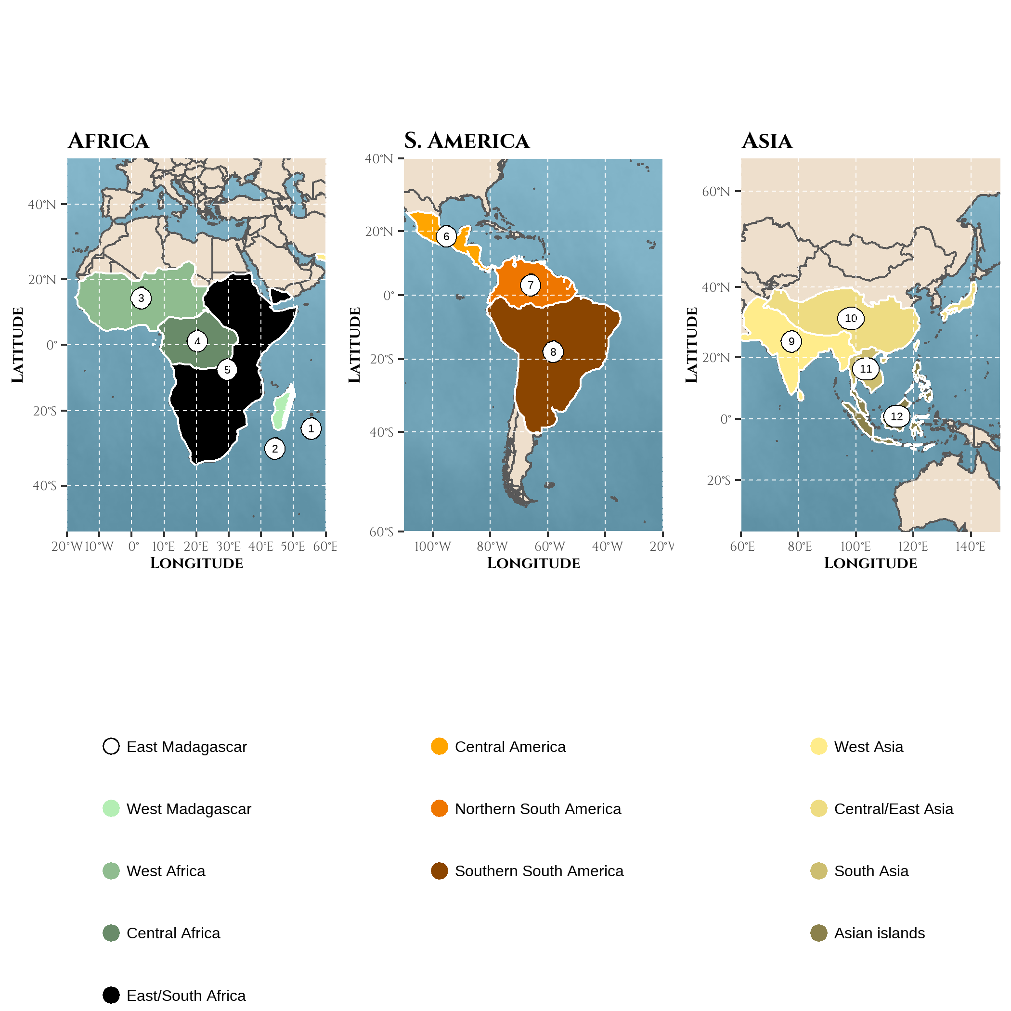
Figure 1: Biogeographic areas used for reconstructing the history of sympatry in frugivorous primates represented on the Mercator projection of the world | Areas were defined as a combination of geographic and environmental criteria relative to the primate taxonomy following results from Kamilar (2009): (1) East Madagascar (2) West Madagascar (3) West Africa (4) Central Africa (5) East/South Africa (6) Central America (7) North South-America (8) South South-America (9) West Asia (10) Central/East Asia (11) South Asia (12) Asian peninsula and islands. Note that the northern Africa and the southern of Europe were discarded because Macaca sylvanus was not considered.
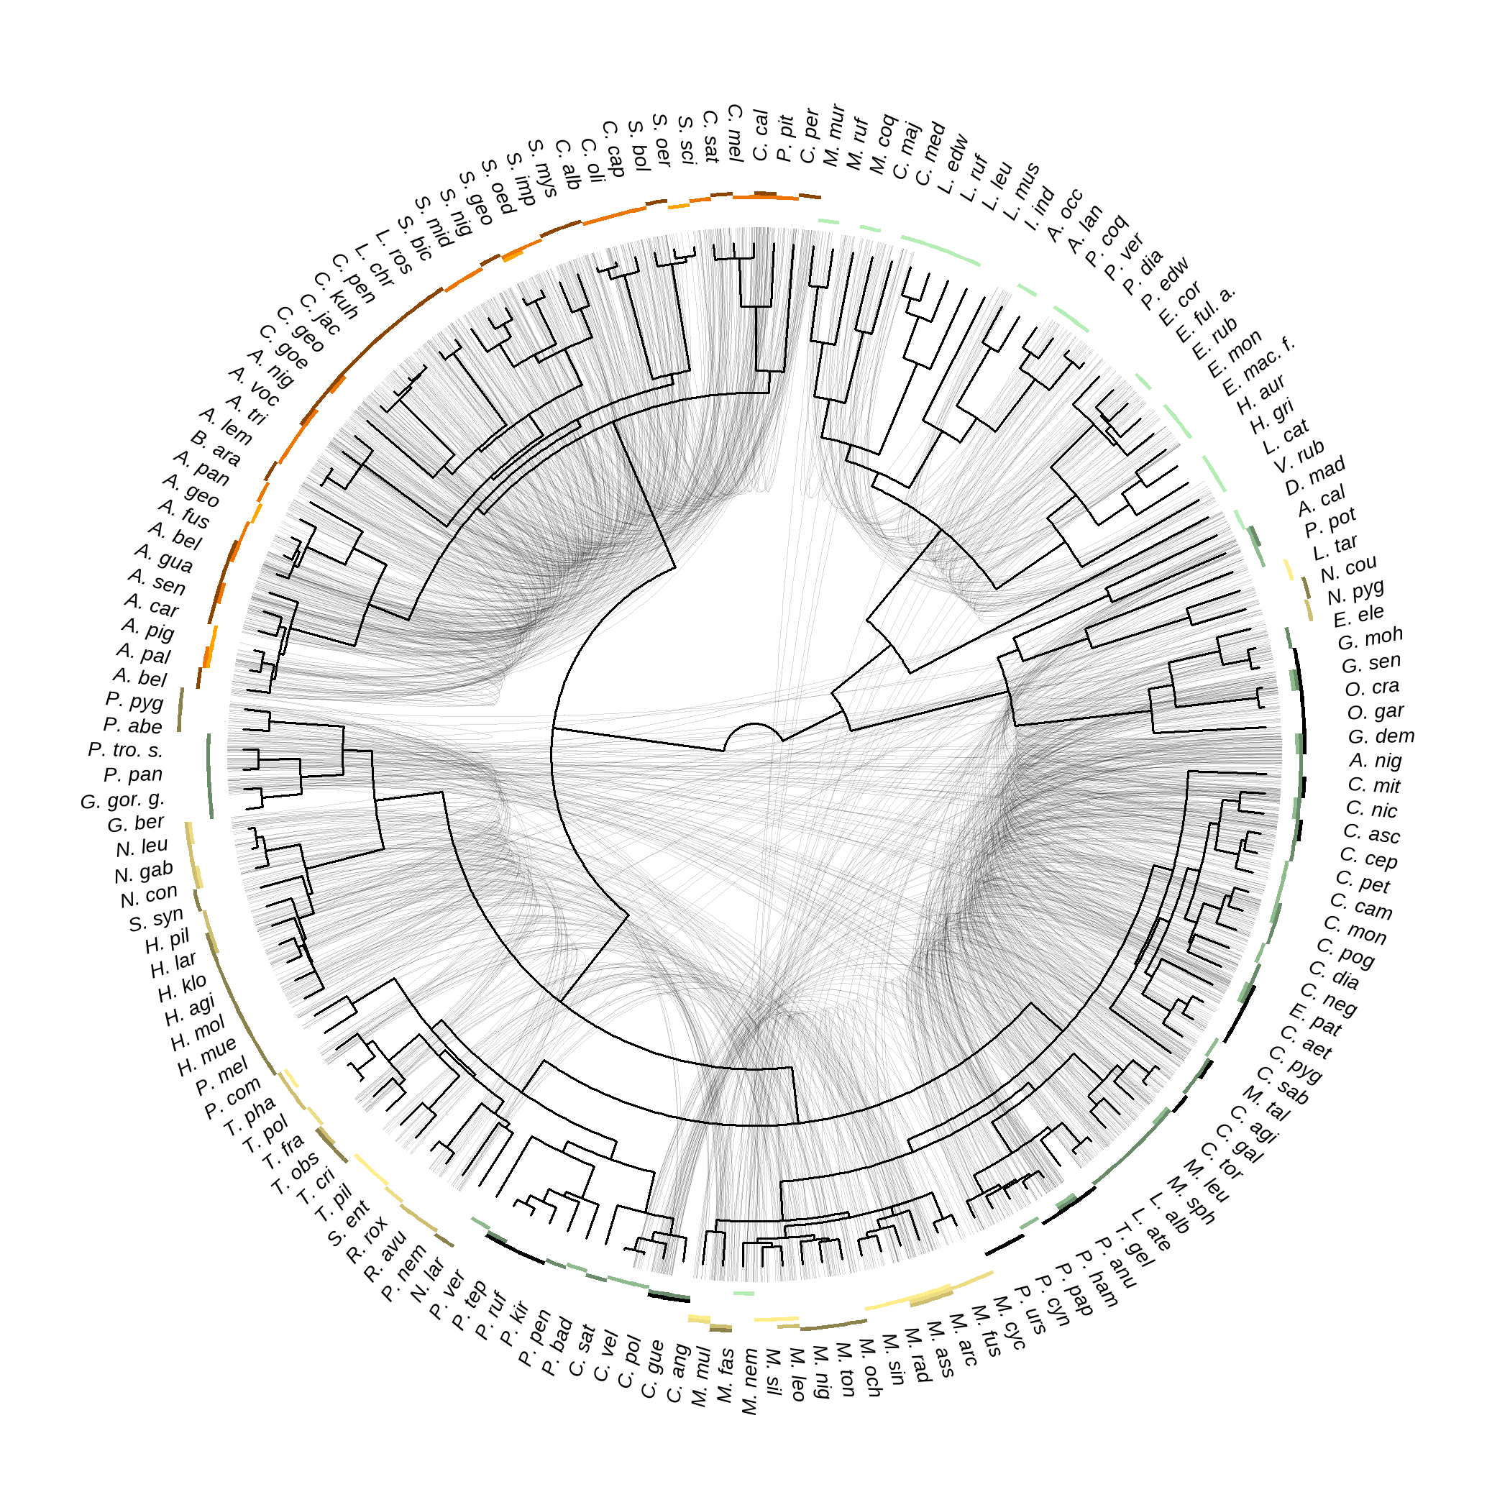
Figure 2: The intensity of species sympatry varies across the primate phylogeny | Primate phylogeny from the consensus tree of the 10kTrees project is depicted in the center, together with abbreviated species names. The corresponding non-abbreviated names can be found using Supplementary Figure S4. Sympatric frugivorous (based on a frugivory threshold of 20% and folivory threshold of 40%) species are linked by light grey lines. The geographic areas occupied by a species are depicted by coloured rectangles. Presence was assessed given an overlap between the species range and the geographic area of 10%.
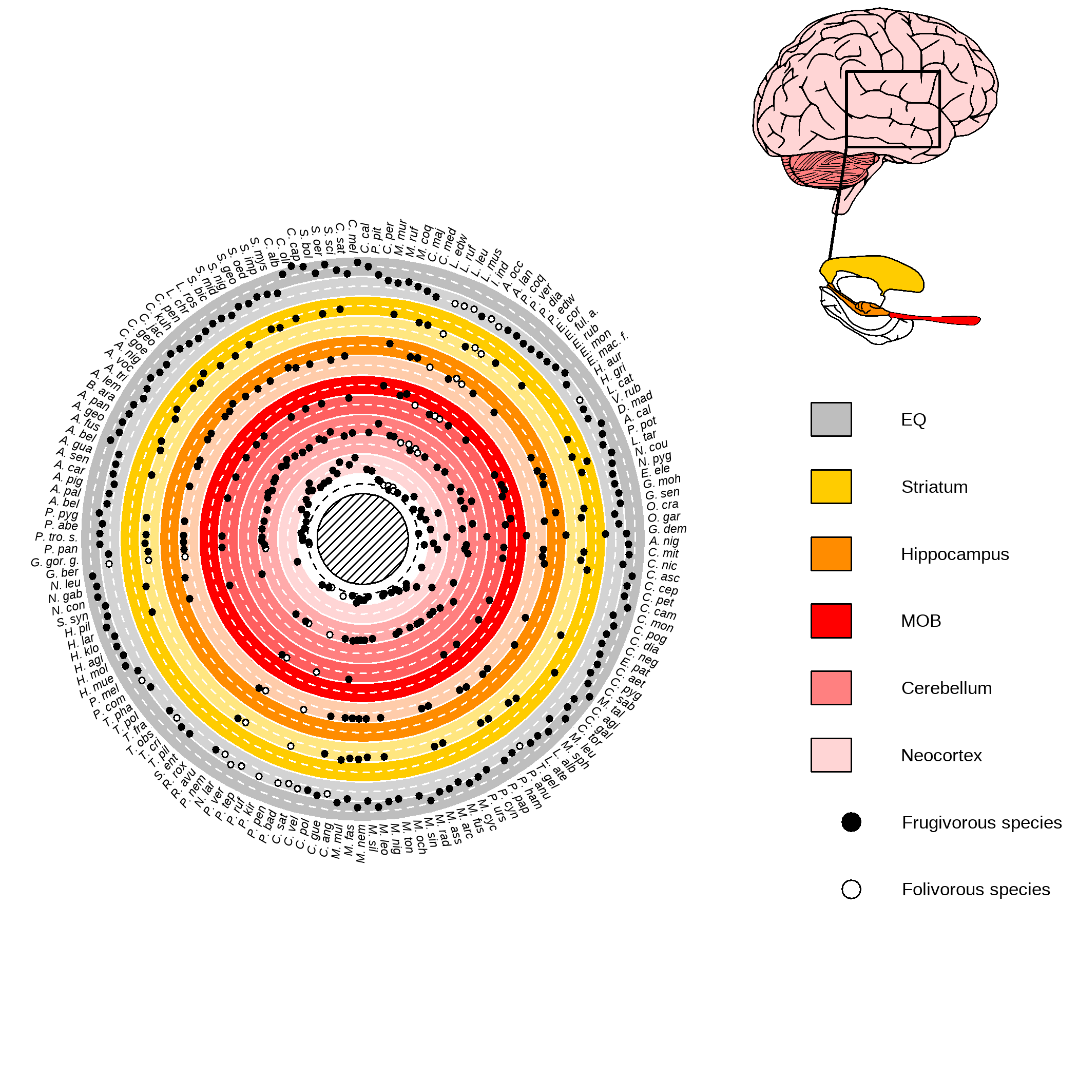
Figure 3: Variations in relative brain size areas among extant frugivorous primates | (Left) Circular plot of the relative sizes of the different brain areas. Colours indicate the rows for the different brain areas. The darker background emphasises when values are above average, while the lighter background emphasises when values are below average. The mean value (after scaling and based on one random sampling among possible values, but see Supplementary Figure S3 for visualization of measure variability) for the Encephalization Quotient (EQ) or relative size of brain areas, when available, is depicted by a plain circle for frugivorous species. The frugivorous threshold was fixed to 20% and the folivory threshold to 40%. (Right) The different studied brain areas (human brain as an illustration). In short, the MOB is involved in immediate olfactory information processing, the neocortex and the cerebellum support working memory and memory consolidation of immediate sensory information processing (Wiltgen et al. 2004; Koziol et al. 2014; Sokolov, Miall, and Ivry 2017), and the hippocampus supports a working memory and a long-term spatio-temporal memory (Burgess, Maguire, and O’Keefe 2002). The striatum is involved in social information processing (Báez-Mendoza and Schultz 2013).
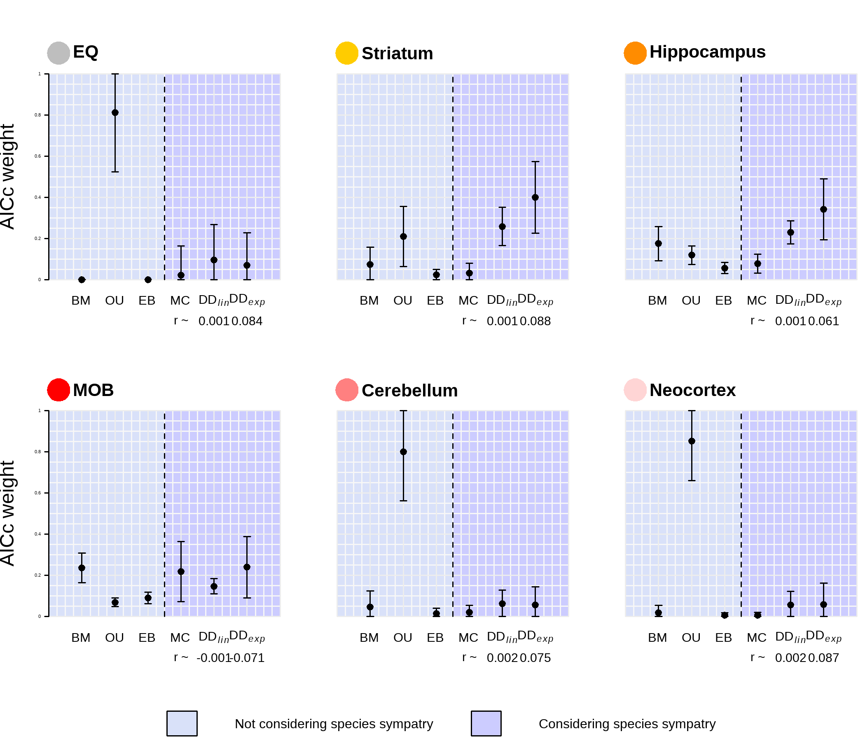
Figure 4: The evolution of the hippocampus and striatum in frugivorous primates are best fitted by models of trait evolution considering species sympatry | Plotted is the AICc weight, a measure of relative support for a given model, for models not considering species sympatry (BM, OU, EB) or considering species sympatry (MC, DD$​_{lin}$, DD$​_{exp}$). The points represent the average AICc weight obtained (when considering the six models from the same run), while the vertical bars indicate the standard deviation given all tested conditions (see Phylogenetic models of trait evolution: does species sympatry shape brain size evolution?).
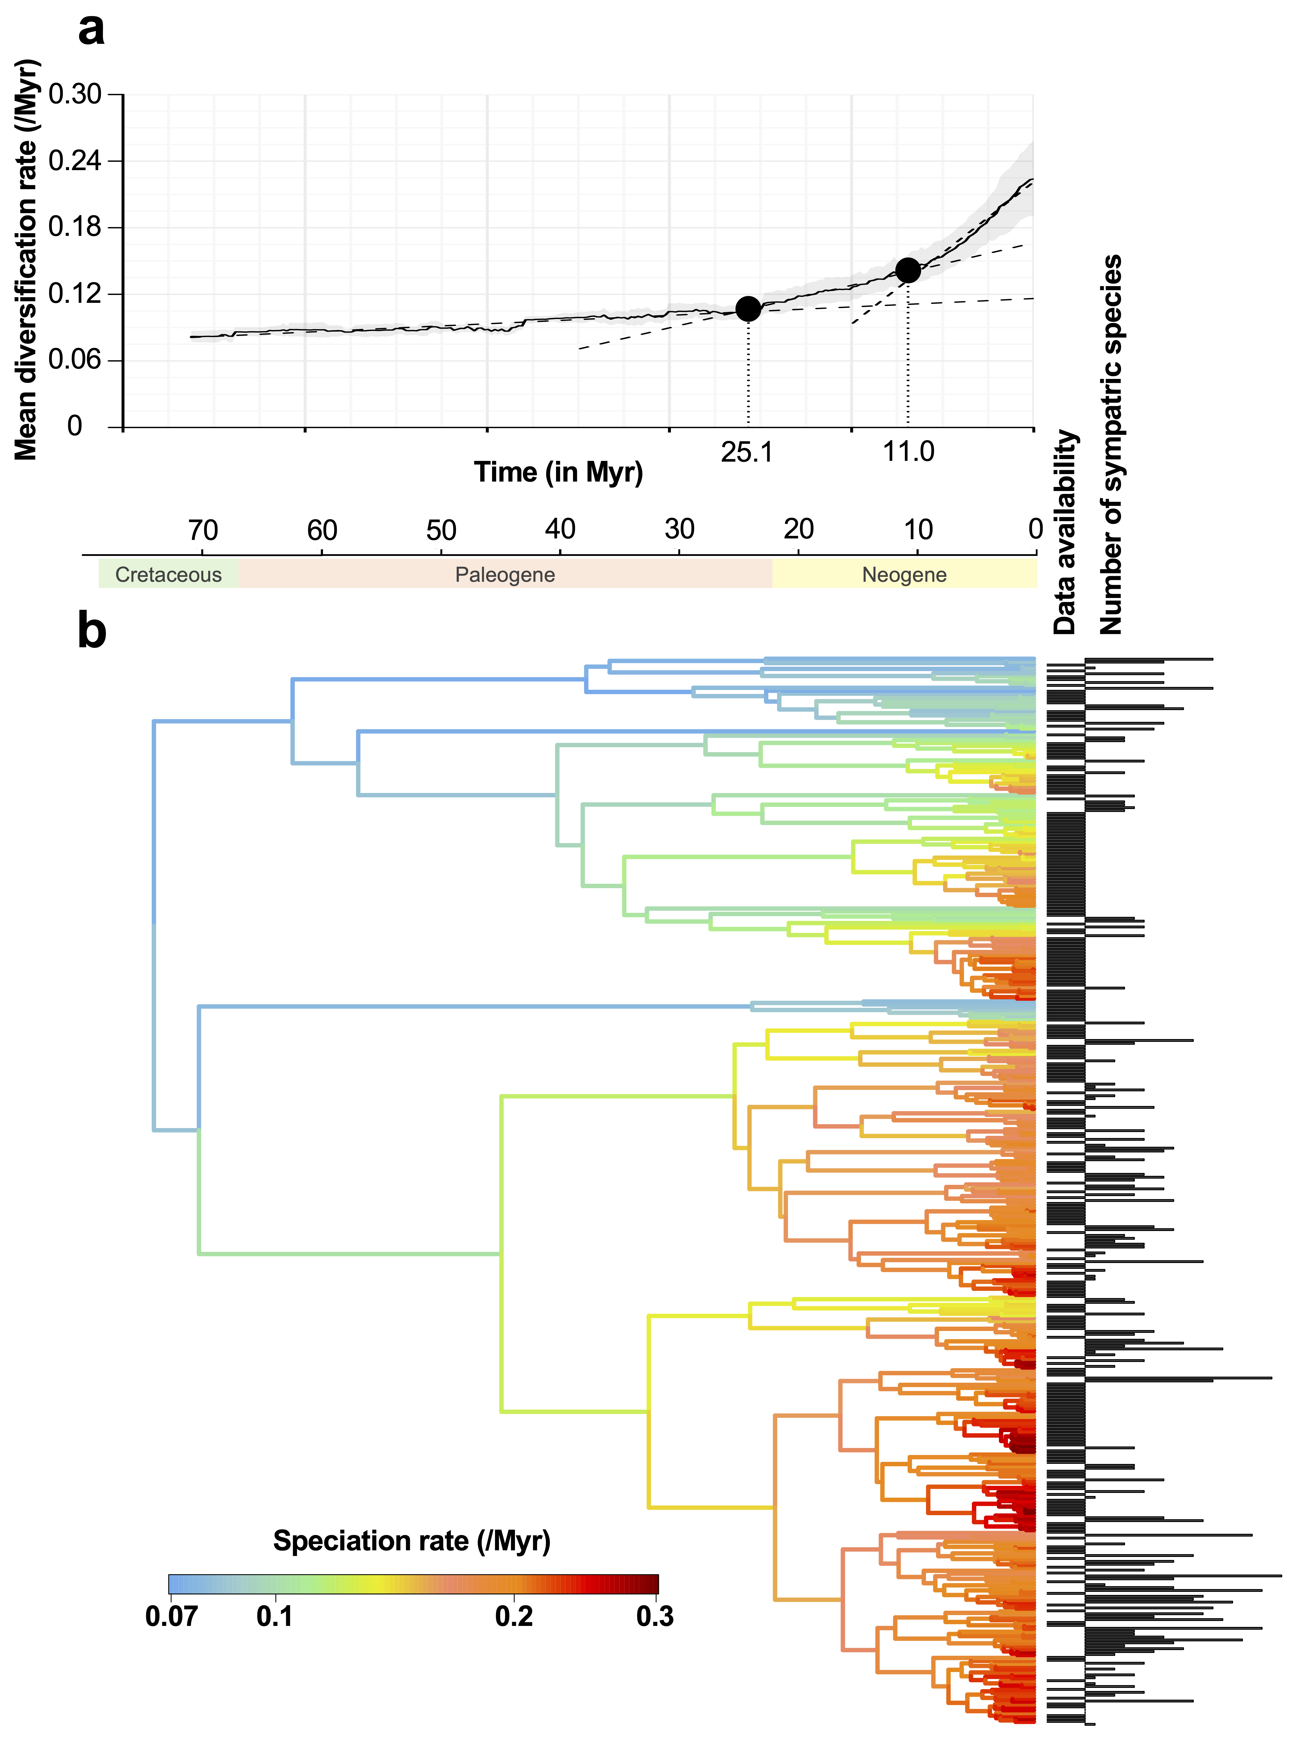
Figure 5: Species sympatry in primates is negatively associated with species diversification | a) Net diversification rate over time in the primate taxon. The average diversification rate estimated based on an assumed sampling fraction of primate species ranging from 60 to 95% (at a step of 10%; then 5% from 90%) is depicted by the plain line. The grey background depicts the standard deviation. The two breakpoints, depicted by the plain dots and the vertical dotted bars, were estimated based on a three-linear regression segmentation using the strucchange package [Zeileis et al. (2002); Zeileis et al. (2003); Zeileis (2006); see the vignette package for statistical details]. The three fitted regressions are displayed by the dashed lines. The choice of two breakpoints was first assessed by choosing the number of breakpoints minimizing the Bayesian Information Criterion. b) The branches of the primate phylogenetic trees are colored according to their speciation rates estimated using ClaDS2: red colors indicate lineages that speciate frequently, whereas blue colors indicate lineages that rarely speciate. At the tips of the tree, we reported for each extant species whether we had data on its biogeography (column ‘Data availability’) and if so, we indicated the number of sympatric species it has. Using PGLS, we found a significant relationship between lineage-specific diversification rates and numbers of sympatric species at present.

References
Altschul, Drew M., Michael J. Beran, Manuel Bohn, Josep Call, Sarah DeTroy, Shona J. Duguid, Crystal L. Egelkamp, et al. 2019. “Establishing an infrastructure for collaboration in primate cognition research.” PLoS ONE 14 (10): e0223675. https://doi.org/10.1371/journal.pone.0223675.
Arbour, Jessica H., and Sharlene E. Santana. 2017. “A major shift in diversification rate helps explain macroevolutionary patterns in primate species diversity.” Evolution 71 (6): 1600–1613. https://doi.org/10.1111/evo.13237.
Aristide, Leandro, Sergio Furtado Dos Reis, Alessandra C Machado, Inaya Lima, Ricardo T Lopes, and S Ivan Perez. 2016. “Brain Shape Convergence in the Adaptive Radiation of New World Monkeys.” Proceedings of the National Academy of Sciences 113 (8): 2158–63.
Ashton, Benjamin J., Patrick Kennedy, and Andrew N. Radford. 2020. “Interactions with conspecific outsiders as drivers of cognitive evolution.” Nature Communications 11 (1): 1–9. https://doi.org/10.1038/s41467-020-18780-3.
Avarguès-Weber, A., E. H. Dawson, and L. Chittka. 2013. “Mechanisms of social learning across species boundaries” 290 (1): 1–11. https://doi.org/10.1111/jzo.12015.
Báez-Mendoza, Raymundo, and Wolfram Schultz. 2013. “The role of the striatum in social behavior.” Frontiers in Neuroscience 7 (7 DEC): 233. https://doi.org/10.3389/fnins.2013.00233.
Barton, Robert A., and Paul H. Harvey. 2000. “Mosaic evolution of brain structure in mammals.” Nature 405 (6790): 1055–58. https://doi.org/https://doi.org/10.1038/35016580.
Benson-Amram, Sarah, Ben Dantzer, Gregory Stricker, Eli M. Swanson, and Kay E. Holekamp. 2016. “Brain size predicts problem-solving ability in mammalian carnivores.” Proceedings of the National Academy of Sciences of the United States of America 113 (9): 2532–37. https://doi.org/10.1073/pnas.1505913113.
Bivand, Roger, and Colin Rundel. 2021. Rgeos: Interface to Geometry Engine - Open Source (’GEOS’). https://CRAN.R-project.org/package=rgeos.
Blomberg, Simone P., Theodore Garland, and Anthony R. Ives. 2003. “Testing for phylogenetic signal in comparative data: Behavioral traits are more labile.” Evolution 57 (4): 717–45. https://doi.org/10.1111/j.0014-3820.2003.tb00285.x.
Blomberg, Simone P., Suren I. Rathnayake, and Cheyenne M. Moreau. 2020. “Beyond brownian motion and the ornstein-uhlenbeck process: Stochastic diffusion models for the evolution of quantitative characters.” American Naturalist 195 (2): 145–65. https://doi.org/10.1086/706339.
Bollback, Jonathan P. 2006. “SIMMAP: Stochastic character mapping of discrete traits on phylogenies.” BMC Bioinformatics 7 (1): 1–7. https://doi.org/10.1186/1471-2105-7-88.
Burgess, Neil, Eleanor A. Maguire, and John O’Keefe. 2002. “The human hippocampus and spatial and episodic memory.” Neuron 35 (4): 625–41. https://doi.org/10.1016/S0896-6273(02)00830-9.
Burnham, Kenneth P., and David R. Anderson. 2002. Model selection and multimodel inference: A practical Information-theoretic approach. Second. New York: Springer.
Byrne, Richard W. 2000. “Evolution of primate cognition.” Cognitive Science 24 (3): 543–70. https://doi.org/10.1207/s15516709cog2403_8.
———. 2018. Machiavellian intelligence retrospective. Vol. 132. 4. Oxford University Press Oxford. https://doi.org/10.1037/com0000139.
Campera, Marco, Michela Balestri, Marianna Chimienti, Vincent Nijman, KAI Nekaris, and Giuseppe Donati. 2019. “Temporal Niche Separation Between the Two Ecologically Similar Nocturnal Primates Avahi Meridionalis and Lepilemur Fleuretae.” Behavioral Ecology and Sociobiology 73 (5): 1–12.
Carroll, Lewis. 1871. Through the looking glass. Macmillan London U.K.
Clutton‐Brock, T. H., and Paul H. Harvey. 1980. “Primates, brains and ecology.” Journal of Zoology 190 (3): 309–23. https://doi.org/10.1111/j.1469-7998.1980.tb01430.x.
Condamine, Fabien L., Jonathan Rolland, and Hélène Morlon. 2019. “Assessing the causes of diversification slowdowns: temperature-dependent and diversity-dependent models receive equivalent support.” Ecology Letters 22 (11): 1900–1912. https://doi.org/10.1111/ele.13382.
de Almeida Rocha, Juliana Monteiro, Míriam Plaza Pinto, Jean Philippe Boubli, and Carlos Eduardo Viveiros Grelle. 2015. “The role of competition in structuring primate communities under different productivity regimes in the amazon.” PLoS ONE 10 (12): e0145699. https://doi.org/10.1371/journal.pone.0145699.
Deane, Andrew S, Mariam C Nargolwalla, László Kordos, and David R Begun. 2013. “New Evidence for Diet and Niche Partitioning in Rudapithecus and Anapithecus from Rudabánya, Hungary.” Journal of Human Evolution 65 (6): 704–14.
Deaner, Robert O., Charles L. Nunn, and Carel P. van Schaik. 2000. “Comparative tests of primate cognition: Different scaling methods produce different results.” Brain, Behavior and Evolution 55 (1): 44–52. https://doi.org/10.1159/000006641.
DeCasien, Alex R., and James P. Higham. 2019. “Primate mosaic brain evolution reflects selection on sensory and cognitive specialization.” Nature Ecology and Evolution 3 (10): 1483–93. https://doi.org/10.1038/s41559-019-0969-0.
DeCasien, Alex R., Scott A. Williams, and James P. Higham. 2017. “Primate brain size is predicted by diet but not sociality.” Nature Ecology and Evolution 1 (5): 1–7. https://doi.org/10.1038/s41559-017-0112.
Drury, Jonathan P., Julien Clavel, Marc Manceau, and Hélène Morlon. 2016. “Estimating the effect of competition on trait evolution using maximum likelihood inference.” Systematic Biology 65 (4): 700–710. https://doi.org/10.1093/sysbio/syw020.
Drury, Jonathan P., Madeline C. Cowen, and Gregory F. Grether. 2020. “Competition and hybridization drive interspecific territoriality in birds.” Proceedings of the National Academy of Sciences of the United States of America 117 (23): 12923–30. https://doi.org/10.1073/pnas.1921380117.
Drury, Jonathan P., Joseph A. Tobias, Kevin J. Burns, Nicholas A. Mason, Allison J. Shultz, and Hélène Morlon. 2018. “Contrasting impacts of competition on ecological and social trait evolution in songbirds.” PLoS Biology 16 (1): e2003563. https://doi.org/10.1371/journal.pbio.2003563.
Dunbar, Robin I. M., and Susanne Shultz. 2007. “Evolution in the social brain.” Science 317 (5843): 1344–47. https://doi.org/10.1126/science.1145463.
———. 2017. “Why are there so many explanations for primate brain evolution?” Philosophical Transactions of the Royal Society B: Biological Sciences 372 (1727): 20160244. https://doi.org/10.1098/rstb.2016.0244.
Dunlap, Aimee S., Matthew E. Nielsen, Anna Dornhaus, and Daniel R. Papaj. 2016. “Foraging bumble bees weigh the reliability of personal and social information.” Current Biology 26 (9): 1195–99. https://doi.org/10.1016/j.cub.2016.03.009.
Estrada, Alejandro, Paul A. Garber, Anthony B. Rylands, Christian Roos, Eduardo Fernandez-Duque, Anthony Di Fiore, K. Anne-Isola Nekaris, et al. 2017. “Impending extinction crisis of the world’s primates: Why primates matter.” Science Advances 3 (1): e1600946. https://doi.org/10.1126/sciadv.1600946.
Gómez-Robles, Aida, William D. Hopkins, and Chet C. Sherwood. 2014. “Modular structure facilitates mosaic evolution of the brain in chimpanzees and humans.” Nature Communications 5 (1): 1–9. https://doi.org/10.1038/ncomms5469.
Gonda, Abigé, Gábor Herczeg, and Juha Merilä. 2013. “Evolutionary ecology of intraspecific brain size variation: A review.” Ecology and Evolution 3 (8): 2751–64. https://doi.org/10.1002/ece3.627.
González-Forero, Mauricio, and Andy Gardner. 2018. “Inference of ecological and social drivers of human brain-size evolution.” Nature 557 (7706): 554–57. https://doi.org/10.1038/s41586-018-0127-x.
Goodale, Eben, Guy Beauchamp, Robert D. Magrath, James C. Nieh, and Graeme D. Ruxton. 2010. “Interspecific information transfer influences animal community structure.” Trends in Ecology and Evolution 25 (6): 354–61. https://doi.org/10.1016/j.tree.2010.01.002.
Grueter, Cyril C. 2015. “Home range overlap as a driver of intelligence in primates.” American Journal of Primatology 77 (4): 418–24. https://doi.org/10.1002/ajp.22357.
Hadfield, Jarrod D. 2010. “MCMC Methods for Multi-Response Generalized Linear Mixed Models: The MCMCglmm R Package.” Journal of Statistical Software 33 (2): 1–22. https://www.jstatsoft.org/v33/i02/.
Havmøller, Linnea W., J. Carter Loftus, Rasmus W. Havmøller, Shauhin E. Alavi, Damien Caillaud, Mark N. Grote, Ben T. Hirsch, Lucia L. Tórrez-Herrera, Roland Kays, and Margaret C. Crofoot. 2021. “Arboreal monkeys facilitate foraging of terrestrial frugivores.” Biotropica 53 (6): 1685–97. https://doi.org/10.1111/btp.13017.
Healy, Susan D., and Candy Rowe. 2007. “A critique of comparative studies of brain size.” Proceedings of the Royal Society B: Biological Sciences 274 (1609): 453–64. https://doi.org/10.1098/rspb.2006.3748.
Henke-von der Malsburg, Johanna, Peter M Kappeler, and Claudia Fichtel. 2020. “Linking Ecology and Cognition: Does Ecological Specialisation Predict Cognitive Test Performance?” Behavioral Ecology and Sociobiology 74 (12): 1–26.
Herrmann, Esther, Josep Call, María Victoria Hernández-Lloreda, Brian Hare, and Michael Tomasello. 2007. “Humans have evolved specialized skills of social cognition: The cultural intelligence hypothesis.” Science 317 (5843): 1360–66. https://doi.org/10.1126/science.1146282.
Heymann, Eckhard W, and Hannah M. Buchanan-Smith. 2000. “The behavioural ecology of mixed-species troops of callitrichine primates.” Biological Reviews 75 (2): 169–90. https://doi.org/10.1111/j.1469-185X.1999.tb00044.x.
Heymann, Eckhard W, and Shin S Hsia. 2015. “Unlike fellows–a review of primate–non-primate associations.” Biological Reviews 90 (1): 142–56.
Hijmans, Robert J. 2021. Geosphere: Spherical Trigonometry. https://CRAN.R-project.org/package=geosphere.
Ho, Lam Si Tung, and Cecile Ane. 2014. “A Linear-Time Algorithm for Gaussian and Non-Gaussian Trait Evolution Models.” Systematic Biology 63: 397–408.
Isler, Karin, and Carel P. van Schaik. 2009. “The Expensive Brain: A framework for explaining evolutionary changes in brain size.” Journal of Human Evolution 57 (4): 392–400. https://doi.org/10.1016/j.jhevol.2009.04.009.
IUCN. 2021. The IUCN Red List of Threatened Species. Downloaded on the 19/01/2021. https://www.iucnredlist.org.
Janmaat, Karline R. L., Christophe Boesch, Richard Byrne, Colin A. Chapman, Zoro B. Goné Bi, Josephine S. Head, Martha M. Robbins, Richard W. Wrangham, and Leo Polansky. 2016. “Spatio-temporal complexity of chimpanzee food: How cognitive adaptations can counteract the ephemeral nature of ripe fruit.” American Journal of Primatology 78 (6): 626–45. https://doi.org/10.1002/ajp.22527.
Janmaat, Karline R. L., Colin A. Chapman, R. Meijer, and Klaus Zuberbühler. 2012. “The use of fruiting synchrony by foraging mangabey monkeys: A ’simple tool’ to find fruit.” Animal Cognition 15 (1): 83–96. https://doi.org/10.1007/s10071-011-0435-0.
Janmaat, Karline R. L., Miguel de Guinea, Julien Collet, Richard W. Byrne, Benjamin Robira, Emiel van Loon, Haneul Jang, et al. 2021. “Using natural travel paths to infer and compare primate cognition in the wild.” iScience 24 (4): 102343. https://doi.org/10.1016/j.isci.2021.102343.
Johnson, Adam, Matthijs AA van der Meer, and A. David Redish. 2007. “Integrating hippocampus and striatum in decision-making.” Current Opinion in Neurobiology 17 (6): 692–97. https://doi.org/10.1016/j.conb.2008.01.003.
Kamilar, Jason M. 2009. “Environmental and geographic correlates of the taxonomic structure of primate communities.” American Journal of Physical Anthropology 139 (3): 382–93. https://doi.org/10.1002/ajpa.20993.
Kamilar, Jason M., and Justin A. Ledogar. 2011. “Species Co-Occurrence Patterns and Dietary Resource Competition in Primates.” American Journal of Physical Anthropology 144 (1): 131–39.
Kashetsky, Tovah, Tal Avgar, and Reuven Dukas. 2021. “The cognitive ecology of animal movement: Evidence from birds and mammals.” Frontiers in Ecology and Evolution 0 (September): 633. https://doi.org/10.3389/FEVO.2021.724887.
Koziol, Leonard F., Deborah Budding, Nancy Andreasen, Stefano D’Arrigo, Sara Bulgheroni, Hiroshi Imamizu, Masao Ito, et al. 2014. “Consensus paper: The cerebellum’s role in movement and cognition.” Cerebellum 13 (1): 151–77. https://doi.org/10.1007/s12311-013-0511-x.
Logan, Corina J., Shahar Avin, Neeltje Boogert, Andrew Buskell, Fiona R. Cross, Adrian Currie, Sarah Jelbert, et al. 2018. “Beyond brain size: Uncovering the neural correlates of behavioral and cognitive specialization.” Comparative Cognition and Behavior Reviews 13 (na): 55–90. https://doi.org/10.3819/CCBR.2018.130008.
Losin, Neil, Jonathan P. Drury, Kathryn S. Peiman, Chaya Storch, and Gregory F. Grether. 2016. “The ecological and evolutionary stability of interspecific territoriality.” Ecology Letters 19 (3): 260–67. https://doi.org/10.1111/ele.12561.
MacLean, Evan L, Brian Hare, Charles L Nunn, Elsa Addessi, Federica Amici, Rindy C Anderson, Filippo Aureli, et al. 2014. “The Evolution of Self-Control.” Proceedings of the National Academy of Sciences 111 (20): E2140–48.
Maliet, Odile, Florian Hartig, and Hélène Morlon. 2019. “A model with many small shifts for estimating species-specific diversification rates.” Nature Ecology and Evolution 3 (7): 1086–92. https://doi.org/10.1038/s41559-019-0908-0.
Maliet, Odile, and Hélène Morlon. 2021. “Fast and accurate estimation of species-specific diversification rates using data augmentation.” Systematic Biology. https://doi.org/10.1093/sysbio/syab055.
Matzke, Nicholas J. 2013. “Probabilistic historical biogeography: new models for founder-event speciation, imperfect detection, and fossils allow improved accuracy and model-testing.” Frontiers of Biogeography 5 (4): na. https://doi.org/10.21425/f5fbg19694.
———. 2016. “Stochastic mapping under biogeographical models.” PhyloWiki BioGeoBEARS na (na): na.
Melchionna, M., A. Mondanaro, C. Serio, S. Castiglione, M. Di Febbraro, L. Rook, J. A. F. Diniz-Filho, et al. 2020. “Macroevolutionary trends of brain mass in Primates.” Biological Journal of the Linnean Society 129 (1): 14–25. https://doi.org/10.1093/biolinnean/blz161.
Merceron, Gildas, Jessica Scott, Robert S Scott, Denis Geraads, Nikolai Spassov, and Peter S Ungar. 2009. “Folivory or Fruit/Seed Predation for Mesopithecus, an Earliest Colobine from the Late Miocene of Eurasia?” Journal of Human Evolution 57 (6): 732–38.
Milham, Michael P, Lei Ai, Bonhwang Koo, Ting Xu, Céline Amiez, Fabien Balezeau, Mark G Baxter, et al. 2018. “An open resource for non-human primate imaging.” Neuron 100 (1): 61–74.
Milton, Katharine. 1981. “Distribution Patterns of Tropical Plant Foods as an Evolutionary Stimulus to Primate Mental Development.” American Anthropologist 83 (3): 534–48. https://doi.org/10.1525/aa.1981.83.3.02a00020.
Minot, Edward O. 1981. “Effects of interspecific competition for food in breeding blue and great tits.” The Journal of Animal Ecology 50 (2): 375. https://doi.org/10.2307/4061.
Modolo, Lara, Walter Salzburger, and Robert D. Martin. 2005. “Phylogeography of Barbary macaques (Macaca sylvanus) and the origin of the Gibraltar colony.” Proceedings of the National Academy of Sciences of the United States of America 102 (20): 7392–97. https://doi.org/10.1073/pnas.0502186102.
Morlon, H, E Lewitus, FL Condamine, M Manceau, J Clavel, and J Drury. 2016. “RPANDA: An r Package for Macroevolutionary Analyses on Phylogenetic Trees.” Methods in Ecology and Evolution 7: 589–97. https://CRAN.R-project.org/package=RPANDA.
Mundry, Roger. 2014. “Statistical issues and assumptions of phylogenetic generalized least squares.” In Modern Phylogenetic Comparative Methods and Their Application in Evolutionary Biology, 131–53. Springer. https://doi.org/10.1007/978-3-662-43550-2_6.
Navarrete, Ana F., Erwin L. A. Blezer, Murillo Pagnotta, Elizabeth S. M. De Viet, Orlin S. Todorov, Patrik Lindenfors, Kevin N. Laland, and Simon M. Reader. 2018. “Primate Brain Anatomy: New Volumetric MRI Measurements for Neuroanatomical Studies.” Brain, Behavior and Evolution 91 (2): 109–17. https://doi.org/10.1159/000488136.
Navarrete, Ana F., Carel P. van Schaik, and Karin Isler. 2011. “Energetics and the evolution of human brain size.” Nature 480 (7375): 91–93. https://doi.org/10.1038/nature10629.
Nuismer, Scott L., and Luke J. Harmon. 2015. “Predicting rates of interspecific interaction from phylogenetic trees.” Ecology Letters 18 (1): 17–27. https://doi.org/10.1111/ele.12384.
Olupot, William, Peter M. Waser, and Colin A. Chapman. 1998. “Fruit finding by mangabeys (Lophocebus albigena): Are monitoring of fig trees and use of sympatric frugivore calls possible strategies?” International Journal of Primatology 19 (2): 339–53. https://doi.org/10.1023/A:1020391901832.
Pavoine, Sandrine, Michael B. Bonsall, T. Jonathan Davies, and Shelly Masi. 2019. “Mammal extinctions and the increasing isolation of humans on the tree of life.” Ecology and Evolution 9 (3): 914–24. https://doi.org/10.1002/ece3.4630.
Pearce, Fiona, Chris Carbone, Guy Cowlishaw, and Nick J. B. Isaac. 2013. “Space-use scaling and home range overlap in primates.” Proceedings of the Royal Society B: Biological Sciences 280 (1751): 20122122. https://doi.org/10.1098/rspb.2012.2122.
Pennell, MW, JM Eastman, GJ Slater, JW Brown, JC Uyeda, RG Fitzjohn, ME Alfaro, and LJ Harmon. 2014. “Geiger V2.0: An Expanded Suite of Methods for Fitting Macroevolutionary Models to Phylogenetic Trees.” Bioinformatics 30: 2216–18.
Pepperberg, Irene M. 2002. “Allospecific referential speech acquisition in grey parrots (Psittacus erithacus): Evidence for multiple levels of avian vocal imitation.” Imitation in Animals and Artifacts, 109–31.
Persson, Tomas, Gabriela Alina Sauciuc, and Elainie Alenkær Madsen. 2018. “Spontaneous cross-species imitation in interactions between chimpanzees and zoo visitors.” Primates 59 (1): 19–29. https://doi.org/10.1007/s10329-017-0624-9.
Pigot, Alex L., and Joseph A. Tobias. 2013. “Species interactions constrain geographic range expansion over evolutionary time.” Ecology Letters 16 (3): 330–38. https://doi.org/10.1111/ele.12043.
Porter, Leila M. 2001. “Benefits of polyspecific associations for the Goeldi’s monkey (Callimico goeldii).” American Journal of Primatology 54 (3): 143–58. https://doi.org/10.1002/ajp.1019.
Powell, Lauren E., Robert A. Barton, and Sally E. Street. 2019. “Maternal investment, life histories and the evolution of brain structure in primates.” Proceedings of the Royal Society B: Biological Sciences 286 (1911): 20191608. https://doi.org/10.1098/rspb.2019.1608.
Powell, Lauren E., Karin Isler, and Robert A. Barton. 2017. “Re-evaluating the link between brain size and behavioural ecology in primates.” Proceedings of the Royal Society B: Biological Sciences 284 (1865): 20171765. https://doi.org/10.1098/rspb.2017.1765.
Price, Trevor D., and Mark Kirkpatrick. 2009. “Evolutionarily stable range limits set by interspecific competition.” Proceedings of the Royal Society B: Biological Sciences 276 (1661): 1429–34. https://doi.org/10.1098/rspb.2008.1199.
R Core Team. 2020. “R: A language and environment for statistical computing.” Vienna, Austria: R Foundation for Statistical Computing. http://www.r-project.org https://www.r-project.org/.
Rabosky, Daniel L., and Irby J. Lovette. 2008. “Density-dependent diversification in North American wood warblers.” Proceedings of the Royal Society B: Biological Sciences 275 (1649): 2363–71. https://doi.org/10.1098/rspb.2008.0630.
Rafacz, Michelle, and Jennifer J. Templeton. 2003. “Environmental unpredictability and the value of social information for foraging starlings.” Ethology 109 (12): 951–60. https://doi.org/10.1046/j.0179-1613.2003.00935.x.
Railsback, Steven F, and Volker Grimm. 2019. Agent-based and individual-based modeling: a practical introduction. Princeton university press.
Ramdarshan, Anusha, Gildas Merceron, and Laurent Marivaux. 2012. “Spatial and Temporal Ecological Diversity Amongst Eocene Primates of France: Evidence from Teeth.” American Journal of Physical Anthropology 147 (2): 201–16.
Reader, Simon M., and Kevin N. Laland. 2002. “Social intelligence, innovation, and enhanced brain size in primates.” Proceedings of the National Academy of Sciences of the United States of America 99 (7): 4436–41. https://doi.org/10.1073/pnas.062041299.
Revell, Liam J. 2012. “Phytools: An r Package for Phylogenetic Comparative Biology (and Other Things).” Methods in Ecology and Evolution 3: 217–23.
Robira, Benjamin, Simon Benhamou, Shelly Masi, Violaine Llaurens, and Louise Riotte-Lambert. 2021. “Foraging efficiency in temporally predictable environments: Is a long-term temporal memory really advantageous?” Royal Society Open Science.
Rosati, Alexandra G. 2017. “Foraging cognition: Reviving the Ecological Intelligence Hypothesis.” Trends in Cognitive Sciences 21 (9): 691–702. https://doi.org/10.1016/j.tics.2017.05.011.
Sayol, Ferran, Oriol Lapiedra, Simon Ducatez, and Daniel Sol. 2019. “Larger brains spur species diversification in birds.” Evolution 73 (10): 2085–93. https://doi.org/10.1111/evo.13811.
Schaik, Carel P. van, and Judith M. Burkart. 2011. “Social learning and evolution: The cultural intelligence hypothesis.” Philosophical Transactions of the Royal Society B: Biological Sciences 366 (1567): 1008–16. https://doi.org/10.1098/rstb.2010.0304.
Schilder, Brian M, Heywood M Petry, and Patrick R Hof. 2020. “Evolutionary Shifts Dramatically Reorganized the Human Hippocampal Complex.” Journal of Comparative Neurology 528 (17): 3143–70.
Schreier, Brian M, Alexander H Harcourt, Stephanie A Coppeto, and Masha F Somi. 2009. “Interspecific Competition and Niche Separation in Primates: A Global Analysis.” Biotropica 41 (3): 283–91.
Shultz, Susanne, and Robin I. M. Dunbar. 2006. “Chimpanzee and felid diet composition is influenced by prey brain size.” Biology Letters 2 (4): 505–8. https://doi.org/10.1098/rsbl.2006.0519.
Slater, GJ, LJ Harmon, D Wegmann, P Joyce, LJ Revell, and ME Alfaro. 2012. “Fitting Models of Continuous Trait Evolution to Incompletely Sampled Comparative Data Using Approximate Bayesian Computation.” Evolution 66: 752–62.
Smaers, Jeroen B, Ryan S Rothman, Daphne R Hudson, Amy M Balanoff, Brian Beatty, Dina KN Dechmann, Dorien de Vries, et al. 2021. “The Evolution of Mammalian Brain Size.” Science Advances 7 (18): eabe2101.
Sokolov, Arseny A., R. Chris Miall, and Richard B. Ivry. 2017. “The cerebellum: Adaptive prediction for movement and cognition.” Trends in Cognitive Sciences 21 (5): 313–32. https://doi.org/10.1016/j.tics.2017.02.005.
Sol, Daniel, Tamás Székely, András Liker, and Louis Lefebvre. 2007. “Big-brained birds survive better in nature.” Proceedings of the Royal Society B: Biological Sciences 274 (1611): 763–69. https://doi.org/10.1098/rspb.2006.3765.
Springer, Mark S, Robert W Meredith, John Gatesy, Christopher A Emerling, Jong Park, Daniel L Rabosky, Tanja Stadler, et al. 2012. “Macroevolutionary Dynamics and Historical Biogeography of Primate Diversification Inferred from a Species Supermatrix.” PloS One 7 (11): e49521.
Todorov, Orlin S., Vera Weisbecker, Emmanuel Gilissen, Karl Zilles, and Alexandra A. De Sousa. 2019. “Primate hippocampus size and organization are predicted by sociality but not diet.” Proceedings of the Royal Society B: Biological Sciences 286 (1914): 20191712. https://doi.org/10.1098/rspb.2019.1712.
Tomasello, Michael. 2019. The cultural origins of human cognition. Harvard university press. https://doi.org/10.2307/j.ctvjsf4jc.
Trapanese, Cinzia, Benjamin Robira, Giordana Tonachella, Silvia Di Gristina, Hélène Meunier, and Shelly Masi. 2019. “Where and what? Frugivory is associated with more efficient foraging in three semi-free ranging primate species.” Royal Society Open Science 6 (5): 181722. https://doi.org/10.1098/rsos.181722.
Van Schaik, Carel P., Zegni Triki, Redouan Bshary, and Sandra A. Heldstab. 2021. “A Farewell to the Encephalization Quotient: A New Brain Size Measure for Comparative Primate Cognition.” Brain, Behavior and Evolution 96 (1): 1–12. https://doi.org/10.1159/000517013.
Weir, Jason T., and Sara Mursleen. 2013. “Diversity-dependent cladogenesis and trait evolution in the adaptive radiation of the auks (Aves: Alcidae).” Evolution 67 (2): 403–16. https://doi.org/10.1111/j.1558-5646.2012.01786.x.
Whiten, Andrew, and Carel P. van Schaik. 2007. “The evolution of animal ’cultures’ and social intelligence.” Philosophical Transactions of the Royal Society B: Biological Sciences 362 (1480): 603–20. https://doi.org/10.1098/rstb.2006.1998.
Willems, Erik P., Barbara Hellriegel, and Carel P. van Schaik. 2013. “The collective action problem in primate territory economics.” Proceedings of the Royal Society B: Biological Sciences 280 (1759): 20130081. https://doi.org/10.1098/rspb.2013.0081.
Wilson, AC. 1991. “From molecular evolution to body and brain evolution.” In Perspectives on Cellular Regulation: From Bacteria to Cancer, 331–40. J. Wiley & Sons.
Wiltgen, Brian J., Robert A. M. Brown, Lynn E. Talton, and Alcino J. Silva. 2004. “New circuits for old memories: The role of the neocortex in consolidation.” Neuron 44 (1): 101–8. https://doi.org/10.1016/j.neuron.2004.09.015.
Wisniewski, Anna L, Graeme T Lloyd, and Graham J Slater. 2022. “Extant Species Fail to Estimate Ancestral Geographical Ranges at Older Nodes in Primate Phylogeny.” Proceedings of the Royal Society B 289 (1975): 20212535.
Zeileis, Achim. 2006. “Implementing a Class of Structural Change Tests: An Econometric Computing Approach.” Computational Statistics & Data Analysis 50: 2987–3008.
Zeileis, Achim, Christian Kleiber, Walter Krämer, and Kurt Hornik. 2003. “Testing and Dating of Structural Changes in Practice.” Computational Statistics & Data Analysis 44: 109–23.
Zeileis, Achim, Friedrich Leisch, Kurt Hornik, and Christian Kleiber. 2002. “Strucchange: An r Package for Testing for Structural Change in Linear Regression Models.” Journal of Statistical Software 7 (2): 1–38. http://www.jstatsoft.org/v07/i02/.

